IEEE P802.11
Wireless LANs
Discussion and Proposed Modifications to Annex C
Date: 2023-05-25
Author(s):
Name | Affiliation | Address | Phone | email
Claudio da Silva | Meta Platforms |  |  | claudiodasilva@meta.com
Abstract
This submission examines MIB concepts and recommends modifications to Annex C.

Discussion
- MIB = Management Information Base
- Informal description:
  - Database used for managing the entities in a communication network
  - Collection of management information available on an entity
- References
  - 09/0533r1, Recomendation-re-MIB-types-and-usage
  - 15/0355r13, MIB TruthValue usage patterns

From 09/0533r1,
- Purpose is to manage STAs and entities within STAs to allow proper and useful interoperation in a wireless network
- Such management is provided by interaction between entities to provide status and exert control
  - MIB attributes (a.k.a. “objects” or “variables”) provide an implicit interface between entities through read (“GET”) and write (“SET”) operations.

- Types of MIB attributes
  - Capability: Static, initialized by entity as part of instantiation, read by other entities.
    - dot11XxxImplemented, dot11RadioMeasurementCapable, dot11ChannelAgilityPresent, dot11FTResourceRequestSupported, dot11ExtendedChannelSwitchEnabled
  - Status: Dynamic, written by the entity to expose current conditions to reading entities.
    - dot11XxxCount, dot11RadioMeasurementEnabled
  - Control: Dynamic, written by another entity to control the applicable entity’s manageable behaviors.
    - dot11RTSThreshold, dot11ShortRetryLimit, dot11LongRetryLimit, dot11FragmentationThreshold, dot11PrivacyInvoked

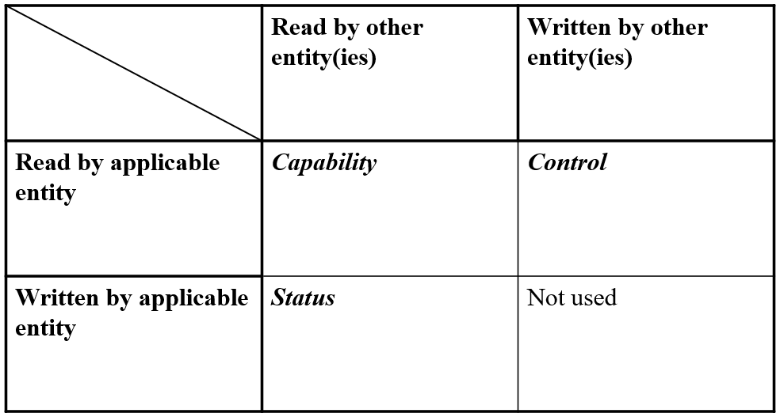

- MIB attributes are not local variables
  - Attributes accessed solely within the entity do not provide any management function
  - Local variables are those that are not exposed outside an entity, for read or write
  - Some example local variables – NAV, used_time, admitted_time, aXxxXxx (e.g. aSlotTime), CW, SSRC, SLRC
  - Local variables should not be part of the MIB
  - Some local variables could be used solely within the Standard’s text, if useful to clarify conforming behaviors, and don’t need formal definition

Discussion (cont.)
- In P802.11bf D1.0’s Annex C:
  - These definitions listed above must be removed from Annex C.

- And in Table 11-29a we have:
  - “Sensing Frame Exchange Timeout value” is correctly defined as a local variable (and does not appear in Annex C).
  - The other three could be defined as a status MIB attribute, or not.
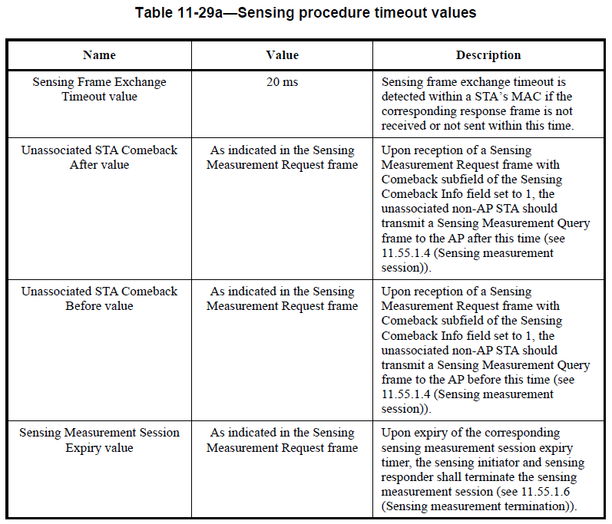

Discussion (cont.)

Example:

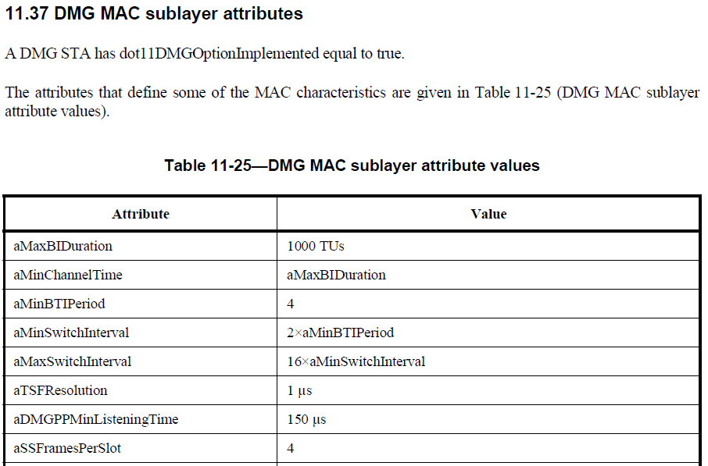

Sensing Procedure
Modifications: TGbf editor:
- Change the title of 11.55.1.2 to “Dependencies and timing-related parameters”.
- Add the following at the end of 11.55.1.2

Table X1 defines timing-related parameters associated with the sensing procedure.

Table X1—Sensing procedure timing-related parameters
Parameter | Value | Description
aSensingProcedureExpiry | 20 ms | Sensing frame exchange timeout is detected within a STA’s MAC if the corresponding response frame is not received or not sent within this time.
aSensingSessionExpiry | Set to the value indicated in the Measurement Session Expiry Exponent field of the Sensing Measurement Request frame that established the sensing session | Upon expiry of the corresponding sensing measurement session expiry timer, the sensing initiator and sensing responder shall terminate the sensing measurement session (see 11.55.1.6 (Sensing measurement termination)).
aSensingComebackAfter | Set to the value indicated in the Unassociated STA Comeback After field of the associated Sensing Measurement Request frame | Upon reception of a Sensing Measurement Request frame with Comeback field of the Sensing Comeback Info field set to 1, the unassociated non-AP STA should transmit a Sensing Measurement Query frame to the AP after this time (see 11.55.1.4 (Sensing measurement session)).
aSensingComebackBefore | Set to the value indicated in the Unassociated STA Comeback Before Exponent field of the associated Sensing Measurement Request frame | Upon reception of a Sensing Measurement Request frame with Comeback field of the Sensing Comeback Info field set to 1, the unassociated non-AP STA should transmit a Sensing Measurement Query frame to the AP before this time (see 11.55.1.4 (Sensing measurement session)).

TGbf editor:
- Delete Table 11-29a.
- Replace references to “Sensing Measurement Session Expiry value”, “Unassociated STA Comeback After value”, and “Unassociated STA Comeback Before value” with aSensingSessionExpiry, aSensingComebackAfter, and aSensingComebackBefore, respectively.

Sensing Procedure (Cont.)
Modifications: TGbf editor:
- Delete the dot11SENSReportSegmentSize entry from Annex C.
- Change 11.55.1.5.3.4 as indicated below:

11.55.1.5.3.4 Rules for generating segmented sensing measurement reports
If a Sensing Measurement Report information exceeds dot11SENSReportSegmentSize aSensingReportSegmentSize, then the Sensing Measurement Report information shall be divided into up to 32 report segments.

aSensingReportSegmentSize shall be 3 750 octets.

Each report segment shall be included in a separate Sensing Measurement Report Container and shall contain successive portions of the Sensing Measurement Report information. The Sensing Measurement Report Control field shall be included in the Sensing Measurement Report Container that carries the first report segment and the Report Control Present field in the Segmentation Control field shall be set to 1(#1154). The Sensing Measurement Report Control field shall not be included in a Sensing Measurement Report Container that does not carry the first report segment and the Report Control Present field in the Segmentation Control field shall be set to 0(#1154). Each report segment shall be of equal length, the length of each report segment being equal to dot11SENSReportSegmentSize aSensingReportSegmentSize, except the last report segment that may be smaller.

Each report segment is identified by the value of the Remaining Report Segments field and the First Report Segment field in the Sensing Measurement Report Control field as defined in Table 9-127f (Segmentation Control field). The other non-reserved fields of the Segmentation Control field shall be the same for all report segments. All report segments shall be sent in a single A-MPDU contained in a PPDU and shall be included in the A-MPDU in the descending order of the values of the Remaining Report Segments field.

Note: Clause 12 example: “This authentication result shall be of fixed length of 128 octets”

SBP Procedure
Discussion:
- In addition to the dot11SBPSetupExpiry attribute, a second timing-related parameter is defined for SBP: SBP Procedure Expiry Exponent.

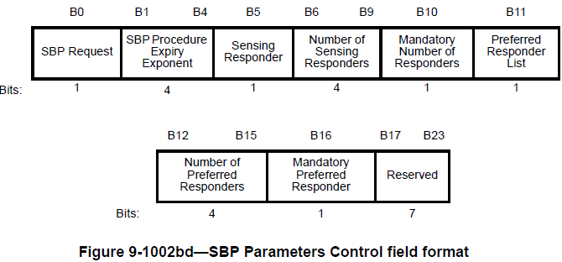

Note: There is no normative text for this field in Clause 11.

Modifications: TGbf editor:
- Add the following at the end of 11.55.2.1 (General)

Table X2 defines timing-related parameters associated with the SBP procedure.

Table X2—SBP procedure timing-related parameters
Attribute | Value | Description
aSBPSetupExpiry | 100 ms | This parameter indicates the time limit the SBP responder shall send an SBP Response frame after receiving an SBP Request.
aSBPProcedureExpiry | Indicated in the SBP Procedure Expiry Exponent field within an SBP Request frame | This parameter indicates the time after which the SBP procedure is terminated if there are no frame exchange sequences.

TGbf editor:
- Replace dot11SBPSetupExpiry with aSBPSetupExpiry through the draft.
- Delete the dot11SBPSetupExpiry entry from Annex C.

DMG Sensing Procedure

TGbf editor:
- Change the title of 11.55.3.2 to “Dependencies and timing-related parameters”.
- Add the following at the end of 11.55.3.2

Table X3 defines a timing-related parameter associated with the DMG sensing procedure.

Table X3—DMG sensing procedure timing-related parameter
Parameter | Value | Description
aDMGSensingProcedureExpiry | 10 s | This parameter indicates the time limit the sensing initiator and sensing responder terminate the DMG sensing measurement session if no handshake happens during the established DMG sensing measurement session.

Option 2: The time limit in which the sensing initiator and sensing responder shall terminate the DMG sensing measurement session if no handshake happens during the established DMG sensing measurement session, aDMGSensingProcedureExpiry, shall be 10 s.

TGbf editor:
- Replace dot11DMGSensingProcedureExpiry with aDMGSensingProcedureExpiry through the draft.
- Delete the dot11DMGSensingProcedureExpiry entry from Annex C.

DMG SBP Procedure

TGbf editor:
- Add the following at the end of 11.55.4.1 (General)

Table X4 defines timing-related parameters associated with the DMG SBP procedure.

Table X4—DMG SBP procedure timing-related parameters
Attribute | Value | Description
aDMGSBPSetupExpiry | 200 ms | This parameter indicates the time limit the SBP responder shall send a DMG SBP Response frame after receiving a DMG SBP Request.
aDMGSBPProcedureExpiry | 10 s | This attribute indicates the time limit the DMG SBP initiator and the DMG SBP responder terminate the DMG SBP procedure if no SBP reporting happens within the time.

TGbf editor:
- Replace dot11DMGSBPSetupExpiry with aDMGSBPSetupExpiry through the draft.
- Replace dot11DMGSBPProcedureExpiry with aDMGSBPProcedureExpiry through the draft.
- Delete the dot11DMGSBPSetupExpiry and dot11DMGSBPProcedureExpiry entries from Annex C.

