IEEE P802.11
Wireless LANs
Discussion and Proposed Modifications to Annex C
Date: 2023-05-15
Author(s):
Name | Affiliation | Address | Phone | email
Claudio da Silva | Meta Platforms |  |  | claudiodasilva@meta.com
Abstract
This submission examines MIB concepts and recommends modifications to Annex C.

Discussion
- References
  - 09/0533r1, Recomendation-re-MIB-types-and-usage
  - 15/0355r13, MIB TruthValue usage patterns

From 09/0533r1,
- MIB is Management Information Base
- Purpose is to manage STAs and entities within STAs to allow proper and useful interoperation in a wireless network
- Such management is provided by interaction between entities to provide status and exert control
  - MIB attributes (a.k.a. “objects” or “variables”) provide an implicit interface between entities through read (“GET”) and write (“SET”) operations.

- Types of MIB attributes
  - Capability: Static, initialized by entity as part of instantiation, read by other entities.
    - dot11XxxImplemented, dot11RadioMeasurementCapable, dot11ChannelAgilityPresent, dot11FTResourceRequestSupported, dot11ExtendedChannelSwitchEnabled
  - Status: Dynamic, written by the entity to expose current conditions to reading entities.
    - dot11XxxCount, dot11RadioMeasurementEnabled
  - Control: Dynamic, written by another entity to control the applicable entity’s manageable behaviors.
    - dot11RTSThreshold, dot11ShortRetryLimit, dot11LongRetryLimit, dot11FragmentationThreshold, dot11PrivacyInvoked

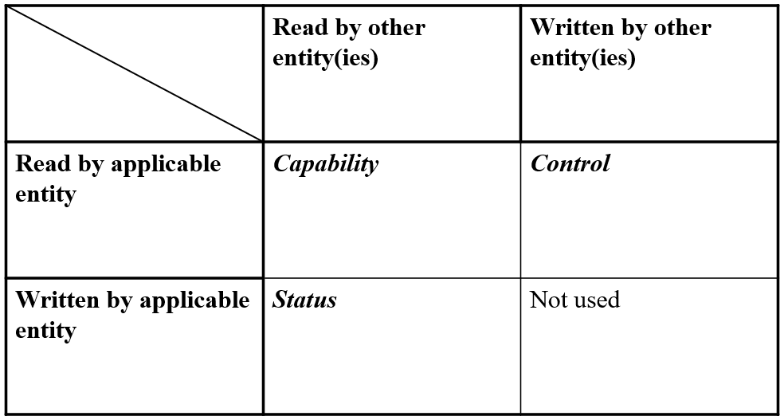

- MIB attributes are not local variables
  - Attributes accessed solely within the entity do not provide any management function
  - Local variables are those that are not exposed outside an entity, for read or write
  - Some example local variables – NAV, used_time, admitted_time, aXxxXxx (e.g. aSlotTime), CW, SSRC, SLRC
  - Local variables should not be part of the MIB
  - Some local variables could be used solely within the Standard’s text, if useful to clarify conforming behaviors, and don’t need formal definition

Discussion (cont.)
- In P802.11bf D1.0’s Annex C:
  - Some/all of the definitions listed above must be removed from Annex C.
- And in Table 11-29a we have:
  - “Sensing Frame Exchange Timeout value” is correctly defined as a local variable (and does not appear in Annex C).
  - The other three could have been defined as a status MIB attribute.
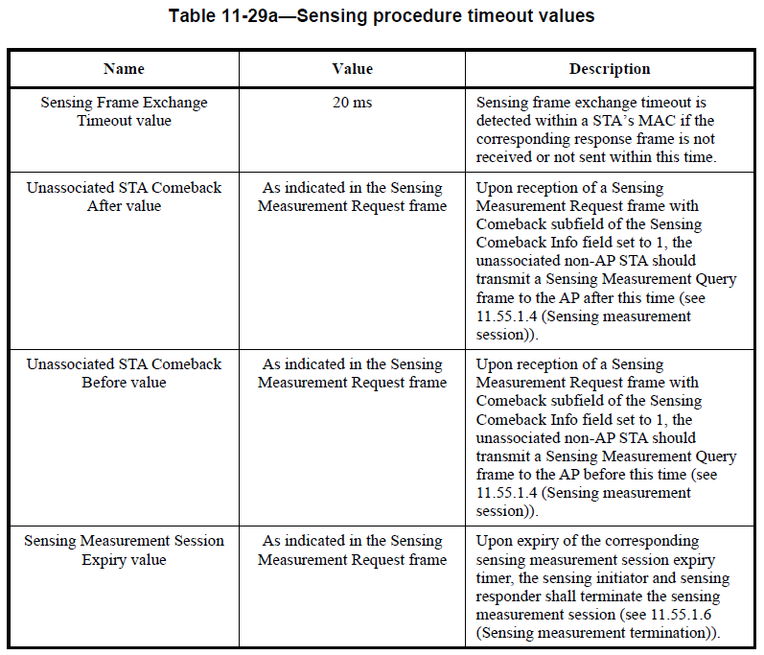
- Note: Duplicate definition?
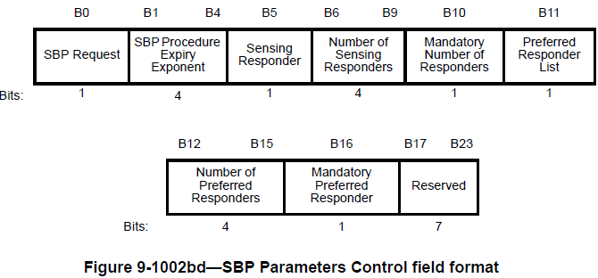
Discussion (cont.)

Example 1:
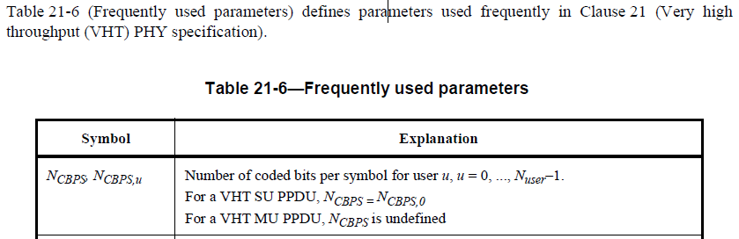

Example 2
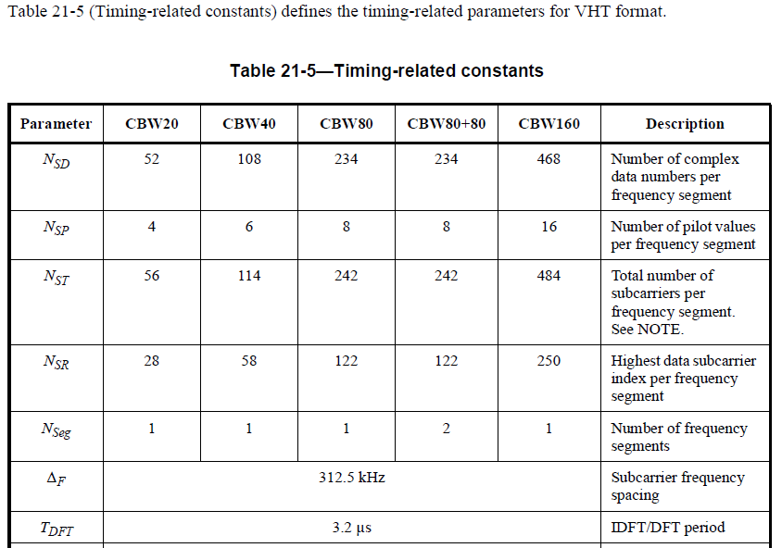

Example 3
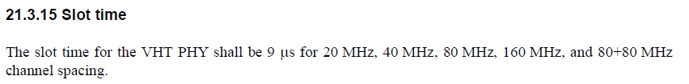

Example 4
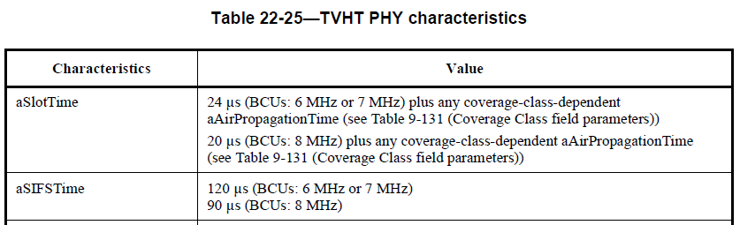

Modifications: Editor, change the existing text in 3.2 as follows:

TBD

