IEEE P802.11
Wireless LANs
LB271 CR for 35.3.7.1.7 Part III
Date: May 11, 2023
Author(s):
Name | Affiliation | Address | Phone | email
Jason Yuchen Guo | Huawei |  |  | guoyuchen@huawei.com
Ming Gan | Huawei
Yunbo Li | Huawei
Guogang Huang | Huawei
Mengyao Ma | Huawei
Hongjia Su | Huawei
Yue Zhao | Huawei
Arik Klein | Huawei

Abstract
This submission proposes resolutions for following 9 CIDs received for TGbe LB271:
18146 17853 16013 18144 16506 18145 16504 16210 17946
Revisions:
- Rev 0: Initial version of the document.
- Rev 1: modify the text based on offline feedback, add discussions for CIDs 16210 and 17946.
- Rev 2: editorial changes.
- Rev 3: Remove the Mapping Switch Time Offset field, add some clarifications
- Rev 4: some minor text changes

Interpretation of a Motion to Adopt

A motion to approve this submission means that the editing instructions and any changed or added material are actioned in the TGbe Draft. This introduction is not part of the adopted material.

Editing instructions formatted like this are intended to be copied into the TGbe Draft (i.e. they are instructions to the 802.11 editor on how to merge the text with the baseline documents).

TGbe Editor: Editing instructions preceded by “TGbe Editor” are instructions to the TGbe editor to modify existing material in the TGbe draft. As a result of adopting the changes, the TGbe editor will execute the instructions rather than copy them to the TGbe Draft.

CID | Commenter | Page | Comment | Proposed Change | Resolution
18146 | Abhishek Patil | 521.29 | If a non-AP MLD had successfully negotiated a mapping 'A' (via T2LM Req/Resp frames) which is a subset of a new (upcoming) advertised mapping 'B' (via Beacon/Probe Resp frames), then which mapping holds true for that non-AP MLD (A or B) after the Mapping Switch Time for the advertised mapping? Shouldn't it be A? Please clarify that this is the case (it will save additional frame exchange for negotiation). | As in comment | Revised –  Agree in principle with the comment.  TGbe Editor:  Please implement the changes in this document tagged as #18146.
17853 | Yunbo Li | 521.10 | It is not discard all negotiated T2LM and revert to default mappings. If a negotiated T2LM complies to a new advertise T2LM, the negotiated T2LM can keeps. | if the mapped links in an negotiated T2LM are a subset of enable links in a new advertised T2LM, the negotiated T2LM keeps after the new advertised T2LM. | Revised –  Agree in principle with the comment.  TGbe Editor:  Please implement the changes in this document tagged as #17853.
16013 | Binita Gupta | 520.31 | Spec should allow a non-AP MLD to keep its individually negotiated TID-to-Link mapping if it does not conflict with the advertised TID-to-Link mapping. Current behavior will result in unnecessary individual renegotiations when the advertised TID-to-Link mapping becomes effective. Also modify NOTE 4 and Figure 35-15 to reflect this behavior. | Modify requirement and NOTE and Figure 35-15 as per comment | Revised –  Agree in principle with the comment.  TGbe Editor:  Please implement the changes in this document tagged as #16013.
18144 | Abhishek Patil | 520.35 | NOTE 4 provides critical guidance and should be converted to normative text. | Replace NOTE 4 as: "An individually negotiated TID-to-link mapping whose negotiation was completed prior to the establishment of an advertised TID-to-link mapping shall be discarded at the time of the establishment of the advertised TID-to-link mapping." | Revised –  Agree in principle with the comment.  TGbe Editor:  Please implement the changes in this document tagged as #18144.
16506 | Arik Klein | 521.05 | Need to clarify that the mapping C has to be identical to the mapping B (advertised) but is applicable only for the links that have been setup between the non-AP MLD and the AP MLD. Please revise the sentence as suggested. | The sentence should be revised as follows: "Note that any mapping between TIDs and links *that are setup between the non-AP MLD and the AP MLD* is enabled in C must be already enabled in the advertised TID-to-link mapping B *(but may include additional links over those included in mapping C)*" | Revised –  The non-AP MLD can request to map the TIDs to less links compared to the advertised TID-to-Link Mapping. The text is changed to directly reflect that.  TGbe Editor:  Please implement the changes in this document tagged with #16506.
18145 | Abhishek Patil | 520.49 | A non-AP MLD is allowed to negotiate a subsetted mapping of what is advertised by the AP MLD. Therefore, this NOTE is confusing. Reword it (as normative) to say that a non-AP MLD shall not transmit a response frame to acknowledge the reception of a T2LM advertisement. However a non-AP MLD may initiate a negotiation of a mapping that is a subset of the advertised mapping by transmitting a T2LM Request frame. NOTE 7 and the following paragraph can be consolidated as suggested above. | As in comment | Revised –  Agree in principle with the comment.  Also use this CID to move the definition of the Expected Duration subfield to the right place (Clause 9). The related CID which was approved previously is 17945.  TGbe Editor:  Please implement the changes in this document tagged as #18145.
16504 | Arik Klein | 520.52 | According to P518L57, the advertised TID-to-link mapping is mandatory for all associated non-AP MLDs. Thus, please clarify how an non-AP MLD can initiate a negotiation on a *different* TID-to-link mapping with the AP MLD? If the negotiated mapping includes a contradicted mapping to one or more TIDs than that advertised, how it can take effect if the advertised is mandatory??? | Please clarify this point or remove this paragraph. | Rejected –  The non-AP MLD can request to map the TIDs to less links compared to the advertised TID-to-Link Mapping.
16210 | Ming Gan | 518.62 | the unit of TU is OK when the Mapping Switch Time field points to a future TBTT on the reporting link, but when it needs to point to a future TBTT on another link, the accuracy of 1 TU is not enough. Please fix this issue. | As in the comment. | Revised –  Agree in principle with the comment.  TGbe Editor:  Please implement the changes in this document tagged as #16210.
17946 | Yuchen Guo | 0 | In Advertised T2LM, the Mapping Switch Time field may indicate the time of the TBTT of the DTIM Beacon to be transmitted on another link, which may not allign with the TU boundary of the current link. However, the unit of the Mapping Switch Time field is 1TU. Hence, there's a miss match. | Please fix this issue. One possible solution is to add a field, together with the Mapping Switch Time field, indicates the time with the acuraccy of 1us. The commenter will bring a contribution to solve this issue. | Revised –  Agree in principle with the comment.  TGbe Editor:  Please implement the changes in this document tagged as #16210.

Discussions for CIDs 16210 and 17946:
The issue raised by the two comments can be depicted by the following figure. Assuming the starting time of a new advertised TID-to-Link mapping is a TBTT on link 2, and a Beacon transmitted on link 1 need to carry a TID-to-Link element to indicate that. However, since the unit of the Mapping Switch Time field is TU, it can only indicate to the TU boundaries on link 1. If the TU boundaries of link 1 and link 2 are not aligned, the Mapping Switch Time field transmitted on link 1 cannot indicate to the accuracy of TU boundaries on link 2. Hence, there will be a mismatch between the AP MLD and the non-AP MLD, which will lead to the following unexpected behaviors:
If a non-AP MLD thinks a link is enabled, but the link is not enabled at the AP MLD side, then it will get no acknowledgement if it transmits to the AP MLD on the link; Same for the AP side.
If a non-AP MLD thinks a link is disabled, but the link is not disabled at the AP side, then it will not be able to send any acknowledgement if the AP MLD transmits to it on that link. Also same for the AP side.

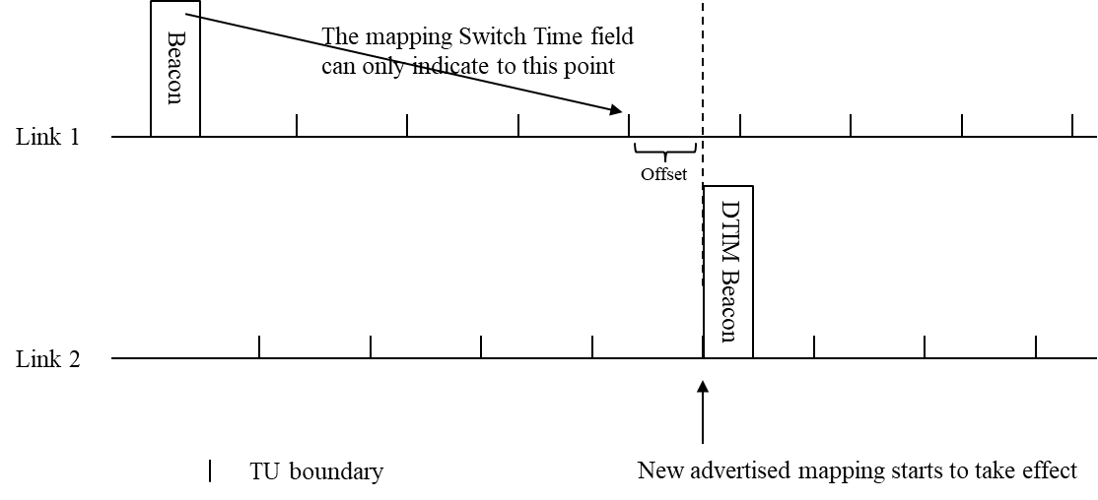
One solution is to add an offset field to close the gap, as described in 11-23-813r2.
The other solution is to add some clarification:
If a link is enabled by the advertised T2LM, the AP MLD needs to enable that link before all non-AP MLDs do;
If a link is disabled by the advertised T2LM, the AP MLD needs to disable that link after all non-AP MLDs do.

TGbe editor: Please update the following paragraphs in this subclause as shown below:
35.3.7.1.7 Advertised TID-to-link mapping in Beacon and Probe Response frames
An AP MLD may advertise a mandatory TID-to-link mapping by including a TID-To-Link Mapping element in the Beacon and Probe Response frames that the APs affiliated with the AP MLD transmit.
An AP that advertises a TID-to-link mapping shall include the Mapping Switch Time field and (#16010)shall set it to the time, in units of TUs, (#17944)of the TBTT of a DTIM Beacon of one of the APs affiliated with the AP MLD. (#16210)If a link is going to be enabled according to the advertised TID-to-link mapping, the AP MLD shall enable that link one TU before the TBTT of that DTIM Beacon frame, and shall not initiate transmission to any non-AP STA on that link before the TBTT of that DTIM Beacon frame. If a link is going to be disabled according to the advertised TID-to-link mapping, the AP MLD shall disable that link no earlier than the TBTT of that DTIM Beacon frame, and shall end the transmission to any non-AP STA on that link at least one TU before the TBTT of that DTIM Beacon frame. (#16009)Beginning at the time indicated in the Mapping Switch Time field, the indicated TID-to-link mapping is established and the Mapping Switch Time field is no longer included.
(#16210)Note – A non-AP MLD might receive more than one TID-to-link Mapping elements on more than one links which indicate different time for the advertised TID-to-link mapping to be established due to the granularity of the Mapping Switch Time field. In that case, the non-AP MLD might choose any time as indicated in the received TID-to-link Mapping elements as the time for the advertised TID-to-link mapping to be established.
Figure 35-7 (An illustration of an advertised TID-to-link mapping taking effect on all links(#18261)) explains the procedure via an example consisting of an AP MLD having three affiliated APs with different DTIM intervals and with TBTTs that are not aligned.
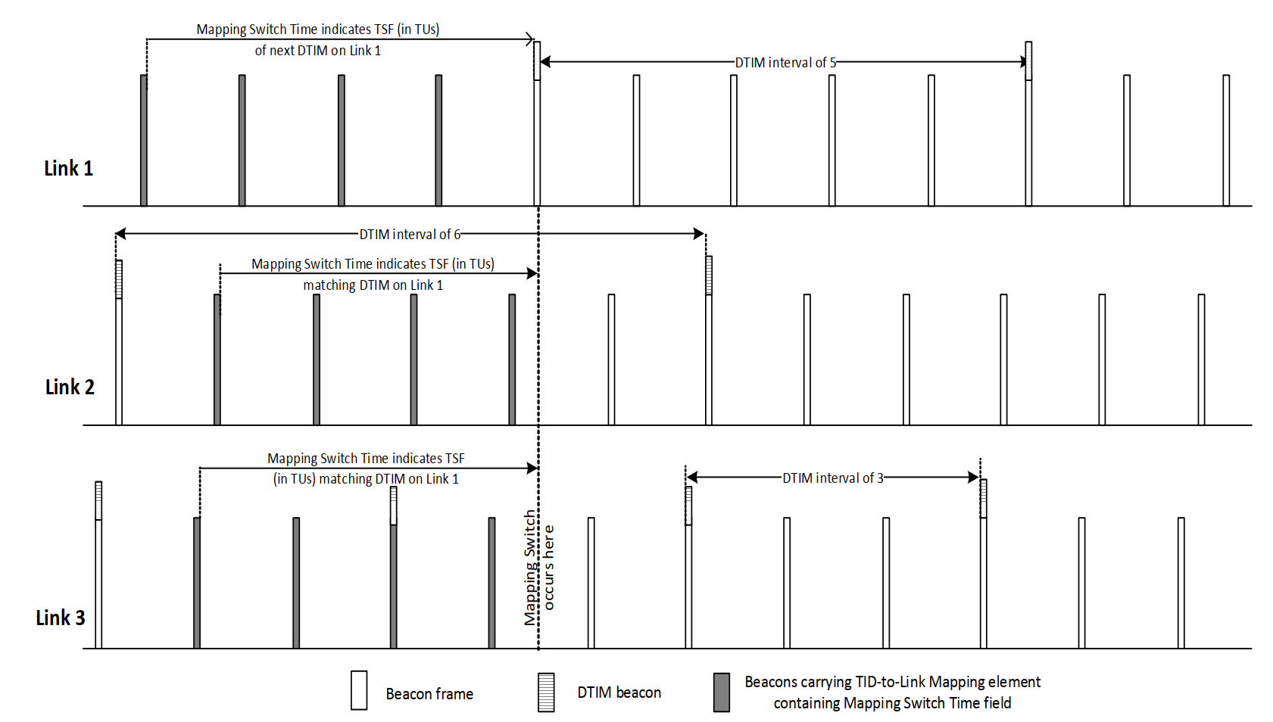
Figure 35-14—An illustration of an advertised TID-to-link mapping taking effect on all links
An AP MLD shall not advertise a TID-to-link mapping that does not map all TIDs to the same link set, both for DL and UL. The Direction field of an advertised TID-To-Link Mapping element shall be set to 2.
NOTE 1—An advertised TID-to-link mapping will include a mapping for all TIDs.
NOTE 2—If the Link ID of each AP in a multiple BSSID set and affiliated with different MLDs is different, then inheritance will not apply to an advertised TID-to-link mapping for the APs that are part of a multiple BSSID set, and therefore the TID-To-Link Mapping element needs to be carried in each nontransmitted BSSID profile to which an advertised mapping applies.
An AP MLD shall include two TID-To-Link Mapping elements in the Beacon and Probe Response frames that the APs affiliated with the AP MLD transmit, if there is already an established advertised TID-to-link mapping and a new nondefault advertised TID-to-link mapping will replace it. In this case, the AP MLD shall not include the Mapping Switch Time field in the currently established advertised TID-To-Link Mapping element, and shall include the Mapping Switch Time field in the new TID-To-Link Mapping element, in order to indicate an advertised TID-to-link mapping that will be established in the future. The value of the Expected Duration field of the existing TID-To-Link Mapping element shall indicate a remaining duration that ends at the same time as indicated by the Mapping Switch Time field of the new TID-To-Link Mapping element.
NOTE 3—If the newly advertised TID-to-link mapping is the default mapping, the AP MLD sets the Expected Duration field of the currently advertised TID-to-link mapping to the remaining time until the default mapping is established as described in 9.4.2.314 (TID-To-Link Mapping element) and does not include the TID-To-Link Mapping element for the newly advertised TID-to-link mapping in the Beacon and Probe Response frames. After the establishment of the default mapping, no TID-To-Link Mapping elements are included in the Beacon or Probe Response frames transmitted by the APs affiliated with the AP MLD.
All APs affiliated with an AP MLD that advertises a TID-to-link mapping shall include the same mapping in all Beacon and Probe Response frames from the time at which the TID-to-link mapping is first advertised until the time at which the TID-to-link mapping is no longer advertised, and shall include the Expected Duration field in all TID-to-link mapping elements in Beacons. (#18141)The Mapping Switch Time field should initially be set to a sufficiently large value. After an advertised TID-to-link mapping is established, the duration indicated by Expected Duration field shall indicate the time when the advertised TID-to-link mapping is expected to end(#18145)(#17945). During the advertisement of the TID-to-link mapping the time indicated (#18142)in the Expected Duration field may be updated to indicate an earlier time than initially indicated, but shall not be updated to indicate a later time than initially indicated. The duration indicated by Expected Duration field shall be exact when the duration is smaller than two DTIM periods of the AP transmitting the frame carrying the field.
At the time indicated by the Mapping Switch Time field of a TID-To-Link Mapping element in a Beacon or a Probe Response frame received by a non-AP STA affiliated with a non-AP MLD from an AP affiliated with its associated AP MLD, or at the time indicated by the Expected Duration field of an existing advertised TID-to-link mapping which will be replaced by an advertised default mapping, the non-AP MLD shall update its TID-to-link mapping according to the rules that establish a TID-to-link mapping in this subclause and with the consequences of the updated mapping defined in 35.3.7.1.1 (General) (#18146, #17853, #16013)unless the current TID-to-Link mapping for the non-AP MLD is a negotiated TID-to-Link mapping and the enabled link set in the current mapping is a subset of the enabled link set in the new advertised mapping.
(#18143)A non-AP MLD applies the advertised TID-to-link mapping only to the links that it has setup with the AP MLD during ML setup.
(#18144) An individually negotiated TID-to-link mapping whose negotiation was completed prior to the establishment of an advertised TID-to-link mapping shall be discarded at the time of the establishment of the advertised TID-to-link mapping if the enabled link set in the advertised TID-to-link mapping is a subset of the enabled link set in the negotiated TID-to-link mapping.
NOTE 5—A non-AP MLD ignores links that are included in the link mappings of an advertised TID-to-link mapping that are not part of the non-AP MLD multi-link setup procedure. For example, if the AP MLD operates on links 1, 2, and 3, and it advertises that link 3 is disabled and all TIDs are mapped to links 1 and 2, then for a non-AP MLD that is associated with the AP MLD using links 1 and 2 the default mapping will apply. In this case, for a non-AP MLD that is associated with the AP MLD using links 1 and 3, link 3 will be disabled.
NOTE 6—In absence of an advertised mapping by the AP a default TID-to-link mapping is assumed unless an individual TID-to-link mapping is successfully negotiated.
(#18145 A non-AP MLD shall not transmit a response frame to acknowledge the reception of an advertised TID-To-Link mapping. However a non-AP MLD may initiate a negotiation of a TID-To-Link mapping that maps all TIDs to a subset of the enabled links of the advertised TID-To-Link mapping by transmitting a TID-To-Link Mapping Request frame.
A non-AP MLD that is associated with an AP MLD that advertises a TID-to-link mapping may initiate a negotiation for a TID-to-link mapping that is different from the TID-to-link mapping established from the advertisement as described in this subclause. (#15599)The non-AP MLD or the AP MLD shall not initiate a negotiation for a TID-to-link mapping that maps a TID to a link if the requested TID is not already mapped to the link in the advertised TID-to-link mapping.
(#15157)An example of TID-to-Link mapping frame exchange involving advertised mapping is shown in AF.5 (Example of TID-to-Link mapping frame exchange(#15157)).

AF.5 Example of TID-to-Link mapping frame exchange(#15157)
TGbe editor: Please update the following paragraphs in this subclause as shown below:
(#18146, #17853, #16013)Figure AF-18 (Example TID-to-link mapping frame exchange where the advertised mapping is a subset of a negotiated mapping) shows an example sequence of TID-to-link mapping frame exchanges. The non-AP MLD operates in default mapping mode in the beginning of the sequence. The non-AP MLD then initiates a negotiation of a TID-to-link mapping A. The AP MLD accepts the request, after which TID-to-link mapping A is active for the non-AP MLD. Next the AP MLD starts to advertise a TID-to-link mapping B (#18146, #17853, #16013)which maps all TIDs to a set of link(s) that is a subset of the enabled link set in the TID-to-Link mapping A. At the time indicated by the Mapping Switch field of the advertised TID-to-Link Mapping element, TID-to-link mapping B is established on the non-AP MLD. Note that we assume that the non-AP MLD includes all the AP MLD link in its multi-link setup, so the same mapping B is established for the non-AP MLD. In the next step the non-AP MLD requests another TID-to-link mapping C. Note that (#16506)the link(s) included in the Link Mapping field of Mapping C is a subset of the link(s) included in the Link Mapping field of Mapping B . The AP MLD accepts the request for TID-to-link mapping C, after which TID-to-link mapping C is active for the non-AP MLD. (#18146, #17853, #16013)

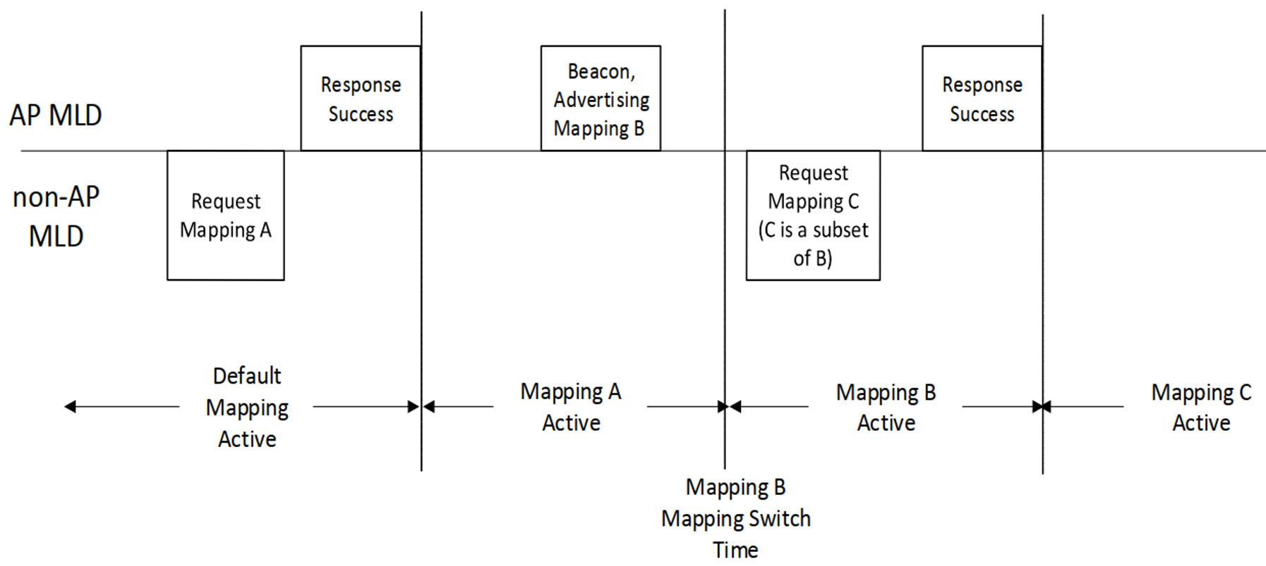
Figure AF-18—Example TID-to-link mapping frame exchange where the advertised mapping is a subset of a negotiated mapping (#18146, #17853, #16013)
TGbe editor: Please add the following paragraph and Figure AF-18a in this subclause as shown below:
(#18146, #17853, #16013)Figure AF-18a (Example of TID-to-link mapping where the negotiated mapping is a subset of an advertised mapping) shows another example of TID-to-link mapping where the negotiated mapping is a subset of an advertised mapping. The non-AP MLD operates in default mapping mode in the beginning of the sequence. The non-AP MLD then initiates a negotiation of a TID-to-link mapping A. The AP MLD accepts the request, after which TID-to-link mapping A is active for the non-AP MLD. Next the AP MLD starts to advertise a TID-to-link mapping B which maps all TIDs to a set of link(s) that is a superset of the enabled link set in the TID-to-Link mapping A. At the time indicated by the Mapping Switch field of the advertised TID-to-Link Mapping element, TID-to-link mapping A continues to hold true for the non-AP MLD.
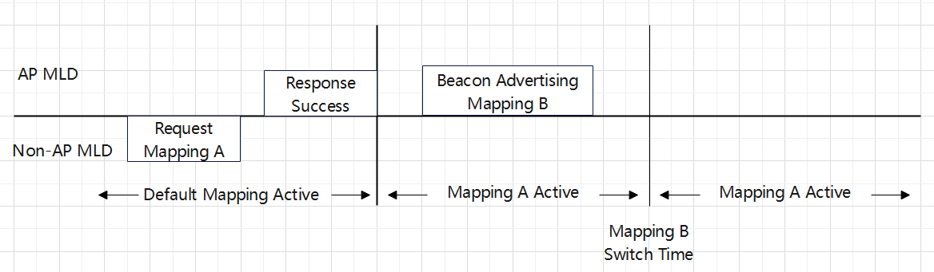
Figure AF-18a—Example TID-to-link mapping frame exchange where the negotiated mapping is a subset of an advertised mapping

9.4.2.314 TID-To-Link Mapping element
TGbe editor: Please update the following paragraphs in this subclause as shown below:
……
The Expected Duration field indicates the duration for which the proposed TID-to-link mapping is expected to be effective in units of TUs when the Mapping Switch Time field is present, and the remaining duration for which the proposed TID-to-link mapping is expected to be effective in units of Tus when the Mapping Switch Time field is not present, (#18145)with the starting point of the remaining duration being the most recent TBTT on or before the time when the frame carrying the field is transmitted. The Expected Duration field is present if the TID-To-Link Mapping element is carried in a Beacon or a Probe Response frame transmitted by an AP affiliated with an AP MLD, and is not present otherwise.
……

