IEEE P802.11
Wireless LANs
LB271 CR for 35.3.7.1.7 Part III
Date: May 11, 2023
Author(s):
Name | Affiliation | Address | Phone | email
Jason Yuchen Guo | Huawei |  |  | guoyuchen@huawei.com
Ming Gan | Huawei
Yunbo Li | Huawei
Guogang Huang | Huawei
Mengyao Ma | Huawei
Hongjia Su | Huawei
Yue Zhao | Huawei
Arik Klein | Huawei

Abstract
This submission proposes resolutions for following 9 CIDs received for TGbe LB271:
18146 17853 16013 18144 18145 16506 16504 16210 17946
Revisions:
- Rev 0: Initial version of the document.

Interpretation of a Motion to Adopt

A motion to approve this submission means that the editing instructions and any changed or added material are actioned in the TGbe Draft. This introduction is not part of the adopted material.

Editing instructions formatted like this are intended to be copied into the TGbe Draft (i.e. they are instructions to the 802.11 editor on how to merge the text with the baseline documents).

TGbe Editor: Editing instructions preceded by “TGbe Editor” are instructions to the TGbe editor to modify existing material in the TGbe draft. As a result of adopting the changes, the TGbe editor will execute the instructions rather than copy them to the TGbe Draft.

CID | Commenter | Page | Comment | Proposed Change | Resolution
18146 | Abhishek Patil | 521.29 | If a non-AP MLD had successfully negotiated a mapping 'A' (via T2LM Req/Resp frames) which is a subset of a new (upcoming) advertised mapping 'B' (via Beacon/Probe Resp frames), then which mapping holds true for that non-AP MLD (A or B) after the Mapping Switch Time for the advertised mapping? Shouldn't it be A? Please clarify that this is the case (it will save additional frame exchange for negotiation). | As in comment | Revised –  Agree in principle with the comment.  TGbe Editor:  Please implement the changes in this document tagged as #18146.
17853 | Yunbo Li | 521.10 | It is not discard all negotiated T2LM and revert to default mappings. If a negotiated T2LM complies to a new advertise T2LM, the negotiated T2LM can keeps. | if the mapped links in an negotiated T2LM are a subset of enable links in a new advertised T2LM, the negotiated T2LM keeps after the new advertised T2LM. | Revised –  Agree in principle with the comment.  TGbe Editor:  Please implement the changes in this document tagged as #17853.
16013 | Binita Gupta | 520.31 | Spec should allow a non-AP MLD to keep its individually negotiated TID-to-Link mapping if it does not conflict with the advertised TID-to-Link mapping. Current behavior will result in unnecessary individual renegotiations when the advertised TID-to-Link mapping becomes effective. Also modify NOTE 4 and Figure 35-15 to reflect this behavior. | Modify requirement and NOTE and Figure 35-15 as per comment | Revised –  Agree in principle with the comment.  TGbe Editor:  Please implement the changes in this document tagged as #16013.
18144 | Abhishek Patil | 520.35 | NOTE 4 provides critical guidance and should be converted to normative text. | Replace NOTE 4 as: "An individually negotiated TID-to-link mapping whose negotiation was completed prior to the establishment of an advertised TID-to-link mapping shall be discarded at the time of the establishment of the advertised TID-to-link mapping." | Revised –  Agree in principle with the comment.  TGbe Editor:  Please implement the changes in this document tagged as #18144.
18145 | Abhishek Patil | 520.49 | A non-AP MLD is allowed to negotiate a subsetted mapping of what is advertised by the AP MLD. Therefore, this NOTE is confusing. Reword it (as normative) to say that a non-AP MLD shall not transmit a response frame to acknowledge the reception of a T2LM advertisement. However a non-AP MLD may initiate a negotiation of a mapping that is a subset of the advertised mapping by transmitting a T2LM Request frame. NOTE 7 and the following paragraph can be consolidated as suggested above. | As in comment | Revised –  Agree in principle with the comment.  TGbe Editor:  Please implement the changes in this document tagged as #18145.
16506 | Arik Klein | 521.05 | Need to clarify that the mapping C has to be identical to the mapping B (advertised) but is applicable only for the links that have been setup between the non-AP MLD and the AP MLD. Please revise the sentence as suggested. | The sentence should be revised as follows: "Note that any mapping between TIDs and links *that are setup between the non-AP MLD and the AP MLD* is enabled in C must be already enabled in the advertised TID-to-link mapping B *(but may include additional links over those included in mapping C)*" | Revised –  The non-AP MLD can request to map the TIDs to less links compared to the advertised TID-to-Link Mapping. The text is changed to directly reflect that.  TGbe Editor:  Please implement the changes in this document tagged with #16506.
16504 | Arik Klein | 520.52 | According to P518L57, the advertised TID-to-link mapping is mandatory for all associated non-AP MLDs. Thus, please clarify how an non-AP MLD can initiate a negotiation on a *different* TID-to-link mapping with the AP MLD? If the negotiated mapping includes a contradicted mapping to one or more TIDs than that advertised, how it can take effect if the advertised is mandatory??? | Please clarify this point or remove this paragraph. | Rejected –  The non-AP MLD can request to map the TIDs to less links compared to the advertised TID-to-Link Mapping.
16210 | Ming Gan | 518.62 | the unit of TU is OK when the Mapping Switch Time field points to a future TBTT on the reporting link, but when it needs to point to a future TBTT on another link, the accuracy of 1 TU is not enough. Please fix this issue. | As in the comment. | Revised –  Agree in principle with the comment.  TGbe Editor:  Please implement the changes in this document tagged as #16210.
17946 | Yuchen Guo | 0 | In Advertised T2LM, the Mapping Switch Time field may indicate the time of the TBTT of the DTIM Beacon to be transmitted on another link, which may not allign with the TU boundary of the current link. However, the unit of the Mapping Switch Time field is 1TU. Hence, there's a miss match. | Please fix this issue. One possible solution is to add a field, together with the Mapping Switch Time field, indicates the time with the acuraccy of 1us. The commenter will bring a contribution to solve this issue. | Revised –  Agree in principle with the comment.  TGbe Editor:  Please implement the changes in this document tagged as #16210.

35.3.7.1.7 Advertised TID-to-link mapping in Beacon and Probe Response frames
An AP MLD may advertise a mandatory TID-to-link mapping by including a TID-To-Link Mapping element in the Beacon and Probe Response frames that the APs affiliated with the AP MLD transmit.
An AP that advertises a TID-to-link mapping shall include the Mapping Switch Time field and sets it to the time, in units of TUs, of a DTIM Beacon of one of the APs affiliated with the AP MLD. Beginning at the indicated time, the indicated TID-to-link mapping is established and the Mapping Switch Time field is no longer included. Figure 35-14 (An illustration of an advertised TID-to-link mapping taking effect on all links) explains the procedure via an example consisting of an AP MLD having three affiliated APs with different DTIM intervals and with TBTTs that are not aligned.
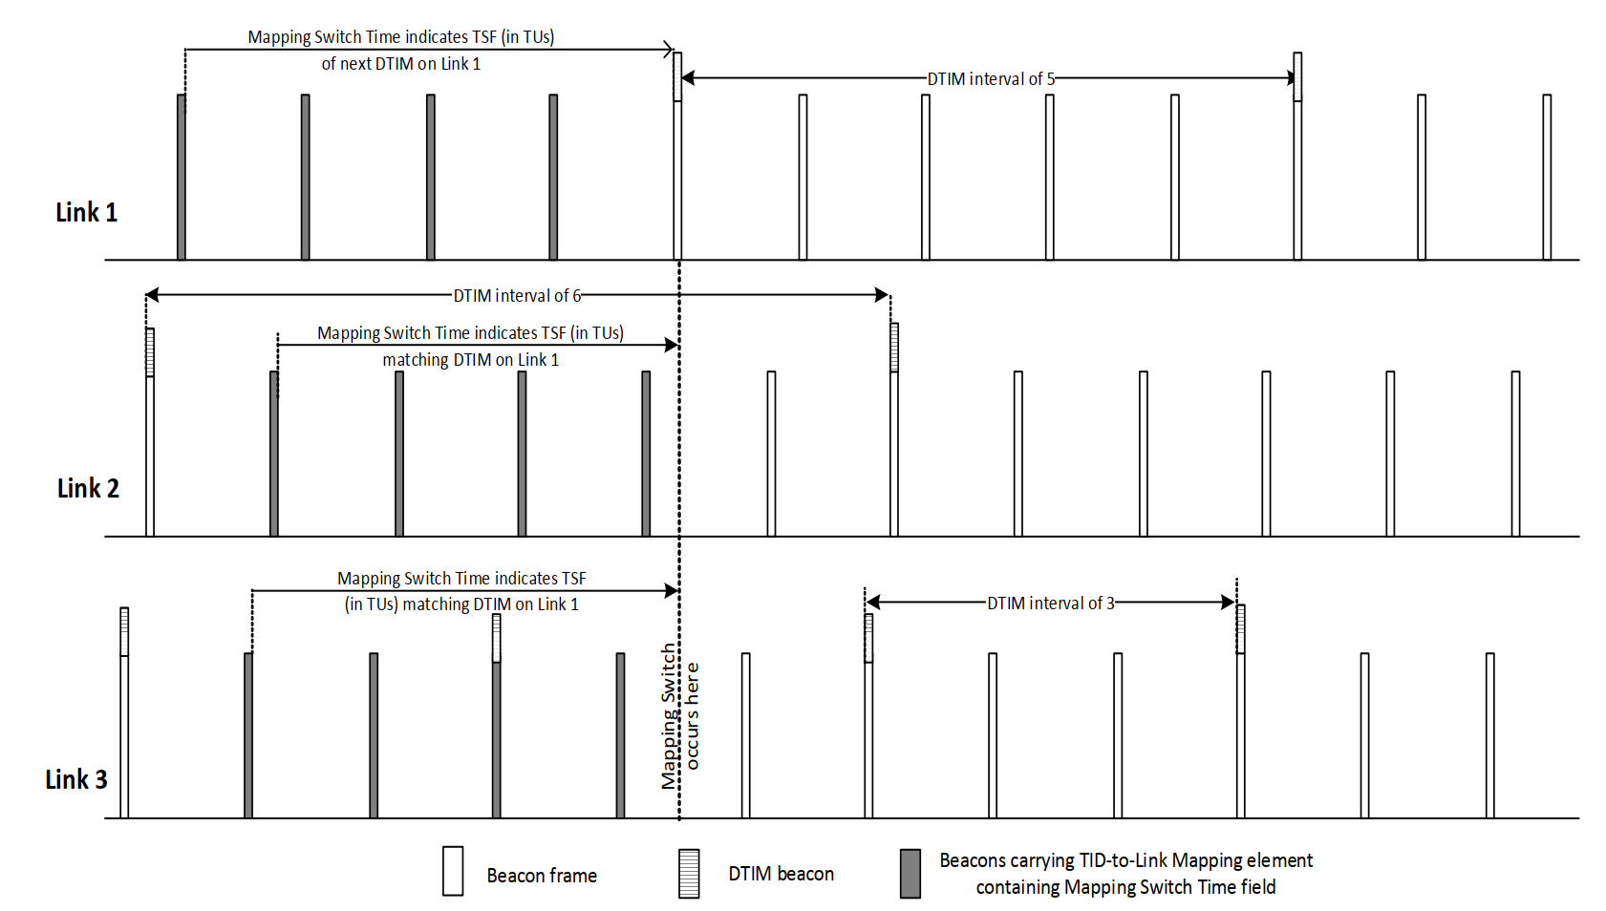
Figure 35-14—An illustration of an advertised TID-to-link mapping taking effect on all links
An AP MLD shall not advertise a TID-to-link mapping that does not map all TIDs to the same link set, both for DL and UL. The Direction field of an advertised TID-To-Link Mapping element shall be set to 2.
NOTE 1—An advertised TID-to-link mapping will include a mapping for all TIDs.
NOTE 2—If the Link ID of each AP in a multiple BSSID set and affiliated with different MLDs is different, then inheritance will not apply to an advertised TID-to-link mapping for the APs that are part of a multiple BSSID set, and therefore the TID-To-Link Mapping element needs to be carried in each nontransmitted BSSID profile to which an advertised mapping applies.
An AP MLD shall include two TID-To-Link Mapping elements in the Beacon and Probe Response frames that the APs affiliated with the AP MLD transmit, if there is already an established advertised TID-to-link mapping and a new nondefault advertised TID-to-link mapping will replace it. In this case, the AP MLD shall not include the Mapping Switch Time field in the currently established advertised TID-To-Link Mapping element, and shall include the Mapping Switch Time field in the new TID-To-Link Mapping element, in order to indicate an advertised TID-to-link mapping that will be established in the future. The value of the Expected Duration field of the existing TID-To-Link Mapping element shall indicate a remaining duration that ends at the same time as indicated by the Mapping Switch Time field of the new TID-To-Link Mapping element.
NOTE 3—If the newly advertised TID-to-link mapping is the default mapping, the AP MLD sets the Expected Duration field of the currently advertised TID-to-link mapping to the remaining time until the default mapping is established as described in 9.4.2.314 (TID-To-Link Mapping element) and does not include the TID-To-Link Mapping element for the newly advertised TID-to-link mapping in the Beacon and Probe Response frames. After the establishment of the default mapping, no TID-To-Link Mapping elements are included in the Beacon or Probe Response frames transmitted by the APs affiliated with the AP MLD.
All APs affiliated with an AP MLD that advertises a TID-to-link mapping shall include the same mapping in all Beacon and Probe Response frames from the time at which the TID-to-link mapping is first advertised until the time at which the TID-to-link mapping is no longer advertised, and shall include the Expected Duration field in all TID-to-link mapping elements in Beacons. From when a new TID-to-link mapping is advertised in a Beacon frame until the advertised TID-to-link mapping is established, the Mapping Switch Time field shall be included in the TID-To-Link Mapping element and set to the time, in units of TUs, at which the TID-to-link mapping will be established, then not included thereafter. The time indicated by the Mapping Switch Time field shall be the TBTT of the DTIM Beacon of one of the APs affiliated with the AP MLD. The Mapping Switch Time field should initially be set to a sufficiently large value. (#16210)If the time indicated by the Mapping Switch Time field Is the TBTT of the DTIM Beacon of one of the APs that Is not the AP transmitting the frame carrying the TID-to-Link Mapping element, a Mapping Switch Time Offset field shall be included in the TID-To-Link Mapping element and set to bits 0 to 9 of the TSF corresponding to the time at which the TID-to-Link mapping is established. After an advertised TID-to-link mapping is established, the duration indicated by Expected Duration field shall indicate the time when the advertised TID-to-link mapping is expected to end. During the advertisement of the TID-to-link mapping the time indicated may be updated to indicate an earlier time than initially indicated, but shall not be updated to indicate a later time than initially indicated. The duration indicated by Expected Duration field shall be exact when the duration is smaller than two DTIM periods of the AP transmitting the frame carrying the field.
At the time indicated by the Mapping Switch Time field of a TID-To-Link Mapping element in a Beacon or a Probe Response frame received by a non-AP STA affiliated with a non-AP MLD from an AP affiliated with its associated AP MLD, or at the time indicated by the Expected Duration field of an existing advertised TID-to-link mapping which will be replaced by an advertised default mapping, the non-AP MLD shall update its TID-to-link mapping according to the rules that establish a TID-to-link mapping in this subclause and with the consequences of the updated mapping defined in 35.3.7.1.1 (General) (#18146, #17853, #16013)unless all of the following conditions are met:
— The current TID-to-Link mapping for the non-AP MLD is a negotiated TID-to-Link mapping;
— The links included in the Link Mapping field of the current TID-To-Link Mapping element for the non-AP MLD is a subset of the links included in the Link Mapping field of the new advertised TID-To-Link Mapping element.

The TID-to-link mapping that is established in a non-AP MLD following an advertised TID-to-link mapping from its associated AP MLD is derived as follows:
— The set of mapped links for each TID and direction for a non-AP MLD are the set of links that are included in the non-AP MLD multi-link setup with the associated AP MLD and have been mapped to that TID for that direction in the advertised TID-to-link mapping.
(#18144) An individually negotiated TID-to-link mapping whose negotiation was completed prior to the establishment of an advertised TID-to-link mapping shall be discarded at the time of the establishment of the advertised TID-to-link mapping if the enabled link set in the advertised TID-to-link mapping is a subset of the enabled link set in the negotiated TID-to-link mapping.
NOTE 5—A non-AP MLD ignores links that are included in the link mappings of an advertised TID-to-link mapping that are not part of the non-AP MLD multi-link setup procedure. For example, if the AP MLD operates on links 1, 2, and 3, and it advertises that link 3 is disabled and all TIDs are mapped to links 1 and 2, then for a non-AP MLD that is associated with the AP MLD using links 1 and 2 the default mapping will apply. In this case, for a non-AP MLD that is associated with the AP MLD using links 1 and 3, link 3 will be disabled.
NOTE 6—In absence of an advertised mapping by the AP a default TID-to-link mapping is assumed unless an individual TID-to-link mapping is successfully negotiated.
(#18145)NOTE 7— A non-AP MLD shall not transmit a response frame to acknowledge the reception of an advertised TID-To-Link mapping. However a non-AP MLD may initiate a negotiation of a TID-To-Link mapping that maps all TIDs to a subset of the enabled links of the advertised TID-To-Link mapping by transmitting a TID-To-Link Request frame.
A non-AP MLD that is associated with an AP MLD that advertises a TID-to-link mapping may initiate a negotiation for a TID-to-link mapping that is different from the TID-to-link mapping established from the advertisement as described in this subclause. Any MLD shall not initiate a negotiation for a TID-to-link mapping that maps a TID to a link if the requested TID is not already mapped to the link in the advertised TID-to-link mapping
Figure 35-15 (Example TID-to-link mapping frame exchange) shows an example sequence of TID-to-link mapping frame exchanges. The non-AP MLD operates in default mapping mode in the beginning of the sequence. The non-AP MLD then initiates a negotiation of a TID-to-link mapping A. The AP MLD accepts the request, after which TID-to-link mapping A is active for the non-AP MLD. Next the AP MLD starts to advertise a TID-to-link mapping B (#18146, #17853, #16013)which maps all TIDs to a link set that is a subset of the enabled link set in the TID-to-Link mapping A. At the time indicated by the Mapping Switch field of the advertised TID-to-Link Mapping element, TID-to-link mapping B is established on the non-AP MLD. Note that we assume that the non-AP MLD includes all the AP MLD link in its multi-link setup, so the same mapping B is established for the non-AP MLD. In the next step the non-AP MLD requests another TID-to-link mapping C. Note that (#16506)the links included in the Link Mapping field of Mapping C shall be a subset of the links included in the Link Mapping field of Mapping B . The AP MLD accepts the request for TID-to-link mapping C, after which TID-to-link mapping C is active for the non-AP MLD. (#18146, #17853, #16013)

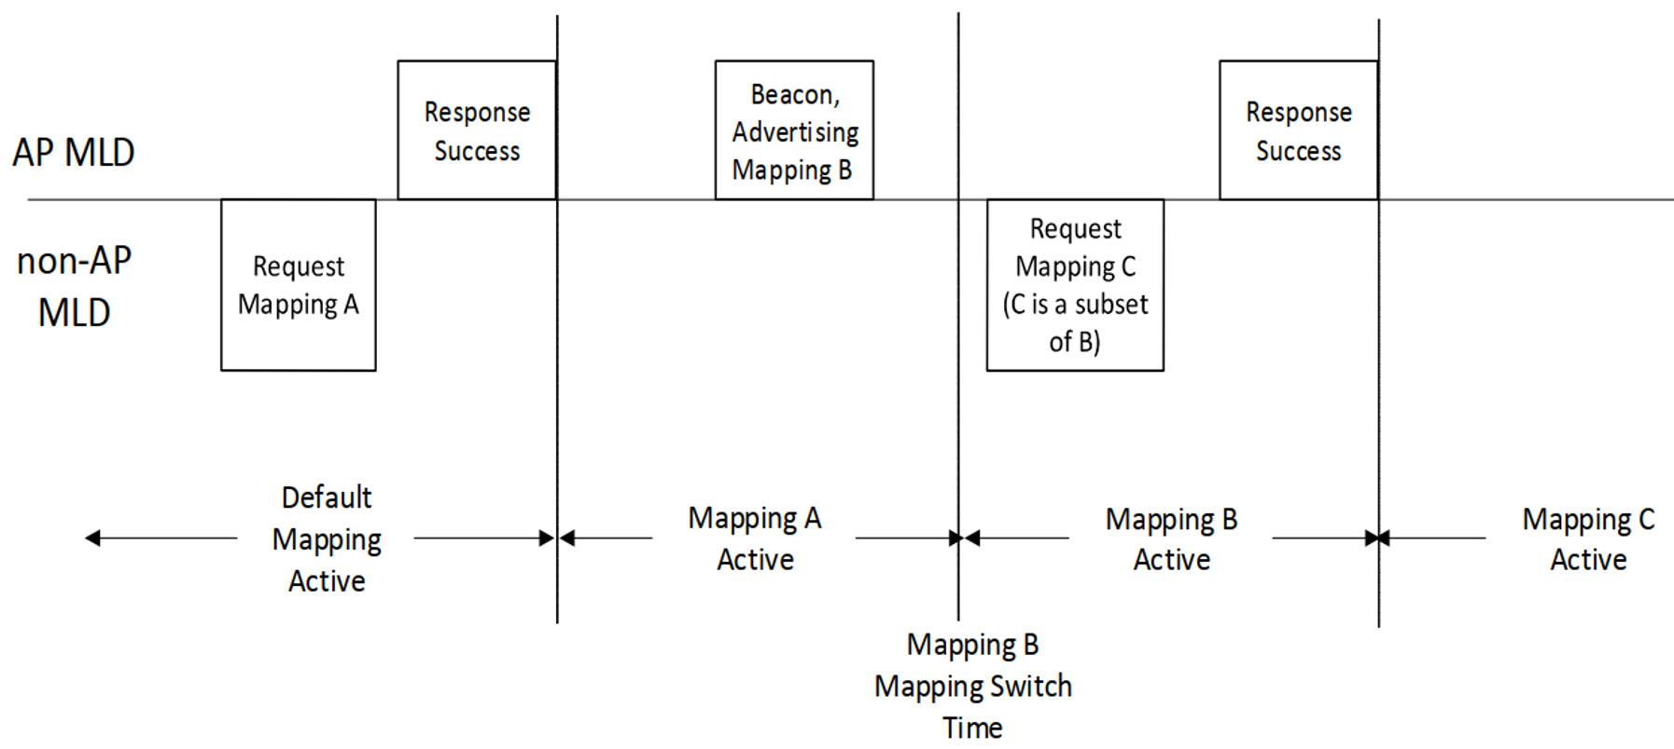
Figure 35-15—Example TID-to-link mapping frame exchange(#18146, #17853, #16013)

9.4.2.314 TID-To-Link Mapping element
The TID-To-Link Mapping element indicates links on which frames belonging to each TID can be exchanged. The format of the TID-To-Link Mapping element is shown in Figure 9-1002ao (TID-To-Link Mapping element format).
 | Element ID | Length | Element ID Extension | TID-To Link Mapping Control | Mapping Switch Time | Expected Duration | Mapping Switch Time Offset Info | Link Mapping Of TID 0 (Optional) | … | Link Mapping Of TID 7 (Optional)
Octets: | 1 | 1 | 1 | 1 0r 2 | 0 or 2 | 0 or 3 | 0 or 2 | 0, 1 or 2 |  | 0, 1 or 2
Figure 9-1002ao—TID-To-Link Mapping element format (#16210)
The Element ID, Length, and Element ID Extension fields are defined in 9.4.2.1 (General).
The format of the TID-To-Link Mapping Control field is defined in Figure 9-1002ap (TID-To-Link Control field format).
 | B0 B1 | B2 | B3 | B4 | B5 | B6 | B7 | B8 B15
 | Direction | Default Link Mapping | Mapping Switch Time Present | Expected Duration Present | Link Mapping Size | Mapping Switch Time Offset Info Present | Reserved | Link Mapping Presence Indicator (Optional)
Bits: | 2 | 1 | 1 | 1 | 1 | 1 | 2 | 0 or 8
Figure 9-1002ap—TID-To-Link Control field format (#16210)
The Direction subfield is set to 0 if the TID-To-Link Mapping element provides the TID-to-link mapping information for frames transmitted on the downlink. It is set to 1 if the TID-To-Link Mapping element provides the TID-to-link mapping information for frames transmitted on the uplink. It is set to 2 if the TID-ToLink Mapping element provides the TID-to-link mapping information for frames transmitted both on the downlink and the uplink. The value of 3 is reserved.
The Default Link Mapping subfield is set to 1 if the TID-To-Link Mapping element represents the default TID-to-link mapping. Otherwise, it is set to 0.
The Mapping Switch Time Present subfield is set to 1 if the Mapping Switch Time field is present and 0 otherwise.
The Expected Duration Present subfield is set to 1 if the Expected Duration field is present and 0 otherwise.
The Link Mapping Size subfield is set to 1 if the length of the Link Mapping Of TID n field is 1 octet and is set to 0 if the length of the Link Mapping Of TID n field is 2 octets.
(#16210)The Mapping Switch Time Offset Info Present subfield is set to 1 if the Mapping Switch Time Offset Info field is present and 0 otherwise.
The Link Mapping Presence Indicator subfield indicates whether the Link Mapping Of TID n field is present in the TID-To-Link Mapping element (i.e., it identifies the TID(s) for which the mapping is provided in the element). A value of 1 in bit position n of the Link Mapping Presence Indicator subfield indicates that the Link Mapping Of TID n field is present in the TID-To-Link Mapping element. Otherwise, the Link Mapping Of TID n field is not present in the TID-To-Link Mapping element. When the Default Link Mapping subfield is set to 1, this subfield is not present.
The Mapping Switch Time field is present when the TID-To-Link Mapping element is transmitted by an AP affiliated with an AP MLD in a Beacon or Probe Response frame and the indicated TID-to-link mapping is not yet established; otherwise it is not present. The absence of Mapping Switch Time field in the TID-To-Link Mapping element in a Beacon or Probe Response frame transmitted by an AP affiliated with an AP MLD indicates that the indicated TID-to-link mapping is already established. The 2 octet Mapping Switch Time field has units of TUs and is set to the time at which the new mapping is established using as a time base the value of the TSF corresponding to the BSS identified by the BSSID of the frame containing the TID-To-Link Mapping element: i.e., bits 10 to 25 of the TSF.
The Expected Duration field indicates the duration for which the proposed TID-to-link mapping is expected to be effective in units of TUs when the Mapping Switch Time field is present, and the remaining duration for which the proposed TID-to-link mapping is expected to be effective in units of TUs when the Mapping Switch Time field is not present. The Expected Duration field is present if the TID-To-Link Mapping element is carried in a Beacon or a Probe Response frame transmitted by an AP affiliated with an AP MLD, and is not present otherwise.
(#16210) The format of the Mapping Switch Time Offset Info field is defined In Figure 9-1002apa (Mapping Switch Time Offset Info field format).
 | B0 B9 | B10 B15
 | Mapping Switch Time Offset | Reserved
Bits: | 10 | 6
Figure 9-1002apa—Mapping Switch Time Offset Info field format.
The Mapping Switch Time Offset field indicates bits 0 to 9 of the TSF corresponding to the time at which the proposed TID-to-Link mapping is established. The Mapping Switch Time Offset field is not present if the Mapping Switch Time field is not present.
The Link Mapping Of TID n field (where n = 0 1 , , , … 7) indicates the link(s) on which frames belonging to TID n are allowed to be sent (i.e., carries a bitmap of the links to which the TID n is mapped to). A value of 1 in bit position i (where ) of the Link Mapping Of TID n field indicates that TID n is mapped to the link associated with the link ID i for the direction as specified in the Direction subfield. A value of 0 in bit position i indicates that the TID n is not mapped to the link associated with the link ID i. When the Default Link Mapping subfield is set to 1, this field is not present.

