IEEE P802.11
Wireless LANs
LB271 CR for 35.3.7.1.7 Part II
Date: May 10, 2023
Author(s):
Name | Affiliation | Address | Phone | email
Jason Yuchen Guo | Huawei |  |  | guoyuchen@huawei.com
Ming Gan | Huawei
Yunbo Li | Huawei
Guogang Huang | Huawei
Mengyao Ma | Huawei
Hongjia Su | Huawei
Yue Zhao | Huawei
Arik Klein | Huawei

Abstract
This submission proposes resolutions for following 8 CIDs received for TGbe LB271:
15525 16501 16502 18141 18261 17827 18143 17945
Revisions:
- Rev 0: Initial version of the document.
- Rev 1: minor revision based on offline feedback. Add one more CID.
- Rev 2: remove one CID, move it to another document with similar CIDs.
- Rev 3: modify the resolution for CID 17945 according to the offline feedback from Pooya and Abhi
- Rev 4: change the resolution for CID 18141 to decouple with CID 16502.

Interpretation of a Motion to Adopt

A motion to approve this submission means that the editing instructions and any changed or added material are actioned in the TGbe Draft. This introduction is not part of the adopted material.

Editing instructions formatted like this are intended to be copied into the TGbe Draft (i.e. they are instructions to the 802.11 editor on how to merge the text with the baseline documents).

TGbe Editor: Editing instructions preceded by “TGbe Editor” are instructions to the TGbe editor to modify existing material in the TGbe draft. As a result of adopting the changes, the TGbe editor will execute the instructions rather than copy them to the TGbe Draft.

CID | Commenter | Page | Clause | Comment | Proposed Change | Resolution
15525 | Chaoming Luo | 519.41 | 35.3.7.1.7 | "each" here means every AP? The note does not cover all the cases. Change the text to reflect this case too: 3 APs in a M-BSSID set, 2 of them have the same link ID and the other 1 is different. | As in comment. | Revised –  Agree in principle with the comment.  TGbe Editor:  Please implement the changes in this document tagged with #15525.
16501 | Arik Klein | 519.46 | 35.3.7.1.7 | In case of different Link ID of each AP in a multiple BSSID set and affiliated with different MLDs, need to clarify that each nontransmitted BSSID shall include two TID-to-link mapping elements. | Add a note to clarify the issue raised in the comment. | Revised –  Agree in principle with the comment.  TGbe Editor:  Please implement the changes in this document tagged with #16501.
16502 | Arik Klein | 520.01 | 35.3.7.1.7 | The following 2 paragraphs seems to be repetitive - including the same normative behavior text in 2 different places in the 802.11be spec. :  Paragraph 1: P518L61 - P519L32  Paragraph 2: P520L1 - P520L27  Please reunite them into a single, coherent one paragraph which includes all the normative rules for the Mapping Switch Time field in the TID-To-Link Mapping element | As in comment | Revised –  Agree in principle with the comment.  TGbe Editor:  Please implement the changes in this document tagged with #16502.
18141 | Abhishek Patil | 520.05 | 35.3.7.1.7 | The text is a repeat of what is covered in the 2nd paragraph of this subclause. | Delete the sentence on P520L5 starting: "From when a new ...". | Revised –  Agree in principle with the comment.  TGbe Editor:  Please implement the changes in this document tagged with #18141.
18261 | Li-Hsiang Sun | 519.06 | 35.3.7.1.7 | The duration of advertising mapping switch time should at least cover 1 DTIM beacon for any link to ensure the mapping is received before switch time | as in comment | Revised –  Agree in principle with the comment.  TGbe Editor:  Please implement the changes in this document tagged with #18261.
17827 | Yunbo Li | 520.11 | 35.3.7.1.7 | how to define this sufficiently large value? | explain what is the sufficiently large value | Revised –  Agree in principle with the comment.  TGbe Editor:  Please implement the changes in this document tagged with #16502.
18143 | Abhishek Patil | 520.31 | 35.3.7.1.7 | The text on P520L31 is confusing to understand. | Simplify it to say - a non-AP MLD apply the advertised mapping only to the link that it has setup with the AP MLD during multi-link setup. Keep NOTE 5 since it provides an example. | Revised –  Agree in principle with the comment.  TGbe Editor:  Please implement the changes in this document tagged with #18143.
17945 | Yuchen Guo | 0 | 0.00 | In Advertised T2LM, the starting time for using the Expected Duration field should be a TU boundary, otherwise, in the scenario where a new mapping replaces the old mapping, the end time of the old mapping will not be exactly the same as the new mapping since all time related fields have the units of 1 TU. Please clarify. | Make the starting time to be the nearest TBTT beofre the Beacon frame that carries this field, which is a TU boundary so that it can indicate the same time as the Mapping Switch Time field indicates. The commenter will bring a contribution to solve this issue. | Revised –  Agree in principle with the comment.  TGbe Editor:  Please implement the changes in this document tagged with #17945.

35.3.7.1.7 Advertised TID-to-link mapping in Beacon and Probe Response frames
An AP MLD may advertise a mandatory TID-to-link mapping by including a TID-To-Link Mapping element in the Beacon and Probe Response frames that the APs affiliated with the AP MLD transmit.
An AP that advertises a TID-to-link mapping shall include the Mapping Switch Time field and sets it to the time, in units of TUs, of a DTIM Beacon of one of the APs affiliated with the AP MLD. Beginning at the indicated time, the indicated TID-to-link mapping is established and the Mapping Switch Time field is no longer included. (#16502) The Mapping Switch Time field should initially be set to a sufficiently large value so that each AP affiliated with the AP MLD can transmit at least one DTIM Beacon before the indicated time. Figure 35-14 (An illustration of an advertised TID-to-link mapping taking effect on all links) explains the procedure via an example consisting of an AP MLD having three affiliated APs with different DTIM intervals and with TBTTs that are not aligned.

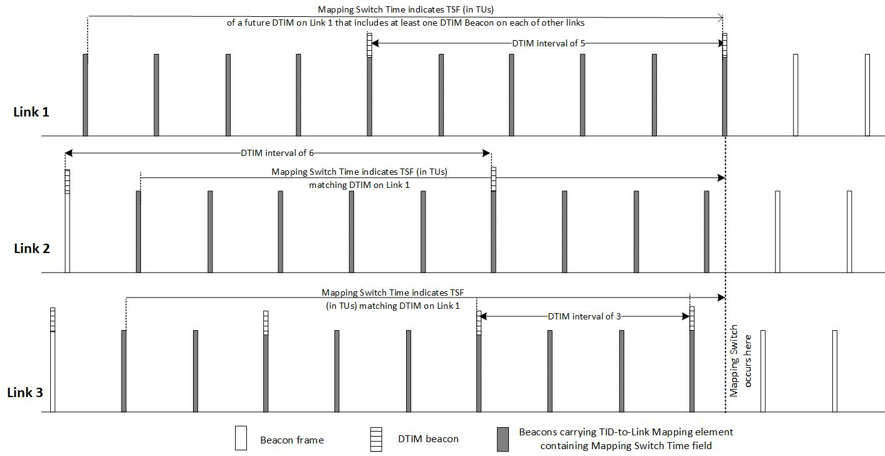
(#18261)Figure 35-14—An illustration of an advertised TID-to-link mapping taking effect on all links
An AP MLD shall not advertise a TID-to-link mapping that does not map all TIDs to the same link set, both for DL and UL. The Direction field of an advertised TID-To-Link Mapping element shall be set to 2.
NOTE 1—An advertised TID-to-link mapping will include a mapping for all TIDs.
(#15525)NOTE 2—If the Link ID of any AP in a multiple BSSID set and affiliated with different MLDs is different, then inheritance will not apply to an advertised TID-to-link mapping for that APthat is part of a multiple BSSID set, and therefore the TID-To-Link Mapping element needs to be carried in the corresponding nontransmitted BSSID profile to which an advertised mapping applies.
An AP MLD shall include two TID-To-Link Mapping elements in the Beacon and Probe Response frames that the APs affiliated with the AP MLD transmit, if there is already an established advertised TID-to-link mapping and a new nondefault advertised TID-to-link mapping will replace it. In this case, the AP MLD shall not include the Mapping Switch Time field in the currently established advertised TID-To-Link Mapping element, and shall include the Mapping Switch Time field in the new TID-To-Link Mapping element, in order to indicate an advertised TID-to-link mapping that will be established in the future. The value of the Expected Duration field of the existing TID-To-Link Mapping element shall indicate a remaining duration that ends at the same time as indicated by the Mapping Switch Time field of the new TID-To-Link Mapping element.
(#16501)Note 2a—If the Link ID of any AP in a multiple BSSID set and affiliated with different MLDs is different, then inheritance will not apply to an advertised TID-to-link mapping for that AP that is part of a multiple BSSID set, and therefore the two TID-To-Link Mapping elements need to be carried in the corresponding nontransmitted BSSID profile to which an advertised mapping applies.
NOTE 3—If the newly advertised TID-to-link mapping is the default mapping, the AP MLD sets the Expected Duration field of the currently advertised TID-to-link mapping to the remaining time until the default mapping is established as described in 9.4.2.314 (TID-To-Link Mapping element) and does not include the TID-To-Link Mapping element for the newly advertised TID-to-link mapping in the Beacon and Probe Response frames. After the establishment of the default mapping, no TID-To-Link Mapping elements are included in the Beacon or Probe Response frames transmitted by the APs affiliated with the AP MLD.
All APs affiliated with an AP MLD that advertises a TID-to-link mapping shall include the same mapping in all Beacon and Probe Response frames from the time at which the TID-to-link mapping is first advertised until the time at which the TID-to-link mapping is no longer advertised, and shall include the Expected Duration field in all TID-to-link mapping elements in Beacons. (#18141) (#16502) After an advertised TID-to-link mapping is established, the duration indicated by Expected Duration field shall indicate the time when the advertised TID-to-link mapping is expected to end (#17945)with the starting point of the duration being the most recent TBTT on or before the time when the frame carrying the field is transmitted. During the advertisement of the TID-to-link mapping the time indicated may be updated to indicate an earlier time than initially indicated, but shall not be updated to indicate a later time than initially indicated. The duration indicated by Expected Duration field shall be exact when the duration is smaller than two DTIM periods of the AP transmitting the frame carrying the field.
At the time indicated by the Mapping Switch Time field of a TID-To-Link Mapping element in a Beacon or a Probe Response frame received by a non-AP STA affiliated with a non-AP MLD from an AP affiliated with its associated AP MLD, or at the time indicated by the Expected Duration field of an existing advertised TID-to-link mapping which will be replaced by an advertised default mapping, the non-AP MLD shall update its TID-to-link mapping according to the rules that establish a TID-to-link mapping in this subclause and with the consequences of the updated mapping defined in 35.3.7.1.1 (General).
(#18143) A non-AP MLD applies the advertised TID-to-link mapping only to the links that it has setup with the AP MLD during multi-link setup.

NOTE 4—An individually negotiated TID-to-link mapping whose negotiation was completed prior to the establishment of an advertised TID-to-link mapping is discarded at the time of the establishment of the advertised TID-to-link mapping.
NOTE 5—A non-AP MLD ignores links that are included in the link mappings of an advertised TID-to-link mapping that are not part of the non-AP MLD multi-link setup procedure. For example, if the AP MLD operates on links 1, 2, and 3, and it advertises that link 3 is disabled and all TIDs are mapped to links 1 and 2, then for a non-AP MLD that is associated with the AP MLD using links 1 and 2 the default mapping will apply. In this case, for a non-AP MLD that is associated with the AP MLD using links 1 and 3, link 3 will be disabled.
NOTE 6—In absence of an advertised mapping by the AP a default TID-to-link mapping is assumed unless an individual TID-to-link mapping is successfully negotiated.
NOTE 7—No TID-To-Link Mapping Request nor TID-To-Link Mapping Response frames are transmitted by non-AP STAs affiliated with the associated non-AP MLDs in response to an advertised TID-to-link mapping
A non-AP MLD that is associated with an AP MLD that advertises a TID-to-link mapping may initiate a negotiation for a TID-to-link mapping that is different from the TID-to-link mapping established from the advertisement as described in this subclause. Any MLD shall not initiate a negotiation for a TID-to-link mapping that maps a TID to a link if the requested TID is not already mapped to the link in the advertised TID-to-link mapping
Figure 35-15 (Example TID-to-link mapping frame exchange) shows an example sequence of TID-to-link mapping frame exchanges. The non-AP MLD operates in default mapping mode in the beginning of the sequence. The non-AP MLD then initiates a negotiation of a TID-to-link mapping A. The AP MLD accepts the request, after which TID-to-link mapping A is active for the non-AP MLD. Next the AP MLD starts to advertise a TID-to-link mapping B. At the time indicated by the Mapping Switch field of the advertised TID-to-Link Mapping element, TID-to-link mapping B is established on the non-AP MLD. Note that we assume that the non-AP MLD includes all the AP MLD link in its multi-link setup, so the same mapping B is established for the non-AP MLD. In the next step the non-AP MLD requests another TID-to-link mapping C. Note that any mapping between TIDs and links that is enabled in C must be already enabled in the advertised TID-to-link mapping B. The AP MLD accepts the request for TID-to-link mapping C, after which TID-to-link mapping C is active for the non-AP MLD. In the next step, the advertised TID-to-link mapping B ends (by expected duration reaching 0). At this point the non-AP MLD also reverts to a default mapping. Note that the ending of the former advertised TID-to-link mapping is treated as an advertisement of a new default mapping, hence the formerly established individually negotiated TID-to-link mapping is discarded.
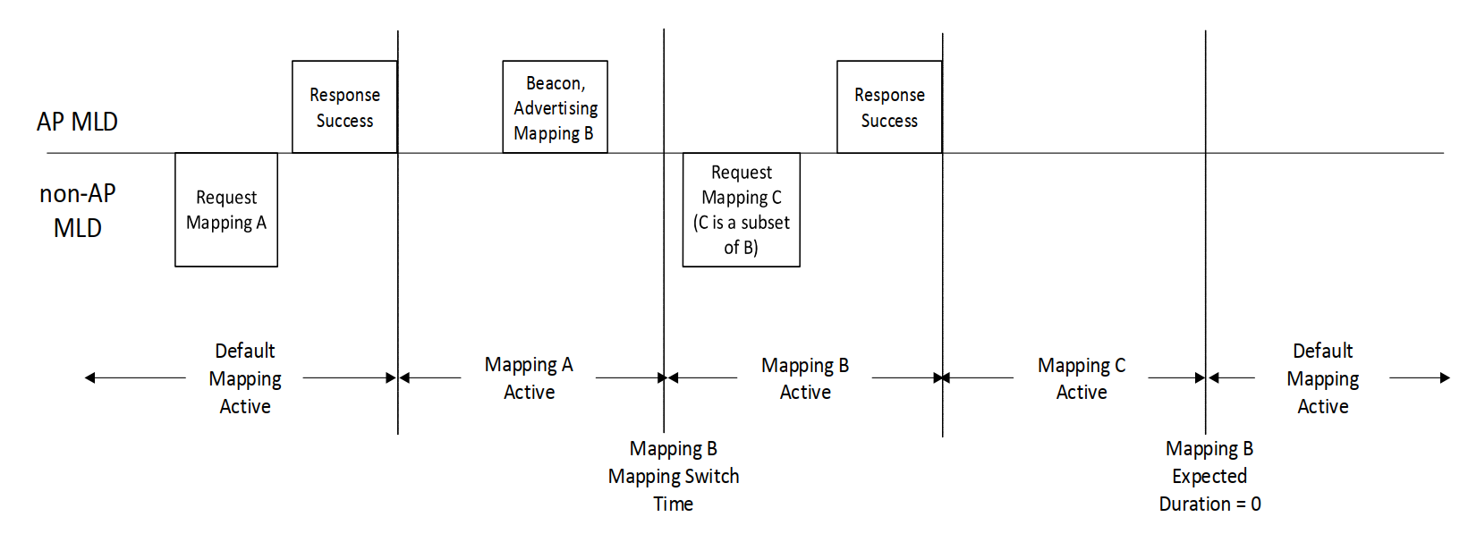
Figure 35-15—Example TID-to-link mapping frame exchange

