IEEE P802.11
Wireless LANs
LB271 CR for CID 16415
on 35.3.17 Enhanced multi-link single radio operation
Date: 2022-09-06
Author(s):
Name | Affiliation | Address | Phone | email
Liuming Lu | OPPO |  |  | luliuming@oppo.com

Abstract
This submission proposes resolutions for the following CIDs for TGbe LB271:
16415

Revisions:
- Rev 0: Initial version of the document

Interpretation of a Motion to Adopt

A motion to approve this submission means that the editing instructions and any changed or added material are actioned in the TGbe Draft. This introduction is not part of the adopted material.

Editing instructions formatted like this are intended to be copied into the TGbe Draft (i.e. they are instructions to the 802.11 editor on how to merge the text with the baseline documents).

TGbe Editor: Editing instructions preceded by “TGbe Editor” are instructions to the TGbe editor to modify existing material in the TGbe draft. As a result of adopting the changes, the TGbe editor will execute the instructions rather than copy them to the TGbe Draft.

TGbe editor: The baseline for this document is 11be D3.1.

CID | Commenter | Clause | Pg/Ln | Comment | Proposed Change | Resolution
16415 | Liuming Lu | 35.3.17 Enhanced multi-link single radio operation | 566.59 | How the non-AP MLD operating in the EMLSR mode receives the group addressed frame is unclear, such as whether it is needed to be switched to an EMLSR link before receiving the group addressed frame on this link. | A procedure for the transmission and reception of the group addressed frames between an AP MLD and its associtated non-AP MLDs operating in the EMLSR mode needs to be specified. | Revised  Agree in principle. It is proposed that a rule for the transmission and reception of the group addressed frames between an AP MLD and its associtated non-AP MLDs operating in the EMLSR mode is specified.  Instruction to the editor, please update the text in the subclause 35.3.17 Enhanced multi-link single radio operation, as shown in this document (doc.: IEEE 802.11-23/802r0).
Discussion:

A non-AP STA affiliated with a non-AP MLD that is in listening operation of EMLSR mode may not be able to receive the group addressed frames using rates that are higher than 24Mb/s or more SS, or being carried in HE PPDUs or EHT PPDUs if MU-RTS is not sent before the group addressede frames according to currently specified rules for EMLSR mode, shown as follows.

“ When a non-AP MLD is operating in the EMLSR mode with an AP MLD supporting the EMLSR mode, the following applies:
—The non-AP MLD shall be able to listen on the EMLSR link(s), by having its affiliated non-AP STA(s) corresponding to those links in awake state. The listening operation includes CCA and receiving the initial Control frame of frame exchanges that is initiated by the AP MLD.
…
—An AP affiliated with the AP MLD that initiates frame exchanges that are not group addressed Data or Management frames with the non-AP MLD on one of the EMLSR links shall begin the frame exchanges by transmitting the initial Control frame to the non-AP MLD with the limitations specified below.
•The initial Control frame of frame exchanges shall be sent in the non-HT PPDU or non-HT duplicate PPDU format using a rate of 6 Mb/s, 12 Mb/s, or 24 Mb/s. ”

Proposal:

The document proposes that AP MLD signals an indication of the capability requirement for the reception of the group addressed frames buffered in an AP affiliated with the AP MLD if there exists a non-AP MLD associated with the AP MLD that is operating in EMLSR mode and the link corresponding to the AP with the buffered group addressed frames is one of the EMLSR links for the non-AP MLD. For example if the buffered group addressed frames will be transmitted using a high rate or more SS, or being carried in HE PPDUs or EHT PPDUs, the indication would be helpful for the non-AP MLD in EMLSR mode to know to switch to the link on which the group addressed frames will be transmitted before or at their scheduled transmission time if the non-AP MLD expects to receive the frames on this link.

The key points of the proposal are shown as follows.
- A EMLSR Operation Indication bit(s) is specified to indicate that the reception of the group addressed frame(s) buffered in the AP(s) of the AP MLD corresponding to this bit requires the non-AP MLD that is associated with the AP MLD and in EMLSR mode to switch to the link(s) corresponding to the AP(s) before or at their scheduled group addressed frame transmission time if this link is one of the EMLSR link(s) for the non-AP MLD which expects to receive the group addressed frames on this link. The EMLSR Operation Indication bit(s) is carried in the EMLSR Operation Indication element with the TIM element included in a Beacon frame.
- The non-AP MLD that expects to receive group addressed frame(s) on one of the EMLSR links corresponding to an AP of the AP MLD should switch to the link before or at the scheduled group addressed frame transmission time if the EMLSR Operation Indication bit corresponding to the AP of the AP MLD for the link is set to 1.

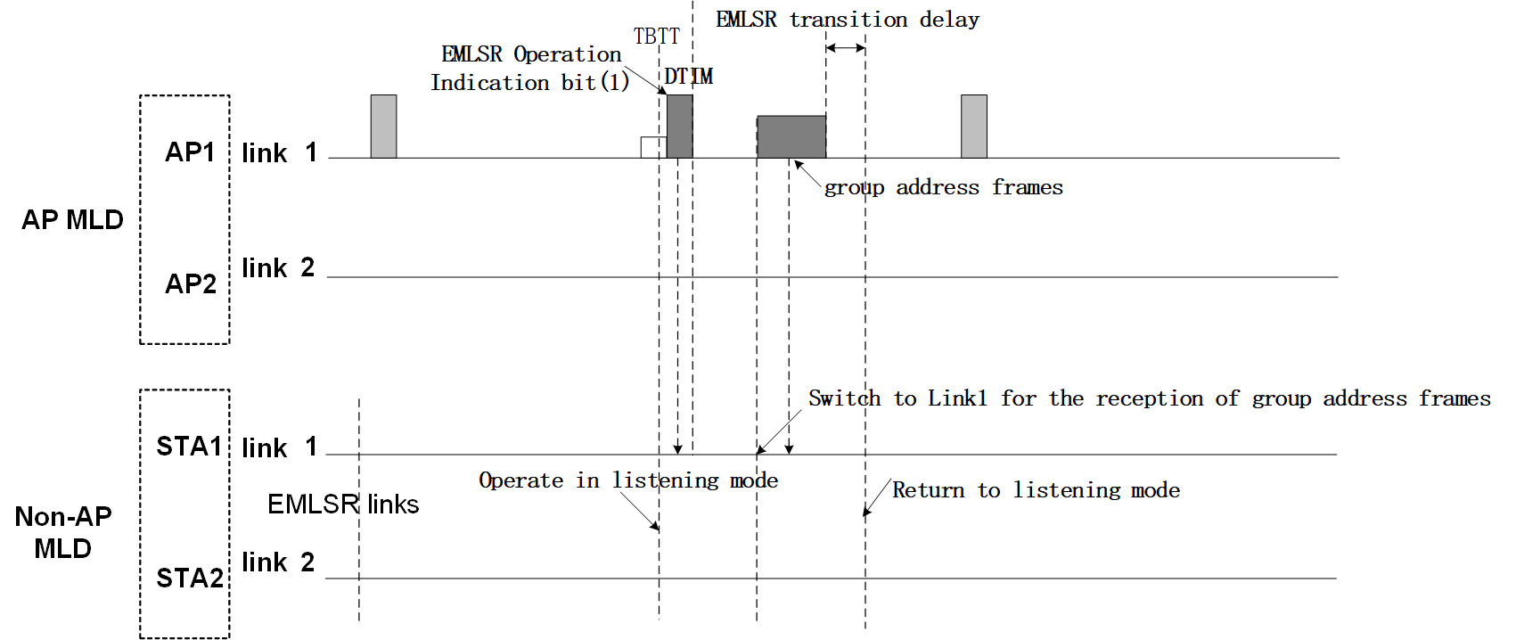

Proposed Text Change:
TGbe editor: please insert the following text:

9.4.2.x EMLSR Operation Indication element

The EMLSR Operation Indication element is defined in Figure 9-xxx (EMLSR Operation Indication element format ).

Element ID | Length | Element ID Extension | EMLSR Operation Indication Control | EMLSR Operation Indication
Octets: 1 1 1 2 variable
Figure 9-xxx—EMLSR Operation Indication element format
The Element ID, Length, and Element ID Extension fields are defined in 9.4.2.1 (General).
The EMLSR Operation Indication Control field is defined in Figure 9-xxx (EMLSR Operation Indication Control field format).
B0 B1 B4 B5 B15
Bits: 1 4 11
EMLSR Operation Indication bit 0 | AID Offset | Reserved

Figure 9-xxx—EMLSR Operation Indication Control field format
The EMLSR Operation Indication bit 0 subfield corresponds to the AP affiliated with an AP MLD to which the DTIM beacon corresponds. The value 1 of this bit indicates that the AP affiliated with the AP MLD corresponding to this bit has buffered group addressed frame(s) and the reception of the group addressed frame(s) will require the non-AP MLD that is associated with the AP MLD and in EMLSR mode to switch to the link corresponding to the AP before or at their scheduled transmission time for the reception of the group addressed frame(s) if the non-AP MLD expects to receive the group addressed frame(s) and this link is one of the EMLSR link(s) for the non-AP MLD. The value 0 of the bit is reserved.
The AID Offset subfield indicates a bit numbered k of the traffic indication virtual bitmap.

EMLSR Operation Indication bit 1 | … | EMLSR Operation Indication bit q | Padding

Bits: 1 1 Variable (0-7)
Figure 9-xxx—EMLSR Operation Indication field format
The EMLSR Operation Indication field is defined in Figure 9-xxx (EMLSR Operation Indication field format).
The q bits from EMLSR Operation Indication bit 1 to EMLSR Operation Indication bit q in the EMLSR Operation Indication field correspond to the other AP(s) in the same AP MLD with one or more group addressed frames buffered in an increasing order of their link IDs indicated in the Partial Virtual Bitmap subfield of the TIM element included in a Beacon frame with the EMLSR Operation Indication element.
For any bit of the q bits the value 1 of the bit indicates that the AP of the same AP MLD corresponding to this bit has the buffered group addressed frame(s) and the reception of the group addressed frame(s) will require the non-AP MLD that is associated with the AP MLD and in EMLSR mode to switch to the link corresponding to the AP before or at their scheduled transmission time for the reception of the group addressed frame(s) if the non-AP MLD expects to receive the group addressed frame(s) and this link is one of the EMLSR link(s) for the non-AP MLD. The value 0 of the bit is reserved.

35.3.15.1 AP MLD operation for group addressed frames
TGbe editor: please insert the following text:

If an AP MLD has a non-AP MLD in EMLSR mode associated with it, then an AP affiliated with the AP MLD shall indicate if the AP(s) affiliated with the AP MLD has buffered group addressed frames the reception of which will require the non-AP MLD that is associated with the AP MLD and in EMLSR mode to switch to the link before or at their scheduled transmission time for the reception of the group addressed frame(s) if the non-AP MLD expects to receive the group addressed frame(s) and this link is one of the EMLSR link(s) for the non-AP MLD by using a EMLSR Operation Indication bit(s) in the EMLSR Operation Indication element.

35.3.17 Enhanced multi-link single radio operation
…
When a non-AP MLD is operating in the EMLSR mode with an AP MLD supporting the EMLSR mode, the following applies:
- …
TGbe editor: please update the text as follows:
- On the EMLSR link(s), the group addressed frame(s) that are expected to be received by the non-AP MLD shall be buffered and delivered following the rules defined in 35.3.15 (Multi-link operation group addressed frames) except that:
- The non-AP MLD that expects to receive group addressed frame(s) on one of the EMLSR links corresponding to an AP of the AP MLD should switch to the link before or at the scheduled group addressed frame transmission time if the EMLSR Operation Indication bit corresponding to the AP of the AP MLD for the link is set to 1.

References:

- 11-22-1335-05-00be-cr-for-cids-related-to-group-addressed-frame-reception-in-emlsr-nstr

