IEEE P802.11
Wireless LANs
LB272 CR for OST CID – Part 1
Date: 2023-05-09
Author(s):
Name | Affiliation | Address | Phone | email
Narengerile | Huawei | Shenzhen, China |  | narengerile@huawei.com
Rui Du
Mengshi Hu
Zhuqing Tang
Yiyan Zhang

Abstract
This document proposes the comment resolution for CIDs 1097, 2110, 1697, 1448, 1690, 1624, 2100, and 2169.

R0: initial version on May 09, 2023.

CID 1097, 2110
CID | Page | Comment | Proposed change | Proposed resolution
1097 | 113.08 | Suggest re-naming this element to "Sensing Capabilities" since it is used to "advertise optional sensing capabilities". | As suggested. | REVISED.  Agree with the commenter in principle.  Please refer to the modifications specified in 23/xxxxr0 (https://mentor.ieee.org/802.11/dcn/23/11-23-0789-00-00bf-lb272-cr-for-ost-cid-part-1.docx) for CID 1097, 2110.
2110 | 87.11 | Word lost: Sensing | Sensing Capabilities
Discussions for CID 1097, 2110
I agree with the commenter for the following reasons:
- The Sensing element is used to advertise sensing capabilities. It will be clearer to include ‘capabilities’ in the element name.
- To make it consistent with DMG, e.g., DMG Sensing Capabilities, and DMG Sensing Short Capabilities.
Modification for CID 1097, 2110
To TGbf editor: Please replace all appearances of ‘Sensing element’ with ‘Sensing Capabilities element’ throughout the 11bf draft.

CID 1697
CID | Page | Comment | Proposed change | Proposed resolution
1697 | 113.12 | Change the text "The element may be present" to | The element is present | REVISED.  Agree with the commenter in principle. Clause 9 is not normative.  Please refer to the discussions and modifications specified in 23/xxxxr0 (https://mentor.ieee.org/802.11/dcn/23/11-23-0789-00-00bf-lb272-cr-for-ost-cid-part-1.docx) for CID 1097, 2110.
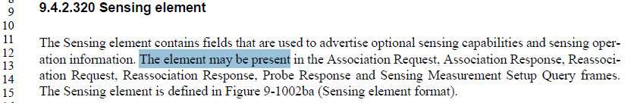
Discussions for CID 1697:
As discussed in 607r0, the 802.11 Style Guide (11-19/1034r20) defines that
“When defining a new element, as a general rule, do not list the frames that carry the element as part of element definition, and only list the element in the body of each of those frames that can include the element. Listing the frames that can carry the element is duplicate information (it can be inferred from frame definitions), and subject to inconsistencies over iterations of the specifications. Notable exception is when element definition depends on the frame it is carried in.”
So, the sentence “The element may be present … Query frames” will be deleted.
Modifications for CID 1697
To TGbf editor: Please modify the text in 9.4.2.320 as follows.
The Sensing element contains fields that are used to advertise optional sensing capabilities and sensing operation information. The Sensing element is defined in Figure 9-1002ba (Sensing element format).

CID 1448, 1690
CID | Page | Comment | Proposed change | Proposed resolution
1448 | 113.13 | Is sensing element a part of probe request frame? As spec doesn't specify this. But then how does AP knows if unassociated STA is capable of sensing and can become a part of sensing responders.  But then In page 114 line 65 mentions about probe request frame for min Time between measurement in sensing IE |  | REVISED.  To answer the question from the commenter: In 11bf D1.0, the Sensing element is not included in the Probe Request frame. The AP does not know the sensing capabilities of an unassociated STA until it receives the Sensing Measurement Setup Query frame from the unassociated STA.  Please refer to the modifications specified in 23/xxxxr0 (https://mentor.ieee.org/802.11/dcn/23/11-23-0789-00-00bf-lb272-cr-for-ost-cid-part-1.docx) for CID 1448.
1690 | 87.44 | Add "Sense element" to the Probe Request frame as well to follow the DMG Sensing Capabilities and add a normative text in section 11.55.3.4 (session setup) to convey that as it could be useful for some implementation | As per comment | REVISED.  Agree with the commenter in principle.  Please refer to the discussions and modifications specified in 23/xxxxr0 (https://mentor.ieee.org/802.11/dcn/23/11-23-0789-00-00bf-lb272-cr-for-ost-cid-part-1.docx) for CID 1690.
Discussions for CID 1448, 1690
I agree with the proposed changes for CID 1690. To include the Sensing element in the Probe Request can bring benefits to some implementations. For example, the AP can catalog the capabilities of the non-AP STA in case the non-AP STA ‘comes back’ with a Sensing Measurement Query frame. If this non-AP STA fits the requirements as a sensing responder, the AP can get the parameter assignment ready when receiving the Sensing Measurement Query frame. The spec can suggest a non-AP STA include the Sensing element in the Probe Request frame during the probing process. And, this way we will have a consistent behavior as DMG.
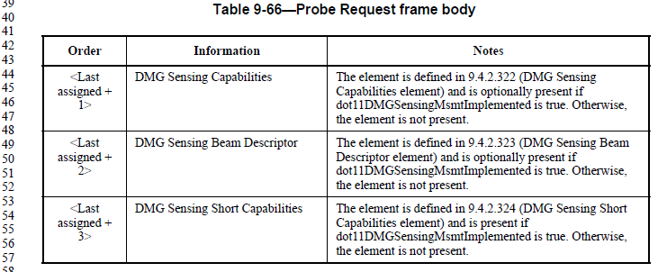

Modifications for CID 1448, 1690:
To TGbf editor: Please modify Table 9-66 as follows in 11bf draft.
Table 9-66—Probe Request frame body
Order | Information | Notes
<Last assigned + 1> | Sensing | The element is defined in 9.4.2.320 (Sensing element) and is optionally present if dot11WLANSensingImplemented is true. Otherwise, the element is not present. (#1448, #1690)
<Last assigned + 2> | DMG Sensing Capabilities | The element is defined in 9.4.2.322 (DMG Sensing Capabilities element) and is optionally present if dot11DMGSensingMsmtImplemented is true. Otherwise, the element is not present.
<Last assigned + 3> | DMG Sensing Beam Descriptor | The element is defined in 9.4.2.323 (DMG Sensing Beam Descriptor element) and is optionally present if dot11DMGSensingMsmtImplemented is true. Otherwise, the element is not present.
<Last assigned + 4> | DMG Sensing Short Capabilities | The element is defined in 9.4.2.324 (DMG Sensing Short Capabilities element) and is present if dot11DMGSensingMsmtImplemented is true. Otherwise, the element is not present.

To TGbf editor: Please add the following text after P172L38 in 11bf draft.
An unassociated non-AP STA shall set the Poll Required subfield in the Sensing element to 1 in any Measurement Setup Query frame that it transmits.
If the Sensing element is included in the Probe Request frame, a non-AP STA shall set the Poll Required subfield in the Sensing element to 1. (#1448, #1690)

To TGbf editor: The following changes are made to 0447r3 and please include them in the latest 11bf spec.
11.55.1.3 Sensing capabilities exchange
To TGbf editor: Please modify the following text in 0447r3 (page 21) and include it in 11bf draft.
The Responder Needed field in the Sensing element within Association Request, Association Response, Reassociation Request, Reassociation Response, and Sensing Measurement Setup Query frames shall be set to the reserved value. If the Sensing element is included in the Probe Request frame, the Responder Needed field in the Sensing element shall be set to the reserved value. (1083, 1526, 1556, 1448, 1690)

To TGbf editor: Please add the following text to the end of page 21 in 0447r3 and include it in 11bf draft.
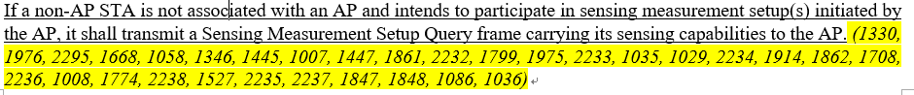
A non-AP STA may carry its sensing capabilities to the AP in the Probe Request frame. (#1448, #1690)

CID 1624
CID | Page | Comment | Proposed change | Proposed resolution
1624 | 189.40 | How the AP would behave differently as a response to receiving the Sensing Measurement Setup Query frame? Recall that in the TB sensing measurement setup with an unassociated STA, this STA is supposed to send a Sensing Measurement Setup Query frame to solicit the Sensing Measurement Setup Request frame | Specify under what conditions the AP would behave differently as a response to receiving the Sensing Measurement Setup Query frame with regard to the sensing measurement setup and the sensing measurement setup termination. | REVISED.  I agree with the commenter that the AP will respond differently to a received Sensing Measurement Query frame.  Please refer to the discussions and modifications specified in 23/xxxxr0 (https://mentor.ieee.org/802.11/dcn/23/11-23-0789-00-00bf-lb272-cr-for-ost-cid-part-1.docx) for CID 1624.
Discussions for CID 1624
(Credits to the OST TTT members, thanks for the constructive discussions via email threads.)
There are two options for the AP to respond to a received Sensing Measurement Setup Query frame that was sent by an unassociated STA:
- AP sends a Sensing Measurement Request frame
This behavior is already specified in the 11bf spec D1.0 (see subclause 11.55.1.4 Sensing measurement setup):
  - The AP is not ready yet to assign parameters to the unassociated STA: Comeback field in the Sensing Measurement Request frame is set to 1. This is discussed in 474r2 which is ready for motion.
  - The AP is ready to assign measurement parameters to the unassociated STA: Comeback field in the Sensing Measurement Request frame is set to 0. This was discussed in 474r2 which is ready for motion.
- AP sends a Sensing Measurement Termination frame
  - AP intends to terminate one or more existing measurement sessions with the unassociated STA.
This behavior is already specified in the 11bf spec D1.0 (see subclause 11.55.1.6 Sensing measurement setup termination):
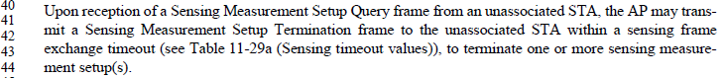
  - AP reckons the unassociated STA’s capabilities do not fit the requirements as a sensing responder, and thus the AP sends a Sensing Measurement Termination frame to turn down the unassociated STA.
This behavior is currently missing from the 11bf spec.
It is up to the AP how to respond to a Sensing Measurement Setup Query frame. The spec does not need to specify all conditions under which the above behaviors take place. Apart from the ‘underlined case’ above, the spec already has relevant normative texts on the corresponding behaviors. As for the ‘underlined case’, we could add normative texts to complete AP’s behaviors after the capability exchange process.

Modifications for CID 1624
To TGbf editor: The following changes are made to 0447r3 and please include them in the latest 11bf spec.
To TGbf editor: Please add the following text to the end of page 21 in 0447r3 in subclause 11.55.1.3 (Sensing capabilities exchange) and include it in 11bf draft.
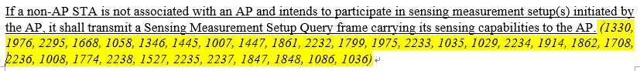
If the AP does not accept the unassociated non-AP STA as a sensing responder, the AP should respond to the received Sensing Measurement Query frame with a Sensing Measurement Termination frame with the Terminate All TB Measurement Setups field set to 1. (#1624)

CID 2100, 2169
CID | Page | Comment | Proposed change | Proposed resolution
2100 | 85.10 | The Extended Capabilities element is carried in Beacon. But Table 9-60 shows the Sensing element is also contained in Beacon. | As in comment. | REVISED.  I agree with the commenter in principle. TGbf have discussed and agreed that AP provides its sensing capabilities in Probe Response, Association Response and Reassociation Response frames, not in the Beacon.  Please refer to the modifications specified in 23/xxxxr0 (https://mentor.ieee.org/802.11/dcn/23/11-23-0789-00-00bf-lb272-cr-for-ost-cid-part-1.docx) for CID 2100, 2169.
2169 | 85.14 | Sensing element is not carried in Beacon. | Remove this row in Table 9-60.
Modifications for CID 2100, 2169
To TGbf Editor: Please remove subclause 9.3.3.2 Beacon frame format from 11bf D1.0.

SP:
Do you agree to the comment resolutions provided for CIDs 1097, 2110, 1697, 1448, 1690, 1624, 2100, and 1269 to be included in the latest 11bf Draft?
Y/N/A

