IEEE P802.11
Wireless LANs
LB271 CR for CID 16333 and 16340
Date: 2023-05-15
Author(s):
Name | Affiliation | Address | Phone | email
Juseong Moon | KNUT |  |  | jsmoon0211@ut.ac.kr
Ronny Yongho Kim | KNUT |  |  | ronnykim@ut.ac.kr
Hyojin Jung | HMC |  |  | hyojin@hyundai.com
Gene Back Hahn | HMC |  |  | geneback.hahn@hyundai.com
Abstract
This submission proposes resolution of following CIDs assigned to Juseong Moon. (2 CIDs)

- Comments related with subclause 35.3.17 (Enhanced Multi-Link Single-Radio Operation):
16333, 16340

R0:
Initial revision.

CID 16340:
CID | Commeter | Subclause | P/L | Comment | Proposed Change | Resolution
16340 | Yongho Kim | 35.3.17 | 565.12 | In an R-TWT SP, when an AP wants to transmit separate TXOPs (i.e., different AC data frames) to an EMLSR STA, every transmission shall start with an initial control frame. After the first reception of the ICF, the STAs of the EMLSR STA MLD can remain on the link without returning to the listening operation until the end of the R-TWT SP. Therefore, starting from the second data frame transmission, there is no need to transmit the ICF and it can mitigate delay in the R-TWT SP. Additionally, according to subclause 35.8.5.1 of 11be draft 3.0, the TXOP end time rule for EMLSR MLD is defined. Therefore, it's reasonable that EMLSR MLD is not to operate of listening opeation in the R-TWT SP. | As in comment, please add the method that EMLSR MLD is not to return to listening operation in R-TWT SP. | Revised:  Agree with the commenter.  TGbe editor: Please make the changes tagged with (#16340)

Discussions for CID 16340

- CID 16340: This comment suggests that a non-AP MLD operating in EMLSR mode should not return to listening operation when participating in an R-TWT SP. In the current 11be draft, an EMLSR non-AP MLD can receive group addressed frames without ICF. The EMLSR non-AP MLD can Tx/Rx without ICF during an R-TWT SP, whether it received the first ICF in the R-TWT SP or not.
- If a large number of EMLSR MLDs are participating in an R-TWT SP, many initial Control frames shall be transmitted, which could potentially degrade the performance of the R-TWT operation.
- To optimize performance when there are no overlapping R-TWT SP(s), omitting the initial Control frame in the R-TWT SP can be deployed.
  - In the R-TWT SP, after a non-AP MLD operating in EMLSR mode received initial Control frame from an AP MLD, it does not be switched back to the listening operation until the R-TWT SP ends. It can receive frame(s) from the AP MLD without initial Control frame.
- 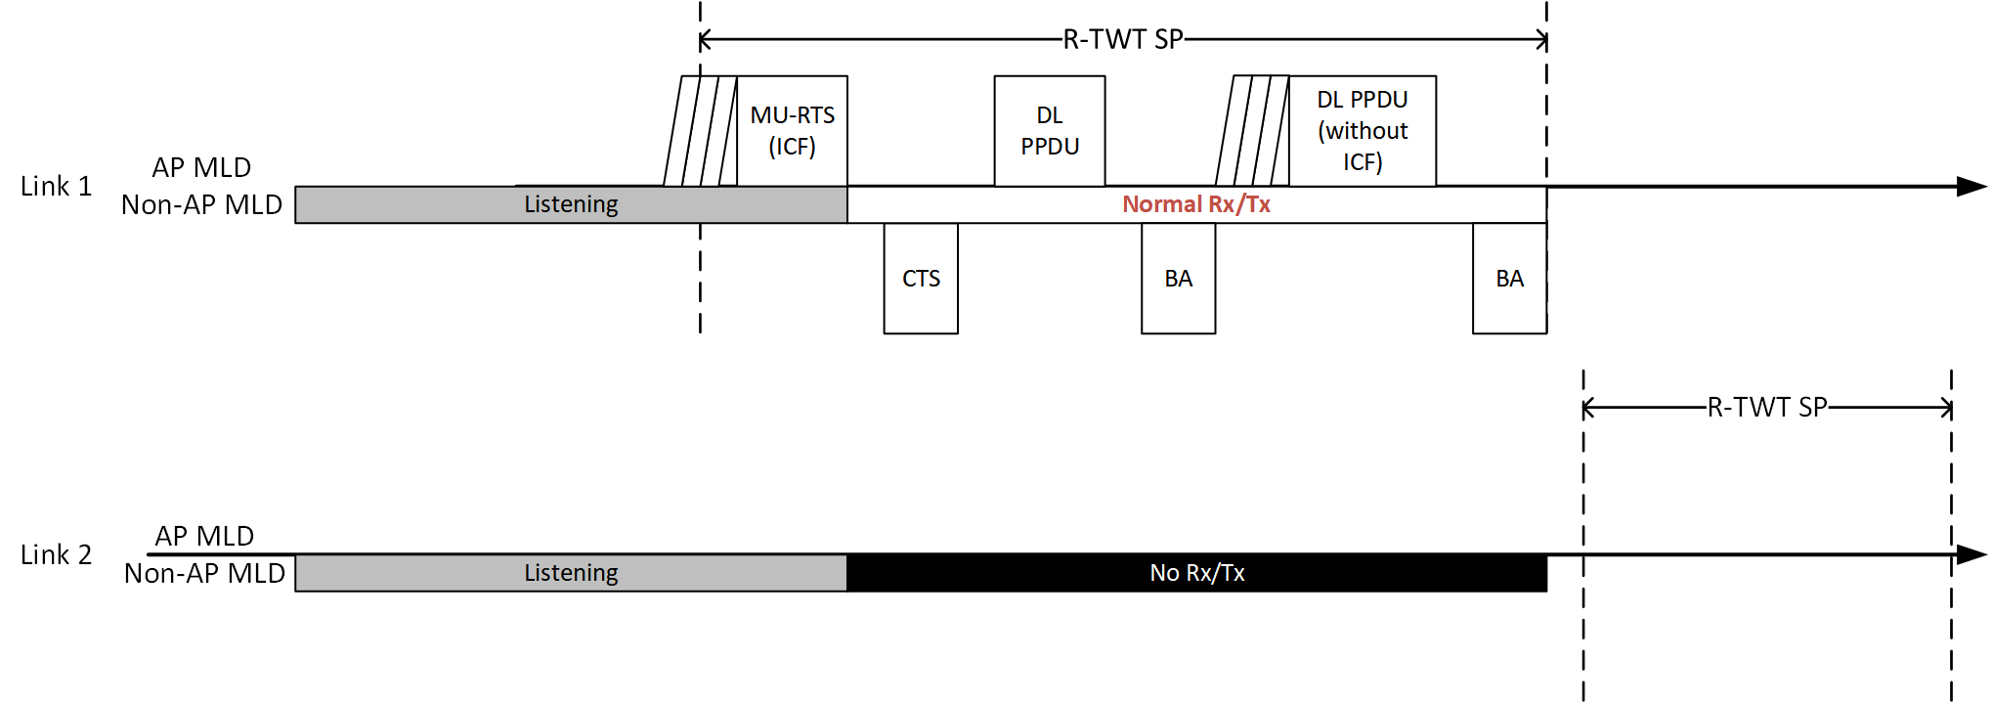

Proposed Changes to 11be Draft 3.1

- When a non-AP STA affiliated with the non-AP MLD initiates a TXOP, the following applies:
• The non-AP MLD shall be switched back to the listening operation on the EMLSR links after the time duration indicated in the EMLSR Transition Delay subfield after the end of the TXOP.
(Instructions to the editor: please add the following changes to Page 573 Line 7 of subclause 35.3.17 in draft 3.1)
- (#16340) When a non-AP STA affiliated with the non-AP MLD is a member of a R-TWT SP on the EMLSR link(s) and the R-TWT SP does not overlap with another R-TWT SP(s) on any links, the following applies:
  - The AP MLD that initiates frame exchanges with the non-AP MLD in the R-TWT SP shall begin the first frame exchanges by transmitting the initial Control frame. When the AP MLD initiates the second frame exchanges with the non-AP MLD, it may initiate the frame exchanges without the initial Control frame.
  - The non-AP MLD shall be switched back to the listening operation on the EMLSR links after the time duration indicated in the EMLSR Transition Delay subfield after the end of the R-TWT SP.

CID 16333:
CID | Commeter | Subclause | P/L | Comment | Proposed Change | Resolution
16333 | Yongho Kim | 35.3.17 | 565.12 | In a scenario where an EMLSR non-AP MLD receives a TIM and/or a multi-link traffic indication in a beacon frame from its associated MLD, the sequential transmission of a PS-poll frame by the non-AP MLD in the link in which the TIM is received and another PS-poll or UL data frame by the same non-AP MLD in another link can potentially cause interference with the receiving operation of the bufferable unit in the firstly notified link with PS-Poll. In order to prevent such situation, the transmission of another PS-poll frame or UL data frame should be restricted until the EMLSR non-AP MLD receives all of the BUs in the firstly notified link with PS-Poll. | As in comment. | Rejected:  There is no issue which the comment is addressing in 11be draft. No further actions are needed.

