IEEE P802.11
Wireless LANs
LB271 CR for CID 16309
Date: 2023-05-15
Author(s):
Name | Affiliation | Address | Phone | email
Sunghyun Hwang | ETRI |  |  | shwang@etri.re.kr
Kyumin Kang | ETRI |  |  | kmkang@etri.re.kr
Juseong Moon | KNUT |  |  | jsmoon0211@ut.ac.kr
Ronny Yongho Kim | KNUT |  |  | ronnykim@ut.ac.kr
Abstract
This submission proposes resolution of following CID assigned to Juseong Moon. (1 CID)

- Comment related with subclause 35.3.17 (Enhanced Multi-Link Single-Radio Operation):
16309

R0:
Initial revision.

CID 16309:
CID | Commeter | Subclause | P/L | Comment | Proposed Change | Resolution
16309 | Juseong Moon | 35.3.17 | 565.22 | In Draft 3.0, an AP affiliated with the AP MLD is allowed to begin the group addressed Data trasnsmission without transmitting the initial control frame.  If the transmission of a group addressed BU is delayed for some reason, such as high channel load, it is unclear from the current specification whether the EMLSR STA MLD should go into listening operation or continue normal Tx/Rx operation. It is necessary to provide clarification on whether the EMLSR STA MLD should return to listening operation if group addressed BUs are not received or operate in normal Tx/Rx operation until the BUs are received. | As in comment. | Revised:  Agree with the commenter.  TGbe editor: Please make the changes tagged with (#16309)

Discussions for CID 16309

- There is no clear description of the state/operation of a non-AP MLD in EMLSR mode when the non-AP MLD is receiving a group-addressed BU during the reception period (“Group addressed BU reception period” in the figure), as shown in the attached figure. In the current draft, an EMLSR non-AP MLD can receive its group-addressed BU without ICF (as defined in P573 L1 in D3.1). This implies that the non-AP MLD can Rx/Tx, without receiving ICF, in a link in which the non-AP MLD received a DTIM. However, the draft does not address when the EMLSR non-AP MLD needs to return to a listening operation.
- Therefore, a note to clarify the operation of EMLSR MLD during the reception of group addressed frames is proposed.
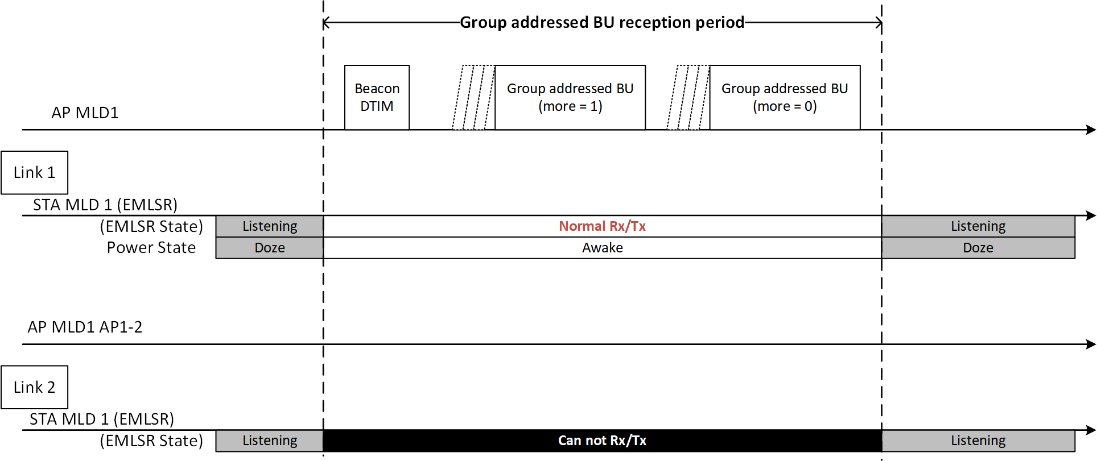

Proposed Changes to 11be Draft 3.1

(Instructions to the editor: please make the following changes to Page 573 Line 4 of subclause 35.3.17 in draft 3.1)
— On the EMLSR link(s), the group addressed frame(s) that are expected to be received by the non-AP MLD shall be buffered and delivered following the rules defined in 35.3.15 (Multi-link operation group addressed frames).
(#16309) NOTE 4 — The non-AP MLD shall stay awake and shall not be switched back to the listening operation during the reception of group addressed frame(s).

