IEEE P802.11
Wireless LANs
LB271 CR for CID 16338
Date: 2023-05-11
Author(s):
Name | Affiliation | Address | Phone | email
Sunghyun Hwang | ETRI |  |  | shwang@etri.re.kr
Kyumin Kang | ETRI |  |  | kmkang@etri.re.kr
Juseong Moon | KNUT |  |  | jsmoon0211@ut.ac.kr
Ronny Yongho Kim | KNUT |  |  | ronnykim@ut.ac.kr
Abstract
This submission proposes resolution of following CID assigned to Juseong Moon. (1 CID)

- Comment related with subclause 35.2.1.2 (Triggered TXOP Sharing procedure):
16338

R0:
Initial revision.

Straw Poll

SP #1:
Which option do you support in the discussion of this document?
1. Option 1
2. Option 2
3. Neither option 1 nor option 2
4. Abstain

- Option 1: Non-AP STA transmits the initial Control frame of EMLSR in the triggered TXS period
- Option 2: Non-AP STA transmits the RTS frame in the triggered TXS period

CID 16338:
CID | Commeter | Subclause | P/L | Comment | Proposed Change | Resolution
16338 | Yongho Kim | 35.2.1.2.1 | 473.58 | When EMLSR STA MLD (or STA affiliated with EMLSR STA MLD) is a recipient of P2P(Triggered TXOP Sharing mode 2), EMLSR operating STA can not receive PPDU from non-AP STA without initial control frame. | Please define a procedure to communication with EMLSR operating STA in triggered TXOP sharing mode 2. | Revised:  Agree with the commenter.  TGbe editor: Please make the changes tagged with (#16338)

Discussions for CID 16338

- EMLSR-operating non-AP STA MLD can not receive a PPDU without the reception of the initial control frame in Triggered TXS.
- If P2P recipient peer is an EMLSR-operating STA, P2P transmitter (non-AP STA MLD with shared TXOP) can not directly transmit data to an EMLSR-operating P2P recipient STA.
- Some kind of P2P communication may not be periodic. Therefore, a non-AP MLD in EMLSR mode may not know schedule of P2P communication.

- Option 1: Non-AP STA transmits the initial Control frame of EMLSR in the triggered TXS period

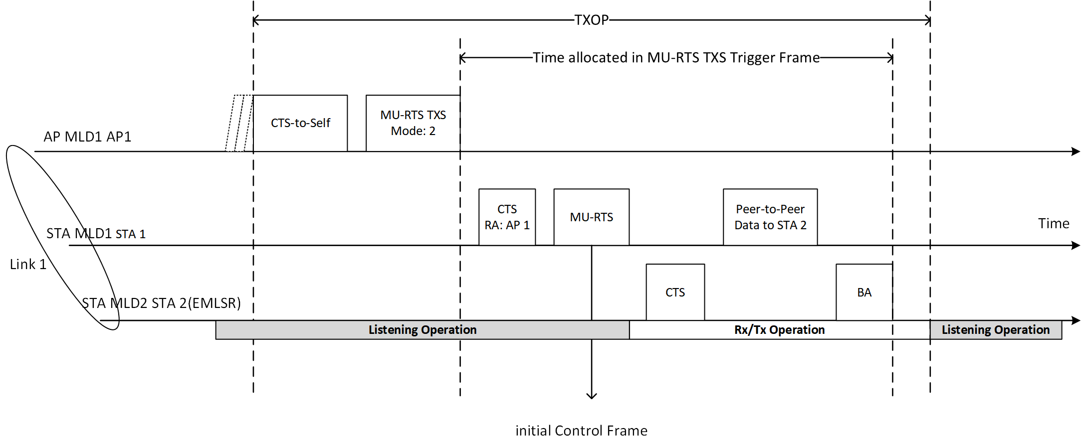
- A non-AP MLD operating in EMLSR mode can receive initial Control frame from another non-AP STA.
- In the current baseline, a non-AP STA cannot transmit a Trigger frame.

- Option 2: Non-AP STA transmits the RTS frame in the triggered TXS period
- A non-AP MLD operating in EMLSR mode can use an RTS frame from another non-AP STA as alternative initial Control frame, in Triggered TXS operation.
(End of discussion)

Proposed Changes for CID 16338

Option 1: Non-AP STA transmits the initial Control frame of EMLSR in the triggered TXS period
35.2.1.2 Triggered TXOP sharing procedure
35.2.1.2.3 Non-AP STA behavior

A non-AP STA addressed by an MU-RTS TXS Trigger frame with the triggered TXOP sharing mode equal to 2 may either perform PIFS recovery within the allocated time or perform a backoff within the allocated time when the non-TB PPDU transmission is not successful. How it chooses among these options is implementation dependent.
(Instructions to the editor: please add the following changes to Page 483 Line 41 of subclause 35.2.1.2.3 in draft 3.1)

(#16338) A non-AP STA addressed by an MU-RTS TXS Trigger frame with the triggered TXOP sharing mode equal to 2 shall transmit an initial Control frame as defined in 35.3.17 (Enhanced multi-link single radio operation) to another non-AP STA affiliated with a non-AP MLD which is in the EMLSR mode.

Option 2: Non-AP STA transmits the RTS frame in the triggered TXS period
35.3.17 Enhanced multi-link single radio operation
(Instructions to the editor: please add the following changes to Page 573 Line 12 of subclause 35.3.17 in draft 3.1)
- Any one of the non-AP STAs affiliated with the non-AP MLD that is operating on one of the EMLSR links may initiate frame exchanges with the AP MLD.
- (#16338) When a non-AP STA of a non-AP MLD received an RTS frame from another non-AP STA in Triggered TXOP sharing procedure as defined in 35.2.1.2, the non-AP STA shall consider the RTS frame as the initial Control frame.
35.2.1.2 Triggered TXOP sharing procedure
35.2.1.2.3 Non-AP STA behavior
A non-AP STA addressed by an MU-RTS TXS Trigger frame with the triggered TXOP sharing mode equal to 2 may either perform PIFS recovery within the allocated time or perform a backoff within the allocated time when the non-TB PPDU transmission is not successful. How it chooses among these options is implementation dependent.
(Instructions to the editor: please add the following changes to Page 483 Line 41 of subclause 35.2.1.2.3 in draft 3.1)
(#16338) A non-AP STA addressed by an MU-RTS TXS Trigger frame with the triggered TXOP sharing mode equal to 2 shall transmit RTS frame to another non-AP STA affiliated with a non-AP MLD which is in the EMLSR mode.

