IEEE P802.11
Wireless LANs
Resolution for CIDs assigned to Abhi – Part 7
Date: June 30th 2023
Author(s):
Name | Affiliation | Address | Phone | email
Abhishek Patil | Qualcomm Inc. |  |  | appatil@qti.qualcomm.com
Gaurang Naik
George Cherian
Alfred Asterjadhi
Duncan Ho
Yanjun Sun
Abdel Karim

Abstract
This submission proposes resolutions for following 24 CIDs received for TGbe LB271:
15967 15969 17973 15686 18118 18151 18119 15988 17636 17654
16975 16981 16986 16978 16988 16989 15750 17855 16077 16660
18268 18089 15869 15851

Revisions:
- Rev 0: Initial version of the document.
- Rev 1: Updates when the document was presented on 7/10 PM1 session (TGbe joint)
  - CIDs highlighted are deferred.
- Rev 2: Updated resolution for CIDs 15686 18118 18151 based on offline f/b from Laurent/Po-Kai
  - No change to resolution for 17973 and 18119
  - Minor updates to the resolution for the other deferred CIDs.
  - CIDs 15686 18118 18151 16975 16981 are still deferred.
- Rev 3: Updated resolution for remaining deferred CIDs: 15686 18118 18151 16975 16981

TGbe editor: Baseline for this document is 11be D3.2

Interpretation of a Motion to Adopt

A motion to approve this submission means that the editing instructions and any changed or added material are actioned in the TGbe Draft. This introduction is not part of the adopted material.

TGbe Editor: Editing instructions preceded by “TGbe Editor” are instructions to the TGbe editor to modify existing material in the TGbe draft. As a result of adopting the changes, the TGbe editor will execute the instructions rather than copy them to the TGbe Draft.

CID | Commenter | Clause | Pg.Ln | Comment | Proposed Change | Resolution
15967 | Binita Gupta | 35.3.3.3 | 482.61 | NOTE 1 describes frames which carry complete profile for a reported STA. It is not obvious which frames carry partial profile of a reported STA. Suggest to add another note which describes management frames carrying partial profile info for clarification. | Add another note which describes management frames carrying partial profile info for reported STA. | Revised  There are several frames that carry Multi-Link element and amongst them (per the current spec), only Basic ML IE can carry complete profile. Some frames can optionally carry complete profiles, while in case of some other frames, the Link Info field may not be present (hence the question about partial or complete doesn’t apply). The proposed resolution provides two options for discussion: The first option (not preferred) is to explicitly call out each frame and provide a reference to the condition(s) when no profile, complete or partial profile is carried in a Basic ML IE (note, does not describe other variants of ML IEs). The second option (preferred) proposes to delete the note since the rules are covered in other parts of the TGbe spec. An SP may be run to determine group’s preference.  Based on group’s preference (polled when the document was presented on 7/10 TGbe joint PM1 session), the NOTE is deleted.  TGbe editor, please make changes shown in 11-23/0770r1 tagged 15967
15969 | Binita Gupta | 35.3.3.5 | 486.05 | It is hard to follow the scenario described by paragraph from line 4-19. Are AP1, AP2 and AP3 part of the same AP MLD or there are multiple AP MLDs? Would be good to draw a Figure to clarify rules for this scenario . | Add a Figure to describe the scenario and the rules. | Revised  Agree that the text can be hard to understand – esp. the scenario which involves multiple BSSID. The resolution has made several updates to the text to improve the clarity, extend applicability to ML Reconfig frames, and also added a NOTE to explain the multiple BSSID case with respect to Figure 35.6.  TGbe editor, please make changes shown in 11-23/0770r1 tagged 15969
17973 | Xiaofei Wang | 11.2.3.15 | 361.61 | What is an existing broadcast TWT element? This sentence needs to be corrected | as in comment | Revised  Agree in principle. Deleted ‘existing’ since the addition of a new bTWT IE (with one or more bTWT parameter set) is already considered an update. Hence ‘existing’ is unnecessary. Furthermore, added removal of a broadcast TWT parameter set as a criterion for a critical update event. This is to aid non-AP STA of a non-AP MLD that is not monitoring a link that will be removed. Note, updating of bTWT parameter set gets covered under insertion of bTWT parameter set.  TGbe editor, please make changes shown in 11-23/0770r1 tagged 17973
15686 | Oren Kedem | 35.3.6.2.2 | 552.59 | Oren Kedem | Does a Transmitted AP in MBSSID configured as Affilated-AP can be removed ? In case MLD AP can remove Affiliated-AP serves as Transmitted AP of MBSSID, what is the procedure to do it? Should a new Transmitted AP is required to be configured ? | Revised  Agree with the comment. Each AP in a multiple BSSID set can be independently disabled or removed. When an AP corresponding to the transmitted BSSID is removed or disabled, it causes the entire set to disintegrate – i.e., causes all nonTxBSSIDs in the set to mirror the TxBSSID’s removal or disablement. Such behavior is disruptive to all associated STAs in the set. TGbe standard much provide mechanism to avoid such situations.  The proposed resolution provides a NOTE to guide an AP in a multiple BSSID set (that support the procedure described in 11.1.3.8.6) to consider the AP Removal Timer or the Mapping Switch Time when selecting the value for Index Adjustment TBTT Count  TGbe editor, please make changes shown in 11-23/0770r3 tagged 15686
18118 | Abhishek Patil | 35.3.6.2.2 | 510.46 | What happens to a multiple BSSID set when an AP corresponding to the transmitted BSSID in the set is removed? The standard should provide a graceful mechanism to keep the set operational (i.e., provide means to prevent the set from collapsing). | TGbe must provide a mechanism to maintain the set by having another BSSID in the set take on the role of TxBSSID. Commenter will provide a contribution. | Revised  Agree with the comment. Each AP in a multiple BSSID set can be independently disabled or removed. When an AP corresponding to the transmitted BSSID is removed or disabled, it causes the entire set to disintegrate – i.e., causes all nonTxBSSIDs in the set to mirror the TxBSSID’s removal or disablement. Such behavior is disruptive to all associated STAs in the set. TGbe standard much provide mechanism to avoid such situations.  The proposed resolution provides a NOTE to guide an AP in a multiple BSSID set (that support the procedure described in 11.1.3.8.6) to consider the AP Removal Timer or the Mapping Switch Time when selecting the value for Index Adjustment TBTT Count  TGbe editor, please make changes shown in 11-23/0770r3 tagged 15686
18151 | Abhishek Patil | 35.3.7.3.2 | 523.12 | What happens to a multiple BSSID set when an AP corresponding to the transmitted BSSID in the set is disabled? The standard should provide a graceful mechanism to keep the set operational (i.e., provide means to prevent the set from collapsing). TGbe must provide a mechanism to maintain the set by having another BSSID in the set take on the role of TxBSSID. | TGbe must provide a mechanism to maintain the set by having another BSSID in the set take on the role of TxBSSID. Commenter will provide a contribution. | Revised  Agree with the comment. Each AP in a multiple BSSID set can be independently disabled or removed. When an AP corresponding to the transmitted BSSID is removed or disabled, it causes the entire set to disintegrate – i.e., causes all nonTxBSSIDs in the set to mirror the TxBSSID’s removal or disablement. Such behavior is disruptive to all associated STAs in the set. TGbe standard much provide mechanism to avoid such situations.  The proposed resolution provides a NOTE to guide an AP in a multiple BSSID set (that support the procedure described in 11.1.3.8.6) to consider the AP Removal Timer or the Mapping Switch Time when selecting the value for Index Adjustment TBTT Count  TGbe editor, please make changes shown in 11-23/0770r23tagged 15686
18119 | Abhishek Patil | 35.3.6.2.2 | 511.06 | It would be helpful to show a figure (similar to the ones shown in clause 35.3.4.6) to indicate the mapping between Reconfiguration ML IE and Basic ML IE | As in comment | Revised  Agree in principle. A new subclause is added to Annex AF.2 to show contents of Management frames during ML reconfig AP removal operation for certain scenarios. The proposed changes also clarify that when ML IEs of different types are carried in a mgmt. frame, then they are carried in the order of the type value.  TGbe editor, please make changes shown in 11-23/0770r1 tagged 18119
15988 | Binita Gupta | 35.3.6.2.2 | 511.01 | It would be good to add a Figure showing how the Reconfiguration ML element is carried for the transmitted and nontransmitted BSSIDs for a multiple BSSID set, similar to Figure 35.12a. | Add a Figure as per comment. | Revised  Agree in principle. A new subclause is added to Annex AF.2 to show contents of Management frames during ML reconfig AP removal operation for certain scenarios. The proposed changes also clarify that when ML IEs of different types are carried in a mgmt. frame, then they are carried in the order of the type value.  TGbe editor, please make changes shown in 11-23/0770r1 tagged 18119
17636 | Brian Hart | 9.4.2.312.2.3 | 256.22 | Since frames come after preambles and the preambles are kinda important, "exchanging frames" seems to narrow. I suspect we want to signal any limitations related to both frames and the PPDUs containing them . | Try "from exchanging frames *and PPDUs*" | Revised  [Based on offline discussion with the commenter, the correct page/line number is P257L02 of D3.0]  Agree in principle. The duration of a preamble is not insignificant and should be accounted for when computing the transition delay.  TGbe editor, please replace ‘exchanging frames’ with ‘exchanging PPDUs’ on P277L49 of TGbe D3.2
17654 | Brian Hart | 9.4.2.312.2.4 | 261.49 | "this subfield" is ambiguous given we're also talking about "STA MAC Address subfield"; also missing article | Try "A STA sets *the STA MAC Address Present* subfield to 1 when the element carries *a* complete profile." Ditto "a complete profile" at P261L56, P261L65 and many other times in this subclause ... and 9.4.2.312.3 etc (i.e., please search & replace) plus "complete or partial profile" at P263L29. Ditto add an article for "partial profile" e.g. at P263L29 | Revised  Agree with the comment.  TGbe editor, please add ‘a’ before ‘complete profile’ at following locations in TGbe draft. All references w.r.t TGbe D3.2: P283L04, P283L11, P283L21, P283L28, P283L56, P824L64, P286L31, P521L01, P522L13, P529L46, P529L47, P529L57, P601L08, P1023L21 (subclause title), P1024L37, P1033L30 and P1033L42.  TGbe editor, please replace ‘this subfield’ with ‘the STA MAC Address Present subfield’ at P283L04 of D3.2.
16975 | Mark RISON | 35.3.21.1 | 576.44 | "When the frames that are exchanged during TDLS discovery or setup do not include a TDLS Multi-Link  element or include a TDLS Multi-Link element containing only the Common Info field carrying only the AP  MLD MAC Address, then the TDLS direct link discovery or setup respectively, is for a single link. A TDLS  non-AP STA affiliated with a non-AP MLD shall only negotiate TDLS over a single link." seems to be saying that this the only option | Change to "The frames that are exchanged during TDLS discovery or setup shall not include a TDLS Multi-Link  element or shall include a TDLS Multi-Link element containing only the Common Info field carrying only the AP  MLD MAC Address. This enables negotiation of TDLS over a single link." | Revised  Agree in principle. The text in the ‘General’ subclause is reorganized and contents related to establishing single link TDLS (cited text) is moved to the subclause dedicated for single link TDLS. Furthermore, the cited paragraph is modified as suggested by the comment with minor changes for improving readability. Duplicate text in paragraph under section 35.3.21.2 are deleted as part of the resolution.  TGbe editor, please make changes shown in 11-23/0770r2 tagged 16975
16981 | Mark RISON | 35.3.21.2 | 577.42 | "When attempting to establish a TDLS direct link over a single link, a TDLS non-AP STA affiliated with a  non-AP MLD shall include a TDLS Multi-Link element containing only the Common Info field carrying  only the AP MLD MAC Address field" -- the first para of 35.3.21.1 allows the absence of a TDLS Multi-Link element | Resolve the contradiction. Ditto para at line 59 | Revised  Agree in principle. The cited paragraph in 35.3.21.1 is moved to 35.3.21.2 and duplicate text in paragraph under section 35.3.21.2 are deleted as part of the resolution for CID 16975.  TGbe editor, please make changes shown in 11-23/0770r2 tagged 16975
16986 | Mark RISON | 35.3.21.2 | 579.25 | The figure seems to be showing the AP looking into the TDLS Discovery Request frames and (a) relabelling the SA and (b) only forwarding one of the two. So this is no longer Tunnelled DLS, i.e. it's not transparent to the AP. Since there is no indication this is optional, all MLD APs will have to support this | Add a NOTE to clarify that MLO TDLS is not transparent to the AP and requires AP intervention | Revised  The basic property of TDLS is not violated by MLO (or TGbe). TDLS discovery/setup is transparent to the intermediate (associated) AP/AP MLD. TDLS Discovery/Setup frames that traverse the AP device are Data frames (see table 11-14a in D3.2) and the intermediate AP device when relaying the frame to the intended destination non-AP sets the A3 field to the MAC address of the source (i.e., A3 is set to SA). This is explained in NOTE 1. In addition, the figures in Annex AF.10 are updated to clarify that the dotted arrows represent alternative path that the frame could have taken (this is due to property of MLO – i.e., a Data frame can be transmitted on any enabled link between the non-AP MLD and its associated AP MLD).  TGbe editor, please make changes shown in 11-23/0770r2 tagged 16986
16978 | Mark RISON | 35.3.21.2 | 577.28 | "may" should be "might" | As it says in the comment | Revised  The cited paragraph and the NOTE 1 are updated as a resolution to CID 16986.  TGbe editor, please make changes shown in 11-23/0770r2 tagged 16986
16988 | Mark RISON | 35.3.21.2 | 0.00 | These examples are confusing. It seems as if what actually happens is that both STAs send two Discovery Reqs (with different LI elements), i.e. a total of 4 Discovery Reqs arrive at the AP, and the AP forwards 2 of them, and then the peer STA discards 1 of them? | Clarify | Revised  The figure is depicting possible path that the Data frame may take (due to the nature of MLO). The figures in Annex AF.10 are updated to clarify that the dotted arrows represent alternative path that the frame could have taken (this is due to property of MLO – i.e., a Data frame can be transmitted on any enabled link between the non-AP MLD and its associated AP MLD).  TGbe editor, please make changes shown in 11-23/0770r2 tagged 16986
16989 | Mark RISON | 35.3.21.2 | 580.25 | The figure has some spurious underlining for the LI elements, and also fails to give all three subfields of the LI elements (cf. previous 2 figures) | As it says in the comment | Revised  The underline within the LI element is to highlight the value carried in the BSSID field. The figures in Annex AF.10 are updated to show the other fields of the LI element.  TGbe editor, please make changes shown in 11-23/0770r1 tagged 16989
15750 | Yanchao Xu | 9.4.2.312.2.4 | 263.12 | The DTIM Info in the Basic ML IE contains the DTIM Count for another AP on other links, and its main intention is to make STA be aware of the other links' AP's DTIM info even the STA is not currently working on that link.  But the DTIM Count is a strong time-sensitive parameter of a specific AP/Beacon. For example, if AP0 transmits a frame on link0 with DTIM info of AP1 on link1, and this AP0's frame is very close to the AP1's Beacon, then the STA that receives AP0's Basic ML IE (containing DTIM info for AP1) may have a false determination of the AP1's DTIM Count.  For example, if AP0's frame with Basic ML IE is slightly earlier than AP1's next Beacon1, so AP0's frame contains the DTIM Count of AP1's Beacon0. But when the STA0 receives this frame and process the DTIM info, the AP1 can already transmit Beacon1, of which the DTIM count has changed. | "For the time-sensitive parameters such as DTIM Count, if those parameters are contained in the Basic ML IE, there shall also other information that can illustrate the timing when the time-sensitive parameters take effect.  So one of the proposed change is to add another information in the Basic ML IE (STA Info field) to illustrate the Beacon information on which the DTIM Info is based. For example, add the correspoding Beacon's TBTT (part) TSF info, which maps to the TBTT TSF of the Beacon on which the DTIM Count is based.  Or another simpliest proposed change is to add illustrations to let STA be aware of such DTIM Info mismatch case, and STA needs keep awake on other links and listen other links' Beacon to get the accurate DTIM Info(Count)" | Rejected  An AP MLD has variety of tools to meet such timing requirements – for example, all APs of an AP MLD can have aligned the TBTTs at each link. In such case the information carried in the Beacon frames will be accurate. The issue may occur in response frames such as a Probe Response or (Re)Assoc Response frame. Alternatively, or in addition to the previous scheme, an AP can take into account factors such as channel access delay, possible retries and an upcoming TBTT on a reported link when it schedules the transmission of a response frame that carries such timing information. An AP can also consider scheduling the transmission of the response frame to occur after the TBTT on the reported link so that the accuracy of any timing information tied to the TBTT of the reported link is maintained. No further changes are needed.
17855 | Binita Gupta | AA.3 | 996.55 | Would be good to add a Figure showing what APs are carried in RNR for a specific scenario involving MLO and multiple BSSID sets (such as in Figure AA-6), to better understand how RNR is populated in such scenarios. | Capture a Figure showing example RNR element as per comment. | Rejected  The figures in Annex AA are meant to be examples to illustrate, at a high-level, the relationship between multiple BSSID and MLO. It is not meant to show signaling details. The diagrams related to signaling details are showing Annex AF.3. These include Link ID and MLD ID values carried in RNR for MBSSID scenario.
16077 | Binita Gupta | AA.3 | 997.11 | It would be good to show how AP MLD IDs are set in the scenario captured in Figure AA-6 for better understanding of setting of this field as described in clause 9.4.2.170.2 on pg 240 ln 38. | Capture example values for how AP MLD ID is set for different AP MLDs (and links) for the scenario captured in Figure AA-6 to further clarify setting of this field. | Rejected  MLD ID value is determined based on transmitting AP and the same MLD can be identified by different MLD ID values on different links. In addition, the figures in Annex AA are meant to be examples to illustrate, at a high-level, the relationship between multiple BSSID and MLO. It is not meant to show signaling details. The diagrams related to signaling details are showing Annex AF.3. These include Link ID and MLD ID values carried in RNR for MBSSID scenario.
16660 | Liwen Chu | 35.3.3.6.1 | 487.24 | The following exception needs to be added: the element is not part of reported STA's complete profile ae defined in P483L14 to P483L35 | As in comment | Rejected  Bullets in clause 35.3.3.3 states that only the elements that are applicable to the reported STA as per the tables in clause 9.3.3 will be part of the reported STA’s per-STA profile and for those elements, the inheritance will be applied to eliminate duplication. Therefore, no further changes are needed.
18268 | Li-Hsiang Sun | 35.3.3.6.1 | 487.16 | "If an element, identified by an Element ID and Element ID Extension (if applicable), is carried in a Management frame transmitted by a reporting STA and the element is outside the Basic Multi-Link element, and there is no element having the same Element ID and Element ID Extension (if applicable) in a complete profile of a reported STA carried in the Basic Multi-Link element, then the element is considered to be part of the reported STA's profile and the value to use is the same as that of the corresponding element carried in the reporting STA's frame"  The element should be also outside Multiple BSSID element in case of ML probe response b/c In the Multiple BSSID element correspond to this MLD, there may be a same element but that is not used for inheritance | change to "If an element, identified by an Element ID and Element ID Extension (if applicable), is carried in a Management frame transmitted by a reporting STA and the element is outside the Basic Multi-Link element and outside Multiple BSSID element (if included), and there is no element having the same Element ID and ..." | Accepted
18089 | Abhishek Patil | 9.4.2.312.2 | 253.45 | The corresponding subfield is not applicable to an NSTR mobile AP MLD. Clarify that the presence indicator is set to 0. | Add a new sentence at the end: "An AP affiliated with an NSTR mobile AP MLD sets this subfield to 0." | Accepted
15869 | Chunyu Hu | 35.3.12.4 | 538.35 | Miss the case where an AP affiliated with an AP MLD but it corresponds to a nontransmitted BSSID. | Add the description for the missing case. | Rejected  The second paragraph in 35.3.12.4 covers the case of traffic indication for a non-AP MLD associated with the AP corresponding to the nontransmitted BSSID. The text “any AP MLD that has an affiliated AP in the same multiple BSSID set as the transmitting AP” includes the nontransmitted BSSID.
15851 | Chunyu Hu | 35.3.3.5 | 485.41 | It would make more sense to first describe the per-STA profile content including its inheritence rule as specified in 35.3.3.4 and 35.3.3.6 ahead of its processing as specified in 35.3.3.5. | Swap subclause 35.3.3.5 and 35.3.3.6. | Accepted

x-x-x-x-x-x-x-x- Start of changes related to CID 15967- x-x-x-x-x-x-x-x
35.3.3.3 Advertisement of complete or partial per-link information
TGbe editor: Please delete NOTE 1 in this subclause.

x-x-x-x-x-x-x-x- End of changes related to CID 15967 -x-x-x-x-x-x-x-x

x-x-x-x-x-x-x-x- Start of changes related to CID 15969 -x-x-x-x-x-x-x-x
35.3.3.5 Processing of Per-STA Profile subelement of Multi-Link element
TGbe editor: Please update the contents of this subclause as shown below:
A non-AP STA (non-AP STA 1) affiliated with a non-AP MLD shall follow the procedures (if any) that are associated with a field that is carried (directly or within an element) in a Management frame received on another link, and transmitted by an AP (AP 2), as if it (non-AP STA 1) had received that field in the same Management frame transmitted by a reported AP (AP 1) that is operating on the same link as the non-AP STA (non-AP STA 1), if all of the following conditions are satisfied:
- The transmitting AP (AP 2) is affiliated with the same AP MLD as the reported AP (AP 1).
- The field is carried within the STA Info field or STA Profile field of a Per-STA Profile subelement of a Multi-Link element, corresponding to the reported AP (AP 1).
- The frame is received by another non-AP STA (non-AP STA 2) that is affiliated with the same non-AP MLD as the non-AP STA (non-AP STA 1) and is operating on the same link as AP 2.
- One of the conditions is true:
  - The Management frame is a Beacon frame, a Probe Response frame or a (Re)Association Response frame and the transmitting AP (AP 2) does not belong to a multiple BSSID set or is the transmitted BSSID in the multiple BSSID set.
  - The Management frame is a (Re)Association Response frame, and the transmitting AP (AP 2) corresponds to a nontransmitted BSSID in a multiple BSSID set.
NOTE 1—In a multiple BSSID set, an AP corresponding to the nontransmitted BSSID responds to a (Re)Association Request frame by transmitting a (Re)Association Response frame that does not include the Multiple BSSID element.
A non-AP STA (non-AP STA 1) affiliated with a non-AP MLD shall follow the procedures (if any) that are associated with a field that is carried (directly or within an element) in a Management frame received on another link, and transmitted by an AP (AP 3), as if it had received that field in the same Management frame transmitted by a reported AP (AP 1) that is operating on the same link as the non-AP STA (non-AP STA 1), if all of the following conditions are satisfied:
- The transmitting AP (AP 3) is the transmitted BSSID in the same multiple BSSID set as an AP (AP 2) that corresponds to a nontransmitted BSSID and the AP (AP 2) is affiliated with the same AP MLD as the reported AP (AP 1).
- The frame is received by another non-AP STA (non-AP STA 2) affiliated with the same non-AP MLD as the non-AP STA (non-AP STA 1) and is operating on the same link as AP 2.
- The field is carried within the STA Info field or STA Profile field of a Per-STA Profile subelement of a Multi-Link element, corresponding to the reported AP (AP 1).
NOTE 2—As an example, take Figure 35-6 as a reference:
AP T in the figure is the same as AP 3 in the above text,
AP n in the figure is the same as AP 2 above text,
AP 2 in the figure is the same as AP 1 above text,
non-AP STA 2 in the figure is same as non-AP STA 1 above text and
non-AP STA 1 in the figure is same as non-AP STA 1 in the above text.
An AP (AP 1) affiliated with an AP MLD shall follow the procedures (if any) that are associated with a field carried (directly or within an element) in a Management frame received on another link, from a non-AP STA (non-AP STA 2), as if it (AP 1) had received that field in the same Management frame transmitted by a reported non-AP STA (non-AP STA 1) operating on the same link as the AP (AP 1), if all of the following conditions are satisfied:
- The transmitting non-AP STA (non-AP STA 2) is affiliated with the same non-AP MLD as the reported non-AP STA (non-AP STA 1).
- The frame is received by another AP (AP 2) affiliated with the same AP MLD as the AP (AP 1) and is operating on the same link as non-AP STA 2.
- The field is carried within the STA Info field or STA Profile field of a Per-STA Profile subelement of a Multi-Link element, corresponding to the reported non-AP STA (non-AP STA 1).

x-x-x-x-x-x-x-x- End of changes related to CID 15969 -x-x-x-x-x-x-x-x

11.2.3.14 TIM Broadcast
TGbe editor: Please update the following bullet in this subclause as shown below:
m1)Insertion or removal of a Broadcast TWT Parameter Set field in a Broadcast TWT element[17973]

35.3.20 Multi-link operation in a multiple BSSID set or co-hosted BSSID set
TGbe editor: Please add the following NOTE at the end of this subclause as shown below:
[15686]NOTE – An AP that supports the procedure described in 11.1.3.8.6 selects the value for the Index Adjustment TBTT Count field of the Multiple BSSID Configuration element based on:
- The value carried in the Mapping Switch Time field of the TID-To-Link Mapping element that carries the advertised mapping if the AP corresponding to the transmitted BSSID is being disabled by following the procedure described in 35.3.7.2.4 (Advertised TID-to-link mapping in Beacon and Probe Response frames).
- The value carried in the AP Removal Timer field carried in the per-STA profile in the Reconfiguration Multi-Link element corresponding to the transmitted BSSID if the AP corresponding to the transmitted BSSID is being removed by following the procedure described in 35.3.6.3 (Removing affiliated APs).

x-x-x-x-x-x-x-x- Start of changes related to CID 18119 -x-x-x-x-x-x-x-x
35.3.6.3 Removing affiliated APs
TGbe editor: Please add the following paragraph after NOTE 1 in this subclause as shown below:
See Annex AF.2.3 for high-level illustrations showing the contents of Management frames during ML reconfiguration AP removal operation for selected scenarios.

TGbe editor: Please add the following subclause after AF.2.2 as shown below:
AF.2.3 Contents of Management frames during ML Reconfiguration AP Remove operation
The following figures in this subclause provide a high-level illustration showing the content of Management frames during ML Reconfiguration AP remove operation for certain selected scenario. The figures are meant to provide an overview of a content, location, and order of certain elements. The illustrations do not show all the possible scenarios.
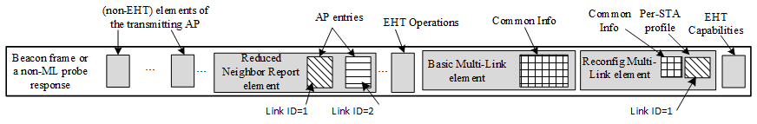
Figure AF-xx1 – Contents of a Beacon frame or a non-ML probe response during ML Reconfig AP removal procedure (non-Multiple BSSID scenario)

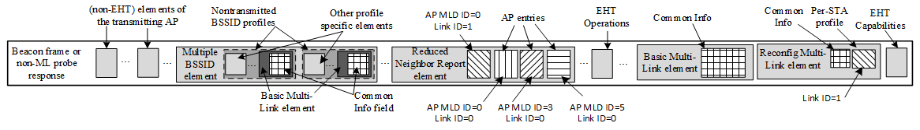
Figure AF-xx2 – Contents of a Beacon frame or a non-ML probe response during ML Reconfig AP removal procedure for an AP affiliated with the AP MLD of the transmitted BSSID

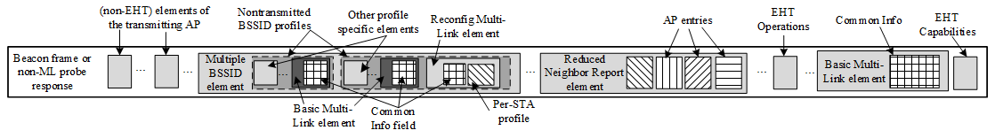
Figure AF-xx3 – Contents of a Beacon frame or a non-ML probe response during ML Reconfig AP removal procedure for an AP affiliated with the AP MLD of a nontransmitted BSSID

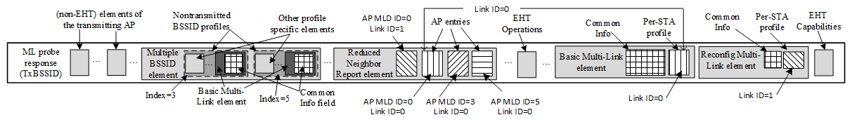
Figure AF-xx4 – Contents of an ML probe response during ML Reconfig AP removal procedure for an AP affiliated with the AP MLD of the transmitted BSSID

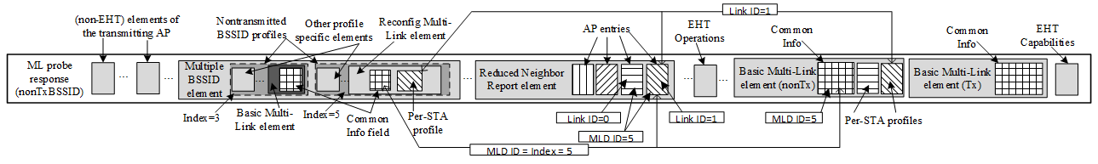
Figure AF-xx5 – Contents of an ML probe response during ML Reconfig AP removal procedure for an AP affiliated with the AP MLD of a nontransmitted BSSID

35.3.3.1 General
TGbe editor: Please add the following paragraph at the end of this subclause as shown below:
When different variants of the Multi-Link element (see Table 9-404b (Type subfield encoding)) are included in the same Management frame or as subelements within the same element, then the Multi-Link elements shall appear in ascending order of the value carried in the Type subfield of the Multi-Link Control field of the Multi-Link element.
x-x-x-x-x-x-x-x- End of changes related to CID 18119 -x-x-x-x-x-x-x-x

x-x-x-x-x-x-x-x- Start of changes related to CID 16975-x-x-x-x-x-x-x-x
35.3.21 TDLS procedure in multi-link operation
35.3.21.1 General
TGbe editor: Please update this subclause as shown below:

TDLS discovery and setup (typically discovery frame exchange followed by setup frame exchange) between a non-AP MLD and a peer STA involves frames that are sent and received via an intermediate AP (MLD) or sent and received through direct communication (see Table 11-14a (Frame type and their pathway in a TDLS setup)).
NOTE 1—As an alternative to transmitting a TDLS Discovery Request frame, a non-AP MLD can discover a TDLS peer by sending an unsolicited TDLS Discovery Response frame or a TDLS Setup Request frame without exchanging TDLS discovery frames (see 11.20.3 (TDLS discovery)).
An EHT non-AP STA affiliated with a non-AP MLD shall establish only a single link TDLS.
NOTE 2—The single link TDLS direct link can be established between a non-AP STA affiliated with a non-AP MLD and another non-AP STA that might not be affiliated with a non-AP MLD.
A non-AP MLD that intends to establish a single link TDLS direct link with a peer STA on one of its links follows the procedures defined in 11.20 (Tunneled direct link setup), with additional rules as defined in 35.3.21.2 (TDLS direct link over a single link).
35.3.21.2 TDLS direct link over a single link
TGbe editor: Please add the following paragraph as the 1st paragraph in this subclause:
A non-AP MLD shall include a TDLS Multi-Link element that does not carry the Link Info field and contains only the MLD MAC address of its associated AP MLD MAC in the Common Info field when it transmits a TDLS Discovery Request frame, TDLS Discovery Response frame or a TDLS Setup Request frame for establishing a single link TDLS direct link.

35.3.21.2 TDLS direct link over a single link
TGbe editor: Please update the following paragraph in this subclause as shown below:
A TDLS non-AP STA affiliated with a non-AP MLD shall not respond to a TDLS Discovery Request frame if the frame carries TDLS Multi-Link element and the MLD MAC address carried in the AP MLD MAC Address field of the TDLS Multi-Link element does not match the MLD MAC address of the AP MLD with which the non-AP MLD has performed ML setup.

TGbe editor: Please update the following paragraph in this subclause as shown below:
A TDLS non-AP STA affiliated with a non-AP MLD shall not respond to a TDLS Setup Request frame if the frame carries the TDLS Multi-Link element and the MLD MAC address carried in the AP MLD MAC Address field of the TDLS Multi-Link element does not match the MLD MAC address of the AP MLD with which the non-AP MLD has performed ML setup. A TDLS non-AP STA affiliated with a non-AP MLD shall include the TDLS Multi-Link element in the TDLS Setup Response frame if the soliciting TDLS Setup Request frame included TDLS Multi-Link element. A TDLS non-AP STA affiliated with a non-AP MLD shall not respond to a TDLS Setup Response frame if the frame carries TDLS Multi-Link element and the MLD MAC address carried in the AP MLD MAC Address field of the TDLS Multi-Link element does not match the MLD MAC address of the AP MLD with which the non-AP MLD has performed ML setup. A TDLS non-AP STA affiliated with a non-AP MLD shall include the TDLS Multi-Link element in the TDLS Setup Confirm frame if the preceding TDLS Setup Response frame included the TDLS Multi-Link element.

x-x-x-x-x-x-x-x- End of changes related to CID 16975-x-x-x-x-x-x-x-x

35.3.21.2 TDLS direct link over a single link
TGbe editor: Please update this subclause as shown below:
[16986]A non-AP MLD that initiates a TDLS discovery might not know the AP (i.e., the BSSID) with whom the intended peer STA is associated with (see NOTE 1 below). Therefore, when a non-AP MLD initiates a TDLS discovery operation, it may need to transmit more than one TDLS Discovery Request frame with the BSSID field of the Link Identifier element set to a different BSSID in each attempt. In each instance, the attempted BSSID corresponds to a different AP affiliated with the AP MLD. Since the TDLS Discovery Response frame is received over the direct link, the initiating non-AP MLD shall be able to determine the link(s) on which the peer non-AP STA or the peer non-AP MLD is operating on.
[16986]NOTE 1—Due to the nature of multi-link operation, when a Data frame that is transmitted by a non-STA affiliated with a non-AP MLD and that is directed towards a peer TDLS STA (i.e., the DA field is set to the target’s MAC address) traverses an AP MLD, it can be relayed (i.e., transmitted by an AP affiliated with the AP MLD)_on any link where the target is reachable. Furthermore, when a frame that was transmitted by a non-AP STA affiliated with a non-AP MLD traverses an AP MLD, the AP MLD sets the SA field to the transmitting non-AP MLD’s MLD MAC address. Therefore, when a non-AP STA affiliated with a non-AP MLD receives a frame from its corresponding associated AP that is affiliated with an AP MLD, it cannot determine the BSSID where the frame originated from or determine if the initiating non-AP STA is affiliated with a non-AP MLD or is a non-MLD non-AP STA.

AF.10 Examples of frame exchanges for TDLS discovery and setup involving a non-AP MLD
TGbe editor: Please update the following paragraph and associated figures in this subclause as shown below:
[16986]Figure AF-28 (Example of a successful TDLS discovery) and Figure AF-29 (Example of a failed TDLS discovery) illustrate the scenario where the TDLS discovery is initiated by a non-AP MLD (MLD_S). MLD_S has performed ML setup with an AP MLD (MLD_A). MLD_S has two affiliated STAs, STA1 and STA2. MLD_A has two affiliated APs, AP1 and AP2, where AP1 operates on link 1 and AP2 operates on link 2. STA3 is a non-MLD non-AP STA associated with AP 1. STA1 operates on link 1 and is associated with AP1. STA2 operates on link 2 and is associated with AP2. In the example figures, MLD_S initiates TDLS discovery by transmitting two TDLS Discovery Request frames (which are Data frames) as it does not know which affiliated AP STA3 is operating on if it a non-MLD non-AP STA or whether STA3 is a non-AP MLD. The first TDLS Discovery Request frame as shown in Figure AF-28 (Example of a successful TDLS discovery) has the BSSID field in the Link Identifier element set to the BSSID of AP1 and the second TDLS Discovery Request frame has this field set to the BSSID of AP2 as shown in Figure AF-29 (Example of an failed TDLS discovery). Both the frames have their A3 (DA) set to the STA3 MAC address and the To DS subfield of the Frame Control field set to 1. The TDLS Discovery Request frame can be transmitted over any enabled link – i.e., either link 1 (through STA1 as represented by solid line) or link 2 (through STA2 as represented by dotted line). When the TDLS Discovery Request frame is received at the AP MLD (i.e., through AP1 or AP2), it routes the frame to STA3, through AP1 by setting the From DS subfield of the Frame Control field to 1 and A3 (SA) to the non-AP MLD Address (i.e., MLD_S). STA3 discards the TDLS Discovery Request frame that had the BSSID field of the Link Identifier element set to BSSID of AP2 as it does not recognize the BSSID. STA3 recognizes the BSSID set to AP1 and responds with a TDLS Discovery Response frame, which is a Management frame, with the RA set to the MLD_S and both To DS and From DS subfields set to 0. STA3 ignores the TDLS Multi-Link element as it does not recognize this element. The TDLS STA affiliated with MLD_S receives the TDLS Discovery Response frame, which is sent on the TDLS direct link (see Table 11-14a). The TDLS initiator STA Address field and the TDLS responder STA Address field contained in the Link Identifier element (denoted as LI in the figure) are carried in the TDLS Discovery Request frame and in the TDLS Discovery Response frame and are set to MLD_S and STA3, respectively.

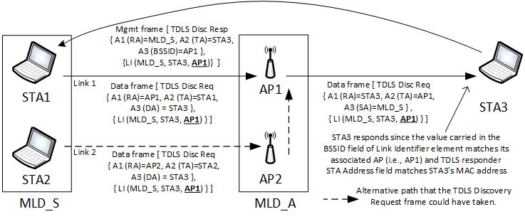
[16986, 16989]Figure AF-28—Example of a successful TDLS discovery

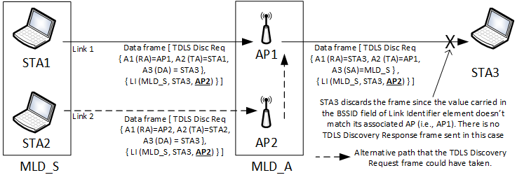
[16986, 16989]Figure AF-29—Example of a failed TDLS discovery
The same considerations apply for setting the fields in the Link Identifier element when the TDLS discovery is initiated by a non-MLD non-AP STA (such as STA3 in the previous examples) to establish a single link TDLS direct link with a non-AP MLD. In this scenario, since STA3 is a non-MLD non-AP STA it is not aware of AP MLD (MLD_A). It is familiar with its associated AP (AP1) and identifies the peer TDLS STA as MLD_S (non-AP MLD’s MLD MAC address). Therefore, the BSSID field of the Link Identifier element it transmits is set to the BSSID of AP1 and the DA is set to MLD_S. Furthermore, its TDLS Discovery Request frame does not carry a TDLS Multi-Link element.
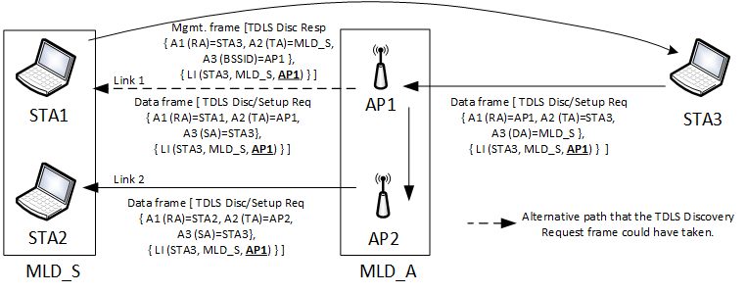
[16986, 16989]Figure AF-30—Example of TDLS discovery initiated by a non-MLD non-AP STA to a non-AP MLD

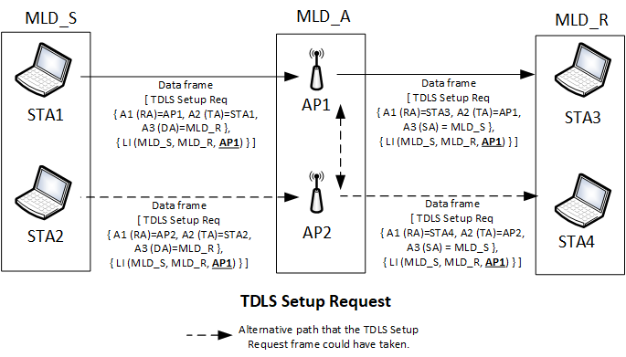
[16986, 16989]Figure AF-31—Transmission of TDLS Setup Request frame from one non-AP MLD to another

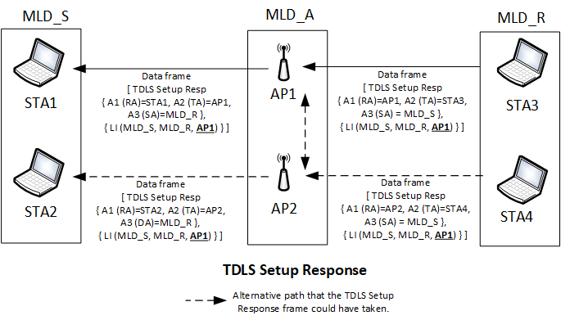
[16986, 16989]Figure AF-32—Transmission of TDLS Setup Response frame from non-AP MLD to another

