IEEE P802.11  
Wireless LANs

|  |  |  |  |  |
| --- | --- | --- | --- | --- |
| Resolutions for SBP Comments in LB272 - Part 1 | | | | |
| Date: 2023-05-05 | | | | |
| Author(s): | | | | |
| Name | Affiliation | Address | Phone | email |
| Cheng Chen | Intel |  |  | cheng.chen@intel.com |
| Ali Raissinia | Qualcomm |  |  | alirezar@qti.qualcomm.com |
| Claudio da Silva | Meta |  |  | claudiodasilva@meta.com |

Abstract

This submission proposes resolutions to the following comments submitted in LB272 under Instance topic. The CIDs are referring to D1.0. The text used as reference is D1.0.

CIDs: 1243 1651 1652 1653 1654 1655 1251 1287 1657 1288 1289 1424 1597 1608 1656 1681 1699 1748 1749 1750 1751 1752 1804 1924 1925 1926 2160 2249 2250 2296

Revision history:

R0: Original version

R1: Remove CIDs 1243 1651 1652 1653 1654 1655 from the document to avoid duplicate contributions.

|  |  |  |  |  |
| --- | --- | --- | --- | --- |
| **CID** | **Clause** | **Page** | **Comment** | **Proposed change** |
| 1251 | 11.55.2.2 | 193.25 | Given the "general" nature of this NOTE, suggest moving it to 11.55.2.1. | As suggested. |

**Proposed resolution**: Accepted.

|  |  |  |  |  |
| --- | --- | --- | --- | --- |
| **CID** | **Clause** | **Page** | **Comment** | **Proposed change** |
| 1287 | 11.55.2.3 | 194.27 | change the term "link access" as "channel access", make it aligned with channel access in line 24 in the subclause. | as in the comment |
| 1657 | 11.55.2.2 | 194.27 | "one or more link accesses" is not clear, perhaps "channel access" is a better term? Or is this really talking about multiple links? | Change as: "one or more channel acesses" |

**Proposed resolution**: Accepted to both.

|  |  |  |  |  |
| --- | --- | --- | --- | --- |
| **CID** | **Clause** | **Page** | **Comment** | **Proposed change** |
| 1288 | 11.55.2.3 | 194.52 | If the SBP initiator is also the sensing responder, a method should be defined to prohibit the SBP initiator sends the sensing measurement setup termination frame to the SBP responder, in order to avoid trigger the SBP termination procedure. | as in the comment |

**Proposed resolution**: Rejected.

**Discussion**: The contributor does not think we should prohibit the SBP initiator sending the sensing measurement setup termination frame to the SBP responder due to the following reasons:

1. If the SBP initiator does intend to get excluded from the responder role due to some reason, it should be allowed. The SBP initiator should understand that this may result in the termination of the SBP procedure.
2. The scenario mentioned in the comment can already occur with other sensing responders in the SBP procedure, where one sensing responder may terminate the sensing measurement setup with the SBP responder AP, which may lead to the termination of the SBP procedure. However, we do not prohibit other sensing responders to do that.
3. If the SBP initiator is also a sensing responder in the SBP procedure, excluding itself from the SBP responder role does not necessarily trigger the SBP termination procedure. Because if the SBP initiator does not have a strict requirement on the number of responders or preferred responder list, removing itself from the responder list would not terminate the SBP procedure.

|  |  |  |  |  |
| --- | --- | --- | --- | --- |
| **CID** | **Clause** | **Page** | **Comment** | **Proposed change** |
| 1289 | 11.55.2.3 | 194.18 | If the SBP initiator is the sensing responder and participants the NDPA sounding, in this case a method should be defined whether the SBP intiator should sends the sensing report to the SBP responder. | as in the comment |

**Proposed resolution**: Rejected.

**Discussion**: This scenario is already covered by the following note in D1.0 in 11.55.2.2. So, no further changes are needed.

NOTE—If an SBP initiator is also a sensing responder and a sensing receiver in the WLAN sensing procedure initiated by the SBP responder, the AP assigns the Sensing Measurement Report Requested subfield to 0 in the Sensing Measurement Setup Request frame transmitted to the SBP initiator.

|  |  |  |  |  |
| --- | --- | --- | --- | --- |
| **CID** | **Clause** | **Page** | **Comment** | **Proposed change** |
| 1424 | 11.55.2.1 | 190.54 | Is it necessary to say here that SBP is optional? This seems to be implied by the dot11SBPImplemented parameter. | Remove the sentence |

**Proposed resolution**: Accepted.

|  |  |  |  |  |
| --- | --- | --- | --- | --- |
| **CID** | **Clause** | **Page** | **Comment** | **Proposed change** |
| 1597 | 9.4.2.321 | 115.56 | It is not clear how the associated STA and the unassociated STA will know the MAC addresses and the AIDs/USIDs of the Preferred Sensing Responders in the SBP Parameters element | Specify how the associated STA and the unassociated STA will know the MAC addresses and the AIDs/USIDs of the Preferred Sensing Responders in the SBP Parameters element |

**Proposed resolution**: Rejected.

**Discussion**: The contributor proposes to reject this CID for the following reasons:

1. If the SBP initiator intends to provide a list of preferred responder list, it will set the Preferred Responder List field to 1 and include a Sensing Responder Addresses field in the SBP Request frame. The Sensing Responder Addresses field contains one or more MAC addresses that indicate a set of preferred sensing respodners. If the SBP initiator does not know the preferred responders, it will simply not include the list.
2. How the SBP initiator gets to know the preferred respondres and their MAC addresses is implementation specific and out of the scope of IEEE 802.11bf.

|  |  |  |  |  |
| --- | --- | --- | --- | --- |
| **CID** | **Clause** | **Page** | **Comment** | **Proposed change** |
| 1608 | 11.55.2.2 | 192.22 | This is a setting not an assignment. | Change the text to "... the AP sets the Sensing Measurement Report Requested subfield to 0 ... " |

**Proposed resolution**: Accepted.

|  |  |  |  |  |
| --- | --- | --- | --- | --- |
| **CID** | **Clause** | **Page** | **Comment** | **Proposed change** |
| 1656 | 11.55.2.2 | 193.28 | Availability Window element should be "ISTA Availability Window element"? | Change Availability Window element to "ISTA Availability Window element" |

**Proposed resolution**: Accepted.

|  |  |  |  |  |
| --- | --- | --- | --- | --- |
| **CID** | **Clause** | **Page** | **Comment** | **Proposed change** |
| 1681 | 9.4.2.321 | 117.51 | In Figure 9-1002be, are the AID/USID fields length should be 16 | As suggested. |

**Proposed resolution**: Revised.

**Discussion**:

* The AID/USID identifier is 16 bits, as specified in the TB Sensing Specific subelement in Figure 9-1002az.

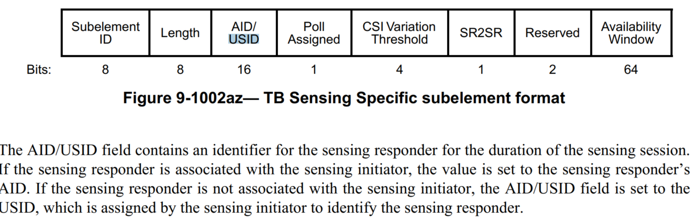

* However, we are also using the AID12/USID12 and AID11/USID11 to identify a STA in a sensing procedure in different frame formrats, such as Sensing Trigger frames and Sensing NDPA frame.
* So, we can simply change every AID/USID field in the Sensing Respodners IDs field to AID12/USID12 field.

***TGbf editor, make the following change for the 1st and 3rd paragraph in 9.4.2.321 in D1.0:***

|  |  |  |  |  |  |
| --- | --- | --- | --- | --- | --- |
|  | AID12/USID12 1 | AID12/USID12 1 | … | AID12/USID12 n | Padding |
| Bits | 12 | 12 | … | 12 | 0 or 4 |

Figure 9-1002be: Sensing Responder IDs field format

***And in the descriptions of the Sensing Responder IDs field, change all “AID/USID” to “AID12/USID12”.***

|  |  |  |  |  |
| --- | --- | --- | --- | --- |
| **CID** | **Clause** | **Page** | **Comment** | **Proposed change** |
| 1699 | 9.4.2.321, 9.4.2.322 | 116.20, 116.44 | Change the text "is interpreted as mandatory" to | to be interpreted as mandatory |

**Proposed resolution**: Accepted.

|  |  |  |  |  |
| --- | --- | --- | --- | --- |
| **CID** | **Clause** | **Page** | **Comment** | **Proposed change** |
| 1748 | 11.55.2.2 | 191.18 | Change the word "is" to "shall be" | As per comment |
| 1749 | 11.55.2.2 | 191.51-52 | Change "is defined to be unsuccessful" to | shall be considered unsuccessful  As it can be normative |

**Proposed resolution**: Accepted for both.

|  |  |  |  |  |
| --- | --- | --- | --- | --- |
| **CID** | **Clause** | **Page** | **Comment** | **Proposed change** |
| 1750 | 11.55.2.2 | 191.64-65 | The text "The SBP Request subfield within the SBPParameters parameter within a MLMESBP.response primitive shall be set to 0." needs to also be included in the MLMESBP.terminate primitive since there's cases where SBPparameter is sent back to the SBP initiator indicating with "SBP Error Status subfield is set to 1. | As per comment  Refer to the normative "If the SBP responder intends to terminate an SBP procedure due to unsuccessful or terminated sensing measurement setups with the sensing responders, and if either the Mandatory Number of Responders or the Mandatory Preferred Responder subfield in the SBP Request frame that invoked this SBP procedure is set to 1, the SBP responder may set the SBP Error Status subfield to 1 and include the SBP Parameters element in the SBP Termination frame" that implies termination behavior |

**Proposed resolution**: Revised.

***TGbf editor, make the following change for following paragraph in 11.55.2.2 in D1.0:***

The SBP Request subfield within the SBPParameters parameter within a MLME-SBP.request primitive shall be set to 1. The SBP Request subfield within the SBPParameters parameter within a MLMESBP.response primitive shall be set to 0. If present, the SBP Request subfield within the SBPParameters parameter within a MLMESBP.terminate primitive shall be set to 0.

|  |  |  |  |  |
| --- | --- | --- | --- | --- |
| **CID** | **Clause** | **Page** | **Comment** | **Proposed change** |
| 1751 | 11.55.2.2 | 192.55-56 | Suggest adding another subbullet under the text "The Preferred Responder List subfield within the SBPParameters parameter of an MLME-SBP.response primitive shall be set to 1 only if:" to include "when SBP Request has Preferred Responder List subfield set to 1" or something like that | As per comment |

**Proposed resolution**: Rejected.

**Discussion**: The point raised by the commente is already covered by the 2nd bullet in the referred sentence. Because the Preferred Responder List subfield within the SBPParameters parameter of the corresponding MLME-SBP.indication primitive are exactly the same as the SBP Parameters element of the received SBP Request frame. As a result, there is no need to add the suggested sentence by the commenter.

---The Preferred Responder List subfield within the SBPParameters parameter of the corresponding

MLME-SBP.indication primitive is equal to 1

|  |  |  |  |  |
| --- | --- | --- | --- | --- |
| **CID** | **Clause** | **Page** | **Comment** | **Proposed change** |
| 1752 | 11.55.2.2 | 193.35-36 | Change the text "The requested sensing measurement periodicity is the same as the requested periodicity of the availability windows" to be normative? | change "is" to "shall be" |

**Proposed resolution**: Accepted.

|  |  |  |  |  |
| --- | --- | --- | --- | --- |
| **CID** | **Clause** | **Page** | **Comment** | **Proposed change** |
| 1804 | 11.55.2.3 | 194.16 | It is better to descibe why SBP report frame is not protected even if other SBP related frames are protected. | Please add description why SBP report frame is unprotected even if other frames are protected. |

**Proposed resolution**: Rejected.

**Discussion:** The report frames (sensing measurement report and SBP report) are under “protected sensing frames” and not under protected dual public frames, see below. The main reason is that they need to be sent inside the availability window, hence out of order with respect to the protected dual public frames (different PN sequence) and are Action no-Ack.

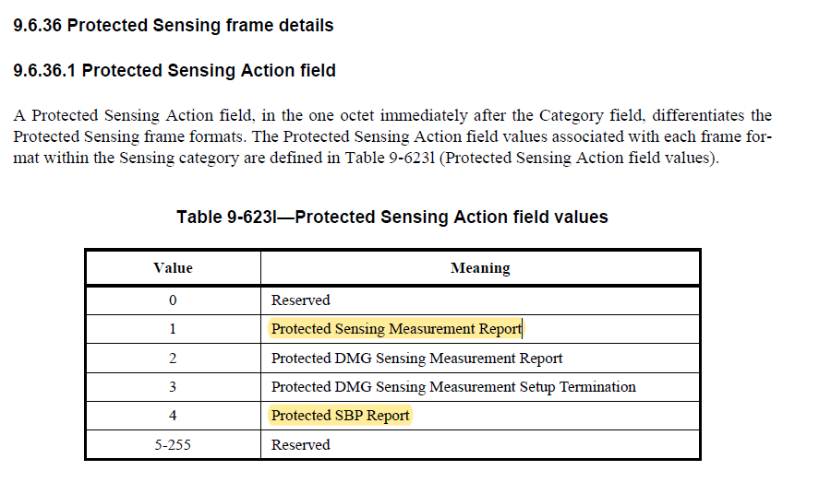

|  |  |  |  |  |
| --- | --- | --- | --- | --- |
| **CID** | **Clause** | **Page** | **Comment** | **Proposed change** |
| 1924 | 11.55.2.2 | 191.37 | Remove ", respectively" | The word "respectively" does not seem to make sense here, it is unclear what that would refer to. Make a full stop after "parameters" and remove ",respectively" |

**Proposed resolution**: Revised.

**Discussion**: The “respectively” is saying the “SesingMeasurementParameter” is for the “preferred measurement setup parameters” and the “SBPParameters” is for the “preferred SBP paramters”.

***TGbf editor, make the following change for following paragraph in 11.55.2.2 in D1.0:***

If the StatusCode parameter within the MLME-SBP.response primitive is set to REJECTED_WITH_SUGGESTED_CHANGES, the MLME-SBP.response primitive shall include ~~SensingMeasurementParameter and~~ SBPParameters and SensingMeasurementParameter parameters and that specify preferred SBP and measurement setup parameters, respectively.

|  |  |  |  |  |
| --- | --- | --- | --- | --- |
| **CID** | **Clause** | **Page** | **Comment** | **Proposed change** |
| 1925 | 11.55.2.2 | 194.5 | seems to be a typo. "and" should probably be "an" | replace "and" with "an" |

**Proposed resolution**: Accepted.

|  |  |  |  |  |
| --- | --- | --- | --- | --- |
| **CID** | **Clause** | **Page** | **Comment** | **Proposed change** |
| 1926 | 11.55.2.2 | 194.13 | seem it should read "element shall be set to 0" | add the word "be" as indicated in the comment |

**Proposed resolution**: Accepted.

|  |  |  |  |  |
| --- | --- | --- | --- | --- |
| **CID** | **Clause** | **Page** | **Comment** | **Proposed change** |
| 2160 | 11.55.2.2 | 191.51 | The last sentence of this paragraph is the condition for unsuccessful SBP procedure setup instead of a definition. | Replace "is defined to be" with "is considered" |

**Proposed resolution**: Accepted.

|  |  |  |  |  |
| --- | --- | --- | --- | --- |
| **CID** | **Clause** | **Page** | **Comment** | **Proposed change** |
| 2249 | 11.55.2.1 | 190.63 | Miss "a" before SBP initiator | A non-AP STA may act as a SBP initiator when ... |
| 2250 | 11.55.2.1 | 191.1 | Miss "a" before SBP responder | An AP may act as a SBP responder when ... |

**Proposed resolution**: Revised.

***TGbf editor, make the following change for following paragraphs in 11.55.2.2 in D1.0:***

A non-AP STA may act as an SBP initiator when both dot11WLANSensingImplemented and dot11SBPImplemented are true.

An AP may act as an SBP responder when both dot11WLANSensingImplemented and dot11SBPImplemented are true.

|  |  |  |  |  |
| --- | --- | --- | --- | --- |
| **CID** | **Clause** | **Page** | **Comment** | **Proposed change** |
| 2296 | 11.55.2.1 | 190.54 | Trigger-based sensing is more efficient since the AP can coordinate the sensing procedure in an optimized way. Sensing by proxy allows non-AP STAs to utilize these advantages of trigger-based sensing. In order to reliably allow non-AP STAs to initiate a TB sensing measurement instance, SBP shall be mandatory for AP STAs. | Make sensing by proxy mandatory for AP STAs |

**Proposed resolution**: Rejected.

**Discussion:** The contributor proposes to reject this CID due to the following reasons:

* TGbf members have agreed that SBP is an optional feature for an AP, and we have defined corresponding capabilities to indicate support for SBP or not.
* The main motivation and objective for a non-AP STA to initiate an SBP procedure is not “In order to reliably allow non-AP STAs to initiate a TB sensing measurement instance”, as stated by the commenter. Instead, the primary usecase for SBP is to allow a non-AP STA to obtain more sensing measuremesnts with the help of the AP, without which the non-AP STA typically can only get sensing measurements with the AP alone.

## SP

Do you support the proposed resolutions to the CIDs and incorporate the text changes into the latest TGbf draft?

Y/N/A