IEEE P802.11
Wireless LANs
Fixing 12.2.10 for MLDs
Date: 2023-05-15
Author(s):
Name | Affiliation | Address | Phone | Email
Brian Hart | Cisco Systems |  |  | brianh@cisco.com
Jerome Henry | Cisco Systems
Stephen Orr | Cisco Systems
Gaurav Patwardhan | HPE

Abstract

This submission is not based on a CID.

Revisions:
- Rev 0: Initial version of the document.
- Rev 1: Corrected MIB variable for MLD
- Rev 2: Account for 35.3.1 with an edit there

Discussion
The clause 12 text in the 802.11 baseline has not been updated for AP MLD MAC addresses, and indeed the current language is inconsistent with the requirements of MLO.

For ESS connectivity, continued baseline behavior is relied upon for troubleshooting client connectivity, network health monitoring and so forth, and is already established in 11be 4.5.3.2 and 35.3.1.

4.5.3.2 Mobility types
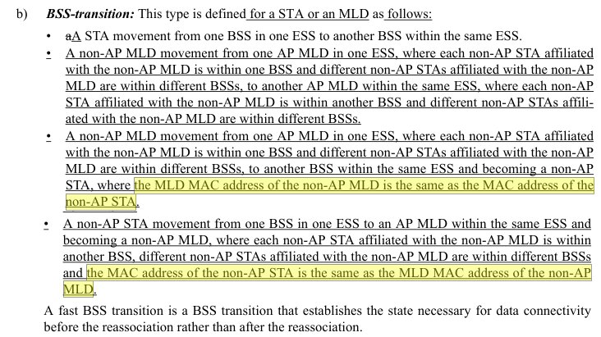
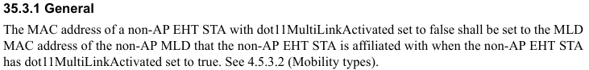

TGbe editor: Please note Baseline is 11be D3.1 and 11me D3.0. Since 12.2.10 is not present in 11be D3.1, please incorporate the text below and record the 11be changes as identified via Word track changes:

12.2.10 Requirements for support of MAC privacy enhancements

MAC privacy enhancements are enabled on a non-AP STA or non-AP MLD when dot11MACPrivacyActivated is set to true. Each STA affiliated with a non-AP MLD shall set dot11MACPrivacyActivated to the same value.

As described in 4.5.3.2 (Mobility Types), a non-AP entity may become a non-AP STA or become a non-AP MLD; and the identity of the non-AP entity known by the DS is defined to be the non-AP DS MAC address and equals the STA MAC address or non-AP MLD MAC address respectively.

The STA or non-AP MLD shall periodically change its MAC address (i.e., STA MAC address) or MLD MAC address to a random value while not associated to a BSS or AP MLD, respectively.

NOTE–These addresses are coupled as defined in 35.3.1 (General).

The STA or non-AP MLD shall construct the randomized MAC address or randomized MLD MAC address respectively from the locally administered address space as defined in IEEE Std 802-2014 and IEEE Std 802c™-2017.

However, the non-AP STA shall not change its MAC address during a transactional exchange, for example, transmitting Public Action frames for preassociation discovery, or during the creation of state on an AP using preassociation capabilities, for example: RSN preauthentication or FT over-the-DS. Similarly, the non-AP entity shall not change its non-AP DS MAC address during a transactional exchange, for example, transmitting Public Action frames for preassociation discovery, or during the creation of state on an AP using preassociation capabilities, for example: RSN preauthentication or FT over-the-DS.

The smaller the period of MAC address and non-AP MLD MAC address change, down to a single transmitted frame between changes, the greater the privacy these enhancements afford. The actual period used when changing a non-AP MAC address or non-AP MLD MAC address is implementation dependent and outside the scope of this standard.

If such a non-AP STA starts any transaction that establishes state bound to a MAC address and might elect to establish an association or establish transaction state with a discovered BSS, it shall check the value of dot11LocallyAdministeredMACConfig and shall configure its MAC address according to the rules of the local address space prior to the start of the transaction. If such a non-AP MLD starts any transaction that establishes state bound to an MLD MAC address and might elect to establish an association or establish transaction state with a discovered MLD, it shall check the value of dot11LocallyAdministeredMACConfig and shall configure its MLD MAC address according to the rules of the local address space prior to the start of the transaction.

State created with an AP using a prior MAC address or non-AP DS MAC address, for instance, RSN preauthentication state or FT state established over-the-DS, is bound to the respective MAC address or non-AP DS MAC address used when that state was created. State created with an AP MLD using a prior MAC address or prior non-AP DS MAC address, for instance, RSN preauthentication state or FT state established over-the-DS, is bound to the respective MAC address or non-AP DS MAC address used when that state was created. Prior to establishing an association to the AP, the non-AP STA shall change its MAC address to the MAC address used when the state was created. Prior to establishing an association with the AP MLD, the non-AP entity shall change its non-AP DS MAC address to the non-AP DS MAC address used when the state was created.

The SME of the non-AP STA may change the MAC address or MLD MAC address by generating an MLME-UPDATEMACADDRESS.request primitive containing a) the new MAC address or new MLD MAC address, respectively and b) which of the MAC address or MLD MAC address is being changed. On receipt of an MLME-UPDATEMACADDRESS.request primitive, the MLME shall attempt to update the MAC address or MLD MAC address that is to be used by the MAC entity or MLD entity and shall generate an MLME-UPDATEMACADDRESS.confirm primitive to notify the SME whether the MAC address or MLD MAC address has been changed to the new value, respectively.

Every time a MAC address or MLD MAC address is changed to a new random value, counters in (#270)all sequence number spaces used to identify each MSDU, A-MSDU or MMPDU shall be reset (see 10.3.2.14.2 (Transmitter requirements)) and the non-MLD STA or each STA affiliated with an MLD shall set the TXVECTOR parameter SCRAMBLER_RESET to RESET_SCRAMBLER on the next transmitted PPDU.

The non-AP entity connecting to an infrastructure BSS shall retain a single non-AP DS MAC address for the duration of its connection across an ESS. A PMKSA created as part of an RSNA will contain the non-AP DS MAC address used to create the PMKSA. The non-AP entity that supports PMKSA caching shall, if necessary, change its non-AP DS MAC address back to that value when attempting a subsequent association to the ESS using PMKSA caching.

To construct a random MAC address, the STA or non-AP MLD shall select a randomized MAC address or randomized MLD MAC address respectively according to IEEE Std 802-2014 and IEEE Std 802c-2017.

To avoid leakage of possibly sensitive network identifying information, STAs should refrain from transmitting Probe Request frames containing preferred SSID values and, instead, use passive scanning or transmit Probe Request frames containing the wildcard SSID.

When dot11MACAddressPolicyActiviated is true, an AP shall set the MAC Address Policy field in the Extended Capabilities field to 1, indicating the existence of a MAC address policy. When dot11MACAddressPolicyActivated is false, an AP STA shall set the MAC Address Policy field in the Extended Capabilities field to 0, indicating that local MAC addresses are not restricted. All APs affiliated with an MLD shall set dot11MACAddressPolicyActivated to the same value and shall advertise the same MAC address policy in their transmitted MAC Address Policy ANQP-elements.

A non-AP STA that receives from an AP an Extended Capabilities field with the Local MAC Address Policy subfield set to 1 should, unless it has previously stored the MAC address policy for the ESS, discover that policy, using the MAC Address Policy ANQP-element, before sending any Association Request frame to that AP using a local MAC address as the TA or a local MLD MAC address as the MLD MAC address of the non-AP MLD with which the STA is affiliated.

35.3.1 General
The MAC address of a non-AP EHT STA with dot11MultiLinkActivated set to false shall be set to the MLD MAC address of the non-AP MLD that the non-AP EHT STA is affiliated with when the non-AP EHT STA has dot11MultiLinkActivated set to true(#15517), and vice versa.

