IEEE P802.11
Wireless LANs
Proposed resolutions for technical comments on D1.0 - Part 1
Date: 2022-05-05
Author(s):
Name | Affiliation | Address | Phone | email
Claudio da Silva | Meta Platforms, Inc |  |  | claudiodasilva@meta.com
Abstract
This document contains proposed resolutions for technical comments on D1.0 (LB272). The text used as reference is D1.0.

CIDs: 1333, 1334, 1241, 1443, 1977, 1917, 1627, 1635, 1952, 1834, 1263

CID | Clause | Page | Comment | Proposed change
1333 | 11.55.1.2 | 170 | The MIB attribute, dot11WLANSensingImplemented, will be misunderstood as it is common to non-DMG and DMG. But in 11.55.3.2, there is dot11DMGSensingMsmtImplemented for DMG sensing. The names should be changed to clarify whether they are for non-DMG or DMG. And the naming of dot11WLANSensingImplemented and dot11DMGSensingMsmtImplemented should align to each other. | Change dot11WLANSensingImplemented to dot11nonDMGWLANSensingImplemented and dot11DMGSensingMsmtImplemented to dot11DMGWLANSensingImplemented throughout the draft.
1334 | 11.55.2.1 | 190 | The MIB attribute, dot11SBPImplemented, will be misunderstood as it is common to non-DMG and DMG. But in 11.55.4.1, there is dot11DMGSBPImplemented. The name should be changed to clarify it is for non-DMG. | Change dot11SBPImplemented to dot11nonDMGSBPImplemented throughout the draft.

Proposed resolution: Revised

Discussion: The terminology “WLAN sensing” was discussed in https://mentor.ieee.org/802.11/dcn/23/11-23-0428-01-00bf-lb272-comments-on-sensing-terminologies.pptx. A SP was run, and the vast majority of the TG supported replacing “WLAN sensing” with “sensing”. Also, to keep the terminology consistent, we propose to continue using the term SBP.

Modifications: TGbf Editor – Replace dot11WLANSensingImplemented with dot11SensingImplemented.
(Note: This modification has already been defined in the document referenced above, which was unanimously supported by the TG. Thus, further modifications are not required.)

CID | Page | Comment | Proposed change | Proposed resolution
1241 | 35.48 | Both MLME-SENSTBMSMTRQ.request and MLME-SENSNTBMSMTRQ.request primitives triger the MAC to obtain one sensing measurement. At the same time, I expect that most sensing applications would require consecutive measurements to be taken (likely with a "as constant as possible" sensing interval). Thus, the group should consider whether it makes sense for the SME to trigger a sequence/number of measurements to be taken with a single primitive. (This may simplify scheduling, for example.) | As suggested. Technical discussion is necessary. | REJECTED  The commenter has withdrawn the comment.

CID | Page | Comment | Proposed change | Proposed resolution
1443 |  | Only three PHY subclauses (HE, EDMG, EHT) are amended. | Suggest adding a pragraph in subclause 4 (General description) to provide the rationale of specifying only HE, EDMG, and EHT PHY from many PHYs. | REJECTED  The IEEE 802.11 standard typically does not include explanations for design decisions made in its development.  Discussions on the NDP format adopted in the sensing procedure can be found, among others, in https://mentor.ieee.org/802.11/dcn/22/11-22-0415-02-00bf-ndp-selection-for-802-11bf.pptx  and  https://mentor.ieee.org/802.11/dcn/22/11-22-1937-03-00bf-pdt-ndp-formats-for-sensing.docx  And for the DMG sensing procedure,  https://mentor.ieee.org/802.11/dcn/22/11-22-1524-04-00bf-edmg-multi-static-ppdu-struct-update.docx

CID | Clause | Page | Comment | Proposed change
1977 | 11.55 | 172.50 | The so called sensing measurement setup seems to be simple request/response exchange the establishes operational parameters for sensing measurement instances. If so, state that right up front. It would greatly help in the undestanding of the procedure. Also, it might be better to not call it a "setup", but rather something closer to its real purpose -- the establishement of operational parameters for sensing measurement instances. | Change the name to "Sensing measurement parameter exchange". As the intorductory paragraph say "The sensing measurement parameter exchange establishes operational parameters for sensing measurement intances. The sensing measurement parameter exchange begins with the sensing initiator sending a Sensing Measurement Setup Request frame and ends when the sensing responder sends a Sensing Measurement Setup Response frame or a timeout occurs."

Proposed resolution: Revised

Discussion: The point raised in this comment was partially discussed and addressed in https://mentor.ieee.org/802.11/dcn/23/11-23-0511-03-00bf-proposed-resolutions-for-editorial-comments-on-d1-0-part-2.docx

Modifications: TGbf Editor –
- Replace “Sensing measurement session” with “Sensing measurement session initiation” as the title of 11.55.1.4.
- Add the text below as the second paragraph of 11.55.1.4:
The sensing measurement session initiation establishes operational parameters for sensing measurement exchanges. The sensing measurement session initiation begins with the sensing initiator sending a Sensing Measurement Request frame and ends when the sensing responder sends a Sensing Measurement Response frame or a timeout occurs."
CID | Clause | Page | Comment | Proposed change
1917 | 11.55.1.5.2.6.1 | 183.35 | conveyed to the STA is unclear | spell out what STA it is. To the initiating STA?

Proposed resolution: Revised

Discussion: Text referred to by the commenter is (includes CID resolutions already approved by the group):
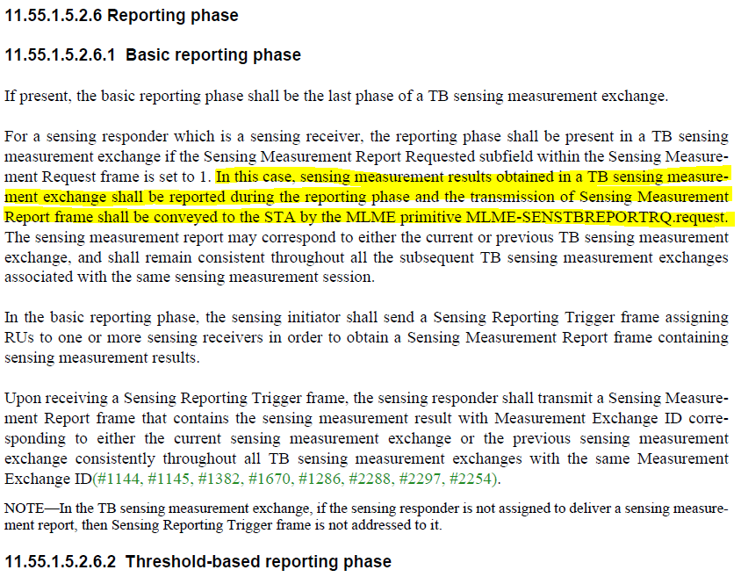

Modifications: TGbf Editor –
- Delete the sentence “In this case, sensing measurement results obtained in a TB sensing measurement instance shall be reported during the reporting phase and the transmission of Sensing Measurement Report frame shall be conveyed to the STA by the MLME primitive MLME-SENSTBREPORTRQ.request.” (183.32-36).
- Change the fourth paragraph of 11.55.1.5.2.6.1 as follows:
The SME of a sensing receiver shall request the transmission of a Sensing Measurement Report frame to the sensing initiator by generating an MLME-SENSREPORTRQ.request primitive. Upon receiving a Sensing Reporting Trigger frame, the sensing responder shall transmit a Sensing Measurement Report frame…
- Delete the sentence “The sensing measurement report may correspond to either the current or previous TB sensing measurement instance, and shall remain consistent throughout all the subsequent TB sensing measurement instances associated with the same measurement setup.” (183.36-39) as normative text is defined for it in the fourth paragraph.

CID | Clause | Page | Comment | Proposed change
1627 | 6.3.136.11 | 37.22 | It is not clear what primitive will be used to communicate the CSI_ESTIMATE between MLME and the SME in case the sensing measurement is not reported in a Sensing Measurement Report frame and consumed locally. What are the parameters of such primitive, if any? | Specify the primitive that will be used to communicate the CSI_ESTIMATE between MLME and the SME in case the sensing measurement is not reported in a Sensing Measurement Report frame and consumed locally and specify the parameters of such primitive, if any?

Proposed resolution: Revised

Discussion:
- Measurements are always conveyed to the sensing receiver’s SME using the MLME-SENSREPORT.indication primitive regardless of whether a Sensing Measurement Report frame is sent or the measurements are consumed locally. If the sensing receiver is expected to send a Sensing Measurement Report frame, an MLME-SENSREPORTRQ.request is issued by the sensing receiver’s SME after measurements are obtained. If the measurements are consumed locally, no further action is required, and no additional primitives are issued.
- With the change in the format of Clause 6, we (TGbf) must define normative behavior for all WLAN sensing-related primitives in Clause 11. In response to comment 1627, below is a suggestion of such text for the SENSREPORT.indication primitive.

Modifications: TGbf Editor – Add the paragraphs below at the end of 11.55.1.5.1 (General).

Upon receiving an SI2SR, SR2SI or SR2SR NDP, the sensing receiver’s MAC shall issue a SENSREPORT.indication primitive.

NOTE – The SENSREPORT.indication primitive includes sensing measurements. If the NDP is preceded by a Sensing NDP Announcement frame, the SENSREPORT.indication primitive also includes operational parameters carried in the Sensing NDP Announcement frame. If the NDP’s transmission is triggered by a Sensing Trigger frame, the SENSREPORT.indication primitive also includes operational parameters carried in the Sensing Trigger frame.

CID | Clause | Page | Comment | Proposed change
1635 | 6.3.136.1 | 26.31 | SR2SR sounding is missing in Figure 6-29a | As in comment

Proposed resolution: Revised

Discussion:
- When Clause 6 was rewritten in the new format defined by the baseline, Figure 6-29a was deleted.
- TB sensing measurement exchanges are initiated upon the issue of a Type 6 (see below) MLME primitive (MLME-SENSTBMSMTRQ). Once the AP’s MLME receives this primitive, the polling, NDPA sounding, and TF sounding phases are performed as defined in Clause 11 according to primitive parameters. No additional MLME primitives are issued.
- MLME-SENSTBMSMTRQ determines whether a given TF sounding phase is SR2SI or SR2SR. Thus, as far as MLME primitives go, no changes are needed since SR2SR is included. Also, the SR2SR frame exchange is already defined in Clause 11.

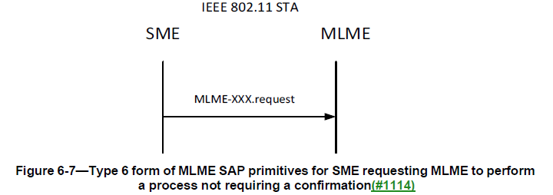

Modifications: TGbf Editor – Add the paragraphs below after the paragraph in 177.51-55 (11.55.1.5.2.1 (General))

The SME of an AP STA shall issue an MLME-SENSTBMSMTRQ.request primitive to request a TB sensing measurement exchange to be performed with one or more non-AP STAs.

NOTE – The different phases present in a TB sensing measurement exchange and, if present, the variant used in the TF sounding phase are determined by MLME-SENSTBMSMTRQ.request primitive parameters.

CID | Clause | Page | Comment | Proposed change
1952 | 6.3.136.9 | 36.01 | The primitive MLME-SENSTBMSMTRQ.request is intended to perform an entire TB measurement instance with one or more STAs. However, only a single "SensingMeasurementParameters" is provided. As a result, it will not be possible to perform TB Sounding and NDPA sounding with different parameters in the same measurement instance. | Allow passing in different SensingMeasurementParameters for the TB Soundingn phase, and NDPA Sounding phase.  Rename "SensingMeasurementParameters" to "TBSensingMeasurementParameters", and add new parameter for NDPA Sounding called "NDPASensingMeasurementParameters".

Proposed resolution: Revised

Discussion:
- In the new format used for Clause 6, except for primitives defined in 6.5, primitive parameters are no longer listed.
- The parameters of the primitive that initiates a TB sensing measurement exchange (MLME-SENSTBMSMTRQ) define all parameters necessary to execute the polling, TF sounding, and NDPA sounding phases (including whether they are performed).
- It is not clear to the author of this document if normative text or an informative note are necessary to define/clarify that the TF sounding and NDPA sounding phase exchanges may use different parameters.

Modifications: TGbf Editor – Incorporate the modifications defined in https://mentor.ieee.org/802.11/dcn/23/11-23-0625-01-00bf-pdt-on-new-clause-6.docx into the draft.
(Note: No further modifications beyond those defined in the document above are required.)

CID | Page | Comment | Proposed change | Proposed resolution
1834 | 241.11 | Has the amended MIB been compiled with the rest of the MIB from the dependant drafts? | If not, the amended MIB should be compiled to ensure it is correct. | REJECTED  The amended MIB has not been compiled with the rest of the MIB from the dependant drafts yet. Amended MIBs are typically compiled during the MDR process. The MDR for the P802.11bf draft is expected to be conducted after the publication of D3.0.

CID | Page | Comment | Proposed change | Proposed resolution
1263 |  | MediaTek Inc. does not agree with the current version of the draft, and requires more content added before it can be approved. |  | REJECTED  The comment fails to identify a specific issue to be addressed. It fails to identify changes in sufficient detail so that the specific wording of the changes that will satisfy the commenter can be determined.

