IEEE P802.11
Wireless LANs
Proposed resolutions for editorial comments on D1.0 - Part 4
Date: 2022-05-10
Author(s):
Name | Affiliation | Address | Phone | email
Claudio da Silva | Meta Platforms, Inc |  |  | claudiodasilva@meta.com
Abstract
This document contains proposed resolutions for editorial comments on D1.0 (LB272). The text used as reference is D1.0.

CIDs: 1025, 1786, 1846, 1791, 1943, 1790, 1331, 1974, 1006, 1792, 1787, 1845, 1812, 1523, 2224,1480, 1126, 1081

CID | Clause | Page | Comment | Proposed change
1025 | 9.3.3.5 | 85.35 | Not sure why the MIB variable is called "dot11WLANSensingImplemented" and not "dot11SensingImplemented" to keep constency with the DMG MIB variables | Rename "dot11WLANSensingImplemented" to "dot11SensingImplemented" in the whole document
1786 | 11.55.1 | 167.07 | "WLAN" in the procedure name is not necessary and somewhat misleading. While the sensing is performed by STAs on the WLAN, it is not the WLAN that is being sensed nor is it the WLAN that is doing the sensing. Let's just call it the "Sensing procedure" | Change title and all occurances of "WLAN sensing procedure" to "sensing procedure" (capitalized first word in title and at start of a sentence).
1846 | 11.55.1 | 167.07 | WLAN sensing consists of mutliple procedures and is not on monolithic procedure. Rather than refer to sensing as "WLAN sensing procedure", refer to the procedures as "WLAN sensing" | Change "WLAN sensing procedure" to "WLAN sensing" throughout the draft. Note to editor "I searched through the draft for the term and it looked as though this change could be made globally.

Proposed resolution: Revised

Discussion: The terminology used in the draft, including the terms WLAN sensing and sensing procedure, was discussed in https://mentor.ieee.org/802.11/dcn/23/11-23-0538-02-00bf-lb272-cr-for-sensing-terminologies.docx .

Modifications: TGbf Editor – Implement the changes defined in https://mentor.ieee.org/802.11/dcn/23/11-23-0538-02-00bf-lb272-cr-for-sensing-terminologies.docx .
(Note: No further modifications are required.)

CID | Clause | Page | Comment | Proposed change
1791 | 11.55.1.2 | 170.11 | "STA" is a generic term for all STAs (not just sensing STAs) so this statement is placing a requirement on everything and is in conflict with the optionality of this feature. | Qualify the STA for which this and subsequent requirements apply. For example, "A sensing STA shall support N_b values of 8 and 10..."< "A sensing STA with 4 or fewer transmit attennas shall...", etc.
1943 | 11.55.1.2 | 170.14 | In the Dependencies section, the last 6 statements should have the condition of "dot11WLANSensingImiplemented field being true", since they apply to only non-DMG sensing features. | Before line 14 insert: "The following requirements apply to a STA in which dot11WLANSensingImplemented is true."

Proposed resolution: Revised

Discussion: This issue was discussed in https://mentor.ieee.org/802.11/dcn/23/11-23-0514-02-00bf-comment-resolution-in-lb272-for-reporting-cid-part-1.docx and approved by the TG. For reference, this section of the draft now reads:
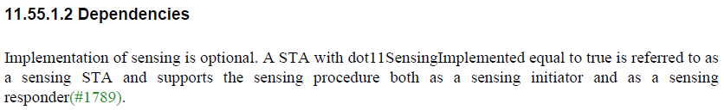
…
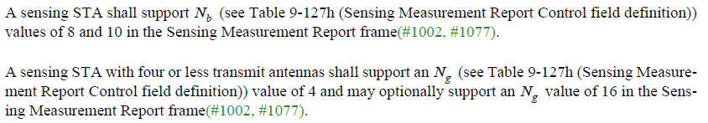

Modifications: TGbf Editor – Implement the changes defined in https://mentor.ieee.org/802.11/dcn/23/11-23-0514-02-00bf-comment-resolution-in-lb272-for-reporting-cid-part-1.docx
(Note: No further modifications are required.)

CID | Page | Comment | Proposed change | Proposed resolution
1790 | 170.11 | It is not feasible for all STAs to retroactively set this field to 0. The Extended Capabilities element expands in length as new fields are added, so older implementations may not even have this field present. | Delete this statement. It is sufficient to have a shall statement for a sensing STA to set the field to 1. By implication, a STA the does not include this field or sets it to 0 is not a sensing STA. | ACCEPTED
1331 | 170.11 | "A STA in which dot11WLANSensingImplemented is false shall set the WLAN Sensing field of the Extended Capabilities element to 0." Do we need this sentence? A legacy STA will not have dot11WLANSensingImplemented and will not set the WLAN Sensing field anyway. | Delete the sentence and add "Otherwise, the STA sets the WLAN Sensing field to 0." at end of the previous paragraph. | REVISED.  Modifications: In 170.11, delete "A STA in which dot11WLANSensingImplemented is false shall set the WLAN Sensing field of the Extended Capabilities element to 0."

Discussion: For reference,

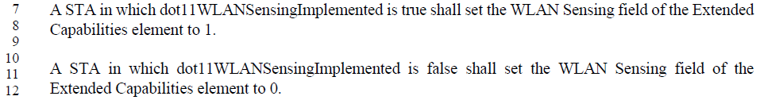

CID | Page | Comment | Proposed change | Proposed resolution
1974 | 170.49 | It is not the meaning of "1" and "0" that is optional it is the the use of the "indication of a need for new sensing responders" that is optional. Also, the setting to 1 and the setting to 0 cannot both be optional. | Change to "An AP may indicate the need for new sensing responders by setting the Responder Needed subfield in the Sensing element in a Probe Response frame to 1." (the default is setting to 0, i.e., not indicating a need for new sensing responder -- no need to mention this). | ACCEPTED
1006 | 170.49 | The second portion of the sentence is unclear because it is missing a noun. | Rephrase as "An AP may set the Responder Needed subfield in the Sensing element within a Probe Response frame to 1 to indicate the need for new sensing responders, and may set the subfield to 0 to indicate new sensing responders are not needed." | REVISED.  Modifications: Change 170.49.52 to "An AP may indicate the need for new sensing responders by setting the Responder Needed subfield in the Sensing element in a Probe Response frame to 1."

Discussion: Text referred to by the commenters is:

CID | Clause | Page | Comment | Proposed change
1792 | 11.55.1.2 | 170.11 | It is not immediately apparent what the bandwidth of a STA is. Be more specific. We could narrow this down a bit by making a "sensing STA" something modern; like an HE STA or an EHT STA (add a statement: "A sensing STA is an EHT STA"). And then saying something like "a sensing STA that is not a 20 MHz only HE STA shall support..." BTW, this inheretence statement is necessary since it is implied by some of the other statements (support for TB operation) that it is at least an HE STA. | As in comment

Proposed resolution: Revised

Discussion: I believe the commenter refers to the following paragraphs (wrong page number)
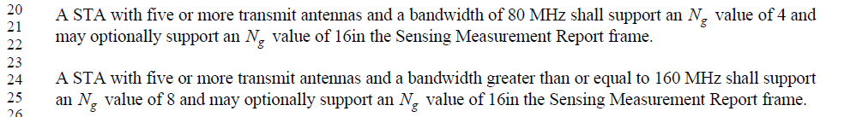

The definition that a sensing procedure “allows a high-efficiency (HE) station (STA) or extremely high throughput (EHT) STA to perform sensing” has been proposed to be included in the draft in https://mentor.ieee.org/802.11/dcn/23/11-23-0633-02-00bf-lb272-crs-for-cid-1477and-2053.docx and was supported by the TG.

Modifications: TGbf Editor – Change 170.20-25 as follows:

A STA with five or more transmit antennas and a bandwidth of 80 MHz shall support an Ng value of 4 and may optionally support an Ng value of 16 in the Sensing Measurement Report frame if the bandwidth of the SI2SR, SR2SI, or SR2SR NDP used to obtain the reported sensing measurements is 80 MHz.

A STA with five or more transmit antennas and a bandwidth greater than or equal to 160 MHz shall support an value of 8 and may optionally support an Ng value of 16 in the Sensing Measurement Report frame if the bandwidth of the SI2SR, SR2SI, or SR2SR NDP used to obtain the reported sensing measurements is greater than or equal to 160 MHz.

CID | Clause | Page | Comment | Proposed change
1787 | 11.55.1.1 | 167.12 | This description is pointless. One can assume that a WLAN sendins procedure is for WLAN sensing, but what is WLAN sensing? Be more descriptive. Also, use the definite article (the) -- there is only one sensing procedure. | Change to "The sensing procedure allows two non-DMG STA to obtain channel state measuments that might be used to infer the range, velocity and motion of objects in an area of interest."
1845 | 11.55.1.1 | 167.11 | The statement is self-referential | Change "to perform WLAN sensing" to "to perform sensing"

Proposed resolution: Revised

Discussion: Text referred to by the commenters is:
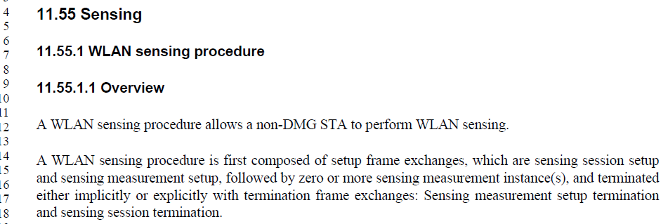

- WLAN sensing, sensing procedure… are already defined in Clause 4, where more detailed descriptions are provided. To avoid duplication and comments, I suggest to delete the sentence referred to by the commenters in Clause 11.

Modifications: TGbf Editor – Delete the sentence in 167.12

CID | Clause | Page | Comment | Proposed change
1812 | 11.55.1.3 | 170.49 | The subfield name should be 'Responders Needed' | Change to 'Responders Needed
1523 | 11.55.1.3 | 170.49 | s' is missing in the name of the subfield 'Responder Needed' | Change the subfield name to 'Responders Needed'

Proposed resolution: Revised

Discussion: Text referred to by the commenters is:

This issue was discussed in https://mentor.ieee.org/802.11/dcn/23/11-23-0476-03-00bf-lb272-ost-misc.docx and the group has approved the following modification:
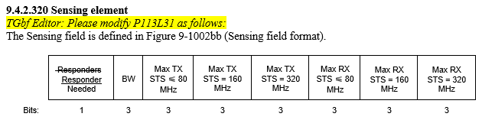

Modifications: TGbf Editor – Implement the changes defined in https://mentor.ieee.org/802.11/dcn/23/11-23-0476-03-00bf-lb272-ost-misc.docx
(Note: No further modifications are required.)

CID | Clause | Page | Comment | Proposed change
2224 | 11.55.1.5.2.3 | 180.53 | The sentence lacks a verb. Suggest to revise the sentence: "Specifically, the time that the first data symbol of the PSDU of the frame was transmitted to the PHY plus the AP's delays through its local PHY from the MAC-PHY interface to its interface with the WM." | As in the comment

Proposed resolution: Revised

Discussion: Text referred to by the commenters is:
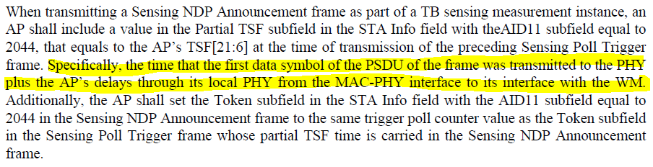

Modifications: TGbf Editor – Replace 180.53-54 with:

Specifically, the AP’s TSF[21:6] shall be set to the time that the first data symbol of the PSDU of the frame was transmitted to the PHY plus the AP’s delays through its local PHY from the MAC-PHY interface to its interface with the WM.

(Note: Given that the baseline already includes normative text on the TSF, it may be appropriate to convert this sentence to a note.)

CID | Clause | Page | Comment | Proposed change
1480 | 9.6.21.15 | 163.55 | I wonder if this sentence could be reworded a bit to be more clear: "The Terminate All SBP Coordinated Monostatic Setups subfield is set to 1 to indicate that the STA requests to terminate using under SBP all sensing measurement setups of the sensing type Coordinated Monostatic; otherwise, it is set to 0." | consider changing to: "The Terminate All SBP Coordinated Monostatic Setups subfield is set to 1 to indicate that the STA requests to terminate all SBP sensing measurement setups of the sensing type Coordinated Monostatic; otherwise, it is set to 0."

Proposed resolution: Revised

Discussion: Text referred to by the commenters is:

Modifications: TGbf Editor – Replace 177.63 with:

The Terminate All SBP Coordinated Monostatic Setups subfield is set to 1 to indicate that the STA requests to terminate all sensing measurement setups established in response to a DMG SBP procedure request of the sensing type Coordinated Monostatic; otherwise, it is set to 0.

CID | Clause | Page | Comment | Proposed change
1126 | 11.55.1.5.2.1 | 177.63 | Suggestion to improve writing | Replace "STA3 does not respond... instance" with "Since STA3 did not respond to the polling, it does not participate in the remaining phases of the TB sensing measurement instance."

Proposed resolution: Revised

Discussion: Text referred to by the commenters is:

Modifications: TGbf Editor – Replace 177.63 with:
Since STA3 did not respond to the polling, it does not participate in the TB sensing measurement exchange.

CID | Clause | Page | Comment | Proposed change
1081 | 9.4.2.36 | 107.27 | Suggested editorial changes | The Sensing field is set to 1 to indicate that the AP represented by this BSSID has the WLAN Sensing field within the Extended Capabilities element set to 1. The Sensing field is set to 0 to indicate that the reported AP has the WLAN Sensing field within the Extended Capabilities element set to 0, or that the WLAN Sensing field of the reported AP is not available to the reporting AP.

Proposed resolution: Revised

Discussion: Text referred to by the commenters is:
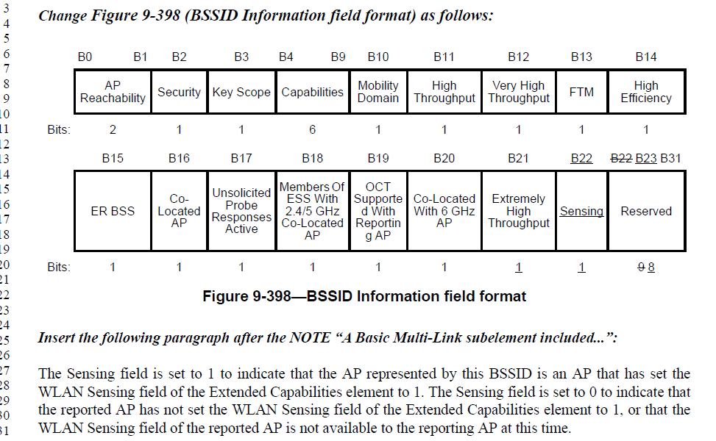

Modifications: TGbf Editor – Replace 107.27-31 with:

The Sensing field is set to 1 if the AP identified by this BSSID is a sensing STA. The Sensing field is set to 0 if the AP identified by this BSSID is not a sensing STA or if information about its support of the WLAN sensing procedure is not available.

