IEEE P802.11
Wireless LANs
LB 271 CIDs on Coexistence Assurance document
Date: 2023-04-24
Author(s):
Name | Affiliation | Address | Phone | email
Sigurd Schelstraete | MaxLinear |  |  | sschelstraete@maxlinear.com
Abstract
This document proposes a resolution for CID 18060.

This particular CID is on the Coexistence Assurance document accompanying the 802.11be amendment, not on the Amendment itself.

This is the only comment received on the Coexistence Assurance document.

Introduction

One comment (CID 18060) was received on the TGbe Coexistence Assessment Document [1].
This contribution proposes a resolution for CID 18060.
An updated version of the TGbe Coexistence Assessment Document will be created once the changes proposed here are approved.

CID and discussion

CID | Must Be Satisfied | Clause | Page | Comment | Proposed Change | Resolution
18060 | No | 9.1 | 5.04 | Comment - for CoEx Assessment doc: 706r7. PSD mask is specified for 320 MHz in 6 GHz and other channel bandwidths 20/40/80/160 MHz as well under FCC 6 GHz rules. Adding a general NOTE is sufficient. | As commented for CoEx doc: 706r7 | REVISED  Revise 11/22-0706r7 [1] by adding NOTE at the end of section 9.1:  NOTE: PSD Masks for 20 to 160 MHz bandwidth in 6 GHz are defined in [4].

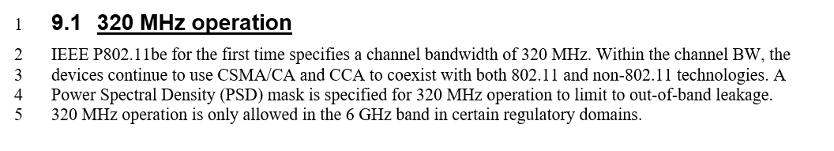

Instructions to the Editor:

Change Clause 9.1 as follows:

320 MHz operation
IEEE P802.11be for the first time specifies a channel bandwidth of 320 MHz. Within the channel BW, the devices continue to use CSMA/CA and CCA to coexist with both 802.11 and non-802.11 technologies. A Power Spectral Density (PSD) mask is specified for 320 MHz operation to limit to out-of-band leakage.
320 MHz operation is only allowed in the 6 GHz band in certain regulatory domains.

NOTE: PSD Masks for 20 to 160 MHz bandwidth in 6 GHz are defined in [4].

Additional Changes

The TGbe Coexistence Assessment Document [1] currently references IEEE P802.11be D2.0.
Although there is no CID associated with this, we proposed to update the reference to IEEE P802.11be D3.0.

I.e.: make the following changes to the References section of [1]

References

[1] IEEE P802.11be D32.0

References
[1] TGbe Coexistence Assessment Document, 802.11-21/0706r7, https://mentor.ieee.org/802.11/dcn/21/11-21-0706-07-00be-tgbe-coexistence-assessment-document.docx

