IEEE P802.11
Wireless LANs
LB271 CID 17146
Date: 2023-04-24
Author(s):
Name | Affiliation | Address | Phone | email
Sigurd Schelstraete | MaxLinear |  |  | sschelstraete@maxlinear.com
Abstract
This submission proposes a resolution for CID 17146.

CIDs

CID | Must Be Satisfied | Clause | Page | Comment | Proposed Change | Resolution
17146 | Yes | B.4.40.1 | 933.28 | MRU is used in numerous instances, whereas M-RU is used only three instances. | Change instances of M-RU to MRU. | REVISED  Change “M-RU” to “MRU” in the following places:  D3.0, P275L56  D3.0, P284L25  D3.0, P933L28  NOTE: this resolution is covered by the proposed resolution of CIDs 17144 and 17145 in 11-23/0682r1

Discussion

Although the comment is made on Annex B, the use of “M-RU” is found in three places in the draft D3.0:

On page 275, Line 56:

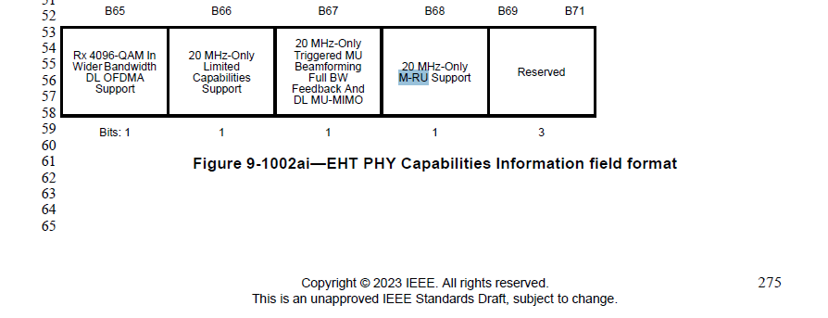

On Page 284, Line 25:
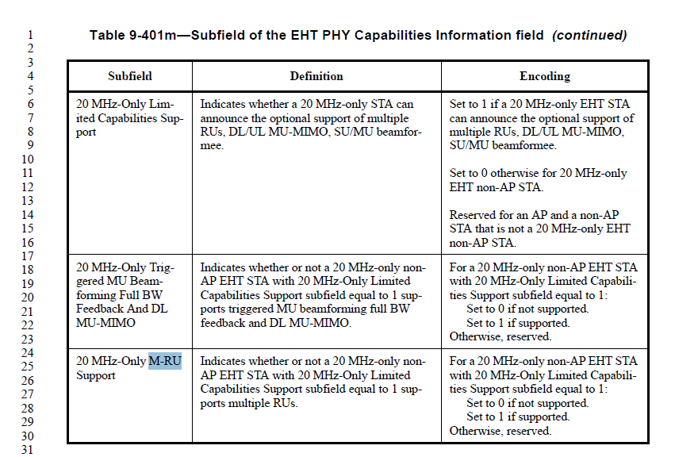

On Page 933, Line 28

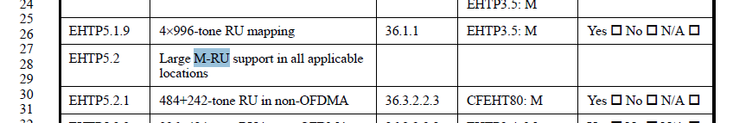

Commenter is correct that the preferred term is “MRU” instead of “M-RU”.
The proposed resolution changes all occurrences of “M-RU” to “MRU”.

