IEEE P802.11
Wireless LANs
LB271 CR for 36.3.7 Overview of the PPDU encoding process
Date: 2023.04.10
Author(s):
Name | Company | Address | Phone | email
Bo Gong | Huawei Technologies | H3, Huawei Base, Bantian, Longgang, Shenzhen, Guangdong, China, 518129 |  | gongbo8@huawei.com
Jian Yu |  |  |  | ross.yujian@huawei.com
Abstract
This submission contains proposed comment resolutions to comments on P802.11be D3.0.
The changes are based on P802.11be D3.0.

This submission provides a resolution to the following CIDs:
- 15768 15769 15770 17929 17930

Revisions:
- Rev 0: Initial version of the document.

CID 15768
Page.  Line | Clause Number | Comment | Proposed Change | Resolution
737.48 | 36.3.7.2 | Preamble puncturing should be considered. So "each 20MHz subchannel" should be changed with " each occupied 20MHz subchannel" | As in comment | Accepted.

Discussion:

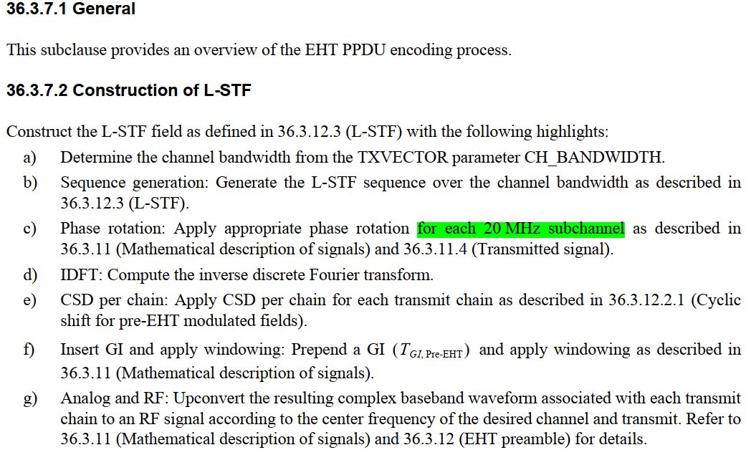

CID 15769
Page.  Line | Clause Number | Comment | Proposed Change | Resolution
738.09 | 36.3.7.3 | Preamble puncturing should be considered. So "each 20MHz subchannel" should be changed with " each occupied 20MHz subchannel" | As in comment | Accepted.

Discussion:
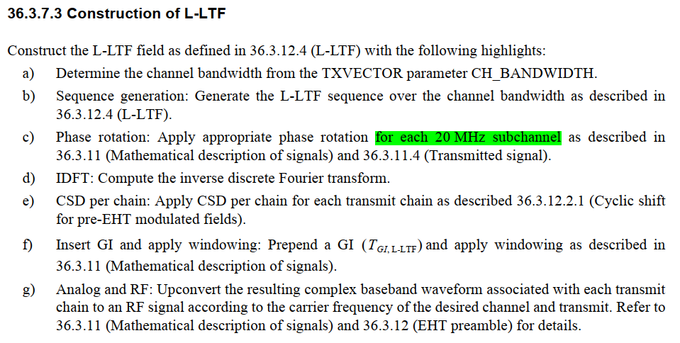

CID 15770
Page.  Line | Clause Number | Comment | Proposed Change | Resolution
740.33 | 36.3.7.7 | Preamble puncturing should be considered. So "each 20MHz subchannel" should be changed with " each occupied 20MHz subchannel" | As in comment | Accepted.

Discussion:

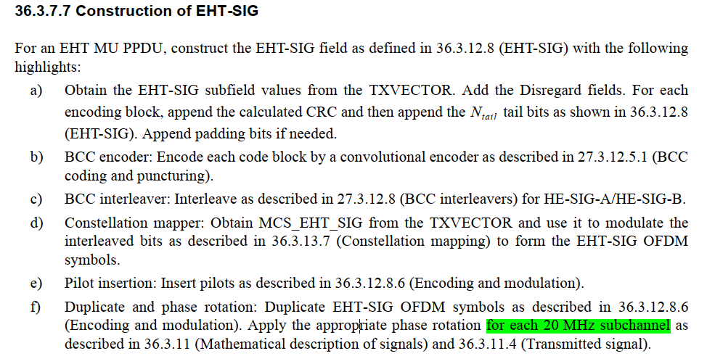

CID 17929
Page.  Line | Clause Number | Comment | Proposed Change | Resolution
737.45 | 36.3.7.2 | This sentence mentions that the L-STF sequence generation is described in subclause 36.3.12.3 (L-STF). But subclause 36.3.12.3 (L-STF) is about the time-domain representation, not the frequency-domain sequence. | Changing "36.3.12.3 (L-STF)" to "21.3.8.2.2 (L-STF definition)". | Rejected.  The sequence generation is described in Line 9, Page 760 in subclause 36.3.12.3 of TGbe Draft D3.0.

Discussion:

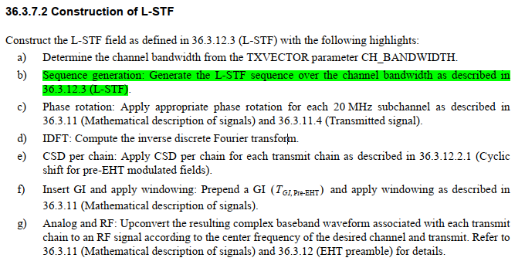
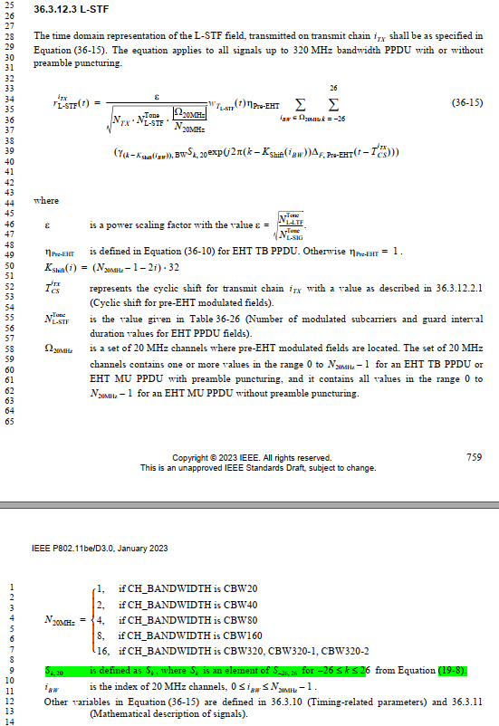

CID 17930
Page.  Line | Clause Number | Comment | Proposed Change | Resolution
738.06 | 36.3.7.3 | This sentence mentions that the L-LTF sequence generation is described in subclause 36.3.12.4 (L-LTF). But subclause 36.3.12.4 (L-LTF) is about the time-domain representation, not the frequency-domain sequence. | Changing "36.3.12.4 (L-LTF)" to "21.3.8.2.3 (L-LTF definition)". | Rejected.  The sequence generation is described in Line 48, Page 760 in subclause 36.3.12.4 of TGbe Draft D3.0.

Discussion:

