IEEE P802.11
Wireless LANs
LB271 CR for 36.2.6 Support for non-HT, HT, VHT, and HE formats
Date: 2023.04.18
Author(s):
Name | Company | Address | Phone | email
Bo Gong | Huawei Technologies | H3, Huawei Base, Bantian, Longgang, Shenzhen, Guangdong, China, 518129 |  | gongbo8@huawei.com
Jian Yu |  |  |  | ross.yujian@huawei.com
Abstract
This submission contains proposed comment resolutions to comments on P802.11be D3.0.
The changes are based on P802.11be D3.0.

This submission provides a resolution to the following CIDs:
- 15023, 15072, 17182, 17183

Revisions:
- Rev 0: Initial version of the document.

CID 15023
Page.  Line | Clause Number | Comment | Proposed Change | Resolution
687.19 | 36.2.6.1 | "20"MHz is missing in the figure. (in clause 19 and 21 boxes) | add "20"MHz channel width | Revised.  Instructions to the editor:  Please add “20” between “on” and “MHz” in the boxes of clause 19 and 21 in Figure 36-1 in Line 19, Page 687 in TGbe Draft D3.0.

Discussions:

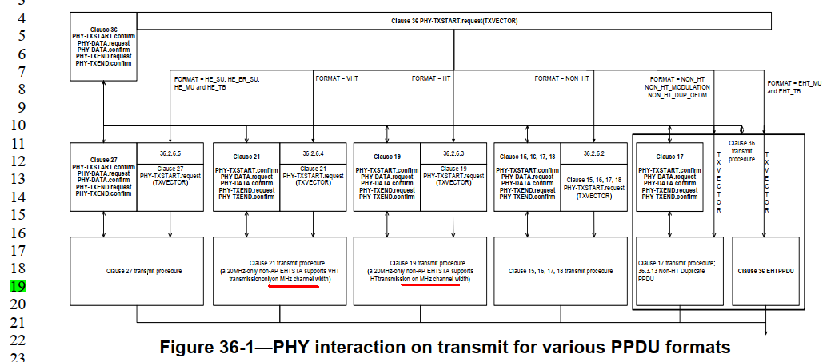

CID 15072
Page.  Line | Clause Number | Comment | Proposed Change | Resolution
691.10 | 36.2.6.4 | Text missing on "without the PHYCONFIG_VECTOR DISABLED_SUBCHANNEL_BITMAP" | without the PHYCONFIG_VECTOR parameter DISABLED_SUBCHANNEL_BITMAP | Revised.  Agreed in principle. Reflect the detailed explanation.  Instructions to the editor:  Please make the changes as shown in 11/23-0686r0 under CID 17182.  Note that the resolutions for CID 15072 and CID 17182 are the same.

CID 17182
Page.  Line | Clause Number | Comment | Proposed Change | Resolution
691.08 | 36.2.6.4 | First bullet doesn't read right: except that without (...) | Change first bullet to "the PHYCONFIG_VECTOR DISABLED_SUBCHANNEL_BITMAP is ignored" | Revised.  Agreed in principle. Reflect the detailed explanation.  Instructions to the editor:  Please make the changes as shown in 11/23-0686r0 under CID 17182.  Note that the resolutions for CID 15072 and CID 17182 are the same.

Instructions to the Editor:

Please make the following changes in Line 10, Page 691 in TGbe Draft D3.0:

On receipt of a PHY-CONFIG.request(PHYCONFIG_VECTOR) primitive, the EHT PHY behaves, for the
purposes of VHT PPDU transmission and reception, as if it were a Clause 21 (Very High Throughput (VHT)
PHY specification) PHY that received the PHY-CONFIG.request(PHYCONFIG_VECTOR) primitive
except that:
— the PHYCONFIG_VECTOR parameter DISABLED_SUBCHANNEL_BITMAP is ignored
— the CHANNEL_WIDTH parameter, if it is equal to 320 MHz, is replaced by 160 MHz
— the CENTER_FREQUENCY_SEGMENT_0 parameter, if the CHANNEL_WIDTH parameter is
equal to 320MHz, is replaced by the center of the primary 160 MHz channel.

CID 17183
Page.  Line | Clause Number | Comment | Proposed Change | Resolution
691.43 | 36.2.6.4 | First bullet doesn't read right: except that without (...) | Change first bullet to "the PHYCONFIG_VECTOR DISABLED_SUBCHANNEL_BITMAP is ignored" | Revised.  Agreed in principle. Reflect the detailed explanation.  Instructions to the editor:  Please make the changes as shown in 11/23-0686r0 under CID 17183.

Instructions to the Editor:

Please make the following changes in Line 45, Page 691 in TGbe Draft D3.0:

On receipt of a PHY-CONFIG.request(PHYCONFIG_VECTOR) primitive, the EHT PHY behaves, for the
purposes of HE PPDU transmission and reception, as if it were a Clause 27 (High Efficiency (HE) PHY
specification) PHY that received the PHY-CONFIG.request(PHYCONFIG_VECTOR) primitive except
that:
— the PHYCONFIG_VECTOR parameter DISABLED_SUBCHANNEL_BITMAP is ignored
— the CHANNEL_WIDTH parameter, if it is equal to 320 MHz, is replaced by 160 MHz
— the CENTER_FREQUENCY_SEGMENT_0 parameter, if the CHANNEL_WIDTH parameter is
equal to 320 MHz, is replaced by the center of the primary 160 MHz channel.

