IEEE P802.11
Wireless LANs
LB 271 comment resolutions for CRs in 9.4.2.313.3
Date: 2023-03-13
Author(s):
Name | Affiliation | Address | Phone | email
Kanke Wu | Qualcomm Inc |  |  | kankew@qti.qualcomm.com
Bin Tian | Qualcomm Inc

Abstract
This submission proposes resolutions for the following comments from LB271 in P802.11be D3.0:
17685, 17144, 17145, 17686, 17687, 17688, 16394, 17689, 17690, 17691
17692, 17693, 17694, 17695, 17696, 17698, 17699, 17770, 17167, 15294
15295, 17701, 17702, 15296, 15297, 17703, 15212, 15246, 17706, 15298
17707, 15299, 17709, 15760, 17710, 16157, 15300, 15761, 15213, 17711
17712, 17713, 17968, 17714, 17697, 17705, 17708, 17801, 17715, 16158
16159, 16160

This proposed text changes in this document are based on TGbe Draft 3.0

Revisions:

- Rev 0: Initial version of the document.

CID 17685
CID | Clause | Page.Line | Comment | Proposed Change | Resolutions
17685 | 9.4.2.313.2 | 275.08 | Rogue "Bits" at end of row | Delete second "Bits:" | Accepted

  - Background
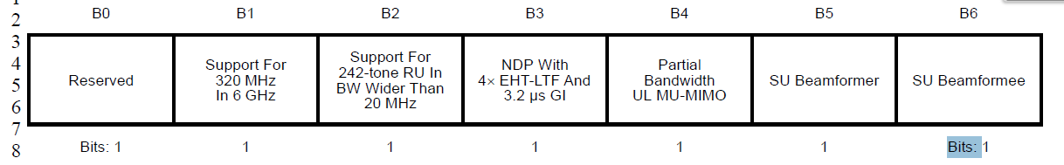

CID 17144, 17145
CID | Clause | Page.Line | Comment | Proposed Change | Resolutions
17144 | 9.4.2.313.2 | 275.53 | MRU is used in numerous instances, whereas M-RU is used only three instances. | Change instances of M-RU to MRU. | Accepted  Note to the editor: The other two other occurrences are at  P284L25  P933L28
17145 | 9.4.2.313.3 | 284.25 | MRU is used in numerous instances, whereas M-RU is used only three instances. | Change instances of M-RU to MRU. | Accepted

  - Background
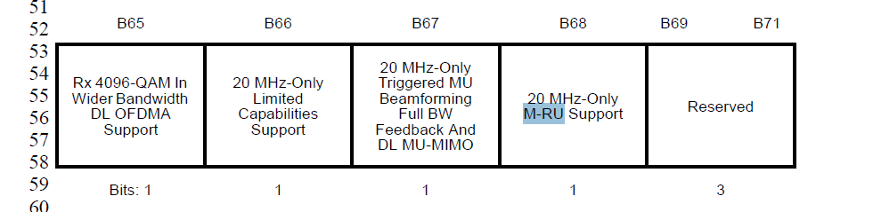

CID 17686
CID | Clause | Page.Line | Comment | Proposed Change | Resolutions
17686 | 9.4.2.313.2 | 276.16 | Missing article | Try "For a beamformee, indicates support for receiving an EHT sounding NDP with *a* 4x EHT-LTF and *a* 3.2 Âµs guard interval duration". Similar article insertion at P278L62 | Revised.  Agree with the commenter. Also need to implement similar change at P278L62 as suggested.  Instruction to the editor:  Please change the second column at P276L16 to the following:  For a beamformee, indicates support for receiving an EHT sounding NDP with a 4x EHT-LTF and a 3.2 µs guard interval duration.  Please change the second column at P278L62 to the following:  Indicates support for the reception of an EHT MU PPDU with a 4x EHT-LTF and a 0.8 μs guard interval duration.

  - Background
P276
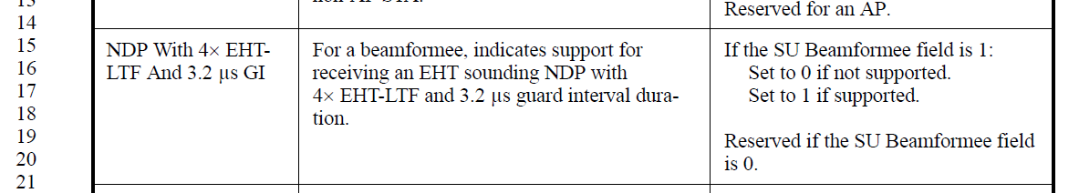
P278
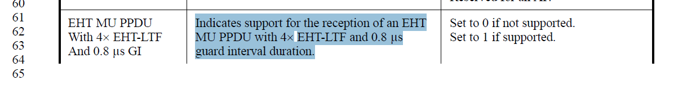

CID 17687
CID | Clause | Page.Line | Comment | Proposed Change | Resolutions
17687 | 9.4.2.313.2 | 276.36 | NOTEs like these are dangerous at best and misleading at worst: they imply a mandatory behavior without using normative language | Include, in the note, a xref to the normative language implied by the note. Add normative language in the appropriate section if missing. | Revised  Agree with the commenter to add cross reference in the note.  Instruction to the editor:  Please make the changes in D3.0 as indicated in 23/0682r2

  - Background
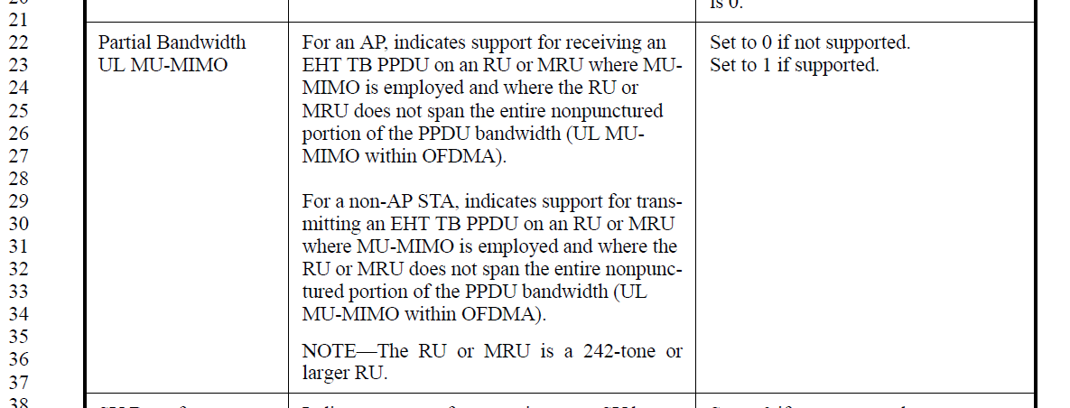

Instruction to the editor:
Please make the indicated modifications at P276L36 as follows:
Partial Bandwidth UL MU-MIMO | For an AP, indicates support for receiving an EHT TB PPDU on an RU or MRU where MU-MIMO is employed and where the RU or MRU does not span the entire nonpunctured portion of the PPDU bandwidth (UL MU-MIMO within OFDMA).  For a non-AP STA, indicates support for transmitting an EHT TB PPDU on an RU or MRU where MU-MIMO is employed and where the RU or MRU does not span the entire nonpunctured portion of the PPDU bandwidth (UL MU-MIMO within OFDMA).  NOTE—The RU or MRU is a 242-tone or larger RU (36.3.3.2.2 Supported RU or MRU sizes in UL MU-MIMO). | Set to 0 if not supported.  Set to 1 if supported.

CID 17688, 16394
CID | Clause | Page.Line | Comment | Proposed Change | Resolutions
17688 | 9.4.2.313.2 | 276.41 | NOTEs like these are dangerous at best and misleading at worst: they imply a mandatory behavior without using normative language | Include, in the note, a xref to the normative language implied by the note. Add normative language in the appropriate section if missing. | Revised  Agree with the commenter to add cross reference in the note.  Instruction to the editor:  Please make the changes in D3.0 as indicated in 23/0682r2
16394 | 9.4.2.313.2 | 276.41 | In Table 9-401m, shouldn't an "or" be used in the NOTE related to "SU Beamformer" instead of an "and"? Note shoudl read: "NOTE--Set to 1 if any of the following subfields, MU Beamformer (BW â‰¤ 80 MHz), MU Beamformer (BW = 160 MHz), or MU Beamformer (BW = 320 MHz), is 1" | As in comment | Accepted.

  - Background
  - P276
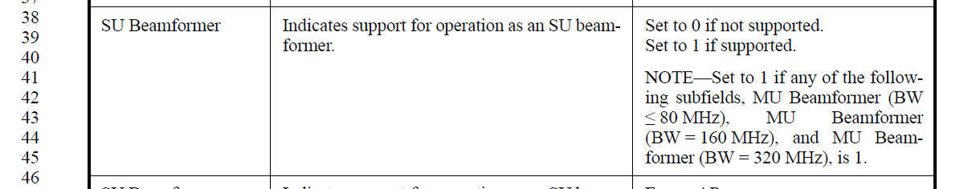

Instruction to the editor:
Please make the indicated modifications at P276L41 as follows:
SU Beamformer | Indicates support for operation as an SU beamformer. | Set to 0 if not supported.  Set to 1 if supported.  NOTE—Set to 1 if any of the following subfields, MU Beamformer (BW ≤ 80 MHz), MU Beamformer (BW = 160 MHz), or MU Beamformer (BW = 320 MHz), is 1( 35.7.2 EHT sounding protocol).

CID 17689, 17690, 17691, 17692, 17693
CID | Clause | Page.Line | Comment | Proposed Change | Resolutions
17689 | 9.4.2.313.3 | 277.10 | I have much sympathy for trying to insert the "which ..." subclause but this is clearly not part of the definition | Convert this to a note and include a xref to where this requirement is defined. Ditto P277L19/29 | Revised  The description of this subfield is rephrased to separate the two use cases.  Instruction to the editor:  Please make the changes in D3.0 as indicated in 23/0682r2
17690 | 9.4.2.313.3 | 277.11 | Spurious article. Also some opportunities to improve since “on an RU or MRU is very disconnected from “over all users”. | Try “which is also the maximum total number of spatial streams, summed over all users in an RU or MRU, that can be sent in a DL MU-MIMO transmission where the RU or MRU includes the STA and might or might not span the entire PPDU bandwidth.”. Ditto at L19 and L29 | Accepted
17691 | 9.4.2.313.3 | 277.21 | What happens if a STA is a SU Bfee but is a 20 MHz-only STA so doesn’t support 40 or 80 MHz? | The encoding should be explicit how 20M-only STAs should populate this aka what meaning should the recipient glean from this field. Ditto similar “<=80MHz” fields e.g. at P277L37 (but P281L42 is good) | Rejected  20MHz operating STAs (including 20MHz-only STAs) are mandatory to support RUs in the primary 20 MHz channel within 40 MHz PPDU in the 2.4 GHz band, and 40 MHz, 80 MHz, and 160 MHz PPDU in the 5 GHz and 6 GHz bands, and 320 MHz PPDU in the 6 GHz band. (P663L35). According to the definition of this field, the BW referred to here are PPDU bandwidths. So it has included instructions on how to set this field for 20MHz-only STA that set SU Bfee subfield to 1.
17692 | 9.4.2.313.3 | 277.21 | What happens if a STA is a SU Bfee but doesn’t support 160 MHz – since apparently the minimum value of this field is 3!? | “If “ condition should include support for 160M. | Rejected  Similar to CID17691, support in the primary 80MHz/20MHz in a 160MHz PPDU is mandatory feature. The BW referred to here are PPDU bandwidths and SU Bfee shall support reception of160MHz NDP, EHT MU PPDU, and EHT TB PPDU in the primary 20MHz/80MHz
17693 | 9.4.2.313.3 | 277.31 | What happens if a STA is a SU Bfee but doesn’t support 320 Mhz – since apparently the minimum value of this field is 3!? | “ | Rejected  Similar to CID17691, support in the primary 160MHz/80MHz/20MHz in a 320MHz PPDU is mandatory feature. The BW referred to here are PPDU bandwidths and SU BFee shall support reception of 320MHz NDP, EHT MU PPDU, and EHT TB PPDU in the primary 20MHz/80MHz/160MHz.

  - Background
  - P277
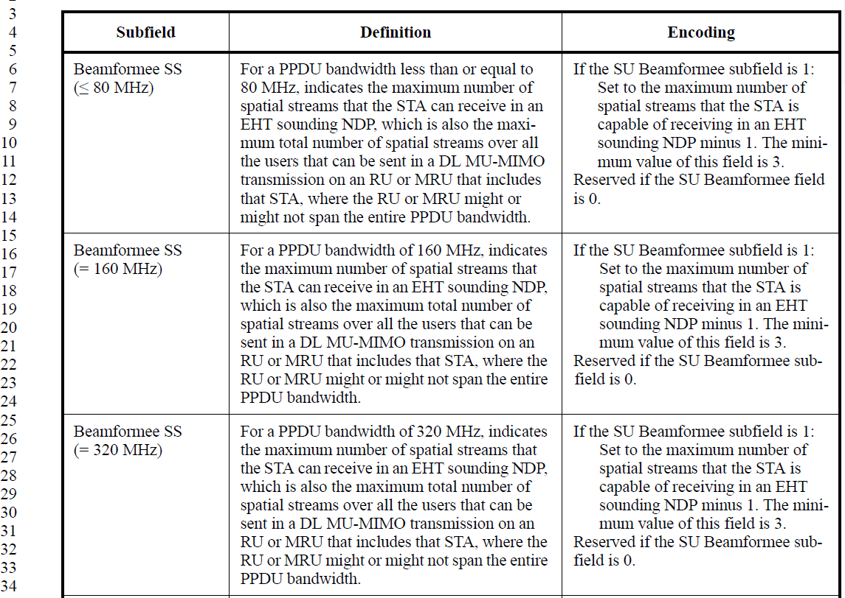

Instruction to the editor:
Please make the indicated modifications as follows:
Beamformee SS (≤ 80 MHz) | For a PPDU bandwidth less than or equal to 80 MHz, indicates:  - The maximum number of spatial streams that the STA can receive in an EHT sounding NDP, and  - If the STA supports MU beamformee, the maximum total number of spatial streams, summed over all users on an RU or MRU, that can be sent in a DL MU-MIMO transmission where the RU or MRU includes that STA and might or might not span the entire PPDU bandwidth. | If the SU Beamformee subfield is 1:  Set to the maximum number of spatial streams described in the definition minus 1. The minimum value of this field is 3.  Reserved if the SU Beamformee field is 0.
Beamformee SS (= 160 MHz) | For a PPDU bandwidth of 160 MHz, indicates:  - The maximum number of spatial streams that the STA can receive in an EHT sounding NDP, and  - If the STA supports MU beamformee, the maximum total number of spatial streams, summed over all users on an RU or MRU, that can be sent in a DL MU-MIMO transmission where the RU or MRU includes that STA and might or might not span the entire PPDU bandwidth. | If the SU Beamformee subfield is 1:  Set to the maximum number of spatial streams described in the definition minus 1. The minimum value of this field is 3.  Reserved if the SU Beamformee subfield is 0.
Beamformee SS (= 320 MHz) | For a PPDU bandwidth of 320 MHz, indicates:  - The maximum number of spatial streams that the STA can receive in an EHT sounding NDP, and.  - If the STA supports MU beamformee, the maximum total number of spatial streams, summed over all users on an RU or MRU, that can be sent in a DL MU-MIMO transmission where the RU or MRU includes that STA and might or might not span the entire PPDU bandwidth. | If the SU Beamformee subfield is 1:  Set to the maximum number of spatial streams described in the definition minus 1. The minimum value of this field is 3.  Reserved if

CID 17694
CID | Clause | Page.Line | Comment | Proposed Change | Resolutions
17694 | 9.4.2.313.3 | 277.31 | Probably unintendedly ambiguous antecedent (it => "80 MHz") | Other rows just omit "it", which works. Ditto L42, L51, | Accepted  Note to the editor:  The first location is at L35 instead of 31

  - Background
  - P277
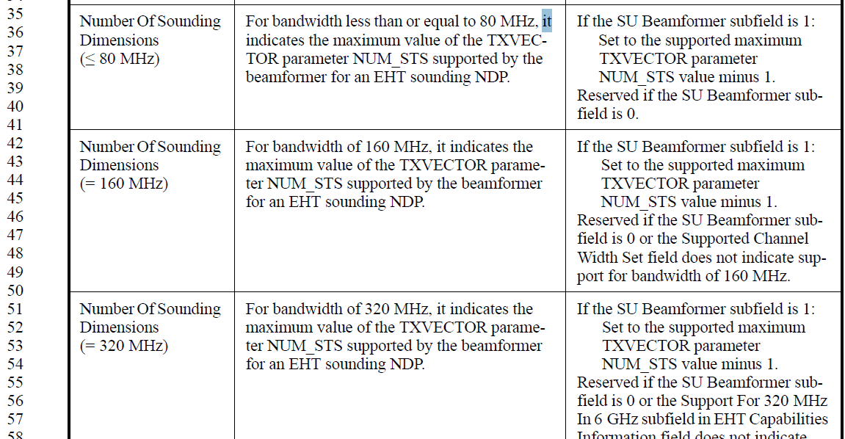

CID 17695
CID | Clause | Page.Line | Comment | Proposed Change | Resolutions
17695 | 9.4.2.313.3 | 277.49 | "for bandwidth of" is missing an article | Try "for a 160 MHz bandwidth" or "for a bandwidth of 160 MHz". Ditto L59 | Revised.  Agree with the commenter.  Instruction to the editor:  Change the last sentence in the 3rd column at P277L49 to “Reserved if the SU Beamformer subfield is 0 or the Supported Channel Width Set field does not indicate support for a bandwidth of 160 MHz.”  Change the last sentence in the 3rd column at P277 L57 to “Reserved if the SU Beamformer subfield is 0 or the Support For 320 MHz In 6 GHz subfield in EHT Capabilities Information field does not indicate support for a bandwidth of 320 MHz.”

  - Background
  - P277
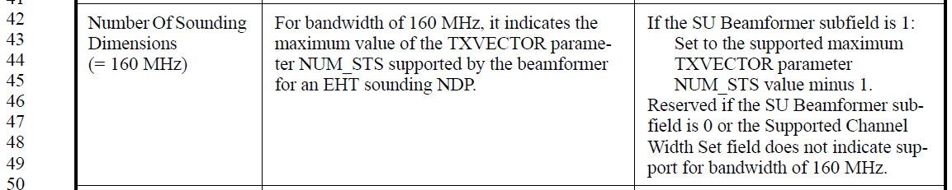

CID 17696
CID | Clause | Page.Line | Comment | Proposed Change | Resolutions
17696 | 9.4.2.313.3 | 277.61 | "Indicates EHT beamformee support" is problematic: this phrasing means that the field should be reserved for an EHT STA that is not a EHT Bfee and/or this phrasing should be reworded. Also "EHT Bfee" is defined in 35.7.2 so provide a xref. | 1) Provide a definition of an EHT BFee. 2) Try "Indicates support as an EHT Beamformee for ..." then ... "Reserved if the EHT STA is not an EHT beamformee (see 35.7.2)." Ditto P280L6/10/15. | Revised  Agree with the commenter’s suggested change.  Instruction to the editor:  Please make the changes in D3.0 as indicated in 23/0682r2

  - Background
  - P277
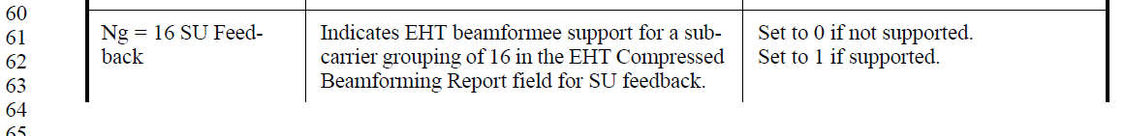
Instruction to the editor:
Please make the indicated modifications as follows:
Ng = 16 SU Feedback | Indicates support as an EHT beamformee for a subcarrier grouping of 16 in the EHT Compressed Beamforming Report field for SU feedback, as described in 35.7.2. | Set to 0 if not supported.  Set to 1 if supported.  Reserved if the EHT STA is not an EHT Beamformee
Ng = 16 MU Feedback | Indicates support as an EHT beamformee for a subcarrier grouping of 16 in the EHT Compressed Beamforming Report field for MU feedback, as described in 35.7.2. | Set to 0 if not supported.  Set to 1 if supported.  Reserved if the EHT STA is not an EHT Beamformee
Codebook Size SU Feedback | Indicates support as an EHT beamformee for a codebook size in the EHT Compressed Beamforming Report field for SU feedback, as described in 35.7.2. | Set to 0 if not supported.  Set to 1 if supported.  Reserved if the EHT STA is not an EHT Beamformee
Codebook Size MU Feedback | Indicates support as an EHT beamformee for a codebook size in the EHT Compressed Beamforming Report field for MU feedback, as described in 35.7.2. | Set to 0 if not supported.  Set to 1 if supported.  Reserved if the EHT STA is not an EHT Beamformee

CID 17698
CID | Clause | Page.Line | Comment | Proposed Change | Resolutions
17698 | 9.4.2.313.3 | 278.26 | In other rows in this element, if the meaning of the field differs by role (e.g. AP / not), then the role-related aspects appear in both the Definition and Encoding columns. See e.g., p272. | Probbably needed for "Triggered MU Beamforming Partial BW Feedback". Worth a look at L20 and L41 too | Rejected  Although the description of this subfield is slightly different on the AP and non-AP side, the function of this field is the same on both sides. The description is different because APs are the receivers of an EHT TB PPDU while non-AP STAs are transmitters of such PPDUs.  Other subfields in this section also doesn’t separate the encoding into different cases when the function is the same on both sides (see Partial Bandwidth UL MU-MIMO on page 276).

  - Background
  - P278
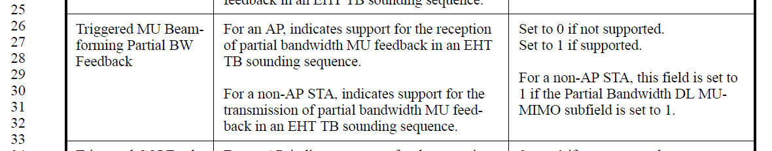
  - P276
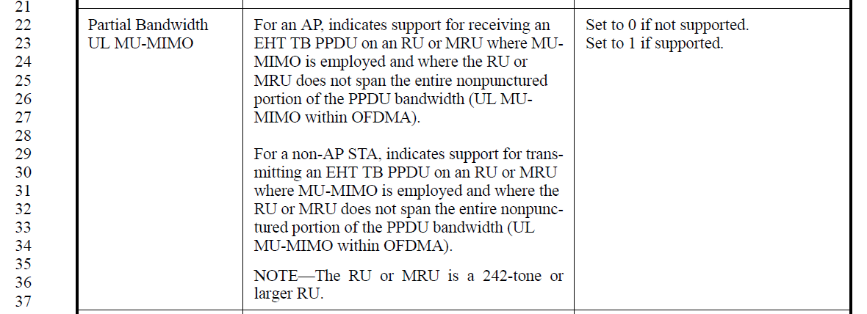

CID 17699, 17770, 17167
CID | Clause | Page.Line | Comment | Proposed Change | Resolutions
17699 | 9.4.2.313.3 | 278.45 | NOTEs like these are dangerous at best and misleading at worst: they imply a mandatory behavior without using normative language | Include, in the note, a xref to the normative language implied by the note. Add normative language in the appropriate section if missing. | Revised  A reference has been added.  Instruction to the editor:  Please make the changes in D3.0 as indicated in 23/0682r2
17770 | 9.4.2.313.3 | 278.45 | "A or B" is singular | Try "one or more other RU(s) or MRU(s) are employing DL MU-MIMO" | Accepted
17167 | 9.4.2.313.3 | 278.45 | "partial bandwidth RU or MRU" is an undefined term. | Change the NOTE to "A non-AP STA that sets this field to 0 supports receiving an RU or an MRU that is allocated to a single user and whose bandwidth is narrower than the EHT MU PPDU bandwidth, in which some other RU(s) or MRU(s) are employing DL MU-MIMO." | Revised  The edit suggested by CID17770 has been accepted. It resolves the same issue with slightly different language  Instruction to the editor:  Please make the changes in D3.0 as indicated in 23/0682r2

  - Background
  - P278
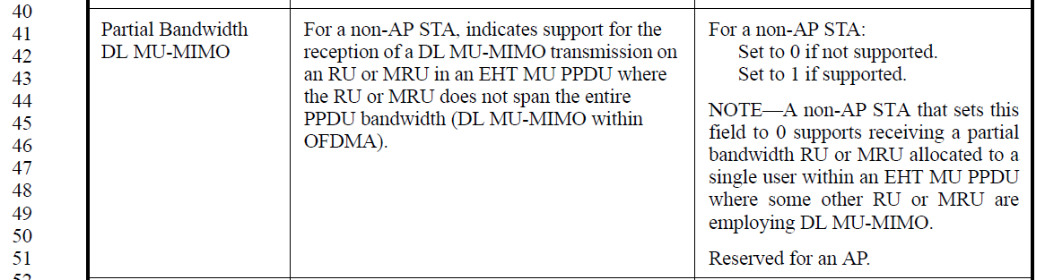

Instruction to the editor:
Please make the indicated modifications as follows:
Partial Bandwidth DL MU-MIMO | For a non-AP STA, indicates support for the reception of a DL MU-MIMO transmission on an RU or MRU in an EHT MU PPDU where the RU or MRU does not span the entire PPDU bandwidth (DL MU-MIMO within OFDMA). | For a non-AP STA:  Set to 0 if not supported.  Set to 1 if supported.  NOTE—A non-AP STA that sets this field to 0 supports receiving a partial bandwidth RU or MRU allocated to a single user within an EHT MU PPDU where one or more other RU(s) or MRU(s) are employing DL MU-MIMO (36.1.1).  Reserved for an AP.

CID 15294, 15295, 17701, 17702, 15296, 15297
CID | Clause | Page.Line | Comment | Proposed Change | Resolutions
15294 | 9.4.2.313.3 | 279.21 | The definition of "Tx 1024-QAM And 4096-QAM < 242-tone RU Support"is not clear. How about only support 1024-QAM but not 4096-QAM? | Clarify. And change to "Set to 0 if transmitting of 1024-QAM and 4096-QAM is not supported for RUs or MRUS smaller than 242 tones. Set to 1 if transmitting of 1024-QAM and 4096-QAM is the same as ..." | Revised  Agree with the commenter to add description about 1024-QAM and 4096-QAM transmission. However, when this field is set to 1, the Rx capability for RU/MRU<242-tone is the same as indicated in the respective EHT-MCS MAP subfield. The case mentioned here (support 1024 QAM but not 4096 QAM) will be indicated through the EHT-MCS MAP subfield.  Instruction to the editor:  Please make the changes in D3.0 as indicated in 23/0682r2
15295 | 9.4.2.313.3 | 279.21 | The "Tx EHT-MCS MAP" subfield is never defined in the spec. Instead, only "EHT-MCS MAP" subfield is defined in "Supported EHT-MCS And NSS Set" field. | Define the "Tx EHT-MCS MAP" subfield and clarify where this subfield is defined when it's referred. | Revised  The subfield referred here is the “Tx Max Nss That Supports MCS x-y” subfields in the “EHT-MCS MAP” subfield. There’s no need to define new subfields, however the description should be rewritten refer to the correct subfields.  Instruction to the editor:  Please make the changes in D3.0 as indicated in 23/0682r2
17701 | 9.4.2.313.3 | 279.24 | Spurious comma | Change ", is" to "is". Ditto P278L40 | Accepted
17702 | 9.4.2.313.3 | 279.24 | Mising sense of "on transmit" | Try "Set to 0 if 1024-QAM and 4096- QAM are not supported *on transmit* for RUs or MRUs smaller than 242 tones." Ditto "on receive" at P278L39 | Revised  Agree with the commenter. The text is updated to reflect this.  Instruction to the editor:  Please make the changes in D3.0 as indicated in 23/0682r2
15296 | 9.4.2.313.3 | 279.38 | The definition of "Rx 1024-QAM And 4096-QAM < 242-tone RU Support"is not clear. How about only support 1024-QAM receiving but not 4096-QAM receiving? | Clarify. And change to "Set to 0 if receiption of 1024-QAM and 4096-QAM is not supported for RUs or MRUS smaller than 242 tones. Set to 1 if receiption of 1024-QAM and 4096-QAM is the same as ..." | Revised  Agree with the commenter to add description about 1024-QAM and 4096-QAM receiving. However, when this field is set to 1, the Rx capability for RU/MRU<242-tone is the same as indicated in the respective EHT-MCS MAP subfield. The case mentioned here (support 1024 QAM but not 4096 QAM) will be indicated through the EHT-MCS MAP subfield.  Instruction to the editor:  Please make the changes in D3.0 as indicated in 23/0682r2
15297 | 9.4.2.313.3 | 279.38 | The "Rx EHT-MCS MAP" subfield is never defined in the spec. Instead, only "EHT-MCS MAP" subfield is defined in "Supported EHT-MCS And NSS Set" field. The same issue appears with "Rx 1024-QAM In Wider Bandwidth DL OFDMA Support" subfield and "Rx 4096-QAM In Wider Bandwidth DL OFDMA Support" | Define the "Rx EHT-MCS MAP" subfield and clarify where this subfield is defined when it's referred. | Revised  The subfield referred here is the “Rx Max Nss That Supports MCS x-y” subfields in the “EHT-MCS MAP” subfield. There’s no need to define new subfields, however the description should be rewritten refer to the correct subfields.  Instruction to the editor:  Please make the changes in D3.0 as indicated in 23/0682r2

  - Background
  - P279
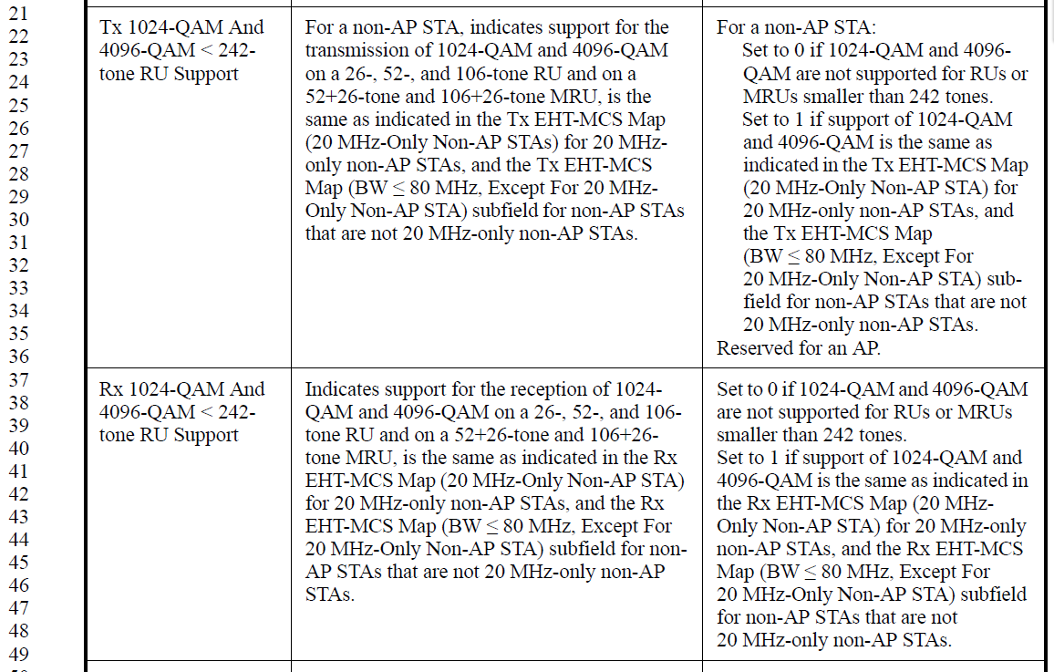

Instruction to the editor:
Please make the indicated modifications at as follows:
Tx 1024-QAM And 4096-QAM < 242-tone RU Support | For a non-AP STA, indicates support for the transmission of 1024-QAM and 4096-QAM on a 26-, 52-, and 106-tone RU and on a 52+26-tone and 106+26-tone MRU is the same as indicated in the EHT-MCS Map (20 MHz-Only Non-AP STAs) for 20 MHz-only non-AP STAs, and the EHT-MCS Map (BW ≤ 80 MHz, Except For 20 MHz-Only Non-AP STA) subfield for non-AP STAs that are not 20 MHz-only non-AP STAs. | For a non-AP STA:  Set to 0 if the transmission of 1024-QAM and 4096-QAM are not supported for RUs or MRUs smaller than 242 tones.  Set to 1 if support of the transmission of 1024-QAM and 4096-QAM is the same as indicated in the EHT-MCS Map (20 MHz-Only Non-AP STA) for 20 MHz-only non-AP STAs, and the EHT-MCS Map (BW ≤ 80 MHz, Except For 20 MHz-Only Non-AP STA) subfield for non-AP STAs that are not 20 MHz-only non-AP STAs.  Reserved for an AP.
Rx 1024-QAM And 4096-QAM < 242-tone RU Support | Indicates support for the reception of 1024-QAM and 4096-QAM on a 26-, 52-, and 106-tone RU and on a 52+26-tone and 106+26-tone MRU is the same as indicated in the EHT-MCS Map (20 MHz-Only Non-AP STA) for 20 MHz-only non-AP STAs, and the EHT-MCS Map (BW ≤ 80 MHz, Except For 20 MHz-Only Non-AP STA) subfield for non-AP STAs that are not 20 MHz-only non-AP STAs. | Set to 0 if the reception of1024-QAM and 4096-QAM are not supported for RUs or MRUs smaller than 242 tones.  Set to 1 if support of the reception of 1024-QAM and 4096-QAM is the same as indicated in the EHT-MCS Map (20 MHz-Only Non-AP STA) for 20 MHz-only non-AP STAs, and the EHT-MCS Map (BW ≤ 80 MHz, Except For 20 MHz-Only Non-AP STA) subfield for non-AP STAs that are not 20 MHz-only non-AP STAs.

CID 17703
CID | Clause | Page.Line | Comment | Proposed Change | Resolutions
17703 | 9.4.2.313.3 | 279.51 | To aide the reader, indicate where to find the PPE Thresholds field | Try " PPE Thresholds field in the EHT Capabilities element" | Accepted

  - Background
  - P279
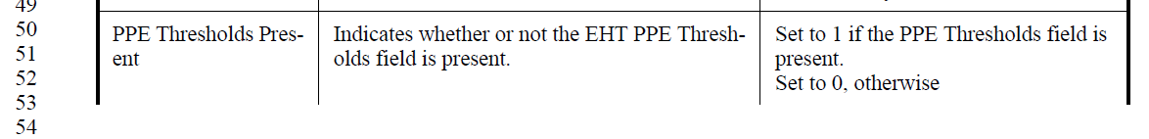

CID 15212, 15246
CID | Clause | Page.Line | Comment | Proposed Change | Resolutions
15212 | 9.4.2.313.3 | 280.20 | Delete the condition "N_ss<=8" since EHT doesn't support more than 8 spatial streams . | As in comment | Accepted
15246 | 9.4.2.313.3 | 280.20 | No need to mention Nss<=8 | As in the comment | Accepted

  - Background
  - P280
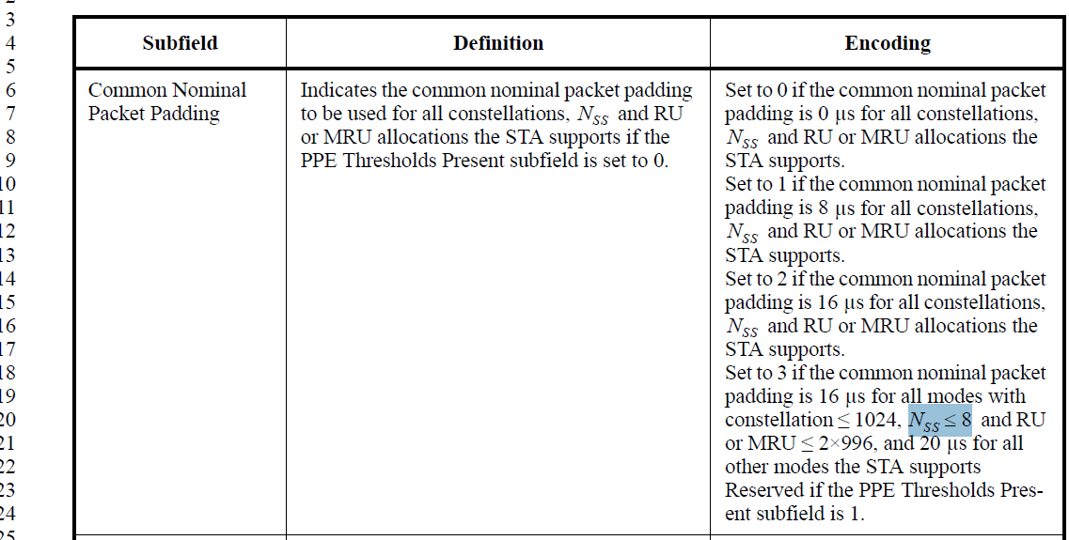

CID 17706
CID | Clause | Page.Line | Comment | Proposed Change | Resolutions
17706 | 9.4.2.313.3 | 280.48 | No "shalls" in clause 9. | Copy this normative text to clause 35, then convert this text to informative language with a xref to the normative text | Revised  Agree to the changes suggested by the commenter. The location for this text should be in the EHT-LTF section instead.  Instruction to the editor:  Please make the changes in D3.0 as indicated in 23/0682r2

  - Background
  - P280
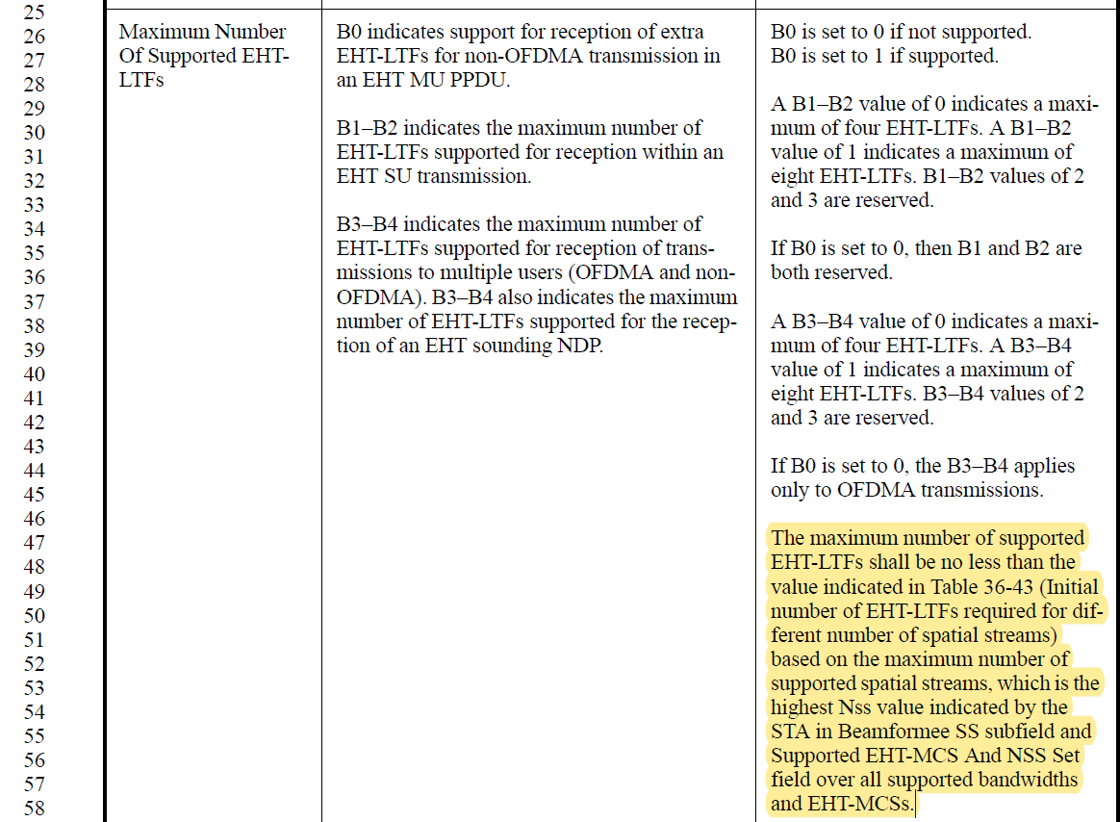

Instruction to the editor:
Please insert the following at the end of paragraph at P816L57 (EHT-LTF):
The maximum number of supported EHT-LTFs shall be no less than the value indicated in Table 36-43 (Initial number of EHT-LTFs required for different number of spatial streams) based on the maximum number of supported spatial streams, which is the highest Nss value indicated by the STA in Beamformee SS subfield and Supported EHT-MCS And NSS Set field over all supported bandwidths and EHT-MCSs in the EHT Capabilities element.
Please modify the P280 as follows:
Maximum Number Of Supported EHT-LTFs | B0 indicates support for reception of extra EHT-LTFs for non-OFDMA transmission in an EHT MU PPDU.  B1–B2 indicates the maximum number of EHT-LTFs supported for reception within an EHT SU transmission.  B3–B4 indicates the maximum number of EHT-LTFs supported for reception of transmissions to multiple users (OFDMA and non-OFDMA). B3–B4 also indicates the maximum number of EHT-LTFs supported for the reception of an EHT sounding NDP. | B0 is set to 0 if not supported.  B0 is set to 1 if supported.  A B1–B2 value of 0 indicates a maximum of four EHT-LTFs. A B1–B2 value of 1 indicates a maximum of eight EHT-LTFs. B1–B2 values of 2 and 3 are reserved.  If B0 is set to 0, then B1 and B2 are both reserved.  A B3–B4 value of 0 indicates a maximum of four EHT-LTFs. A B3–B4 value of 1 indicates a maximum of eight EHT-LTFs. B3–B4 values of 2 and 3 are reserved.  If B0 is set to 0, the B3–B4 applies only to OFDMA transmissions.  The maximum number of supported EHT-LTFs satisfies the condition defined in 36.3.12.10 (EHT-LTF).

CID 15298, 17707
CID | Clause | Page.Line | Comment | Proposed Change | Resolutions
15298 | 9.4.2.313.3 | 281.06 | The definition of "Support Of EHT-MCS 15 In MRU"is not clear. Please clarify whether the support is for both transmission and receiption. | As in the comment. | Revised  If EHT-MCS 15 is supported in MRU, it should be supported for both transmission and reception.  Instruction to the editor:  Please make the changes in D3.0 as indicated in 23/0682r2
17707 | 9.4.2.313.3 | 281.13 | Missing article x2 | Try " in a 996+484-tone MRU and a 996+484+242-tone MRU" | Accepted

  - Background
  - P281
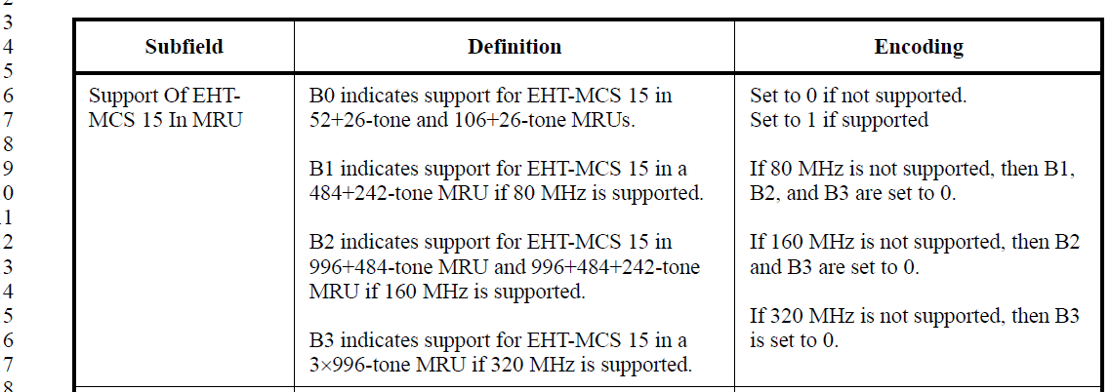

Instruction to the editor:
Please make the indicated modifications at as follows:
Support Of EHT-MCS 15 In MRU | B0 indicates support for the transmission and reception of EHT-MCS 15 in 52+26-tone and 106+26-tone MRUs.  B1 indicates support for the transmission and reception of EHT-MCS 15 in a 484+242-tone MRU if 80 MHz is supported.  B2 indicates support for the transmission and reception of EHT-MCS 15 in a 996+484-tone MRU and a 996+484+242-tone MRU if 160 MHz is supported.  B3 indicates support for the transmission and reception of EHT-MCS 15 in a 3996-tone MRU if 320 MHz is supported. | Set to 0 if not supported.  Set to 1 if supported  If 80 MHz is not supported, then B1, B2, and B3 are set to 0.  If 160 MHz is not supported, then B2 and B3 are set to 0.  If 320 MHz is not supported, then B3 is set to 0.

CID 15299, 17709
CID | Clause | Page.Line | Comment | Proposed Change | Resolutions
15299 | 9.4.2.313.3 | 281.19 | The definition of "Support Of EHT DUP (EHT-MCS 14) In 6 GHz"is not clear. Please clarify whether the support is for both transmission and receiption. | As in the comment. | Revised  If EHT DUP is supported in 6 GHz, it should be support for both transmission and reception.  Instruction to the editor:  Please make the changes in D3.0 as indicated in 23/0682r2
17709 | 9.4.2.313.3 | 281.22 | These are capabilities per link right? Then "Set to 0 if 6 GHz is not supported." is not right | Try "Set to 0 if this EHT Capabilities element does not apply to 6 GHz." or similar | Revised  If the device does not support transmission/reception in the 6GHz band, then naturally it won’t support EHT DUP in 6 GHz. The encoding of this field is modified to better reflect this.  Instruction to the editor:  Please make the changes in D3.0 as indicated in 23/0682r2

  - Background
  - P659
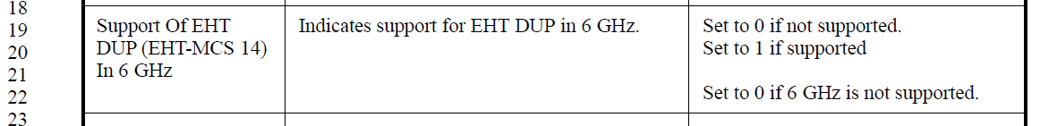

Instruction to the editor:
Please make the indicated modifications at as follows:
Support Of EHT DUP (EHT-MCS 14) In 6 GHz | Indicates support for the transmission and reception of EHT DUP in 6 GHz. | Set to 0 if not supported.  Set to 1 if supported  Set to 0 if the STA does not support operations in the 6 GHz band.

CID 15760, 17710
CID | Clause | Page.Line | Comment | Proposed Change | Resolutions
15760 | 9.4.2.313.3 | 281.27 | It has a typo in the 3rd column in table 9-401m. Please correct it. | Delete left bracket | Accepted
17710 | 9.4.2.313.3 | 281.27 | Spurious "(" | Delete | Accepted

CID 16157, 15300, 15761, 15213, 17711, 17712
CID | Clause | Page.Line | Comment | Proposed Change | Resolutions
16157 | 9.4.2.313.3 | 281.28 | Non-OFDMA UL MU-MIMO (BW â‰¤ 80 MHz) subfield describes only the definition on the indication of AP support for non-OFDMA UL MU-MIMO reception of an EHT TB PPDU, whilst the description of encoding includes the supporting capability of 20 MHz-only non-AP EHT STA with 20 MHz-Only Limited Capabilities Support subfield equal to 1. Need to clarify or add the definition of the corresponding non-AP EHT STA case as well. | As in comment | Revised  The description of this subfield is updated to include 20 MHz-only non-AP STA with 20 MHz-Only Limited Capabilities Support subfield equal to 1.  Instruction to the editor:  Please make the changes in D3.0 as indicated in 23/0682r2
15300 | 9.4.2.313.3 | 281.29 | The definition of "Non-OFDMA UL MU-MIMO (BW<=80 MHz)" subfield is uncompleted. This subfield is also used for some specific Non-AP STAs (20 MHz-only non-AP EHT STA with "20 MHz-Only Limited Capabilities Support" subfield equal to 1.) | Remove "For an AP". | Revised  The description of this subfield is updated to include 20 MHz-only non-AP STA with 20 MHz-Only Limited Capabilities Support subfield equal to 1.  Instruction to the editor:  Please make the changes in D3.0 as indicated in 23/0682r2
15761 | 9.4.2.313.3 | 281.40 | It is defined for AP. Thus, It seems not necessary to include the following text In the row for " Non-OFDMA UL MU-MIMO (BW <=80 MHZ).  " For a 20 MHz-only non-AP EHT STA with 20 MHz-Only Limited Capabilities Support subfield equal to 1:  Set to 0 if not supported.  Set to 1 if supported.  Reserved for a non-AP STA that is not a 20 MHz-only non-AP EHT STA with 20 MHz-Only Limited Capabilities Support subfield equal to 1."  Change this text to " Reserved for a non-AP STA. " | As in comment | Revised  The description of this subfield is updated to include 20 MHz-only non-AP STA with 20 MHz-Only Limited Capabilities Support subfield equal to 1.  Instruction to the editor:  Please make the changes in D3.0 as indicated in 23/0682r2
15213 | 9.4.2.313.3 | 281.42 | Either delete the 20 MHz-only non AP-EHT STA relevant sentences since this subfield is for the AP STA or add a detailed description related to the 20 MHz-only non AP-EHT STA in the definition column. | As in comment | Revised  The description of this subfield is updated to include 20 MHz-only non-AP STA with 20 MHz-Only Limited Capabilities Support subfield equal to 1.  Instruction to the editor:  Please make the changes in D3.0 as indicated in 23/0682r2
17711 | 9.4.2.313.3 | 281.43 | Why would an UL MU-MIMO capability bit apply to a non-A EHT STA? What meaning does this have? (Nothing is provided in the definition column) | Needs a relevant definition in the "Definition" column for this case, and/or a xref | Revised  The description of this subfield is updated to include 20 MHz-only non-AP STA with 20 MHz-Only Limited Capabilities Support subfield equal to 1.  Instruction to the editor:  Please make the changes in D3.0 as indicated in 23/0682r2
17712 | 9.4.2.313.3 | 281.39 | The "set to 1" should really be a note with xreferences since this setting is a consequence of normative requirements in the PHY that affect the allowed values of MIB variables that are read by the MAC and reported in this section. See 35.11.3, 36.3.3.1.2, 36.3.3.2.2, etc | Ditto P281L62, P282L16/31/44/57 | Revised.  Agree with the commenter to add cross-reference. Support for reception of non-OFDMA UL MU-MIMO is mandatory if the AP supports more than 4ss as described in 36.1.1.  Instruction to the editor:  Please make the changes in D3.0 as indicated in 23/0682r2

  - Background
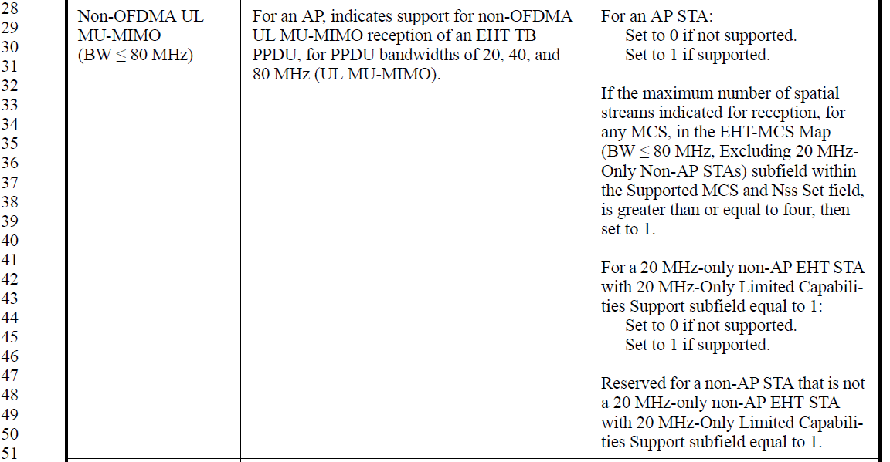

Instruction to the editor:
Please make the indicated modifications at as follows:
Non-OFDMA UL MU-MIMO (BW ≤ 80 MHz) | For an AP, indicates support for non-OFDMA UL MU-MIMO reception of an EHT TB PPDU, for PPDU bandwidths of 20, 40, and 80 MHz (UL MU-MIMO).  For a 20 MHz-only non-AP EHT STA with 20 MHz-Only Limited Capabilities Support subfield equal to 1, indicates support for non-OFDMA UL MU-MIMO transmission of an EHT TB PPDU, for PPDU bandwidths of 20 MHz (UL MU-MIMO). | For an AP STA:  Set to 0 if not supported.  Set to 1 if supported.  If the maximum number of spatial streams indicated for reception, for any MCS, in the EHT-MCS Map (BW ≤ 80 MHz, Excluding 20 MHz-Only Non-AP STAs) subfield within the Supported MCS and Nss Set field, is greater than or equal to four, then set to 1 (36.1.1).  For a 20 MHz-only non-AP EHT STA with 20 MHz-Only Limited Capabilities Support subfield equal to 1:  Set to 0 if not supported.  Set to 1 if supported.  Reserved for a non-AP STA that is not a 20 MHz-only non-AP EHT STA with 20 MHz-Only Limited Capabilities Support subfield equal to 1.
CID17712 Instruction to the editor
Please make the indicated modifications at P282L16 (3rd column) as follows:
If the maximum number of spatial streams indicated for reception, for any MCS, in the EHT-MCS Map (BW = 320 MHz) subfield within the Supported MCS and Nss Set field, is greater than or equal to four, then set to 1 (36.1.1).
Please make the indicated modifications at P282L31 (3rd column) as follows:
If the maximum number of spatial streams indicated for transmission, for any MCS, in the EHT-MCS Map (BW ≤ 80 MHz, Excluding 20 MHz-Only Non-AP STA) subfield within the Supported MCS and Nss Set field, is greater than or equal to four, then set to 1 (36.1.1).
Please make the indicated modifications at P282L44 (3rd column) as follows:
If the maximum number of spatial streams indicated for transmission, for any MCS, in the EHT-MCS Map (BW = 160 M) subfield within the Supported MCS and Nss Set field, is greater than or equal to four, then set to 1 (36.1.1).
Please make the indicated modifications at P282L57 (3rd column) as follows:
If the maximum number of spatial streams indicated for transmission, for any MCS, in the EHT-MCS Map (BW = 320 MHz) subfield within the Supported MCS and Nss Set field, is greater than or equal to four, then set to 1 (36.1.1).

CID 17713, 17968, 17714
CID | Clause | Page.Line | Comment | Proposed Change | Resolutions
17713 | 9.4.2.313.3 | 284.06 | Confusing mix of "STA" and "non-AP STA". When set to 1, can this be an AP STA!? | Consistently say "non-AP STA" x2 in this row | Revised.  The 20 MHz only STA referred here should be 20 MHz only non-AP STA. The spec is revised to reflect this.  Instruction to the editor:  Please make the changes in D3.0 as indicated in 23/0682r2
17968 | 9.4.2.313.3 | 284.06 | It is not clear whether the 20 MHz-only Limited Capabilities support should be sent by an AP or by a STA. Clarification is needed | provides clarification | Revised.  The 20 MHz only STA referred here should be 20 MHz only non-AP STA. The spec is revised to reflect this.  Instruction to the editor:  Please make the changes in D3.0 as indicated in 23/0682r2
17714 | 9.4.2.313.3 | 284.08 | Missing "and" | Try "and SU/MU beamformee" | Accepted

  - Background
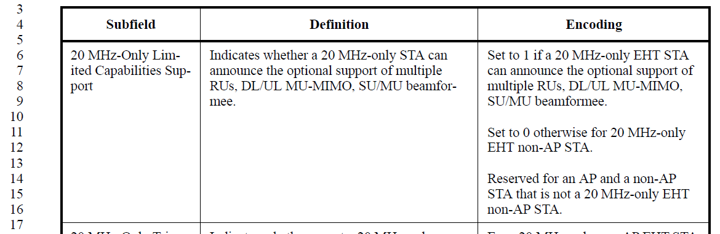

Instruction to the editor:
Please make the indicated modifications at as follows:
20 MHz-Only Limited Capabilities Support | Indicates whether a 20 MHz-only non-AP EHT STA can announce the optional support of multiple RUs, DL/UL MU-MIMO, and SU/MU beamformee. | Set to 1 if a 20 MHz-only non-AP EHT STA can announce the optional support of multiple RUs, DL/UL MU-MIMO, and SU/MU beamformee.  Set to 0 otherwise for 20 MHz-only non-AP EHT STA.  Reserved for an AP and a non-AP STA that is not a 20 MHz-only non-AP EHT STA.

CID 17697
CID | Clause | Page.Line | Comment | Proposed Change | Resolutions
17697 | 9.4.2.313.3 | 278.10 | Just saying, since field/subelement/element names are commonly used foras variable names, and programming languages don't usually support Greek letters, defining fieldnames using Greek letters is quite unhelpful. | Add to the 802.11 style guide a rule that all frame/element/field names (in future amendments) should exclusively use characters found on a typical keyboard. | Rejected  The naming of this field is the same as in previous generations (11ac, 11ax..)  It is better to make global change of this field in TGme instead.
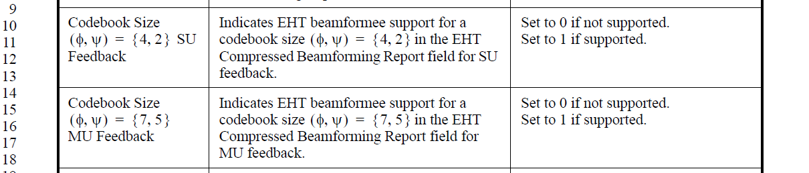

CID 17705
CID | Clause | Page.Line | Comment | Proposed Change | Resolutions
17705 | 9.4.2.313.3 | 280.26 | This field really comprises three unrelated subfields | Since talking of bits in fields is never good practice, define three fields (or 3 subfields of this 1 field, all defined below) instead. | Rejected  The function of these 3 parts are closely related. Depending on the value of B0, the interpretation of B1-B2 and B3-B4 would be different. There are also other subfields that contain closely related information with bits indicating different aspect of the capability previously used. See, for example, “Supported Channel Width Set” subfield.

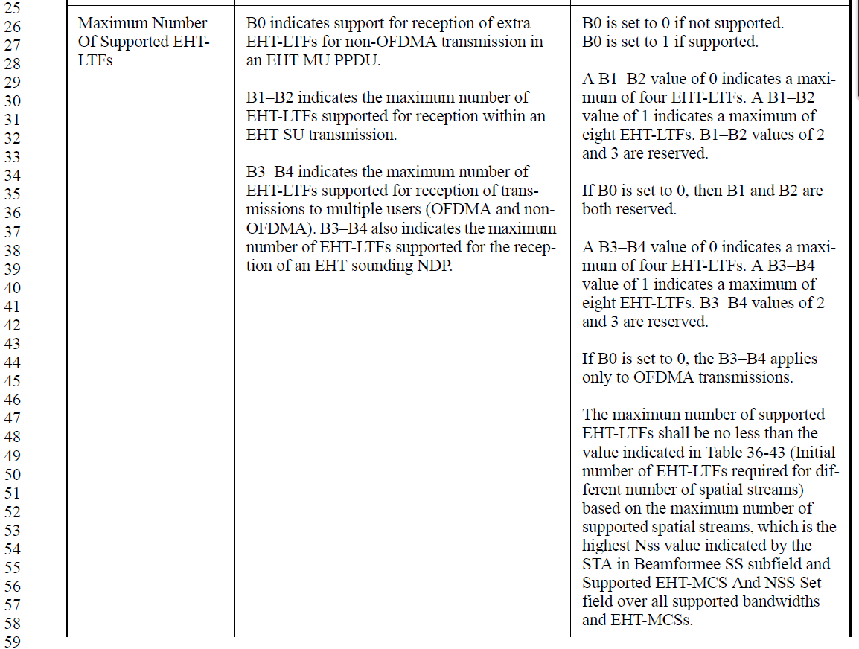

CID 17708
CID | Clause | Page.Line | Comment | Proposed Change | Resolutions
17708 | 9.4.2.313.3 | 281.06 | This field really comprises four unrelated subfields And, catastrophically, the "set to 0 .. 1 " applies for the whole field not individual bits so B1/2/3 are always zero ... i.e., this approach just does not work. | Since talking of bits in fields is never good practice, define four fields (or 4 subfields of this 1 field, all defined below) instead. | Rejected  The function of these parts are closely related. There are also other subfields that contain closely related information with bits indicating different aspect of the capability previously used. See, for example, “Supported Channel Width Set” subfield.
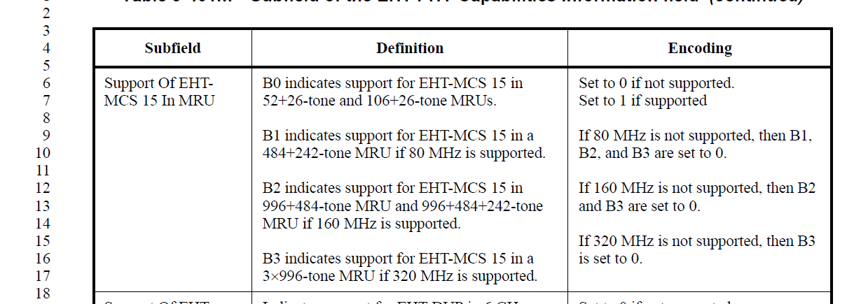

CID 17801
CID | Clause | Page.Line | Comment | Proposed Change | Resolutions
17801 | 9.4.2.313.3 | 293.60 | New PHY capabilities added in figure 9-1002au related to 20 MHz-Only STA mode, but corresponding description not available in table 9-401o | Add details about newly added 20 MHz-only STA capabilities in table 9-401o. Here capabilities corresponding to B66-68 i figure 9-1002au. | Rejected  After checking with the commenter, the comment was based on an earlier version of the draft and the issue raised is no longer present in D3.0.

CID 17715
CID | Clause | Page.Line | Comment | Proposed Change | Resolutions
17715 | 9.4.2.313.3 | 284.08 | Inferred subject for "are indicated" is incorrect: MCS 14&15 are not indicated the PHY Cap, rather *support* for these MCSes are indicated. Also, missing article and reference is the wrong place. | Try "and support for these EHT-MCSes is indicated in the EHT PHY Capabilities Information field (see 9.4.2.313.3 (EHT PHY Capabilities Information field))" | Accepted.  Note to the editor:  The indicated change should be applied at P284L39
  - Background
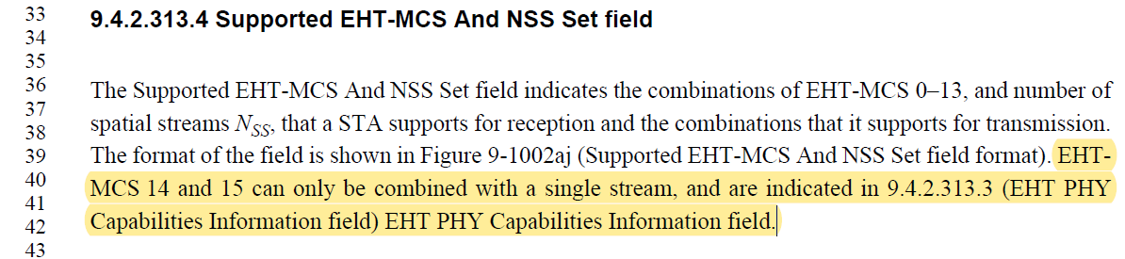

CID 16158, 16159, 16160
CID | Clause | Page.Line | Comment | Proposed Change | Resolutions
16158 | 9.4.2.313.3 | 284.06 | In 20 MHz-Only Limited Capabilities Support subfield, the definition and encoding address the support of multiple RUs, DL/UL MU-MIMO, SU/MU beamformee, but there is no capability subfield of MU beamformee in EHT PHY Capabilities Information field so it's not clear if a 20 MHz-only non-AP EHT STA (with 20 MHz-Only Limited Capabilities Support subfield equal to 1) support for MU beamformee. If this is implicitly indicated by the subfield of 20 MHz-Only Triggered MU Beamforming Full BW Feedback And DL MU-MIMO, it's not also clear enough since the subfield doesn't address if it's for transmission or reception capability of triggered MU beamforming full BW feedback and DL MU-MIMO(no description even for UL MU-MIMO transmission). Need to clarify the current text. | As in comment | Revised  The support for MU Beamformee is implied by setting the “20MHz-Only Triggered MU Beamforming Full BW feedback and DL MU-MIMO” subfield.  The description for the “20MHz-Only Triggered MU Beamforming Full BW feedback and DL MU-MIMO” subfield is modified to clarify requirements on full BW feedback and DL MU-MIMO receptions.  Instruction to the editor:  Please make the changes in D3.0 as indicated in 23/0682r2
16159 | 9.4.2.313.3 | 284.09 | Corrent spec doesn't specify MU beamformee capability (in PHY capabilities information field). Shouldn't it be MU beamformer? If more precisely, SU beamformer/beamformee and MU beamformer, or simply saying SU/MU beamforming may also work. | As in comment | Revised  The description in this field is correct and it should be MU beamformee.  The support for MU Beamformee is implied by setting the “20MHz-Only Triggered MU Beamforming Full BW feedback and DL MU-MIMO” subfield, and the language for the subfield is modified to reflect the support requirement.
16160 | 9.4.2.313.3 | 284.18 | It's not clearly indicated if the 20 MHz-only non-AP EHT STA with 20 MHz-Only Limited Capabilities Support subfield equal to 1 support the transmission or reception of triggered MU beamforming full BW feedback and DL MU-MIMO. Need to clarify how this type of STA needs to support each by transmission or reception. | As in comment | Revised  The description for the subfield is modified to clarify requirements on full BW feedback and DL MU-MIMO receptions.  Instruction to the editor:  Please make the changes in D3.0 as indicated in 23/0682r2

  - Background
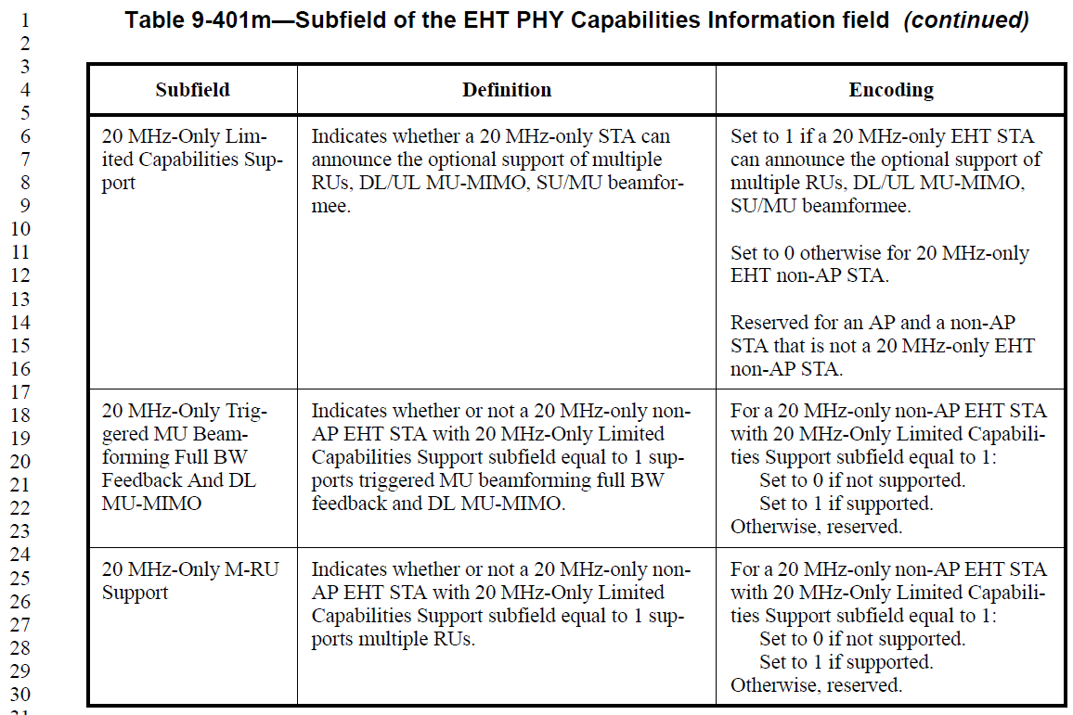

Instruction to the editor:
Please make the indicated modifications at as follows:

20 MHz-Only Triggered MU Beamforming Full BW Feedback And DL MU-MIMO | Indicates whether or not a 20 MHz-only non-AP EHT STA with 20 MHz-Only Limited Capabilities Support subfield equal to 1 supports the transmission of triggered MU beamforming full BW feedback and the reception of DL MU-MIMO. | For a 20 MHz-only non-AP EHT STA with 20 MHz-Only Limited Capabilities Support subfield equal to 1:  Set to 0 if not supported.  Set to 1 if supported.  Otherwise, reserved.

