IEEE P802.11  
Wireless LANs

|  |  |  |  |  |
| --- | --- | --- | --- | --- |
| LB272 Clause 11 Reporting CID Resolution Part 1. | | | | |
| Date: 2023-04-20 | | | | |
| Author(s): | | | | |
| Name | Affiliation | Address | Phone | email |
| Chris Beg | Cognitive Systems |  |  | chris.beg@cognitivesystems.com |
|  |  |  |  |  |
|  |  |  |  |  |
|  |  |  |  |  |
|  |  |  |  |  |

Abstract

This submission addresses the following 10 LB272 CIDs: 2126, 2045, 2046, 1158, 1159, 1160, 1003, 1489, 1490, and 1491.

Revision history:

R0 – initial version

|  |  |  |  |  |  |
| --- | --- | --- | --- | --- | --- |
| **CID** | **Clause** | **Page** | **Comment** | **Proposed Change** | **Resolution** |
| 2126 | 36.1.1 | 660.08 | The paragraph is to illustrate mandatory features. However, 20MHz only nonAP STA is included, which would cause ambiguity. | Suggest to use separate paragraph to illustrate 20MHz only nonAP STA. | Reject  Comment is not relevant to P802.11bf D1.0. |

**Proposed Resolution**: Reject

Discussion:

* Comment appears to be submitted to incorrect ballot, as clause 36.1.1 and page 660 are not valid references to P802.11bf D1.0.
* Comment text is not relevant to P802.11bf D1.0.

|  |  |  |  |  |  |
| --- | --- | --- | --- | --- | --- |
| **CID** | **Clause** | **Page** | **Comment** | **Proposed Change** | **Resolution** |
| 2045 | 11.55.1.5.4 | 188.15 | "The sensing transmitter shall use the same ordered set of antennas with no antenna swapping" is not very precise (antennas are not ordered, swapping is not defined, ...). | Change to e.g. "The sensing transmitter shall use same set of tx antennas with the same spatial mapping matrix" | Revised  Agree with commenter in principle. Additional clarifications added.  TGbf editor to make changes shown in 11-23/0660r0. |
| 2046 | 11.55.1.5.4 | 188.15 | "The sensing transmitter shall use the same ordered set of antennas with no antenna swapping". Not clear if this allows for a generic Q matrix, or only allows mapping each stream to a single antenna. | Clarify. Consider that using all antennas (and hence allowing for a generic Q matrix) has its benefits. | Revised  Agree with commenter in principle. Additional clarifications added.  TGbf editor to make changes shown in 11-23/0660r0. |

**Notes:**

* Initial text was derived from P802.11az, section 27.3.18a.1 and 27.3.18a.2, which describe the HE Ranging NDP and HE TB Ranging NDP:

* Additional constraint in the UL MU case (TB instance) can be clarified. In this case, the AP may allocate different space-time-streams to the participating STAs using the SS Allocation field.

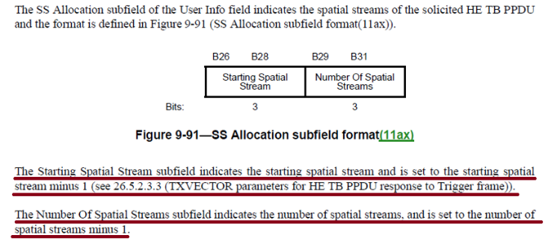

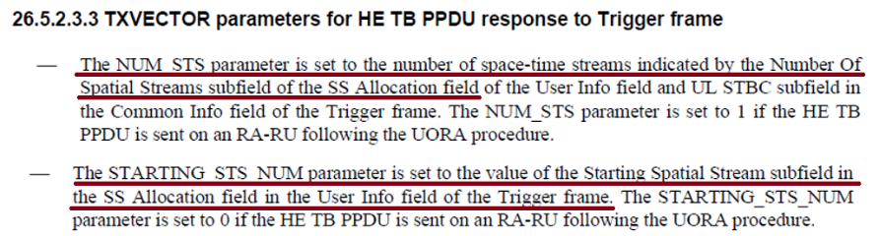

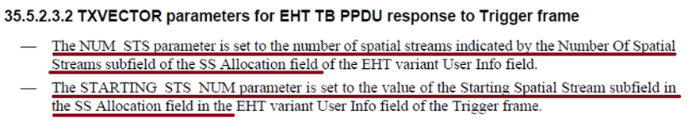

* The result is the antennas used by each responder/transmitter when sending the SR2SI or SR2SR NDP shall ensure the first antenna in the ordered subset always maps to the Starting Spatial Stream (STARTING_STS_NUM).



**Proposed Resolutions**: Revise

***TGbf Editor: Modify the text in D1.0 188.15-18 as follows:***

The sensing transmitter shall use the same ordered set of antennas with no antenna swapping for transmission of an SI2SR, SR2SI or SR2SR NDP in all sensing measurement instances associated with that sensing measurement session to ensure the sensing receiver computes the CSI from a consistent transmit configuration. In the SR2SI or SR2SR variant of the TF sounding phase, the sensing transmitter shall always map the first antenna in the ordered set to the Starting Spatial Stream indicated by the SS Allocation field and maintain ordering for the remaining space-time streams to ensure the sensing receiver computs CSI from a consistent transmit configuratin regardless of the UL resource assignment(#2045,#2046). If any of the transmit antennas is not available, the sensing transmitter shall not transmit the SI2SR, SR2SI or SR2SR NDP for that sensing measurement instance.

|  |  |  |  |  |  |
| --- | --- | --- | --- | --- | --- |
| **CID** | **Clause** | **Page** | **Comment** | **Proposed Change** | **Resolution** |
| 1158 | 11.55.1.5.4 | 188.36 | Remove the SBP responder case from this paragraph (since it is out of scope for 11.55.1). Create an equivalent paragraph specific for the SBP case in 11.55.2. | As noted. | Revised.  Agree with commenter.  Created paragraph in section 11.55.2.3 as requested.  TGbf editor to make changes shown in 11-23/0660r0. |

**Proposed Resolution**: Revised

***TGbf Editor: Modify the text in D1.0 188.36-40 as follows:***

A sensing responder which is a sensing receiver shall include the Reference Timestamp field in the Sensing Measurement Report Control field and indicate its presence by setting the Timestamp Present field in the Presence & Control Bitmap field to 1 when the sensing initiator set the Report Timestamp subfield to 1 in the Measurement Setup Request frame (#1158).

***TGbf editor: Please append D1.0 sub clause 11.55.2.3 as follows:***

In the SBP reporting procedure, the SBP responder may transmit sequentially (i.e., a SIFS separated) one or

more A-MPDUs, each carrying multiple SBP report frames.

An SBP responder which is a sensing receiver shall include the Reference Timestamp field in the Sensing Measurement Report Control field and indicate its presence by setting the Timestamp Present field in the Presence & Control Bitmap field to 1 when the SBP initiator set the Report Timestamp field to 1 in the SBP Request frame (#1158).

|  |  |  |  |  |  |
| --- | --- | --- | --- | --- | --- |
| **CID** | **Clause** | **Page** | **Comment** | **Proposed Change** | **Resolution** |
| 1159 | 11.55.1.5.5 | 188.51 | The sentence "Once set, the sensing receiver... a sensing measurement setup" is not needed as all parameters negotiated during sensing measurement setup cannot be changed. | Delete the sentence. | Revised  Agree with commenter that clarity can be added to indicated sentence. However, this Rx_OP_Gain_Type is not negotiated and left up to implementation to determine what quantities to report.  TGbf editor to make changes shown in 11-23/0660r0. |

**Notes:**

* The purpose of the Rx_OP_Gain_Type field is to indicate to the SME what is encoded into the RX_OP_Gain_Index values.
* The selection of the Rx_OP_Gain_Type is not negotiated but determination is left up to implementation.

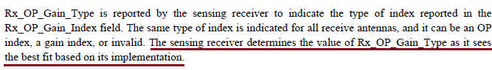

* The purpose of the sentence is to add normative behavioural description which prevents the receiver implementation from changing the Rx_OP_Gain_Type and providing inconsistent values across different measurement instances belonging to the same measurement session.
* Modify sentence to provide clarity in expected behaviour.

**Proposed Resolution**: Revised

***TGbf Editor: Modify the text in D1.0 188.45-52 as follows:***

The sensing receiver operating condition affects the accuracy of its CSI estimates. A sensing receiver which reports sensing measurement results should also report its operating condition in the form of either an OP index or gain index in the Rx_OP_Gain_Index field within the Sensing Measurement Report field (see Table 9-127j (Sensing Measurement Report information)), and set the value in the Rx_OP_Gain_Type field within the Sensing Measurement Report Control field (see Table 9-127h (Sensing Measurement Report Control field definition)) accordingly. The Rx_OP_Gain_Type field value first selected by a sensing reciver and reported during a reporting phase shall remain consistent throughout all subsequent measurement reports associated with the same measurement session(#1159).

|  |  |  |  |  |  |
| --- | --- | --- | --- | --- | --- |
| **CID** | **Clause** | **Page** | **Comment** | **Proposed Change** | **Resolution** |
| 1160 | 11.55.1.5.5 | 189.01 | Sentence must be made normative: "sensing receiver shall follow", "sensing receiver should follow"... | As noted. | Revised  Agree with commenter that sentence and description must be made normative.  TGbf editor to make changes shown in 11-23/0660r0. |

**Notes:**

* Alignment with text proposed in 23-0478r3 relating to description of Rx_OP_Gain_Index field.
* Referring to the result of different operating points as a “nonlinear effect” is not completely accurate. Some potential effects like gain compression are nonlinear, however a different impulse response of the receiver due to a modified filter shape is not necessarily a “nonlinear effect”.
* Propose removing “nonlinear effect” and describing as “impact of the sensing receiver operating point on the corresponding CSI estimate”.
* Discussion as part of 23-0478r3 pointed to using decimal notation for Rx_OP_Gain_Type field. Changes made as part of this CID in clause 11 and clause 9.

**Proposed Resolution**: Revised

***TGbf Editor: Modify the text in D1.0 188.44-189.15 as follows:***

The sensing receiver shall set the Rx_OP_Gain_Type field to a value in the range of 0 to 2 to indicate the format and contents of each Rx_OP_Gain_Index field (see 9.4.1.75.3 (Sensing Measurement Report Control field) and 9.4.1.75.4 (Sensing Measurement Report field)). The value of 3 is reserved.

When a sensing receiver maps an Rx OP index to a RX_OP_Gain_Index field value, the following statements apply(#1160):

* Each Rx_OP_Gain_Index field shall be set to a value in the range of 0 to 255. A larger value shall indicate that the impact of the sensing receiver operating point on the corresponding CSI estimates is greater. In the case where the impact of the sensing receiver operating point is negligible on the corresponding CSI estimate, the Rx_OP_Gain_Index field value shall be set to 0.
* The value set in the Rx_OP_Gain_Index field may vary between sensing measurement instances belonging to the same sensing measurement session. A change in value indicates a change in the sensing receiver operating point, and thus a change in the impact on the corresponding CSI estimate.
* The same Rx_OP_Index field value may be reported for two sensing measurement instances with the same sensing measurement session. This indicates that the sensing receiver operating point is the same when CSI is estimated for each of these two sensing measurement instances. It further indicates that the impact of the sensing receiver operating point on the CSI for each of the two sensing measurement instances is the same.

***TGbf Editor: Modify the text in D1.0 Table 9-127h (93.52-64) as follows:***

|  |  |  |  |
| --- | --- | --- | --- |
| Rx_OP_Gain_Type | 2 | Indicates the type of report in Rx_OP_Gain_Index | Set to 0 to indicate neither Rx OP index nor Rx gain index is reported.  Set to 1 to indicate the Rx OP index is reported and the value set in the Rx_OP_Gain_Index field(s) represent an RX OP index mapping.  Set to 2 to indicate the Rx gain index is reported and the value set in the Rx_OP_Gain_Index field(s) represent an RF/Analog Gain Index field and a Digital Gain Index field (Figure 9-144n (Rx_OP_Gain_Index field format when the Rx_OP_Gain_Type field is 2)).  The value of 3 is reserved (#1160). |
| Reserved | 2 |  |  |
| Reference Timestamp | 0 or 32 | Optionally present, inclusion signaled by the Timestamp Present subfield within the Presence & Control Bitmap field. | Optionally present, inclusion signaled by the Timestamp Present subfield within the Presence & Control Bitmap field. |

***TGbf Editor: Modify the text in D1.0 Table 9-127j (96.18-30) as follows:***

|  |  |  |
| --- | --- | --- |
|  | 8 | RSSI at receive antenna |
| Rx_OP_Gain_Index(1) | 8 | If the Rx_OP_Gain_Type field is 1, the Rx_OP_Gain_Index(1) field contains the Rx OP index for receive antenna 1.  If the Rx_OP_Gain_Type field is 2, the Rx_OP_Gain_Index(1) field contains the Rx gain index for receive antenna 1.  If the Rx_OP_Gain_Type field is 0 or 3, the Rx_OP_Gain_Index(1) field is reserved(#1160). |
| Rx_OP_Gain_Index(2) | 8 | If the Rx_OP_Gain_Type field is 1, the Rx_OP_Gain_Index(2) field contains the Rx OP index for receive antenna 2.  If the Rx_OP_Gain_Type field is 2, the Rx_OP_Gain_Index(2) field contains the Rx gain index for receive antenna 2.  If the Rx_OP_Gain_Type field is 0 or 3, the Rx_OP_Gain_Index(2) field is reserved(#1160). |
| … | … | … |
| Rx_OP_Gain_Index | 8 | If the Rx_OP_Gain_Type field is 1, the Rx_OP_Gain_Index() field contains the Rx OP index for receive antenna .  If the Rx_OP_Gain_Type field is 2, the Rx_OP_Gain_Index() field contains the Rx gain index for receive antenna .  If the Rx_OP_Gain_Type field is 0 or 3, the Rx_OP_Gain_Index() field is reserved(#1160). |

***Modify the text in D1.0 104.56-105.15 as follows:***

If the Rx_OP_Gain_Type field is set to 1, each Rx_OP_Gain_Index field represents an Rx OP index mapped to a value in the range of 0 to 255. The Rx OP index indicates the level of impact the sensing receiver operating point has on corresponding CSI estimation.

If Rx_OP_Gain_Type field is set to 2, each Rx_OP_Gain_Index field represents an Rx gain index.

The Rx gain index indicates the sensing receiver RF/analog and digital gain indexes. The format of the

Rx_OP_Gain_Index field when the Rx_OP_Gain_Type field is 2 is defined in Figure 9-144n (Rx_OP_Gain_Index field format when Rx_OP_Gain_Type field is 2). The RF/analog Gain Index field and the Digital Gain Index field within the Rx_OP_Gain_Index field indicate a mapping to the sensing receiver RF/analog and digital gains respectively.

|  |  |  |
| --- | --- | --- |
|  | B0               B5 | B6               B7 |
|  | RF/Analog Gain Index | Digital Gain Index |
| Bits: | 6 | 2 |

**Figure 9-144n— Rx_OP_Gain_Index field format when the Rx_OP_Gain_Type field is 2**

If the Rx_OP_Gain_Type field is set to 0 or 3, then each Rx_OP_Gain_Index field is reserved.

|  |  |  |  |  |  |
| --- | --- | --- | --- | --- | --- |
| **CID** | **Clause** | **Page** | **Comment** | **Proposed Change** | **Resolution** |
| 1003 | 11.55.1.2 | 170.17 | The phrase "A STA with four or less transmit antennas..." should be "A STA with four or fewer transmit antennas..." | As in comment | Revised  Agree in principle.  Replacing “four or less” with “up to four”.  TGbf editor to make changes shown in 11-23/0660r0. |
| 1489 | 11.55.1.2 | 170.17 | This capability for a STA should have been written in terms of the number of supported receive spatial streams, but was written incorrectly in terms of transmit antennas. The number of transmit antennas is on the transmitting device, which is the source of the confusion, I believe. | Change "A STA with four or less transmit antennas shall support an N_g value of 4 and may optionally support an N_g value of 16 in the Sensing Measurement Report frame." To "A STA that can support reception of up to four spatial streams shall support an N_g value of 4 and may optionally support an N_g value of 16 in the Sensing Measurement Report frame." | Revised  Update wording to make clear this requirement is intended for the receiving STA, not the transmitting STA.  TGbf editor to make changes shown in 11-23/0660r0. |

**Notes:**

* This statement is intended for the STA which is the sensing receiver since it is the sensing receiver who generates the measurement report.
* The wording “A STA with for or less transmit antennas shall” suggests that this requirement is for the sensing transmitter, which is not intended.
* The constraint should be re-worded such that it is clear this requirement is intended for the sensing receiver.

***TGbf Editor: Modify the text in D1.0 170.17-18 as follows:***

A WLAN sensing STA capable of receiving up to four space-time streams shall support an *Ng* (see Table 9-127h (Sensing Measurement Report Control field definition)) value of 4 and may optionally support an *Ng* value of 16 in the Sensing Measurement Report frame(#1003,#1489).

|  |  |  |  |  |  |
| --- | --- | --- | --- | --- | --- |
| **CID** | **Clause** | **Page** | **Comment** | **Proposed Change** | **Resolution** |
| 1490 | 11.55.1.2 | 170.20 | This capability for a STA should have been written in terms of the number of supported receive spatial streams, but was written incorrectly in terms of transmit antennas. The number of transmit antennas is on the transmitting device, which is the source of the confusion, I believe. | Change “A STA with five or more transmit antennas and a bandwidth of 80 MHz shall support an N_g value of 4 and may optionally support an N_g value of 16 in the Sensing Measurement Report frame.” To “A STA that can support reception of five or more spatial streams and a bandwidth of 80 MHz shall support an N_g value of 4 and may optionally support an N_g value of 16 in the Sensing Measurement Report frame.” | Revised  Agree with commenter that the requirement is intended for the receiver not transmitter. Applied changes to clarify requirement is for the sensing receiver.  TGbf editor to make changes shown in 11-23/0660r0. |

**Notes:**

* This statement is intended for the STA which is the sensing receiver since it is the sensing receiver who generates the measurement report.
* The wording “A STA with for or less transmit antennas shall” suggests that this requirement is for the sensing transmitter, which is not intended.
* The constraint should be re-worded such that it is clear this requirement is intended for the sensing receiver.

***TGbf Editor: Modify the text in D1.0 170.20-21 as follows:***

A WLAN sensing STA capable of receiving five or more space-time streams and a bandwidth up to 80 MHz shall support an *Ng* value of 4 and may optionally support an *Ng* value of 16 in the Sensing Measurement Report frame(#1490).

|  |  |  |  |  |  |
| --- | --- | --- | --- | --- | --- |
| **CID** | **Clause** | **Page** | **Comment** | **Proposed Change** | **Resolution** |
| 1491 | 11.55.1.2 | 170.24 | This capability for a STA should have been written in terms of the number of supported receive spatial streams, but was written incorrectly in terms of transmit antennas. The number of transmit antennas is on the transmitting device, which is the source of the confusion, I believe. | Change "A STA with five or more transmit antennas and a bandwidth greater than or equal to 160 MHz shall support an N_g value of 4 and may optionally support an N_g value of 16 in the Sensing Measurement Report frame." To "A STA that can support reception of five or more spatial streams and a bandwidth of greater or equal to 160 MHz shall support an N_g value of 8 and may optionally support an N_g value of 16 in the Sensing Measurement Report frame." | Revised  Agree with commenter that the requirement is intended for the receiver not transmitter. Applied changes to clarify requirement is for the sensing receiver.  TGbf editor to make changes shown in 11-23/0660r0. |

**Notes:**

* This statement is intended for the STA which is the sensing receiver since it is the sensing receiver who generates the measurement report.
* The wording “A STA with for or less transmit antennas shall” suggests that this requirement is intended for the sensing transmitter, which is not intended.
* The constraint should be re-worded such that it is clear this requirement is intended for the sensing receiver.

***TGbf Editor: Modify the text in D1.0 170.24-25 as follows:***

A WLAN sensing STA capable of receiving five or more space-time streams and a bandwidth greater than or equal to 160 MHz shall support an *Ng* value of 8 and may optionally support an *Ng* value of 16 in the Sensing Measurement Report frame(#1491).

**SP:**

Do you support the resolution to CIDs 2126, 2045, 2046, 1158, 1159, 1160, 1003, 1489, 1490, 1491 as proposed in 11-23/0660r0 and incorporating the changes into the latest TGbf draft?

Y/N/A