IEEE P802.11
Wireless LANs
Resolutions for CID1735&1739 in LB272
Date: 2023-04-14
Author(s):
Name | Affiliation | Address | Phone | email
Xiandong Dong | Xiaomi |  |  | dongxiandong@xiaomi.com
Abstract
This submission proposes resolutions to editorial comments submitted in LB272. The text used as reference is D1.0.

CIDs: 1735 1739（2CIDs）

Revisions:

- V0：Initial version of the document

CID | Clause | Page | Comment | Proposed change | resolution
1735 | 11.55.1.5.2.6.1 | 183.42 | Change the text "a Sensing Measurement Report frame" to "Sensing Measurement Report frame(s) | As per comment | Accepted
1739 | 11.55.1.5.2.6.2 | 184.39 | Change the word "is" to 'shall' | As per comment  Since it is normative | Revised  Agree in principle with the commenter and the changes are applied according to CID1739  Gbf editor to make the changes shown in IEEE 802.11-23/0648r0 under all headings that include CID1739

Discussion on CID 1735

Discussion on 1739
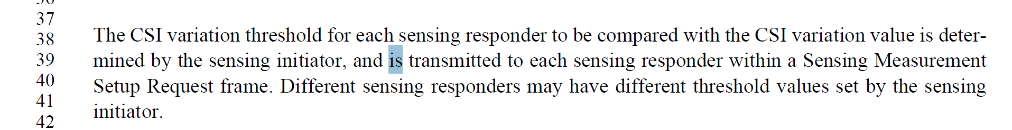
TGbf editor: please make the following change in subclause 11.55.1.5.2.6.2, P183L39

The CSI variation threshold for each sensing responder to be compared with the CSI variation value is determined by the sensing initiator, and shall be transmitted to each sensing responder within a Sensing Measurement Setup Request frame.(#1739)

SP: Do you agree to incorporate the changes proposed in IEEE 802.11-23/0648r0 to the latest 11bf draft for the following CIDs: 1735 1739 ?

