IEEE P802.11
Wireless LANs
LB271 CR for Nominal Packet Padding Values
Date: 2023.04.17
Author(s):
Name | Company | Address | Phone | email
Mengshi Hu | Huawei Technologies | F3, Huawei Base, Bantian, Longgang, Shenzhen, Guangdong, China, 518129 |  | humengshi@huawei.com
Ming Gan
Stephen McCann
Abstract
This submission contains the proposed comment resolutions of CIDs in 23/0272 IEEE 802.11be LB271 comments.

16 comments in subclause 35.13 (Nominal packet padding values selection rules) are resolved.

Resolved CIDs: 15215, 15216, 15217, 15265, 15266, 15267, 15270, 15271, 15273, 15274, 17111, 17112, 17113, 17114, 17115, 17116.
Revision Notes
R0 | Initial revision
R1 | Editorial changes
R2 | Use green tagging
R3 | Editorial changes

CID 15215, 15265
CID | Page.  Line | Clause Number | Comment | Proposed Change | Resolution
15215 | 630.55 | 35.13.2 | Delete the condition "N_ss less than or equal to 8" since EHT doesn't support more than 8 spatial streams . | As in comment | REVISED.  Agree with the commenter.  Instructions to the editor:  Please make the changes as shown under CID 15265 in 11-23/0635r4.
15265 | 630.56 | 35.13.2 | No need to mention Nss<=8 | As in the comment | REVISED.  Agree with the commenter.  Instructions to the editor:  Please make the changes as shown under CID 15265 in 11-23/0635r4.

Instructions to the editor: please make the following changes to Page 630, Line 55 in the subclause 35.13.2 (PPET not present in both HE and EHT) in D3.0 (Page 636, Line 26 in D3.1) as shown below:
An EHT STA that sets the PPE Thresholds Present subfield to 0 in both the EHT and HE Capabilities elements, and the Common Nominal Packet Padding subfield to 3 in the EHT Capabilities element that it transmits shall have a nominal packet padding of 16 µs for all modes with constellation order up to 1024- QAM and large size RU or MRU size less than or equal to 2×996, and shall have a nominal packet padding of 20 µs for all the other modes with a large size RU or MRU that the STA supports.

CID 15216, 15266
CID | Page.  Line | Clause Number | Comment | Proposed Change | Resolution
15216 | 633.40 | 35.13.4 | Delete the conditions "n<=8" and "n>8" since EHT doesn't support more than 8 spatial streams. | As in comment | REVISED.  Agree with the commenter.  Instructions to the editor:  Please make the changes as shown under CID 15266 in 11-23/0635r4.
15266 | 633.43 | 35.13.4 | In Table 35-6, the description n>8 in the second row and the wording "and less than or equal to 8" in NOTE 4 are not needed. | As in the comment | REVISED.  Agree with the commenter.  Instructions to the editor:  Please make the changes as shown under CID 15266 in 11-23/0635r4.

Instructions to the editor: please make the following changes to Page 633, Line 40 in the subclause 35.13.4 PPET present in EHT) in D3.0 (Page 639, Line 16 in D3.1) as shown below:
Delete “and $n≤8$”.
Instructions to the editor: please make the following changes to Page 633, Line 42 in the subclause 35.13.4 (PPET present in EHT) in D3.0 (Page 639, Line 18 in D3.1) as shown below:
Delete “or $n>8$”.

Instructions to the editor: please make the following changes to Page 633, Line 58 in the subclause 35.13.4 (PPET present in EHT) in D3.0 (Page 639, Line 33 in D3.1) as shown below:
Delete “and less than or equal to 8”.

Discussion (the related figure is shown below):
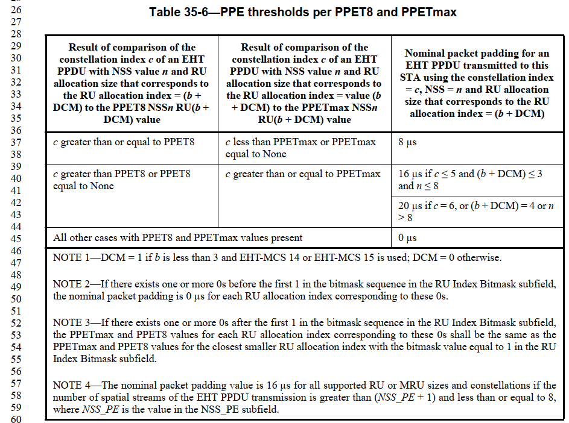

CID 15217, 15267
CID | Page.  Line | Clause Number | Comment | Proposed Change | Resolution
15217 | 634.40 | 35.13.4 | Even if 4096 QAM or RU/MRU larger than 2x996 is used, is the nominal packet padding value 16 us when the number of spatial streams of the EHT PPDU is greater than (NSS_PE+1)? Please clarify this. Ditto NOTE 4 in Table 35-6. | As in comment | REJECTED.  The answer for the comment is yes. This is a question of why 16 µs is used for signalling simplification, instead of 20 µs. According to a previous discussion within the task group, 16 µs was preferred by most people. If 20 µs is needed, just use a larger value of NSS_PE.
15267 | 634.40 | 35.13.4 | Delete "and less than or equal to 8" | As in the comment |  | ACCEPTED.  Note to the editor: Page 640, Line 14 in 802.11be D3.1.

Discussion (the related text is shown below):
The PPETmax and PPET8 subfields for an NSS value n shall be present only if n is less than or equal to (NSS_PE + 1), where NSS_PE is the value in the NSS_PE subfield in the EHT PPE Thresholds field of the EHT Capabilities element. When the number of spatial streams of the EHT PPDU transmission is greater than (NSS_PE + 1) and less than or equal to 8, the nominal packet padding value shall be 16 µs for all supported RU or MRU sizes and constellations.

CID 15270, 17112
CID | Page.  Line | Clause Number | Comment | Proposed Change | Resolution
15270 | 632.40 | 35.13.3 | According to 22/183r2, it should be EHT common norminal packet padding value instead of EHT norminal packet padding value. The former one describes the values in the case of EHT PPET not present. | As in the comment | REVISED.  Agree with the commenter.  Instructions to the editor: please make the following changes to Table 35-5 in 802.11be D3.0:  Change all “EHT nominal packet padding value” into “EHT common nominal packet padding value” in Table 35-5 from Line 37 in 802.11be D3.0 (in Table 35-5 from Line 14 in 802.11be D3.1).
17112 | 631.33 | 35.13.2 | "EHT common nominal packet padding value is" missing article | Prepend "The". Ditto in Table 35-5 | REVISED.  Agree with the commenter.  Instructions to the editor:  Please make the changes as shown under CID 17112 in 11-23/0635r4.

Instructions to the editor: please make the following changes to Page 637, Line 10 in the subclause 35.13.2 (PPET not present in both HE and EHT) in D3.0 (Page 639, Line 33 in D3.1) as shown below:
NOTE—The EHT common nominal packet padding value is the value conveyed by the Common Nominal Packet Padding subfield in the EHT PHY Capabilities Information field in the EHT Capabilities element.

Instructions to the editor: please make the following changes to Page 632, Line 50 in the subclause 35.13.2 (PPET not present in both HE and EHT) in D3.0 (Page 638, Line 28 in D3.1) as shown below:
NOTE 1—The nominal packet padding value conveyed by the PPE Thresholds field in the HE Capabilities element is 0 µs in these cases.
NOTE 2—The HE nominal packet padding value is the value conveyed by the PPE Thresholds field in the HE Capabilities element.
NOTE 3—The EHT common nominal packet padding value is the value conveyed by the Common Nominal Packet Padding subfield in the EHT PHY Capabilities Information field in the EHT Capabilities element.
NOTE 4—EHT-MCS 14 only applies to 80 MHz, 160 MHz, and 320 MHz EHT MU PPDUs, and the nominal packet padding value can be taken from the values for 996-, 2×996-, and 4×996-tone RUs, respectively.
Discussion (the related figure is shown below):

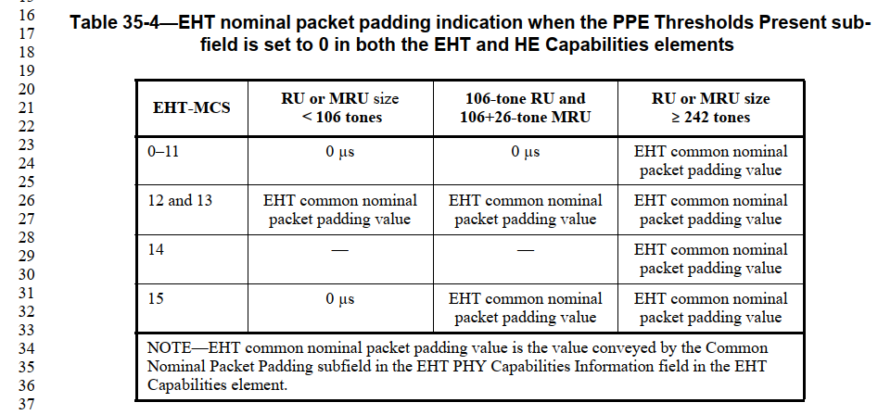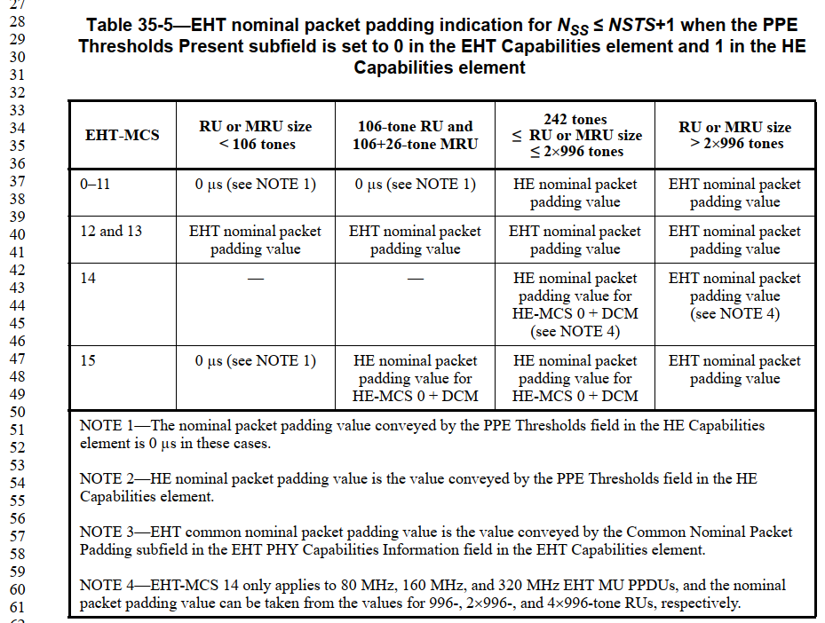

CID 15271
CID | Page.  Line | Clause Number | Comment | Proposed Change | Resolution
15271 | 630.43 | 35.13.2 | The reference of large size MRU should be placed after the previous paragraph (Line 37), since the description of large size MRU firstly appears in the previous paragraph in this subclause. | As in the comment | REVISED.  Instructions to the editor: please make the following changes to Page 630, Line 37 in 802.11be D3.0:  Move the reference from Page 630 Line 43 to Page 630 Line 37 in 802.11be D3.0 (to Page 636 Line 7 in 802.11be D3.1).
Discussion (the related text is shown below):
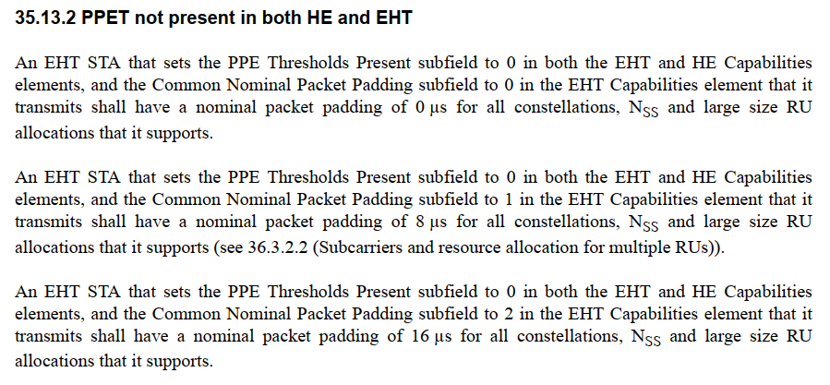

CID 15273, 15274
CID | Page.  Line | Clause Number | Comment | Proposed Change | Resolution
15273 | 633.16 | 35.13.4 | "... RU specified by the field" should be "... RU or MRU specified by the field". | Change "... RU specified by the field" into "... RU or MRU specified by the field". | ACCEPTED.  Note to the editor: Page 638, Line 57 in 802.11be D3.1.
15274 | 633.19 | 35.13.4 | Nominal packet padding values are not only used in subclause 35.13.4, but also in other subclauses in 35.13. Thus it is a little bit confusing tto mention the relationship between the nominal TPE and nominal packet padding here. | Delete this note or put it to somewhere else in subclause 35.13. | REVISED.  Agree with the commenter.  Instructions to the editor: please make the following changes to Page 633, Line 19 in 802.11be D3.0 (Page 638, Line 60 in 802.11be D3.1):  Delete the Note on Page 633, Line 19: “NOTE—If the pre-FEC padding factor is 4, then the value of nominal is equal to the nominal packet padding (see Table 36-61 (Nominal TPE values)).”

Discussion (the related text is shown below):
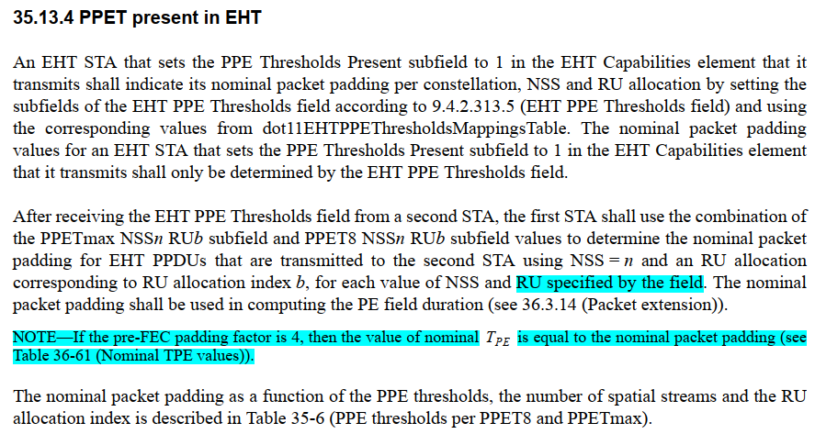

CID 17111
CID | Page.  Line | Clause Number | Comment | Proposed Change | Resolution
17111 | 630.23 | 35.13.1 | I think we say equal to not set to, except on tx | Change "dot11EHTPPEThresholdsRequired set to" to "dot11EHTPPEThresholdsRequired equal to", and ditto at line 27 | ACCEPTED.  Note to the editor: Page 635, Lines 60 and 63 in 802.11be D3.1.
Discussion (the related text is shown below):
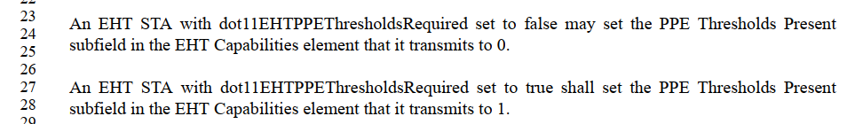

CID 17113
CID | Page.  Line | Clause Number | Comment | Proposed Change | Resolution
17113 | 631.48 | 35.13.3 | I'm not sure what "shall be in the scope of/in" means | Change "shall be in the scope from 1" to "shall be in the range 1" and "shall be in the scope of ([242, 484, 996, 2ï‚´996])" to "shall be in the set (242, 484, 996, 2ï‚´996)" | REVISED.  Agree with the commenter.  Instructions to the editor: please make the following changes to Page 631, Line 48 in 802.11be D3.0 (Page 637, Line 25 in 802.11be D3.1):  Change "shall be in the scope from 1 …" to "shall be in the range 1 …" and "shall be in the scope of ([242, 484, 996, 2×996])" to "shall be in the set {242, 484, 996, 2×996}".

Discussion (the related text is shown below):
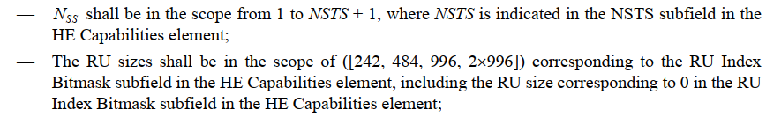

CID 17114
CID | Page.  Line | Clause Number | Comment | Proposed Change | Resolution
17114 | 632.10 | 35.13.3 | " for 484+242-tone MRU" missing article | As it says in the comment | REVISED.  Agree with the commenter.  Instructions to the editor:  Please make the changes as shown under CID 17114 in 11-23/0635r4.

Instructions to the editor: please make the following changes to Page 632 Line 10 in the subclause in the subclause 35.13.3 (PPET not present in EHT but present in HE) in D3.0 as shown below:
The nominal packet padding values for a 484+242-tone MRU shall be the same as for a 996-tone RU derived above, and the nominal packet padding values for a 996+484-tone MRU and a 996+484+242-tone MRU shall be the same as for a 2×996-tone RU derived above, in the case of the PPE Thresholds Present subfield equal to 0 in the EHT Capabilities element and equal to 1 in the HE Capabilities element.

CID 17115
CID | Page.  Line | Clause Number | Comment | Proposed Change | Resolution
17115 | 632.01 | 35.13.3 | "(NSTS + 1)" does not need parens | Delete the parens | ACCEPTED.  Note to the editor: Page 637, Lines 43 in 802.11be D3.1.
Discussion (the related text is shown below):

CID 17116
CID | Page.  Line | Clause Number | Comment | Proposed Change | Resolution
17116 | 635.17 | 35.13.5 | "A STA transmitting an EHT MU PPDU to a receiving STA" -- you can't transmit to anything except a receiving STA | Delete "to a receiving STA" | ACCPETED.  Note to the editor: Page 640, Lines 57 in 802.11be D3.1.

Discussion (the related text is shown below):
