IEEE P802.11
Wireless LANs
LB 271 CR for 35.7.2 Part II
Date: 2023-04-05
Author(s):
Name | Affiliation | Address | Phone | email
Zinan Lin | InterDigital |  |  | zinan.lin@interdigital.com
Mahmoud Kamel
Hanqing Lou
Youhan Kim | Qualcomm

Abstract

This submission present proposed resolutions for the following 17 CIDs:

17273, 17046, 17047, 17048, 18011, 17981, 17982, 17049, 15576, 17050, 17052, 15577, 17054, 17983, 17984, 17053, 17055

The proposed changes are based on 802.11be/D3.1.

Revision history:

r0 – initial version
r1 – changes based on suggestions of Mark and Youhan
r2 – Add SP for CID 17048 based on Youhan’s suggestions

CID 17273, 17046
CID | Clause | P.L | Comment | Proposed Change | Resolution
17273 | 35.7.2 | 600.10 | Why "242-tone RU" is emphasized? | An EHT NDP Announcement frame shall not request partial bandwidth feedback on any RU outside of the beamformee's operating channel width. | Revised. Agree with the commenter in principle.  According to 9.3.1.19.4, The Resolution subfield in the Partial BW Info subfield indicates the resolution bandwidth for each bit in the Feedback Bitmap subfield. When the bandwidth of the PPDU carrying the EHT NDP Announcement frame is less than 320 MHz, the Resolution bit B0 is set to 0 to indicate a resolution of 20 MHz. When the bandwidth of the PPDU carrying the EHT NDP Announcement frame is equal to 320 MHz, set the Resolution bit B0 to 1 to indicate a resolution of 40 MHz. Therefore, to be accurate, the sentence is changed to:  “An EHT NDP Announcement frame shall not request partial bandwidth feedback on any RU outside of the beamformee’s operating channel width.  Similarly, the sentence above this one is not accurate (P600L6 in 802.11be 3.0). Similar change is applied.  TGbe editor: please incorporate changes shown in 11-23/0630r1 under the tag 17273
17046 | 35.7.2 | 600.15 | “ In an EHT non-TB sounding sequence case” – spurious “case” | Delete “case" | Accepted

TGbe editor: please make the following change in subclause 35.7.2
P606L31
An EHT NDP Announcement frame shall not request feedback on (#17273) any RU that is signaled as punctured in the U-SIG field of the EHT sounding NDP that follows the EHT NDP Announcement frame.
P606L35
An EHT NDP Announcement frame shall not request partial bandwidth feedback on (#17273) any RU outside of the beamformee’s operating channel width.

P606L41
In an EHT non-TB sounding sequence (#17046), the occupied subchannel(s) indicated by the BW and Puncturing Channel Information fields in the U-SIG field of the EHT sounding NDP shall be the same as the requested subchannel(s) indicated in the Partial BW Info subfield of the immediately preceding EHT NDP Announcement frame.

CID 17047, 17048, 18011, 17981, 17982

CID | Clause | P.L | Comment | Proposed Change | Resolution
17047 | 35.7.2 | 601.10 | This " in the STA Info field " is unnecessary (already on previous line) | Delete the cited text | Accepted
17048 | 35.7.2 | 601.27 | "An EHT beamformee shall set the Beamformee SS (â¤ 80 MHz) subfield to indicate a maximum number of  spatial streams of 4 or greater.  An EHT beamformee shall set the Beamformee SS (= 160 MHz) subfield to indicate a maximum number of  spatial streams of 4 or greater.  An EHT beamformee shall set the Beamformee SS (= 320 MHz) subfield to indicate a maximum number of  spatial streams of 4 or greater." duplicates Clause 9 ("The mini-  mum value of this field is 3.") | Delete the cited text | Revised  Agree with the comment in principle. However, it is necessary to emphasize that the setting of the maximum number of spatial streams in the Beamformee SS (<= 80 MHz), the Beamformee SS ( = 160 MHz) and Beamformee SS ( = 320 MH) respectively. Therefore, to be more concise, the 2nd sentence and the 3rd sentence are moved to the following paragraphs respectively.  Please refer to CIDs 18011, 17981 and 17982.  TGbe editor: please incorporate changes shown in 11-23/0630r1 under the tag 17048
18011 | 35.7.2 | 601.27 | The 3 paragraphs starting from this line look a little out of place. Pls move them downwards, after line 46. | As in comment | Revised. Agree with the comment in principle.  The first paragraph indicated in the comment is kept in the original place as the previous paragraph addressed the setting of the Beamformee SS (<= 80 MHz) subfield. Following this logic, the 2nd paragraph indicated in the comment is moved to the paragraph addressing the setting of the Beamformee SS (=160 MHz) subfield; the 3rd paragraph indicated in the comment is moved to the paragraph addressing the setting of the Beamformee SS (=320 MHz) subfield.  Please refer to CIDs 17981, 17982.  TGbe editor: please incorporate changes shown in 11-23/0630r1 under the tag 18011.
17981 | 35.7.2 | 601.31 | Move paragraph on lines 31-32 to after the paragraph that discusses the Beamformee SS (= 160 MHz) subfield (lines 38-41). | See comment | Accepted
17982 | 35.7.2 | 601.35 | Move paragraph on lines 35-36 to after the paragraph that discusses the Beamformee SS (= 320 MHz) subfield (lines 43-46). | See comment | Accepted

Discussions on CID 17048:
There are two options to modify the following texts as the resolution of CID 17048.

P278
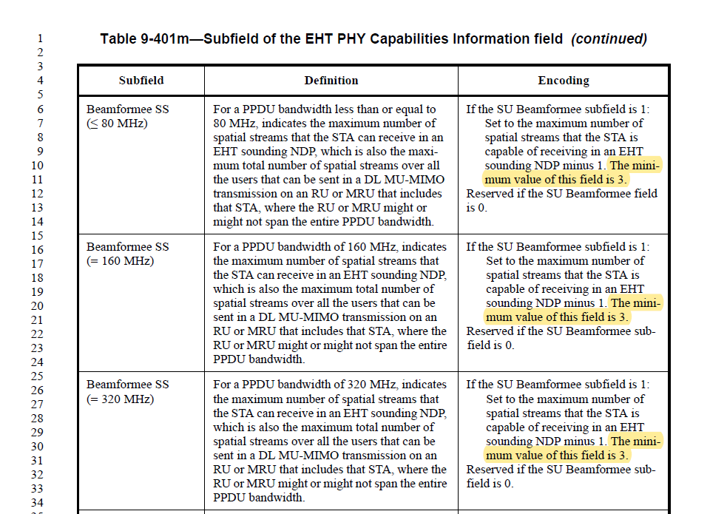

P607
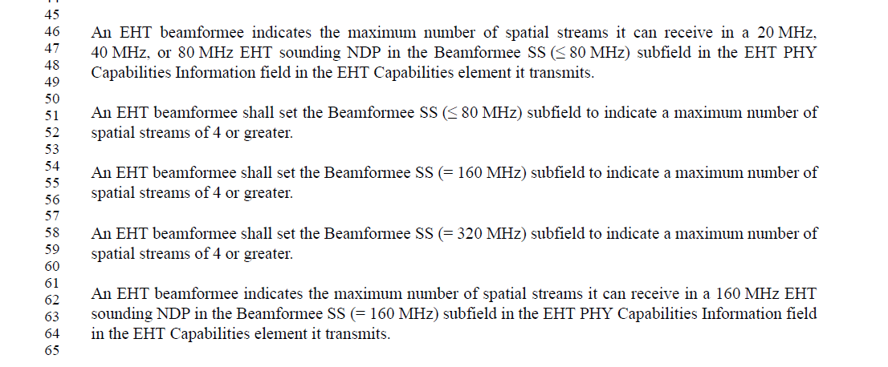

P608
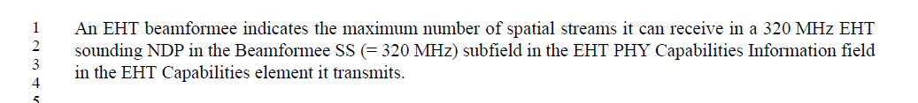

Option 1:
At D3.1 P278L10, P278L20, P278L30, change
“The minimum value of this field is 3.”
to
“<Line Change>NOTE – The minimum value of this field is 3 when the SU Beamformee subfield is 1 (see 35.7.2).<Line Change>”

In D3.1, move the sentence at P607L54-56 to P607L65.
In D3.1, move the sentence at P607L58-60 to P608L4.

Option 2:
At D3.1 P278L10, P278L20, P278L30, change
“The minimum value of this field is 3.”
to
“<Line Change>NOTE – The minimum value of this field is 3 when the SU Beamformee subfield is 1 (see 35.7.2).<Line Change>”

Delete the paragraph at D3.1 P607L46-48.
Delete the two paragraphs at D3.1 P607L62-P608L3.

SP: Which option do you prefer as the resolution of CID 17048

- Option 1
- Option 2
- Abs

End of discussion

Tgbe editor: please make the following change in subclause 35.7.2
P607L32
The Feedback Type And Ng subfield and Codebook Size subfield in the STA Info field indicate MU, the Codebook Size subfield (#17047) indicates codebook resolution $\left(ϕ, ψ\right)=\{7,5\}$ , and the Codebook Size $\left(ϕ, ψ\right)=\{7,5\}$ MU Feedback subfield in the EHT PHY Capabilities Information field is 0.

P607L54
(#17048)
(#17048)
An EHT beamformee indicates the maximum number of spatial streams it can receive in a 160 MHz EHT sounding NDP in the Beamformee SS (= 160 MHz) subfield in the EHT PHY Capabilities Information field in the EHT Capabilities element it transmits.
An EHT beamformee shall set the Beamformee SS (= 160 MHz) subfield to indicate a maximum number of spatial streams of 4 or greater (#17048).

An EHT beamformee indicates the maximum number of spatial streams it can receive in a 320 MHz EHT sounding NDP in the Beamformee SS (= 320 MHz) subfield in the EHT PHY Capabilities Information field in the EHT Capabilities element it transmits.
An EHT beamformee shall set the Beamformee SS (= 320 MHz) subfield to indicate a maximum number of spatial streams of 4 or greater (#17048).

CID 17049, 15576, 17050, 17052

CID | Clause | P.L | Comment | Proposed Change | Resolution
17049 | 35.7.2 | 602.06 | "An EHT beamformer indicates the maximum number of spatial streams it might transmit in a 20 MHz,  40 MHz, or 80 MHz EHT sounding NDP in the Number Of Sounding Dimensions (â¤ 80 MHz) subfield.  An EHT beamformer indicates the maximum number of spatial streams it might transmit in a 160 MHz EHT  sounding NDP in the Number Of Sounding Dimensions (= 160 MHz) subfield.  An EHT beamformer indicates the maximum number of spatial streams it might transmit in a 320 MHz EHT  sounding NDP in the Number Of Sounding Dimensions (= 320 MHz) subfield." is essentially duplicated in the next 3 paras | Delete the cited text | Accepted.
15576 | 35.7.2 | 602.08 | Add "in the EHT PHY Capabilities Information field in the EHT Capabilities element it transmits".  Do the same in the next 5 paragraphs. | As in comment | Revised  CID 17049 suggests removing the first 3 paragraphs. The changes are only applied to 2 paragraphs.  TGbe editor: please incorporate changes shown in 11-23/0630r1 under the tag 15576.
17050 | 35.7.2 | 602.37 | "sent by the EHT beamformee" should be just "it sends" | As it says in the comment | Accepted
17052 | 35.7.2 | 602.50 | "An EHT NDP Announcement frame carried by a PPDU of bandwidth larger than 40 MHz shall not solicit  from an EHT beamformee with 40 MHz operating channel width." -- solicit what? Any feedback? Partial-bw feedback? | Clarify | Revised. Agree with the commenter in principle.  As indicated in Table 9-45b, no feedback is allowed to be solicited by the EHT NDP Announcement frame carried by a PPDU of BW larger than 40 MHz if the beamformee’s operating BW is 40 MHz.  TGbe editor: please incorporate changes shown in 11-23/0630r1 under the tag 17052.

Tgbe editor: please make the following change in subclause 35.7.2
P608L30
An EHT beamformer shall not transmit a 20 MHz, 40 MHz, or 80 MHz EHT sounding NDP where the number of spatial streams exceeds the value indicated in the Number Of Sounding Dimensions (≤ 80 MHz) subfield (#15576) in the EHT PHY Capabilities Information field in the EHT Capabilities element it transmits.
An EHT beamformer shall not transmit a 160 MHz EHT sounding NDP where the number of spatial streams exceeds the value indicated in the Number Of Sounding Dimensions (= 160 MHz) subfield (#15576) in the EHT PHY Capabilities Information field in the EHT Capabilities element it transmits.

An EHT beamformer shall not transmit a 320 MHz EHT sounding NDP where the number of spatial streams exceeds the value indicated in the Number Of Sounding Dimensions (= 320 MHz) subfield (#15576) in the EHT PHY Capabilities Information field in the EHT Capabilities element it transmits.

P608L57

An EHT beamformee indicates the maximum supported data rate used in the EHT TB PPDU carrying the EHT compressed beamforming/CQI report in the TB Sounding Feedback Rate Limit subfield in the EHT PHY Capabilities Information field in the EHT Capabilities element (#17050) it transmits.

P609L8
An EHT NDP Announcement frame carried by a PPDU of bandwidth larger than 40 MHz shall not solicit (#17052) any feedback from an EHT beamformee with 40 MHz operating channel width.

CID 15577, 17054, 17983,17984, 17053

CID | Clause | P.L | Comment | Proposed Change | Resolution
15577 | 35.7.2 | 603.25 | The sentence should be removed, since it is covered by the previous three bullets. | As in comment | Accepted
17054 | 35.7.2 | 603.25 | "242-tone and 484-tone RU solicited with an EHT NDP Announcement frame carried by a PPDU of  bandwidth of 20 MHz and 40 MHz." is missing its bullet | As it says in the comment | Revised. Agree with the comment in principle.  However, since the first three bullets cover the case shown in this sentence, the sentence is removed from the text.  Please refer to CID 15577.  TGbe editor: please incorporate changes shown in 11-23/0630r1 under the tag 17054.
17983 | 35.7.2 | 603.25 | Sentence on lines 25-27 looks out of place or is a left-over segment from editing previous text. It may be already covered in the bullets above. | See comment | Revised. Agree with the comment in principle.  This sentence is removed as the previous three bullets cover the case indicated in this sentence.  Please refer to CID 15577.  TGbe editor: please incorporate changes shown in 11-23/0630r1 under the tag 17983.
17984 | 35.7.2 | 603.29 | "A 40 MHz operating EHT beamformee shall support MU feedback ...". This is specifc for EHT TB sounding sequence, but that information is missing (for comparison - lines 5, 14, 41, 56, ... all explicitly refer to the sounding type when stating the requirements) | Add "In an EHT TB sounding sequence, " in front of the sentence.  Make the same change on P603L38, P603L63, P604L13, P604L54, P605L7, P605L62, P606L15. | Revised.  Similar problems are existing on P602L63 and P603L1. The resolutions also include the modifications shown in P602L63 and P603L1 (802.11be D3.0).  TGbe editor: please incorporate changes shown in 11-23/0630r1 under the tag 17984.
17053 | 35.7.2 | 0.00 | "for 242-tone RU" missing article (5x) | Add missing article (suspect other subclauses too) | Revised. Agree with the commenter in principle.  Add “a” between “for” and “242-tone RU” in five locations (P609L12, P609L17, P609L21, P609L25, P609L62) in 35.7.2.  TGbe editor: please incorporate changes shown in 11-23/0630r1 under the tag 17053.

Tgbe editor: please make the following change in subclause 35.7.2
P609L49
(#15577, 17054, 17983)

P609L12
In an EHT non-TB sounding sequence, a 20 MHz operating EHT beamformee shall support SU feedback for (#17053) a 242-tone RU solicited with an EHT NDP Announcement frame carried by a PPDU of bandwidth of 20 MHz.

P609L17
In an EHT TB sounding sequence, a 20 MHz operating EHT beamformee may support SU feedback for (#17053) a 242-tone RU solicited with an EHT NDP Announcement frame carried by a PPDU of bandwidth of 20 MHz, 40 MHz, 80 MHz, and 160 MHz.
P609L21
(#17984) In an EHT TB sounding sequence, a 20 MHz operating EHT beamformee shall support MU feedback for (#17053) a 242-tone RU solicited with an EHT NDP Announcement frame carried by a PPDU of bandwidth of 20 MHz.
(#17984) In an EHT TB sounding sequence, a 20 MHz operating EHT beamformee may support MU feedback for (#17053) a 242-tone RU solicited with an EHT NDP Announcement frame carried by a PPDU of bandwidth of 40 MHz, 80 MHz, and 160 MHz.

P609L53
(#17984) In an EHT TB sounding sequence, a 40 MHz operating EHT beamformee shall support MU feedback for the combinations of RU size and NDP announcement bandwidth below:
- 242-tone RU feedback solicited with an EHT NDP Announcement frame carried by a PPDU of bandwidth of 20 MHz.
- 484-tone RU feedback solicited with an EHT NDP Announcement frame carried by a PPDU of bandwidth of 40 MHz.

P609L61
(#17984) In an EHT TB sounding sequence, a 40 MHz operating EHT beamformee may support MU feedback for (#17053) a 242-tone RU solicited with an EHT NDP Announcement frame carried by a PPDU of bandwidth of 40 MHz.

P610L22
(#17984) In an EHT TB sounding sequence, an 80 MHz operating EHT beamformee shall support MU feedback for the combinations of RU or MRU (if the MRU is full bandwidth feedback) size and NDP announcement bandwidth below:
- 242-tone RU feedback solicited with an EHT NDP Announcement frame carried by a PPDU of bandwidth of 20 MHz.
- 484-tone RU feedback solicited with an EHT NDP Announcement frame carried by a PPDU of bandwidth of 40 MHz.
- 996-tone RU and 484+242-tone MRU feedback solicited with an EHT NDP Announcement frame carried by a PPDU of bandwidth of 80 MHz or 160 MHz.
- 996-tone RU feedback solicited with an EHT NDP Announcement frame carried by a PPDU of bandwidth of 320 MHz.

P610L37
(#17984) In an EHT TB sounding sequence, an 80 MHz operating EHT beamformee may support MU feedback for the combinations of RU or MRU (if the MRU is partial bandwidth feedback) size and NDP announcement bandwidth below:
- 242-tone RU feedback solicited with an EHT NDP Announcement frame carried by a PPDU of bandwidth of 40 MHz.
- 242-tone and 484-tone RU, and 484+242-tone MRU feedback solicited with an EHT NDP Announcement frame carried by a PPDU of bandwidth of 80 MHz or 160 MHz.
- 484-tone RU feedback solicited with an EHT NDP Announcement frame carried by a PPDU of bandwidth of 320 MHz.

P611L14
(#17984) In an EHT TB sounding sequence, a 160 MHz operating EHT beamformee shall support MU feedback for the combinations of RU or MRU (if the MRUs are full bandwidth feedback) size and NDP announcement bandwidth below:
- 242-tone RU feedback solicited with an EHT NDP Announcement frame carried by a PPDU of bandwidth of 20 MHz.
- 484-tone RU feedback solicited with an EHT NDP Announcement frame carried by a PPDU of bandwidth of 40 MHz.
- 996-tone RU and 484+242-tone MRU feedback solicited with an EHT NDP Announcement frame carried by a PPDU of bandwidth of 80 MHz.
- 2$×$996-tone RU, 996+484-tone and 996+484+242-tone MRU feedback solicited with an EHT NDP Announcement frame carried by a PPDU of bandwidth of 160 MHz.
- 2$×$996-tone RU and 996+484-tone MRU feedback solicited with an EHT NDP Announcement frame carried by a PPDU of bandwidth of 320 MHz.

P611L32

(#17984) In an EHT TB sounding sequence, a 160 MHz operating EHT beamformee may support MU feedback for the combinations of RU or MRU (if the MRUs are partial bandwidth feedback) size and NDP announcement bandwidth below:
- 242-tone RU feedback solicited with an EHT NDP Announcement frame carried by a PPDU of bandwidth of 40 MHz.
- 242-tone and 484-tone RU, and 484+242-tone MRU feedback solicited with an EHT NDP Announcement frame carried by a PPDU of bandwidth of 80 MHz.
- 242-tone, 484-tone, and 996-tone RU, and 484+242-tone and 996+484-tone MRU feedback solicited with an EHT NDP Announcement frame carried by a PPDU of bandwidth of 160 MHz.
- 484-tone and 996-tone RU, and 996+484-tone MRU feedback solicited with an EHT NDP Announcement frame carried by a PPDU of bandwidth of 320 MHz.

P612L22
(#17984) In an EHT TB sounding sequence, a 320 MHz operating EHT beamformee shall support MU feedback for the combinations of RU or MRU (if the MRUs are full bandwidth feedback) size and NDP announcement bandwidth below:
- 242-tone RU feedback solicited with an EHT NDP Announcement frame carried by a PPDU of bandwidth of 20 MHz.
- 484-tone RU feedback solicited with an EHT NDP Announcement frame carried by a PPDU of bandwidth of 40 MHz.
- 96-tone RU and 484+242-tone MRU feedback solicited with an EHT NDP Announcement frame carried by a PPDU of bandwidth of 80 MHz.
- 2$×$996-tone RU, 996+484-tone and 996+484+242-tone MRU feedback solicited with an EHT NDP Announcement frame carried by a PPDU of bandwidth of 160 MHz.
- 4$×$996-tone RU and 2$×$996+484-tone, 3$×$996-tone, and 3$×$996+484-tone MRU feedback solicited with an EHT NDP Announcement frame carried by a PPDU of bandwidth of 320 MHz.

P612L39
(#17984) In an EHT TB sounding sequence, a 320 MHz operating EHT beamformee may support MU feedback for the combinations of RU or MRU (if the MRUs are partial bandwidth feedback) size and NDP announcement bandwidth below:
- 242-tone RU feedback solicited with an EHT NDP Announcement frame carried by a PPDU of bandwidth of 40 MHz.
- 242-tone and 484-tone RU, and 484+242-tone MRU feedback solicited with an EHT NDP Announcement frame carried by a PPDU of bandwidth of 80 MHz.
- 242-tone, 484-tone, and 996-tone RU, and 484+242-tone and 996+484-tone MRU feedback solicited with an EHT NDP Announcement frame carried by a PPDU of bandwidth of 160 MHz.
- 484-tone, 996-tone, and 2$×$996-tone RU, and 996+484-tone, 2$×$996+484-tone, 3$×$996-tone, and 3$×$996+484-tone MRU feedback solicited with an EHT NDP Announcement frame carried by a PPDU of bandwidth of 320 MHz.

CID 17055

CID | Clause | P.L | Comment | Proposed Change | Resolution
17055 | 35.7.2 | 607.01 | "Informative summary" -- a while ago there was an extensive discussion in TGm, and I think the conclusion was that nothing in a non-Annex could be informative (apart from NOTEs, etc.) | Move to an annex | Revised. Agree with the comment in principle.  It is particularly useful to include this summary in the end of 35.7.2 for a clearer and better understanding of mandatory and optional support of RU/MRU feedback in different sounding modes. Therefore, this table is kept in this subclause.  The title of the table is changed to “Summary of Supported RU or MRU sizes for sounding feedback”.  TGbe editor: please incorporate changes shown in 11-23/0630r1 under the tag 17055.

Tgbe editor: please make the following change in subclause 35.7.2
P612L55
Table 35-3 ((#17055) Summary of supported RU or MRU sizes for sounding feedback) summarizes the supported sounding bandwidth for the various sounding modes and feedback types.

P613L1
Table 35-3—(#17055) Summary of supported RU or MRU sizes for sounding feedback

