IEEE P802.11
Wireless LANs
LB272 CR for SBP CID – part 1
Date: 2023-04-11
Author(s):
Name | Affiliation | Address | Phone | email
Narengerile | Huawei | Shenzhen, China |  | narengerile@huawei.com
Stephen McCann
Rui Du
Mengshi Hu
Zhuqing Tang
Yiyan Zhang

Abstract
This document proposes comment resolutions for CIDs 2124, 1248, 1242, 1245, 1258, 1801, 2108, 2211, 2222, and 2223

R0: initial version on April 11, 2023.
R1: revised version on May 16 based on offline discussions, changed the resolutions for CID 2108, 2211, and 2222.
R2: revised version on May 17, changed the resolutions for CID 1258, 1801, and 2223.

CID 2124, 1248, 1242
CID | Page | Comment | Proposed change | Proposed resolution
2124 | 116.02 | Confusing term | Perhaps change "The SBP Procedure Expiry Exponent value is equal to" to "The SBP Procedure Expiry value is equal to" | REVISED.  Agree with the commenter in principle.  Please incorporate the modifications specified in 23/0626r2 (https://mentor.ieee.org/802.11/dcn/23/11-23-0626-02-00bf-lb272-cr-for-sbp-cid-part-1.docx) for CID 2124.
1248 | 116.1 | I believe the SBP Procedure Expiry Exponent subfield shall not be reserved only when the SBP Request field is set to 1. If this is true, move 116.1-5 to be the first item below "If the SBP Request subfield is set to 1" in 116.7. And also define that this subfield is reserved when the SBP Request subfield is set to 0. | As suggested. | REVISED.  Agree with the commenter in principle.  Please refer to the discussions and modifications given in 23/0626r2 (https://mentor.ieee.org/802.11/dcn/23/11-23-0626-02-00bf-lb272-cr-for-sbp-cid-part-1.docx) for CID 1248
1242 | 191.16 | Replace "SBP procedure expiry timer value is indicated in the SBP Request frame..." with "SBP procedure expiry timer value is indicated in the SBP Parameters element within the SBP Request frame..." | As suggested. | REVISED.  Agree with the commenter in principle.  Please incorporate the modifications specified in 23/0626r2(https://mentor.ieee.org/802.11/dcn/23/11-23-0626-02-00bf-lb272-cr-for-sbp-cid-part-1.docx) for CID 1242.
Discussions for CID 1248
For SBP, it is assumed that the sensing application sits at the SBP initiator, so the duration of SBP should be determined and indicated by the SBP initiator when sending the SBP Request frame during the SBP setup. And, the duration is not a negotiable operational parameter like no. of sensing responders. Therefore, we need to differentiate the value of the SBP procedure timer between the SBP Request frame and the SBP Response frame.

Modification for CID 2142 and 1248
To TGbf Editor: Please delete the text in P116 from L1 to L5, and modify the following texts in P116L7.
If the SBP Request subfield is equal to 1,
- The SBP Procedure Expiry Exponent field contains an unsigned integer. It is encoded according to the conventions in 9.2.2 (Conventions). The SBP procedure expiry timer value is set to $2^{(SBP Procedure Expiry Exponent+8)}$ms. It is a time after which the SBP procedure is terminated, if there are no frame exchange sequences (see 11.55.2.4 (Termination)).
— The Sensing Responder subfield is set to 1 to indicate …
- …
To TGbf Editor: Please modify the following text in P116L63.
If the SBP Request subfield is equal to 0:
- The SBP Procedure Expiry Exponent field is reserved.
— The Sensing Responder subfield is reserved.
- …

Modification for CID 1242
To TGbf Editor: Please modify the text in P191L16 in D1.0 as follows.
The SBP procedure expiry timer value is indicated in the SBP Parameters element within the SBP Request frame (see 9.6.7.54 ((Protected) SBP Request frame format)). Upon expiry of the corresponding SBP procedure expiry timer, the SBP procedure is considered terminated (see 11.55.2.4 (Termination)).

CID 1245
CID | Page | Comment | Proposed change | Proposed resolution
1245 | 191.35 | 191.34-38 defines behavior for REJECTED_WITH_SUGGESTED_CHANGES; and 191.39-44, for SUCCESS. A paragraph is needed for the REQUEST_DECLINED case. Specifically, normative text is needed to define that .response primitive shall not include Sensing MeasurementParameter nor SBPParameters in this case. | As suggested. | REVISED.  Agree with the commenter in principle.  Please refer to the discussions and modifications given in 23/0626r2 (https://mentor.ieee.org/802.11/dcn/23/11-23-0626-02-00bf-lb272-cr-for-sbp-cid-part-1.docx) for CID 1245

Discussions for CID 1245
Given the three status codes, i.e., SUCCESS, REJECTED_WITH_SUGGESTED_CHANGES and REQUEST_DECLINED, the spec only specifies the MLME-SBP.response primitive parameters when the status code is set to SUCCESS or REJECTED_WITH_SUGGESTED_CHANGES, but lacks the case where the status code is set to REQUEST_DECLINED, which should be added to the spec.
Modification for CID 1245
To TGbf Editor: Please add the text after P191L44 in D1.0 as follows.
If the StatusCode parameter within the MLME-SBP.response primitive is equal to REQUEST_DECLINED, the MLME-SBP.response primitive shall not include a SensingMeasurementParameter nor an SBPParameters parameter.

CID 1258, 1801
CID | Page | Comment | Proposed change | Proposed resolution
1258 | 194.52 | 11.55.2.4 uses the terms "associated SBP initiator" and "unassociated SBP initiator" without definition. | Either define these two terms or remove these terms from the subclause. | REVISED.  Please refer to the discussions and modifications given in 23/0626r2 (https://mentor.ieee.org/802.11/dcn/23/11-23-0626-02-00bf-lb272-cr-for-sbp-cid-part-1.docx) for CID 1258, 1801
1801 | 190.48 | Specification should menton about associateion state for SBP procedure | add sentence like below  the SBP initiator non-AP STA may associate with the SBP responder AP.
Discussions for CID 1258, 1801
As I understand the comments, the commenters are seeking clarification for the association state between the SBP initiator and the SBP responder. The 11bf spec allows a non-AP STA to initiate an SBP procedure with the AP that this non-AP STA is associated with, and also allows a non-AP STA to initiate an SBP procedure with a different AP that this non-AP STA is not associated with. For reference, we do consider the case where the SBP initiator is unassociated with the SBP responder in the 11bf spec: we have two appearances of ‘unassociated SBP initiator’ in subclause 11.55.2 (SBP procedure).
To clarify the association state between the SBP initiator and the SBP responder, the following modifications are proposed:
- Add a NOTE in the 11.55.2.1 (General) to specify both cases;
- Rephrase the text that mentions ‘unassociated SBP initiator’ or ‘associated SBP initiator’ to improve clarification.

Modification for CID 1258, 1801
11.55.2 SBP procedure
11.55.2.1 General
SBP is a procedure that allows a non-AP STA to request an AP to perform WLAN sensing (see 11.55.1(WLAN sensing procedure)) on its behalf.
Implementation of SBP is optional.
To TGbf Editor: Please modify the following text from P190L56.
A STA in which both dot11WLANSensingImplemented and dot11SBPImplemented are equal to true shall set the SBP field of the Extended Capabilities element to 1.
A STA in which dot11SBPImplemented is equal to false shall set the SBP field of the Extended Capabilities element to 0.
A non-AP STA may act as SBP initiator when both dot11WLANSensingImplemented and dot11SBPImplemented are equal to true.
An AP may act as SBP responder when both dot11WLANSensingImplemented and dot11SBPImplemented are equal to true.
To TGbf Editor: Please add the following note to the end of 11.55.2.1..
NOTE – The non-AP STA that acts as an SBP initiator can be associated or unassociated with the AP that acts as an SBP responder. (#1258, #1801)

To TGbf Editor: Please modify the following text in 11.55.2.4 from P194L54-L60.
If the SBP initiator is associated with the SBP responder, an SBP procedure may be terminated either by the SBP initiator or the SBP responder by transmitting an SBP Termination frame at any time. If the SBP initiator is unassociated with the SBP responder, an SBP procedure may be terminated by the SBP initiator by transmitting an SBP Termination frame at any time. If the SBP responder intends to terminate an SBP procedure with an SBP initiator that is unassociated with it, the SBP responder should transmit an SBP Termination frame during the availability window.(#1258, #1801)

CID 2108, 2211
CID | Page | Comment | Proposed change | Proposed resolution
2108 | 194.61 | The sentence "The SBP initiator is available during the availability window" is confusing | It can change to "The SBP initiator is available for SBP reporting or for TB sensing measurement instance if the SBP initiator intends to be a sensing responder." | REVISED.  Agree with the commenter in principle.  Please refer to the discussions and modifications given in 23/0626r2 (https://mentor.ieee.org/802.11/dcn/23/11-23-0626-02-00bf-lb272-cr-for-sbp-cid-part-1.docx) for CID 2108, 2211.
2211 | 194.61 | This NOTE is inaccurate. If the SBP initiator is unassociated to the AP, AP cannot guarantee that the SBP initiator will be available during the scheduled window. | Remove the NOTE if not clarified.
Discussions for CID 2108, 2211
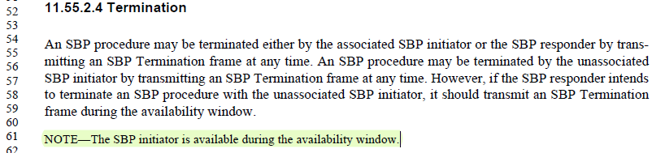
The statement that ‘The SBP initiator is available’ can give a wrong impression that the SBP initiator is always present/available during the availability window, which is not entirely true. We cannot rule out the possibility that the SBP initiator may not respond to the polling from the SBP responder. It helps to specify the availability of the SBP initiator in normative texts. And, this NOTE is attached to the SBP termination section. But the availability of the SBP initiator is not only important for termination, but also for SBP reporting. The proposed changes are
- Adding normative texts in the section of SBP reporting;
- Removing the NOTE in P194L61 and revising the text in 11.55.2.4.

Modification for CID 2108, 2211
To TGbf Editor: Please add the following text after P194L21 in 11bf spec.
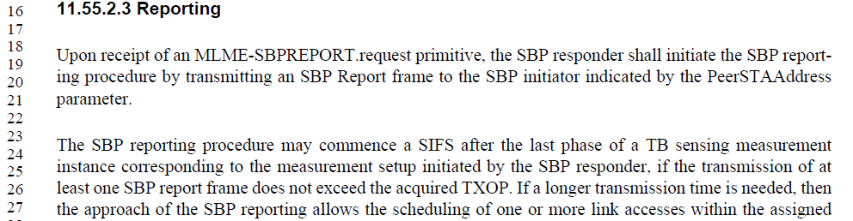
The SBP initiator shall be present in the availability window assigned by the SBP responder if it intends to receive SBP report frames from the SBP responder obtained as a result of TB sensing measurement exchanges in the corresponding availability window. (#2108, #2211)

To TGbf Editor: Please remove the following NOTE and modify the text on P194 as follows.
An SBP procedure may be terminated either by the associated SBP initiator or the SBP responder by transmitting an SBP Termination frame at any time. An SBP procedure may be terminated by the unassociated SBP initiator by transmitting an SBP Termination frame at any time. However, if the SBP responder intends to terminate an SBP procedure with the unassociated SBP initiator, it should transmit an SBP Termination frame during the availability window in which the SBP initiator is present (#2108, #2211).

CID 2222, 2223
CID | Page | Comment | Proposed change | Proposed resolution
2222 | 193.56 | In 11bf draft, there are other subclauses that are referenced without a NOTE. There is no need to have this NOTE. | Delete the NOTE. | REJECTED.  A brief discussion is given in 23/0626r2 (https://mentor.ieee.org/802.11/dcn/23/11-23-0626-02-00bf-lb272-cr-for-sbp-cid-part-1.docx) for CID 2222.
2223 | 194.05 | Typo. | Change "for SBP from and SBP initiator" to "for SBP from SBP initiator" | REVISED.  Please refer to the modifications given in 23/0626r2 (https://mentor.ieee.org/802.11/dcn/23/11-23-0626-02-00bf-lb272-cr-for-sbp-cid-part-1.docx) for CID 2223.
Discussions for CID 2222
This NOTE is suggested to be kept. Because it gives a clear instruction to the developers where to find the example of the availability window element by reading the 11bf spec. This issue will not exist anymore when both 11az and 11bf specs are included in the baseline spec.
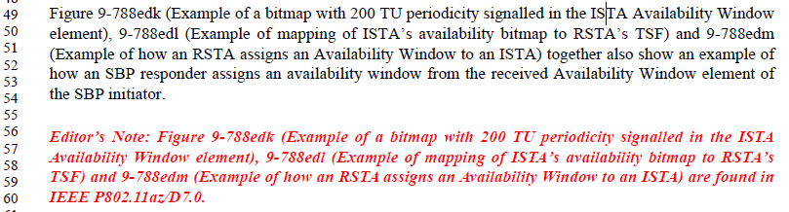

To TGbf Editor: Please modify the text on P194L5 as follows:
If the SBP responder rejects a request for SBP from an SBP initiator by setting the Status Code field in the SBP Response frame to REJECTED_WITH_SUGGESTED_CHANGES,…

SP:
Do you agree to the resolutions provided for CIDs 2124, 1248, 1242, 1245, 1258, 1801, 2108, 2211, 2222, and 2223 to be included in the latest 11bf Draft?
Y/N/A

