IEEE P802.11
Wireless LANs
LB271 CR for EHT PPE Thresholds Field
Date: 2023.04.10
Author(s):
Name | Company | Address | Phone | email
Mengshi Hu | Huawei Technologies | F3, Huawei Base, Bantian, Longgang, Shenzhen, Guangdong, China, 518129 |  | humengshi@huawei.com
Ming Gan
Abstract
This submission contains the proposed comment resolutions of CIDs in 23/0272 IEEE 802.11be LB271 comments.

11 comments in subclause 9.4.2.313.5 (EHT PPE Thresholds field) of 9.4.2.313 (EHT Capabilities element) are resolved.

Resolved CIDs: 16271, 17719, 17720, 17721, 17722, 17723, 17724, 17725, 17726, 17727, 17729.
Revision Notes
R0 | Initial revision

CID 16271
Page.  Line | Clause Number | Comment | Proposed Change | Resolution
291.65 | 9.4.2.313.5 | typo "is 7" | Change "is 7" to "is equal to 7" | ACCEPTED.

Discussion (the related text is shown below):

CID 17719
Page.  Line | Clause Number | Comment | Proposed Change | Resolution
290.27 | 9.4.2.313.5 | Missing article | "a particular NSS" | ACCEPTED.

Discussion (the related text is shown below):
The EHT PPE Thresholds field determines the nominal packet padding value (see 35.13 (Nominal packet padding values selection rules)) for a particular RU or MRU allocation and a particular NSS in an EHT PPDU.

CID 17720
Page.  Line | Clause Number | Comment | Proposed Change | Resolution
290.45 | 9.4.2.313.5 | "Shall" does not belong in clause 9 after 9.1. Also spurious "values" | Since this is already normative due to 9.1, just write "The NSS_PE subfield is less than" | REVISED.  Agree with the commenter.  Instructions to the editor:  Please make the changes as shown under CID 17720 in 11-23/0611r0.

Instructions to the editor: please make the following changes to Page 290, Line 45 in the subclause 9.4.2.313.5 (EHT PPE Thresholds field) in D3.0 as shown below:
The NSS_PE subfield value is less than 8, and a value greater than or equal to 8 is reserved.

CID 17721 & 17724
Page.  Line | Clause Number | Comment | Proposed Change | Resolution
290.43  (CID 17721) | 9.4.2.313.5 | Since italics NPE_PE and fieldname NSS_PE are one and the same thing, no need for italics NPE | Try "The NSS_PE subfield contains an unsigned integer ..." Remove italics for NSS_PE at L45.5 and streamline other references below. | REJECTED.  NSS_PE and its italics format have different meanings. The normal one is always used along with the word “subfield”, and the italics NSS_PE indicates the value in the NSS_PE subfield. The similar format is used in 802.11ax. Suggest keeping the existing format.
291.07  (CID 17724) | 9.4.2.313.5 | It would be clearer than this is a bunch of bits for every bit equal to 1 in the bitmask if the text "where NSS_PE is the value in the NSS_PE field" didn't spearate the two entities. Further, since NSS_PE is defined in the same section and just two paragraphs earlier, this explanation can be omitted | Delete "where NSS_PE is the value in the NSS_PE field," | ACCEPTED.

Discussion
(the related text of CID 17721 is shown below):
(the related text of CID 17724 is shown below):

The NSS_PE is only used when describing the subfield. Thus it is always used along with the word “subfield”.
The italics NSS_PE indicates the value indicated by the NSS_PE subfield. This makes the scope of NSS clearer.
I think the similar way is used in describing the NSTS subfield in 802.11ax-2020. We call the subfield NSTS subfield, and we use the italics NSTS to describe a specific number (see the figure below).
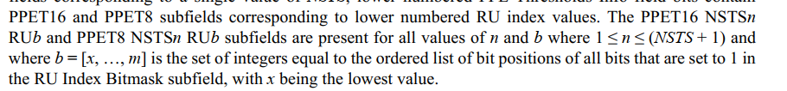
Regarding the CID 17724, I agree with the commenter that the NSS_PE definition has been defined in the same section and just two paragraphs earlier. Thus the related part could be deleted.

CID 17722
Page.  Line | Clause Number | Comment | Proposed Change | Resolution
290.60 | 9.4.2.313.5 | "Shall" does not belong in clause 9 after 9.1. Also spurious "values" | Change "shall contain" to "contains". Similar changes at P290L62.5, P291L2 | REVISED.  Agree with the commenter.  Instructions to the editor:  Please make the changes as shown under CID 17722 in 11-23/0611r0.

Instructions to the editor: please make the following changes to Page 290, Line 60 in the subclause 9.4.2.313.5 (EHT PPE Thresholds field) in D3.0 as shown below:
The RU Index Bitmask subfield contains at least one bit equal to 1.

Instructions to the editor: please make the following changes to Page 290, Line 62 in the subclause 9.4.2.313.5 (EHT PPE Thresholds field) in D3.0 as shown below:
To indicate nominal packet padding values of 0 µs for all modes, the PPE Thresholds Present subfield and the Common Nominal Packet Padding subfield are set to 0 in the EHT Capabilities element (see 35.13 (Nominal packet padding values selection rules) for details).

Instructions to the editor: please make the following changes to Page 291, Line 2 in the subclause 9.4.2.313.5 (EHT PPE Thresholds field) in D3.0 as shown below:
… while the PPETmax and PPET8 values of that RU allocation index are the same as the PPETmax and PPET8 values of the closest smaller RU allocation index with the bitmask value equal to 1 in the RU Index Bitmask subfield.

CID 17723
Page.  Line | Clause Number | Comment | Proposed Change | Resolution
290.64 | 9.4.2.313.5 | "0s" is ambiguous - could be bits/nibbles/octets/words etc | Try " If there exists one or more bits equal to 0 after the first bit equal to 1 in the bitmask sequence in the RU Index Bitmask subfield .. those bits equal to 0" | REVISED.  Agree with the commenter.  Instructions to the editor:  Please make the changes as shown under CID 17723 in 11-23/0611r0.

Instructions to the editor: please make the following changes to Page 290, Line 64 in the subclause 9.4.2.313.5 (EHT PPE Thresholds field) in D3.0 as shown below:
If there exists one or more bits equal to 0 after the first bit equal to 1 in the bitmask sequence in the RU Index Bitmask subfield, the PPETmax and PPET8 subfields for each RU allocation index corresponding to those bits equal to 0 are not present …

CID 17725
Page.  Line | Clause Number | Comment | Proposed Change | Resolution
291.28 | 9.4.2.313.5 | "RU index" should be "RU allocation index" | As in comment | ACCEPTED.

Discussion (the related text is shown below):
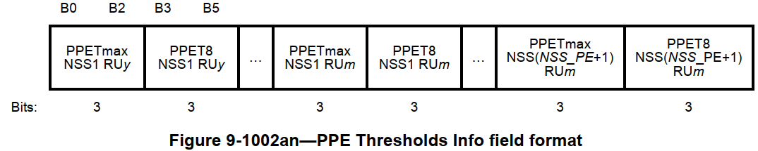
Within a set of PPETmax and PPET8 subfields corresponding to a single value of NSS, lower numbered PPE Thresholds Info field bits contain PPETmax and PPET8 subfields corresponding to lower numbered RU index values.

CID 17726
Page.  Line | Clause Number | Comment | Proposed Change | Resolution
292.02 | 9.4.2.313.5 | Number not right; missing article | Could consider "For RU allocation indices 2, 3, and 4, .." but then a search on RU allocaton index" fails, so try the preferred "For an RU allocation index equal to 2, 3, and 4, ..." | ACCEPTED.

Discussion (the related text is shown below):
For RU allocation index 2, 3, and 4, more than one RU or MRU shares the same RU allocation index.

CID 17727
Page.  Line | Clause Number | Comment | Proposed Change | Resolution
292.03 | 9.4.2.313.5 | Spurious article | Try "for 80 MHz, 160 MHz, and 320 MHz PPDUs" | ACCEPTED.

Discussion (the related text is shown below):
The initial RU allocation indices for 80 MHz, 160 MHz, and 320 MHz PPDUs …

CID 17729
Page.  Line | Clause Number | Comment | Proposed Change | Resolution
292.26 | 9.4.2.313.5 | A bald "round" is a misleading verb since it imples round-to-nearest which allows for rounding *down*. | Try "round up". Or better, follow the style of other pad fields more closely: "The length of the PPE Pad subfield is up to seven bits and is chosen so that the EHT PPE Thresholds field is an integer multiple of 8 bits." | REVISED.  Agree with the commenter. The sentence is revised to be clear.  Instructions to the editor:  Please make the changes as shown under CID 17729 in 11-23/0611r0.

Instructions to the editor: please make the following changes to Page 292, Line 26 in the subclause 36.3.16 (Transmit requirements for PPDUs sent in response to a triggering frame) in D3.0 as shown below:
The PPE Pad subfield contains all 0s. The maximum length of the PPE Pad subfield is seven bits and the length is chosen so that the EHT PPE Thresholds field is an integer multiple of 8 bits.

Instructions to the editor: please make the following changes to Page 290, Line 38 in the subclause 36.3.16 (Transmit requirements for PPDUs sent in response to a triggering frame) in D3.0 as shown below:
Change “0 or 7” to “0 to 7” in Figure 9-1002am.

Discussion (the related figure is shown below):
