IEEE P802.11
Wireless LANs
Proposed resolutions for editorial comments on D1.0 - Part 3
Date: 2022-04-20
Author(s):
Name | Affiliation | Address | Phone | email
Claudio da Silva | Meta Platforms, Inc |  |  | claudiodasilva@meta.com
Abstract
This document contains proposed resolutions for editorial comments on D1.0 (LB272). The text used as reference is D1.0.

CIDs: 1092, 1093, 1094, 1095, 1096, 2021, 1991, 1992, 2118, 1532, 1020, 1173, 1803, 1449, 1495, 1502, 1756, 1998, 1994, 1311, 2253, 1731, 1585, 2145

CID | Page | Comment | Proposed change | Proposed resolution
1092 | 113.15 | The 802.11 Style Guide (11-19/1034r20) defines that "When defining a new element, as a general rule, do not list the frames that carry the element as part of element definition, and only list the element in the body of each of those frames that can include the element. Listing the frames that can carry the element is duplicate information (it can be inferred from frame definitions), and subject to inconsistencies over iterations of the specifications. Notable exception is when element definition depends on the frame it is carried in." | Delete "The element may be present in the Association Request, Association Response, Reassociation Request, Reassociation Response, Probe Response and Sensing Measurement Setup Query frames." | Accepted

Discussion: Comment is on the definition of the Sensing element. This element is correctly included in the definitions of all frames that carry it:
- Association Request frame
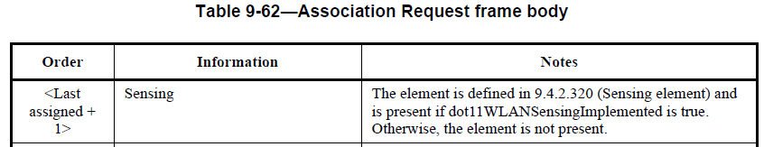
- Association Response frame
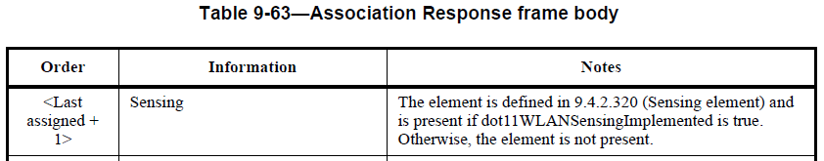
- Reassociation Request frame
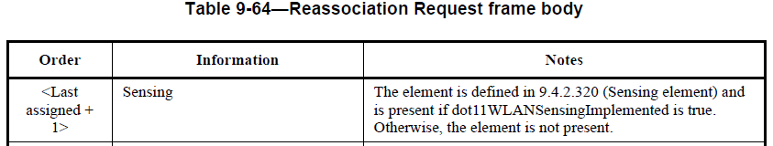
- Reassociation Response frame
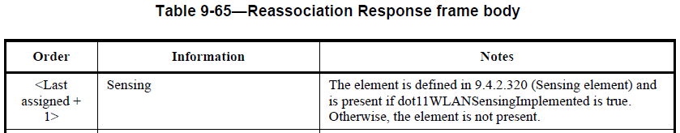
- Probe Response frame
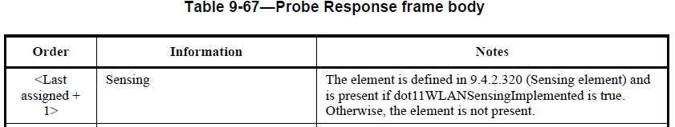
- Sensing Measurement Setup Query frame
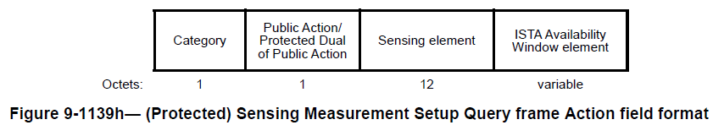

CID | Page | Comment | Proposed change | Proposed resolution
1093 | 118.08 | The 802.11 Style Guide (11-19/1034r20) defines that "When defining a new element, as a general rule, do not list the frames that carry the element as part of element definition, and only list the element in the body of each of those frames that can include the element. Listing the frames that can carry the element is duplicate information (it can be inferred from frame definitions), and subject to inconsistencies over iterations of the specifications. Notable exception is when element definition depends on the frame it is carried in." | Delete "The element is present in the Association Request, Association Response, Reassociation Request, Reassociation Response, Probe Request and Probe Response frames and can be present in the DMG Beacon, Information Request, and Information Response frames." | Accepted

Discussion:
- Comment is on the definition of the DMG Sensing Capabilities element.
- Our draft correctly includes this element in the definitions of the Association Request, Association Response, Reassociation Request, Reassociation Response, Probe Request, Probe Response, and DMG Beacon frames.
- In our baseline, the Information Request and Information Response frames defines the possible presence of “provided elements”/”requested elements” (“Zero or more provided elements”, “zero or more requested elements”), which may be a DMG Sensing Capabilities element.

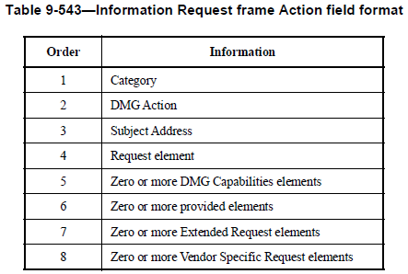

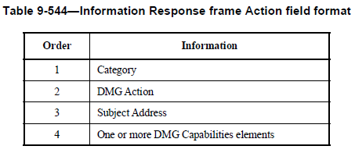
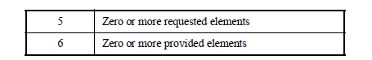
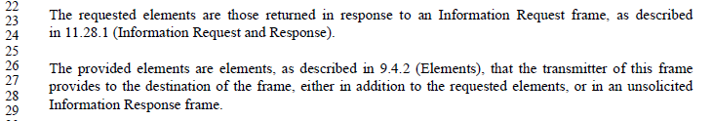

CID | Page | Comment | Proposed change | Proposed resolution
1094 | 121.12 | The 802.11 Style Guide (11-19/1034r20) defines that "When defining a new element, as a general rule, do not list the frames that carry the element as part of element definition, and only list the element in the body of each of those frames that can include the element. Listing the frames that can carry the element is duplicate information (it can be inferred from frame definitions), and subject to inconsistencies over iterations of the specifications. Notable exception is when element definition depends on the frame it is carried in." | Delete "The element may be present in DMG Beacons, Association Request, Association Response, Reassociation Request, Reassociation Response, Probe Request, Probe Response Information Request, and Information Response frames." | Accepted

Discussion:
- Comment is on the definition of the DMG Sensing Short Capabilities element.
- Our draft correctly includes this element in the definitions of the Association Request, Association Response, Reassociation Request, Reassociation Response, Probe Request, Probe Response, and DMG Beacon frames.
- In our baseline, the Information Request and Information Response frames defines the possible presence of “provided elements”/”requested elements” (“Zero or more provided elements”, “zero or more requested elements”), which may be a DMG Sensing Capabilities element.

CID | Page | Comment | Proposed change | Proposed resolution
1095 | 122.05 | The 802.11 Style Guide (11-19/1034r20) defines that "When defining a new element, as a general rule, do not list the frames that carry the element as part of element definition, and only list the element in the body of each of those frames that can include the element. Listing the frames that can carry the element is duplicate information (it can be inferred from frame definitions), and subject to inconsistencies over iterations of the specifications. Notable exception is when element definition depends on the frame it is carried in." | Delete "The DMG Sensing Measurement Setup element is contained in Sensing Setup frames." | Accepted

Discussion:
- There is no “Sensing Setup frame” (incorrectly capitalized).
- DMG Sensing Measurement Setup element is included in the DMG Sensing Measurement Setup Request, DMG Sensing Measurement Setup Response, DMG SBP Request, and DMG SBP Response frame.

CID | Page | Comment | Proposed change | Proposed resolution
1096 | 138.05 | The 802.11 Style Guide (11-19/1034r20) defines that "When defining a new element, as a general rule, do not list the frames that carry the element as part of element definition, and only list the element in the body of each of those frames that can include the element. Listing the frames that can carry the element is duplicate information (it can be inferred from frame definitions), and subject to inconsistencies over iterations of the specifications. Notable exception is when element definition depends on the frame it is carried in." | Delete "The BRP Sensing element is sent within a BRP frame if the DMG Sensing subfield in the BRP Request field is set to 1." | Revised

Discussion:
- BRP Sensing element is included in the BRP frame:
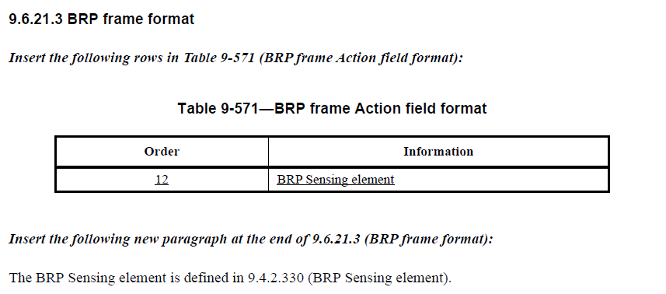
- In our baseline,
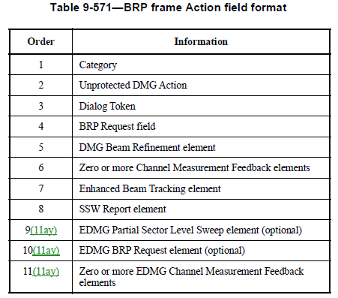
- The fact that the DMG Sensing element is included only if the DMG Sensing subfield in the BRP Request field is set to 1 must be moved to the frame definition.

Modifications: TGbf Editor – Change 155.45 (D1.0) as follows:
The BRP Sensing element is defined in 9.4.2.330 (BRP Sensing element). The BRP Sensing element is present in the frame if the DMG Sensing subfield within the BRP Request field is set to 1.

CID | Clause | Page | Comment | Proposed change
2021 | 9.4.2.319 | 109.30 | It's helpful to indicate in which frames this element can be included. Compare with e.g. P113L12, which indicates in which frames the Sensing Element may be present. | "Mention the frames that can use the Sensing Measurement Parameters Element.  Similar comment for SBP Parameters element (9.4.2.321)"

Proposed resolution: Rejected

Discussion: The 802.11 Style Guide (11-19/1034r20) defines that "When defining a new element, as a general rule, do not list the frames that carry the element as part of element definition, and only list the element in the body of each of those frames that can include the element. Listing the frames that can carry the element is duplicate information (it can be inferred from frame definitions), and subject to inconsistencies over iterations of the specifications. Notable exception is when element definition depends on the frame it is carried in."

CID | Clause | Page | Comment | Proposed change
1991 | 9.4.2.1 | 105.48 | The "Element ID Extension" numbers in Table 9-128 are not in the ANA database. Please request allocation of the "Element ID Extension" numbers in Table 9-128 in the ANA database. | As in comment
1992 | 9.4.2.26 | 106.56 | The "Extended Capabilities field" Table 9-190 is in the ANA database. The Bits "90" and "91" are reserved by 11az. Please request allocation of "WLAN Sensing" and "SBP" information in Table 9-190 in the ANA database. | As in comment

Proposed resolution: Revised

Discussion:
- ANA assignments used in the P802.11bf draft were made by the IEEE 802.11 Editor in https://www.ieee802.org/11/email/stds-802-11-editors/msg00523.html
- As found in the email referred above, “The other things [Note: Including "Element ID Extension" numbers in Table 9-128] requested are not ANA administered, so assign numbers editorially. For the order of elements in Beacon, Probe Request, etc., look at you baseline and choose the next available (maintain these numbers similar to paragraph numbering). Same with some of the Action fields. The probability of conflict here between the TGs is pretty low.”
- For the sake of being consistent with other parts of the draft (such as in Table 9-487) and reduce the likelihood of errors, suggest using the format “<Last assigned + n>” instead of numerical values

Modifications: TGbf Editor – Change the Element ID Extension values in Table 9-128 from numerical values to the format “<Last assigned + n>”.

CID | Clause | Page | Comment | Proposed change
2118 | 11.55.1.5.2.1 | 163.20 | Typo: The comma should be full stop | As in comment

Proposed resolution: Revised

Discussion:
- Correct page number is P178L5.
- Sentence “In the TF sounding phase, the AP sends an SR2SI Sounding Trigger frame to STA1 and STA 2 to solicit SR2SI NDP transmissions,” appears twice.

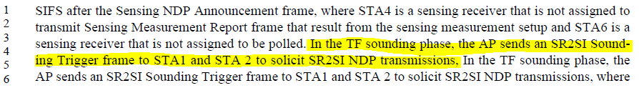

Modifications: TGbf Editor – Delete one of the two “In the TF sounding phase, the AP sends an SR2SI Sounding Trigger frame to STA1 and STA 2 to solicit SR2SI NDP transmissions,” sentences in 178.3-5.

CID | Clause | Page | Comment | Proposed change
1532 | 11.55.1.5.2.2 | 178.65 | Missing article | change the text to "one of the following"

Proposed resolution: Revised

Discussion:
- Correct page number is P173L65.
- For reference,

Modifications: TGbf Editor – In P173L65, change “one of following” with “one of the following”.

CID | Page | Comment | Proposed change | Proposed resolution
1020 | 37.59 | change 'sensing responder to sensing responder (SR2SR)' to SR2SR | change 'sensing responder to sensing responder (SR2SR)' to SR2SR | REJECTED  The acronym is spelled out because it is its 1st occurrence within the draft text.
1173 | 46.37 | change 'unassociated STA identifier (USID)' to USID | change 'unassociated STA identifier (USID)' to USID

CID | Page | Comment | Proposed change | Proposed resolution
1803 | 190.50 | It is better to descibe What does SBP mean. | add sentence like below SBP means Sensing By Proxy. | REJECTED  The acronym is defined in 3.4 (Abbreviations and acronyms) and spelled out in its 1st occurrence within the draft text (24.16).

CID | Page | Comment | Proposed change | Proposed resolution
1449 | ?.27 | Heading level is wrong. Looks like "11.55.1.5.2 TB sensing measurement instance" and "11.55.1.5.2.1 General" are at the same heading level. |  | REJECTED  The comment fails to identify changes so that the specific formating/wording of the changes that will satisfy the commenter can be determined.

Discussion: Text referred to by the commenter is:
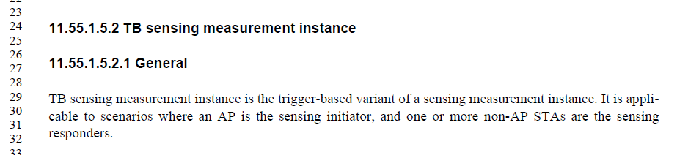

CID | Page | Comment | Proposed change | Proposed resolution
1495 | 112.01 | Clarify AP type | Change "AP" to "AP STA" | REJECTED  AP is defined as “An entity that contains one station (STA) and provides access to the distribution system  services, via the wireless medium (WM) for associated STAs. An AP comprises a STA and a distribution  system access function (DSAF).” That is, by definition, an AP contains a STA and, for this reason, “AP STA” is not used in the baseline.
1502 | 170.40 | The exchange is between an AP STA and a non-AP STA. | Change "of an AP" to "of an AP STA"

Discussion: Texts referred to by the commenter are:

CID | Page | Comment | Proposed change | Proposed resolution
1756 | 0.00 | Delete text associated with references as the baseline has been modified to reflect as such. For instance the text "(see 11.55.1 (WLAN sensing procedure))" and "shown in Figure 9-83d (STA Info field in a Sensing NDP Announcement frame with AID11 subfield equal to 2044)" would be replaced with | "(see 11.55.1)" and "shown in Figure 9-83d" respectively | REJECTED  The titles of all figures, tables, clauses… are used in all drafts (including in our baseline, REVme/D1.4 and 11be/D2.2) to allow editors and contributors to more easily refer to the correct figure/table/clause and track changes.  These titles are removed by IEEE editorial staff once the draft is ratified. Final published standards and amendments, such as IEEE Std 802.11‐2020 and IEEE Std 802.11ay-2021, do not include the titles of figures, tables, clauses…

CID | Page | Comment | Proposed change | Proposed resolution
1998 | 176.45 | Please use "X" instead of the square root sign for indicateing the presence of a phase as in REVme D1.4 Table 8-2. | As in comment | ACCEPTED

CID | Page | Comment | Proposed change | Proposed resolution
1994 | 114.51 | In 11be D2.2 the "EHT Capbilities element" is in subclause 9.4.2.313. Please correct the subclause number in the reference from "9.4.2.213" to "9.4.2.313". | As in comment | ACCEPTED
Discussion: For reference, from IEEE P802.11be/D2.2,

CID | Page | Comment | Proposed change | Proposed resolution
1311 | 141.26 | belonmging to' is a typo | change 'belonmging to' as 'with' | ACCEPTED
Discussion: For reference,

CID | Page | Comment | Proposed change | Proposed resolution
2253 | 180.41 | Since two subfields are mentioned in the sentence, use "values" in the setence. | In the Sensing NDP Announcement frame, the AP shall set the values of the SI2SR NSTS subfield and of the SI2SR Rep subfield within the STA Info fields corresponding to each of the STAs addressed by that frame, to be less than or equal to the values of the Sensing Assigned SI2SR STS and Sensing Assigned SI2SR Rep, respectively. | ACCEPTED
Discussion: For reference,
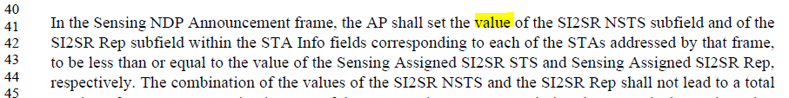

CID | Page | Comment | Proposed change | Proposed resolution
1731 | 180.41 | Delete the word "of" after the word "and" | As per comment | ACCEPTED
Discussion: For reference,

CID | Page | Comment | Proposed change | Proposed resolution
1585 | 90.14 | bad preposition | remove 'for' in "remaining report segments for corresponding" | ACCEPTED
Discussion: For reference,

CID | Page | Comment | Proposed change | Proposed resolution
2145 | 113.05 | Availability Window in TB Sensing Specific subelement is a subfield instead of field. | Replace "Availability Window field" with "Availability Window subfield" | ACCEPTED
Discussion: For reference,

