IEEE P802.11
Wireless LANs
Proposed IEEE 802.11 AIML TIG Technical Report Text for the Dual CSI Feedback Use Case
Date: 2023-04-05
Author(s):
Name | Affiliation | Address | Phone | Email
Eunsung Jeon | Samsung | 1-1, Samsungjeonja-ro, Hwaseong-si, Gyeonggi-do 18448 Korea | +82-10-2317-5808 | eunsung.jeon@samsung.com
Myeongjin Kim |  |  | +82-10-9120-7244 | mj1108.kim@samsung.com
Chulho Chung |  |  | +82-10-7294-0729 | ch29.chung@samsung.com
Abstract
This document contains the proposed technical report text of the IEEE 802.11 AIML TIG, especially for the dual CSI feedback use case.

Revision history:
r0: initial version

Table of Contents

- Introduction
  - Terminologies
  - Background information

- AIML Use cases for IEEE 802.11
Note: use cases potentially can be organized into different categories
Note: use cases potentially can identify KPIs

Use case N: Dual CSI feedback

Use case description

A beamforming is a technique of multiple antennas for steering a beam of an antenna array only to a corresponding STA. The channel state information (CSI) feedback should be preceded for a beamforming transmission. In order to reduce CSI feedback overhead, numerous CSI compression techniques have been developled so far. This can be can be categorized into two groups: one is based on the vector quantization using codebook (CB) and the other is using Givens rotation (GV).

The CB-based compression can reduce the feedback overhead significantly by feeding back an index of the predefined codebook, which has been used in 3GPP LTE systems. However, the selected codebook is not necessarily the optimal beamforming feedback matrix due to the limited cardinality of the codebook, showing PER performance compared with the GV-based compression. On the other hand, the GV-based compression has been adopted in WLAN systems such as 802.11n/ac/ax/be [1], [2]. The beamforming feedback matrix, which is a unitary matrix, is compressed by a series of GV matrices and each of the GV matrices is exprssed in the angular form. However, GV-based compression is known to incur huge feedback overhead, especially for the systems using a large bandwidth and/or a large number of antennas. This problem was addressed by the IEEE 802.11 standardization and a new designs for CSI compression may be needed to support higher number of spatial streams (e.g., 16 spatial streams) MIMO and/or wider bandwidth (e.g., 640 MHz).

The dual CSI compression combines CB and GV to maximize the advantages of both techniques. The basic idea is to decompose a large size CSI into a subband CSI and a subcarrier CSI, giving lower feedback rate for the slow-varying subband CSI using the CB while allocating higher feeback rate for the frequency-selective subcarrier CSI using the GV. Without loss of generality, a unitary matrix V can be expressed as the multiplication of two unitary matrices, i.e., V = V₁ V₂. Using this fact, a unitary matrix V is decomposed by multiplication of two unitary matrices, i.e., V₁ and V₂ as shown in Fig.1. Here, V₁ consists of K eigenvectors corresponding to the K largest eigenvalues which maximizes the channel capacity averaged over one subband. Since only K eigenvectors are chosen from the full dimensional matrix, the dimension reduced V₁ can reduce the overall feedback overhead. More detail algorithms for the dimension reduction are shown in [3], [4].

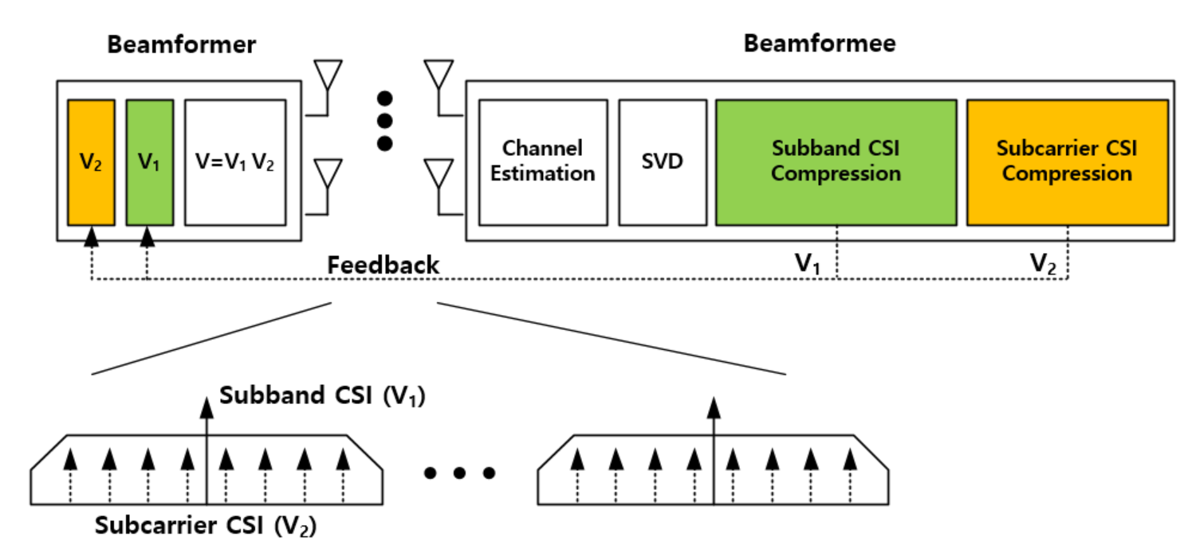
Figure 1. Illustration of WLAN systems with the dual CSI feedback.

Furthermore, in order to improve the reliability for subband CSI, the AIML technique based on the K-means algorithm is exploited in the codebook generation [5]. As shown in Fig.2, it finds a predefined number of centroids of data samples in an iterative manner. This process continues by updating the centroid in each cluster until the average Euclidean distance (ED) between the centroid and the data samples is minimized. The converged centroids are selected as the final codebook. The difference to the conventional K-means algorithm is that it finds a new centroid in terms of the minimum ED in each cluster, while the conventional K-means algorithm computes the mean of the data samples in each cluster to obtain the centroid. For fast convergence, the DFT-codebook is used for the initial centroid of the algorithm.

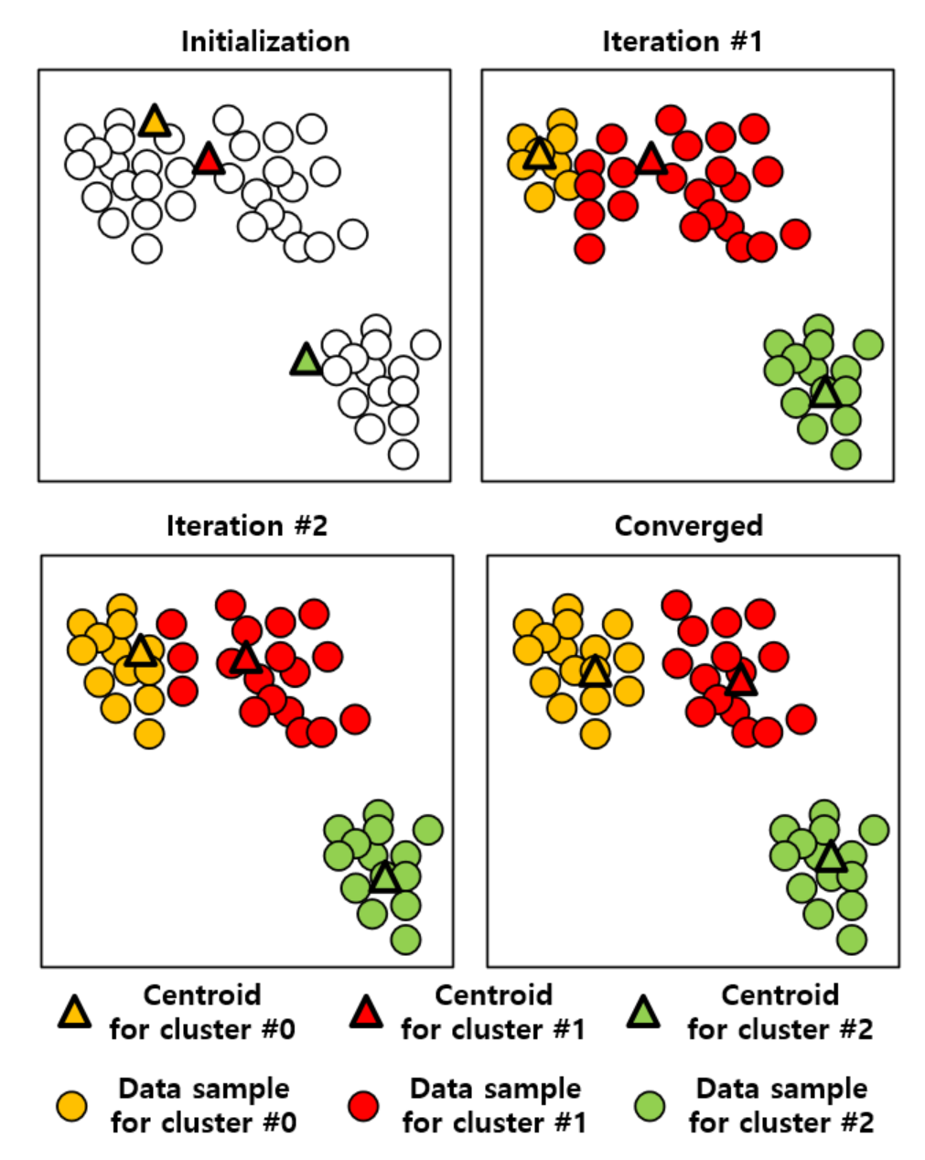
Figure 2. An example of the K-means algorithm iteration.

The simulation is performed extensively using an IEEE 802.11be link-level simulator. For a 8x2 SU-MIMO, the results shows that the AIML aided dual CSI compression can reduce the feedback overhead more than 50% compared with the conventional GV-based scheme. In addition, the throughput improvement from the reduced overhead is about 20% [6].

This use case proposes to apply AIML technique to dual CSI compression to reduce the feedback overhead with minimum loss of PER performance.

KPIs
KPIs considered in this use case are proposed as follows:
- Number of feedback bits
- Achieved PER
- Throughput
- Computation complexity/Latency:
  - Additional delay or computation is introduced by AIML processing.
Evaluation methodology needs to be established.

Requirements
- Backward compatibility with legacy 802.11
  - Support backward compatibility and coexistence with legacy 802.11 CSI report schemes
- Performance should follow the guidance below:
  - CSI airtime reduction: achieve airtime reduction of CSI feedback over 802.11be for a given N_{r} x N_{c} MIMO, where N_{r} is the number of rows in the compressed beamforming feedback matrix, N_{c} is the number of columns in the compressed beamforming feedback matrix.
  - Packet Error rate (PER): guarantee minimum SNR loss compared with 802.11be to achieve the target PER (e.g., 1% and/or 10%) at a given MCS in all types of channels [7].
  - Computation complexity/Latency: minimize the additional computation complexity or latency required by AIML process

Technical Feasibility Analysis

Standard Impact
The standard impact may include:
- Define the signaling between AP and non-AP STAs, e.g., CSI report format indication, capability indication, training model parameters, etc.

Technical feasibility

The following metrics will be studied:

- Backward compatibility: The STAs with supporting AIML enabled dual CSI compression shall support the legacy 802.11 CSI report scheme. This compatibility is expected to be supported since AIML capable STAs are expected to support legacy CSI report scheme.

- Hardware/software capability: The STAs that use AIML to generate the AIML enabled dual CSI compression shall have the hardware and software capability to support AIML algorithms.

- Summary
- References
- IEEE 802.11-REVme D2.0, October 2022
- IEEE P802.11be D2.2, October 2022
- 802.11-19/1018r0, Feedback Overhead Reduction
- 802.11-19/1115r1, Reduced Beamforming Feedback for 802.11be
- 802.11-22/950r2 Discussion on Interaction between AI/ML & Wireless LAN
- 802.11-23/0280r0, ML aided Dual CSI Feedback for Next Generation WLANs
- 802.11-19/0719r1, IEEE 802.11be Channel Model Document

