IEEE P802.11
Wireless LANs
TGbe D3.0 LB271 Comment Resolutions
for A-MPDU in 9.7
Date: 2023-05-03
Author(s):
Name | Affiliation | Address | Phone | email
SunHee Baek | LG Electronics | 19, Yangjae-daero 11gil, Seocho-gu, Seoul 137-130, Korea |  | sunhee.baek@lge.com
Insun Jang |  |  |  | insun.jang@lge.com
Geonhwan Kim |  |  |  | geonhwan.kim@lge.com
Yelin Yoon |  |  |  | yl.yoon@lge.com
Jinsoo Choi |  |  |  | js.choi@lge.com

Abstract
This submission proposes resolutions for comments on TGbe D3.0 regarding A-MPDU format with the following CIDs (4 CIDs):
- 16136, 17790, 17791, 18005

Revisions:
- Rev 0: Initial version of the document.

Interpretation of a Motion to Adopt

A motion to approve this submission means that the editing instructions and any changed or added material are actioned in the TGbe Draft. This introduction is not part of the adopted material.

Editing instructions formatted like this are intended to be copied into the TGbe Draft (i.e. they are instructions to the 802.11 editor on how to merge the text with the baseline documents).

TGbe Editor: Editing instructions preceded by “TGbe Editor” are instructions to the TGbe editor to modify existing material in the TGbe draft. As a result of adopting the changes, the TGbe editor will execute the instructions rather than copy them to the TGbe Draft.

CID | Commenter | Clause  (page.line) | Comment | Proposed Change | Resolution
17790 | Brian Hart | 9.7.1  (326.19) | Can we order names by amendment order? | "HT, VHT, HE and EHT" | Accepted  TGbe editor, please make changes as shown in doc 11-23/0559r0 tagged as CID 11986
18005 | Yanjun Sun | 9.7.3  (326.52) | Revise "and is not an EHT TB PPDU" to "or an EHT TB PPDU". | As in comment | Accepted  TGbe editor, please make changes as shown in doc 11-23/0559r0 tagged as CID 18005

Propose:
TGbe editor: Please note that the baseline is 11be D3.1.
9.7 Aggregate MPDU (A-MPDU)
9.7.1 A-MPDU format

TGbe editor: Please change the 15th paragraph as follows:

NOTE 2—The format of the MPDU Length field maintains a common encoding structure for (17790)HT, VHT, HE, and EHT PPDUs. For HT PPDUs, only the MPDU Length Low subfield is used, while for VHT, HE, and EHT PPDUs, both subfields are used.

9.7.3 A-MPDU contents

TGbe editor: Please change the 10th paragraph as follows:

A VHT MU PPDU, S1G MU PPDU, HE MU PPDU, and EHT MU PPDU do not carry more than one A-MPDU that contains one or more MPDUs soliciting an immediate response if the immediate response is carried in a PPDU that is not an HE TB PPDU (18005)or an EHT TB PPDU. An HE MU PPDU and an EHT MU PPDU can carry more than one A-MPDU each of which contains one or more MPDUs soliciting an immediate response if the immediate response is carried in an HE TB PPDU or an EHT TB PPDU.

CID | Commenter | Clause  (page.line) | Comment | Proposed Change | Resolution
17791 | Brian Hart | 9.7.1  (326.60) | Missing article x2, fieldname not capitalized, should be called a field | "or in *a* Reconfiguration Multi-Link element with an Operation Update Type subfield equal to 0" | Revised  Agree with the commenter. The changes are applied below.  TGbe editor, please make changes as shown in doc 11-23/0559r0 tagged as CID 17791
16136 | SunHee Baek | 9.7.3  (326.60) | Maximum A-MSDU Length field in Reconfiguration Multi-Link element is located only when Operation Update Type subfield in STA Control field equal to 0 and Maximum A-MSDU Length Present subfield in STA Info field is set to 1. | Please change "or in Reconfiguration Multi-Link element with operation update type equal to 0" to "in Reconfiguration Multi-Link element with Operation Update Type subfield equal to 0 and Maximum A-MSDU Length Present subfield equal to 1". | Revised  Maximum A-MSDU Length subfield in the Operation Parameter Info subfield is optional and whether the subfield is present is indicated by a value of the Maximum A-MSDU Legth Present subfield. Only when the Maximum A-MSDU Length Present subfield is set to 1, the Maximum A-MSDU length subfield is included in Operation Parameter Info subfield of Reconfiguration Multi-Link element.  TGbe editor, please make changes as shown in doc 11-23/0559r0 tagged as CID 16136

*Reference: Reconfiguration Multi-Link element format based on 11be D3.1

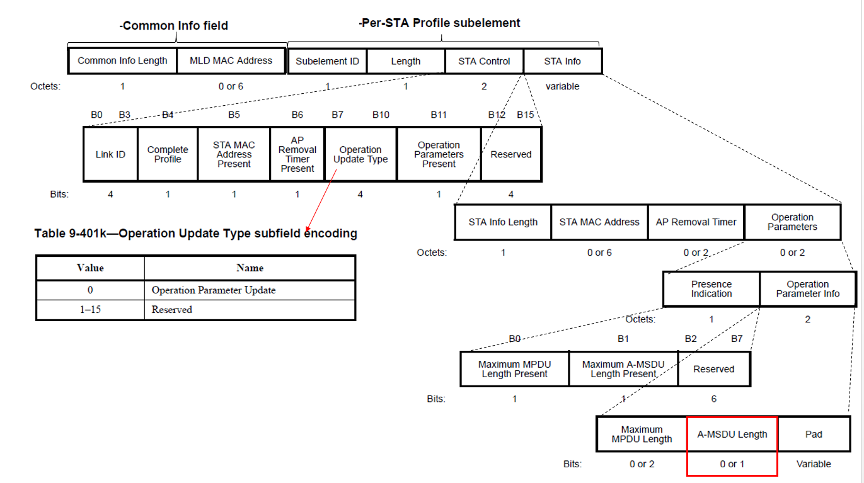

Propose:
TGbe editor: Please note that the baseline is 11be D3.1.
9.7 Aggregate MPDU (A-MPDU)
9.7.3 A-MPDU contents

TGbe editor: Please change the 12th paragraph as follows:

NOTE 4—If a STA supports A-MSDUs of 7935 octets (indicated by the Maximum A-MSDU Length field in the HT Capabilities element or in (17791)a Reconfiguration Multi-Link element with (16136)Operation Update Type subfield in the STA Control field equal to 0 and Maximum A-MSDU Length Present subfield in the STA Info field equal to 1), A-MSDUs transmitted by that TA within an A-MPDU carried in a PPDU with FORMAT HT_MF or HT_GF or within an MPDU carried in a non-HT PPDU are constrained so that the length of the QoS Data frame carrying the A-MSDU is no more than 4095 octets. The 4095-octet MPDU length limit does not apply to A-MPDUs carried in VHT, HE, EHT or DMG PPDUs. The use of A-MSDU within A-MPDU might be further constrained as described in 9.4.1.13 (Block Ack Parameter Set field) through the operation of the A-MSDU Supported field.

