IEEE P802.11  
Wireless LANs

|  |  |  |  |  |
| --- | --- | --- | --- | --- |
| LB271 Comment Resolution | | | | |
| Date: 2023-07-12 | | | | |
| Author(s): | | | | |
| Name | Affiliation | Address | Phone | email |
| Michail Koundourakis | Samsung Cambridge Solution Centre |  |  | m.koundou at partner.samsung.com |
| Mark Rison | Samsung Cambridge Solution Centre |  |  |  |
| Srinivas Kandala | Samsung |  |  |  |

Abstract

This submission proposes comment resolution for the following 1 CID received in LB271 on TGbe D3.0 related to EMLSR mode:

CIDs:

15062

Revisions:

* Rev 0: Initial version of the document.
* Rev 1: Updated to D3.2

|  |  |  |  |  |  |  |
| --- | --- | --- | --- | --- | --- | --- |
| **CID** | **Commenter** | **Clause Number** | **Page.**  **Line** | **Comment** | **Proposed Change** | **Resolution** |
| 15062 | Michail Koundourakis | 35.3.17 | 564.37 | There is no need to transition to active mode on all EMLSR links, one link should be enough. | Allow the non-AP STA to operate with only 1 EMLSR link in PM=0. | Revised  TGbe editor to make the changes with the CID tag (#15602) in IEEE 802.11-23/0544r1. |

**Discussion:**

Current EMLSR behaviour moves all EMLSR links to awake when EMLSR is enabled. This might be reasonable and optimal when the non-AP MLD plans to use all EMLSR links immediately after enabling EMLSR mode, but the non-AP MLD may have other plans:

* It may want to enable EMLSR for a number of links, but not use them all at all times.
* For a single radio MLD (*A single radio non-AP MLD shall set the Maximum Number Of Simultaneous Links subfield in the Common Info field of the Basic Multi-Link element carried in transmitted Management frames to 0*), enabling EMLSR for a subset of links (i.e. leaving links out of the EMLSR links in PM=1) does not prohibit the AP MLD from advertising BUs on any links (links which are not included in EMLSR are not defined as disabled).
* It tries to be power efficient, so the overhead of explicitly moving all unused links back to PM=1 wastes power (note that transmitting a frame with PM=1 is EMLSR mode on a specific link may have much higher latency compared to single link operation, as the single radio may be engaged on DL TXOP(s) on another link).

The following diagram demonstrates the current EMLSR enable sequence and the issue with the increased power consumption:

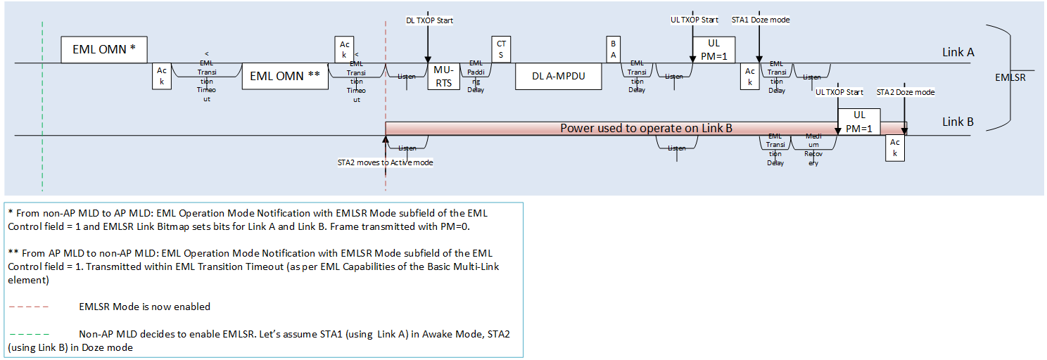

The next diagram demonstrates how EMLSR enable sequence can become more power efficient using this proposal.

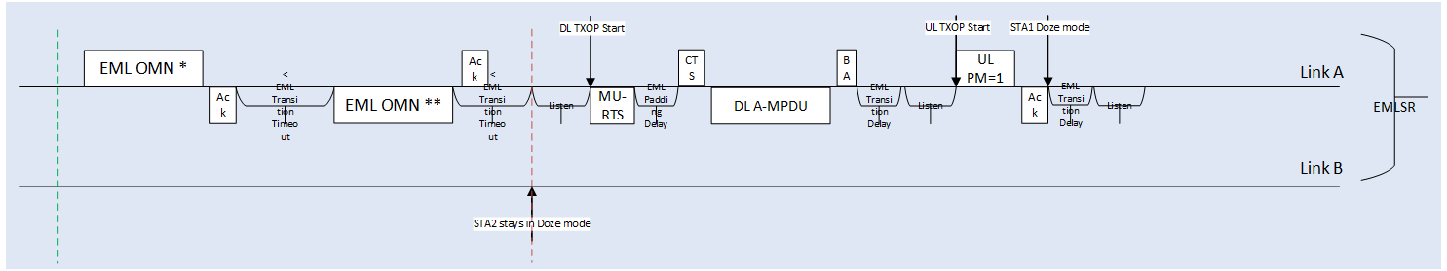

Note that the proposal maintains backward compatibility with D3.0 (and maybe earlier versions); the value of 0 is used to signal existing behaviour.

**Resolution:**

**TGbe Editor to make the following changes in Subclause 9.4.2.312.2.3 (Common Info field of the Basic Multi-Link element) in TGbe D3.2**

**9.4.2.312.2.3 Common Info field of the Basic Multi-Link element**

…

**TGbe Editor to modify Table 9-1001j in Subclause 9.4.2.312.2.3 (Common Info field of the Basic Multi-Link element) in TGbe D3.2 (#15062):**

B0 B1 B3 B4 B6 B7 B8 B10 B11 B14 B15

|  |  |  |  |  |  |  |
| --- | --- | --- | --- | --- | --- | --- |
| EMLSR  Support | EMLSR  Padding Delay | EMLSR  Transition Delay | EMLMR  Support | EMLMR  Delay | Transition Timeout | (#15062)PM Transition Mode |

Bits: 1 3 3 1 3 4 1

**Figure 9-1002j—EML Capabilities subfield format**

…

**TGbe Editor to add the following two paragraphs (P279L34 in TGbe D3.2) with the Table 9-401x in Subclause 9.4.2.312.2.3 (Common Info field of the Basic Multi-Link element) in TGbe D3.2 (#15062):**

(#15062)The PM Transition Mode subfield indicates the power management state of the STA(s) affiliated with the non-AP MLD for which the EMLSR Link Bitmap subfield of the EML Control field of the EML Operating Mode Notification frame has the corresponding bits set to 1, when EMLSR mode is enabled (see 35.3.18 (Enhanced multi-link multi-radio operation)).

When the PM Transition Mode subfield is included in a frame sent by a non-AP STA affiliated with a non-AP MLD, the PM Transition Mode subfield is set as defined in Table 9-401x (Encoding of the PM Transition Mode subfield). When the PM Transition Mode subfield is included in a frame sent by an AP affiliated with an AP MLD, the PM Transition Mode subfield is reserved.

**Table 9-401x—Encoding of the PM Transition Mode subfield**

|  |  |
| --- | --- |
| **PM Transition Mode subfield value** | **Transition** |
| 0 | Non-AP STAs transition to active mode when EMLSR is enabled |
| 1 | Non-AP STAs remain in existing power save mode when EMLSR is enabled or disabled |

**TGbe Editor to make the following changes in Subclause 35.3.17 (Enhanced multi-link single radio operation) in TGbe D3.2**

…

**TGbe Editor to modify the following paragraphs (starting from P590L58 in TGbe D3.2) in Subclause 35.3.17 (Enhanced multi-link single radio operation) in TGbe D3.2 (#15062):**

When a non-AP MLD with dot11EHTEMLSROptionActivated equal to true intends to enable the EMLSR mode on the EMLSR links, (#15075)then:

* A non-AP STA affiliated with the non-AP MLD shall transmit an EML Operating Mode Notification frame with the EMLSR Mode subfield of the EML Control field of the frame set to 1 to an AP affiliated with (#15562)its associated AP MLD with dot11EHTEMLSROptionActivated equal to true.
* An AP affiliated with the AP MLD (#16675)should (#15592)successfully transmit an EML Operating Mode Notification frame, after the AP MLD is ready to serve the non-AP MLD in the EMLSR (#15112)operation, as a response to the received EML Operating Mode Notification frame, to (#16675)a non-AP STA that is in (#16258)the awake state and affiliated with the non-AP MLD(#16918), within the (#15080)transition timeout interval, and the following rules apply:
  1. (#15884)The transition timeout interval is indicated in the Transition Timeout subfield in the EML Capabilities subfield of the Basic Multi-Link element.
  2. The transition timeout interval starts at the end of the PPDU[+SigExt] that is transmitted by the AP affiliated with the AP MLD carrying the immediate acknowledgement to the EML Operating Mode Notification frame transmitted by the STA affiliated with the non-AP MLD.
  3. The EML Control field of the EML Operating Mode Notification frame transmitted by the AP affiliated with the AP MLD is set to the same value as the EML Control field in the received (#16232)EML Operating Mode Notification frame.
* (#15077)(#15563)(#15062)A non-AP MLD that transmitted the EML Operating Mode Notification frame with the EMLSR Mode subfield of the EML Control field of the frame set to 0 shall operate in the EMLSR mode (#16919)on the EMLSR links and the other non-AP STAs affiliated with the non-AP MLD operating on the corresponding EMLSR links, which did not transmit the EML Operating Mode Notification frame, shall transition to active mode (#15885)without being required to transmit a frame with the Power Management subfield set to 0, either:
  1. At the end of the (#15080)transition timeout interval, or
  2. Before the end of the transition timeout interval, immediately after transmitting an acknowledgment as a response to the received EML Operating Mode Notification frame from one of the APs (#16675)affiliated with the AP MLD,

whichever comes first.

* (#15062) The non-AP STAs operating on the corresponding EMLSR links, affiliated with a non-AP MLD that set the PM Transition Mode subfield to 0, shall not transmit a frame with the Power Management subfield set to 1 before receiving the EML Operating Mode Notification frame from one of the APs affiliated with the AP MLD or before the end of the transition timeout interval, whichever comes first.
* A non-AP MLD that set the PM Transition Mode subfield to 1 shall operate in the EMLSR mode on the EMLSR links, either:
  1. At the end of the transition timeout interval, or
  2. Before the end of the transition timeout interval, immediately after transmitting an acknowledgment as a response to the received EML Operating Mode Notification frame from one of the APs affiliated with the AP MLD,

whichever comes first.

* The non-AP STAs operating on the corresponding EMLSR links, affiliated with a non-AP MLD that set the PM Transition Mode subfield to 1, shall not transmit a frame with the Power Management subfield set to 0 before receiving the EML Operating Mode Notification frame from one of the APs affiliated with the AP MLD or before the end of the transition timeout interval, whichever comes first.

(#15076)When a non-AP MLD with dot11EHTEMLSROptionActivated equal to true intends to disable the EMLSR mode, then:

* A non-AP STA affiliated with the non-AP MLD shall transmit an EML Operating Mode Notification frame with the EMLSR Mode subfield of the EML Control field of the frame set to 0 to an AP affiliated with (#15562)its associated AP MLD with dot11EHTEMLSROptionActivated equal to true.
* An AP affiliated with the AP MLD (#16675)should (#15592)successfully transmit an EML Operating Mode Notification frame, after the AP MLD is no longer serving the non-AP MLD in the EMLSR (#15112)operation, as a response to the received EML Operating Mode Notification frame, to (#16675)a non-AP STA that is in (#16258)the awake state and affiliated with the non-AP MLD(#16918), within the (#15080)transition timeout interval, and the following rules apply:
  1. (#15884)The transition timeout interval is indicated in the Transition Timeout subfield in the EML Capabilities subfield of the Basic Multi-Link element.
  2. The transition timeout interval starts at the end of the PPDU[+SigExt] that is transmitted by the AP affiliated with the AP MLD carrying the immediate acknowledgement to the EML Operating Mode Notification frame transmitted by the non-AP STA affiliated with the non-AP MLD.
  3. The EML Control field of the EML Operating Mode Notification frame transmitted by the AP affiliated with the AP MLD is set to the same value as the EML Control field in the received (#16232)EML Operating Mode Notification frame.
* (#15563) (#15062)A non-AP MLD that set the PM Transition Mode subfield to 0 shall disable the EMLSR mode and the other non-AP STAs affiliated with the non-AP MLD operating on the corresponding EMLSR links, which did not transmit the

EML Operating Mode Notification frame, shall transition to power save mode (#15885)without being required to transmit a frame with the Power Management subfield set to 1, either:

* 1. At the end of the (#15080)transition timeout interval, or
  2. (#15080)Before the end of the transition timeout interval, immediately after transmitting an acknowledgment as a response to the received EML Operating Mode Notification frame from one of the APs (#16675)affiliated with the AP MLD,

whichever comes first.

* (#15062)A non-AP MLD that set the PM Transition Mode subfield to 1 shall disable the EMLSR mode on the EMLSR links, either:
  1. At the end of the transition timeout interval, or
  2. Before the end of the transition timeout interval, immediately after transmitting an acknowledgment as a response to the received EML Operating Mode Notification frame from one of the APs affiliated with the AP MLD,

whichever comes first.

* Any of the other non-AP STAs operating on the corresponding EMLSR link shall not transmit a frame with the Power Management subfield set to 0 before receiving the EML Operating Mode Notification frame from one of the APs (#16675)affiliated with the AP MLD or before the end of the (#15080)transition timeout interval, whichever comes first.

NOTE 1—Each of the STAs on the other links of the EMLSR links can transmit a frame with the Power Management subfield set to 1 and transition to power save mode immediately after successful transmission of the frame (#18059)as described in 11.2.3.2 (Non-AP STA power management modes).