IEEE P802.11
Wireless LANs
LB272 comments measurement setup comments resolution part 2
Date: 2023.06.xx
Author(s):
Name | Company | Address | Phone | email
Rui Du | Huawei Technologies | F3, Huawei Base, Shenzhen, Guangdong, China, 518129 |  | Ray.du@huawei.com
Narengerile
Mengshi Hu
Zhuqing Tang
Yiyan Zhang
Abstract
This submission contains the proposed comment resolutions for the CIDs 2165, 1561, 1038, 1562 and 1598.

R0: initial document
R1: further modifications based on discussions.

CID 2165
CID | Page.  Line | Clause Number | Comment | Proposed Change | Resolution
2165 | 78.36 | 9.3.1.22.14.2 | When the Comeback subfield is set to 1, it does not necessarily mean a new measurement setup is needed. Establishing a new measurement setup is one possbile case after the unassociated STA "comeback". More accurately, "Comeback" being 1 means AP wants the unassociated STA to send a Query frame sometime after. | Modify the text as in the comment | Revised.  TGbf Editor make changes specified in 0530r1  (https://mentor.ieee.org/802.11/dcn/23/11-23-0530-01-00bf-lb272-comments-measurement-setup-comments-resolution-part-2.docx).

Instructions to the editor: please make the following changes to the paragraph from P37L35 to P37L39 in the subclause 9.3.1.22.14.2 Sensing Polling Trigger frame in D1.2 as shown below:

The Comeback field indicates whether the AP requests the unassociated non-AP STA to send a Sensing Measurement Query frame (9.6.7.53 (Protected) Sensing Measurement Query frame format) to either establish a sensing measurement session or terminate existing sensing measurement session(s) . The Comeback field is set to 1 to indicate that the AP requests the unassociated non-AP STA to send a Sensing Measurement Query frame, otherwise is set to 0.. The Comeback field is reserved for associated STAs (#1558, #2165).

CID 1561

CID | Page.  Line | Clause Number | Comment | Proposed Change | Resolution
1561 | 173.10 | 11.55.1.4 | It is not clear what parameters the responder may suggest in the Sensing Measurement Setup Response frame if the Status Code is REJECTED_WITH_SUGGESTED_CHANGES. For example, Measurement Setup Expiry Exponent and BSS Information cannot be suggested by the responder. | Specify what parameters can be suggested by the sensing responder. | .  Rejected.  The parameter values proposed by the sensing responder in this case shall be selected based upon the sensing responder's capabilities. The group does not believe to be necessary to define the validity of suggesting values for individual parameters in this exchange.

Discussion

Sensing Measurement Parameters element and its relevant subelements have been listed as follows.

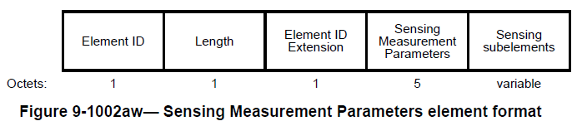

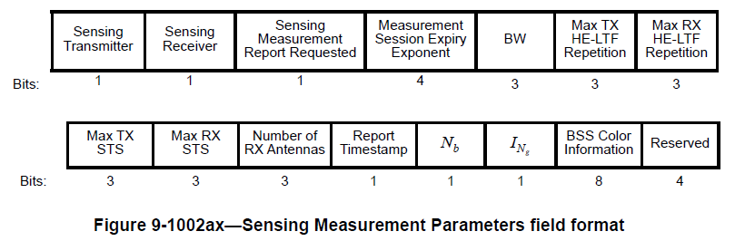
In Sensing Measurement Parameters field, all the parameters except Measurement Session Expiry Exponent and BSS Color Information, can be used to contain the sensing parameters suggested by the sensing responder.

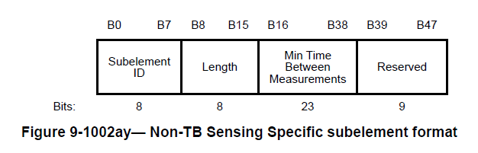
In Non-TB Sensing Specific subelement, all the parameters (i.e. Min Time Between Measurements) can be suggested by the sensing responder when the Status Code in Sensing Measurement Response frame equals to REJECTED_WITH_SUGGESTED_CHANGES.

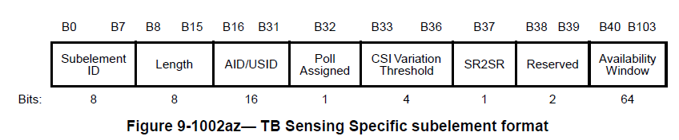
In TB Sensing Specific subelement, all the fileds except Poll Assigned, SR2SR and XXX can be suggested by the sensing responder when the Status Code in Sensing Measurement Response frame equals to REJECTED_WITH_SUGGESTED_CHANGES.

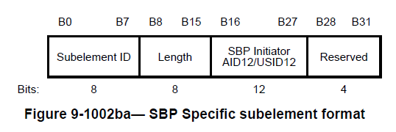
SBP Specific subelement shall not be included in the Sensing Measurement Response frame when its Status Code equals to REJECTED_WITH_SUGGESTED_CHANGES.

Discussion end.

Instructions to the editor: please make the following changes to the paragraph from P134L1 to P134L5 in the subclause 11.55.1.4 Sensing measurement session in D1.1 as shown below:

- If the sensing responder declines the requested sensing measurement session parameters in the received Sensing Measurement Request frame and provides its preferred sensing measurement parameters in the Sensing Measurement Response frame, it shall set the Status Code field to REJECTED_WITH_SUGGESTED_CHANGES in the Sensing Measurement Response frame. In this case, XXX fields shall be reserved.

CID 1038, 1562 and 1598

1038 | 173.37 | 11.55.1.4 | Why "shall" is needed in text lin line 37 page 173? Does an unassocated non-AP STA have to come back? I would say there could be cases where a non-AP STA does not want or need to come back, e.g., it has its intended sensing measurement done with another AP during the unavailable time of this AP. | Suggest considering "should" or "may", instead of "shall". | Revised.  TGbf Editor make changes specified in 0530r1  (https://mentor.ieee.org/802.11/dcn/23/11-23-0530-01-00bf-lb272-comments-measurement-setup-comments-resolution-part-2.docx).
1562 | 173.37 | 11.55.1.4 | This behavior should be specified for unassociated non-AP STAs only. | Change the text to "... an unassociated non-AP STA shall transmit a Sensing Measurement Setup Query frame to the AP..." | Revised  TGbf Editor make changes specified in 0530r1  (https://mentor.ieee.org/802.11/dcn/23/11-23-0530-01-00bf-lb272-comments-measurement-setup-comments-resolution-part-2.docx
1598 | 173.49 | 11.55.1.4 | It is not clear if the unassociated non-AP STA will send the Sensing Measurement Setup Query frame in case the Comeback subfield of the corresponding User Info field in the Sensing Poll/Polling Trigger frame is set to 1 | Specify if the unassociated non-AP STA shall/may send the Sensing Measurement Setup Query frame in this scenario or not? | Revised.  TGbf Editor make changes specified in 0530r1  (https://mentor.ieee.org/802.11/dcn/23/11-23-0530-01-00bf-lb272-comments-measurement-setup-comments-resolution-part-2.docx).

Instructions to the editor: please modify the paragraphes from P134L25 to P134L41 in the subclause 11.55.1.4 Sensing measurement session in D1.1 as shown below:

Upon reception of a Sensing Measurement Request frame with the Comeback field of the Sensing Comeback Info field set to 1, if an unassociated non-AP STA wants to transmit a Sensing Measurement Query frame to the AP, it shall transmit the frame to the AP after the time specified as Unassociated STA Comeback After value (see Table 11-29a (Sensing procedure timeout values)) and before the time specified as Unassociated STA Comeback Before value (see Table 11-29a (Sensing procedure timeout values)) to solicit a Sensing Measurement Request frame from the AP. Both STAs(#1085) start a corresponding unassociated STA comeback timer when the exchange of the Sensing Measurement Query frame and the Sensing Measurement Request frame with the Comeback field of the Sensing Comeback Info field set to 1 completes. The unassociated STA comeback timer shall be set to the Unassociated STA Comeback Before value (see Table 11-29a (Sensing procedure timeout values)) indicated in the Sensing Measurement Request frame.
If an AP intends to request from one of the unassociated non-AP STAs in this TB sensing measurement exchange to participate in another sensing measurement session as a sensing responder, the AP may set the Comeback field of the corresponding User Info field in the Sensing Polling Trigger frame to 1. Upon reception of a Sensing Polling Trigger frame with the Comeback subfield of corresponding User Info field set to 1, if an unassociated non-AP STA wants to transmit a Sensing Measurement Query frame to the AP, it shall transmit the frame out of the current sensing availability window.

Instructions to the editor: please modify the paragraphes from P134L9 to P134L20 in the subclause 11.55.1.4 Sensing measurement session in D1.1 as shown below:

Upon reception of a Sensing Measurement Request frame with the Comeback field of the Sensing Comeback Info field set to 1, an unassocaited non-AP STA should transmit a Sensing Measurement Query frame to the AP after aSensingComebackAfter (see Table 11-29a (Sensing procedure timing-related parameters)) and before aSensingComebackBefore (see Table 11-29a (Sensing procedure timing-related parameters)) to solicit a Sensing Measurement Request frame from the AP. Both STAs(#1085) start a corresponding unassociated STA comeback timer when the exchange of the Sensing Measurement Query frame and the Sensing Measurement Request frame with the Comeback field of the Sensing Comeback Info field set to 1 completes(#1038, #1562, #1598). The unassociated STA comeback timer shall be set to aSensingComebackBefore (see Table 11-29a (Sensing procedure timing-related parameters)).

SP
Do you support resolutions to the following CIDs and incorporate the text changes into the latest TGbf draft: 2165, 1561, 1038, 1562 and 1598 in 11-23/0530r1

Y/N/A

