IEEE P802.11
Wireless LANs
Proposed resolutions for editorial comments on D1.0 - Part 2
Date: 2022-04-10
Author(s):
Name | Affiliation | Address | Phone | email
Claudio da Silva | Meta Platforms, Inc |  |  | claudiodasilva@meta.com
Abstract
This document contains proposed resolutions for editorial comments on D1.0 (LB272). The text used as reference is D1.0.

CIDs: 1973, 1980, 1510, 2200, 1039, 2098, 1124, 1602, 1018, 1019, 1313, 1677, 1630, 1838, 2094, 1678, 1632, 1839, 1633, 1907, 1840, 2187, 1631, 2095, 1981

CID | Clause | Page | Comment | Proposed change
1973 | 11.55.1.3 | 170.36 | "Setup" is cumbersome as a noun. It is better to use a real noun. | Change to "Sensing session setup exchange". Change the intro paragraph to "The sensing session setup exchange of the [WLAN] sensing procedure establishes the sensing session. During the sensing session setup exchange the sensing capabilities of an AP and non-AP STA are exchanged." (If the term "sensing STA" is adopted -- see other comment -- then the last sentence could end with "of the sensing STAs are exchanged."). Change occurances of "sensing session setup" to "sensing session setup exchange".
1980 | 11.55.1.5 | 176.01 | "Sensing measurement instance" is a bad name | Change title to "Sensing measurement exchange", in the title and throughout.

Proposed resolution: Revised

Discussion: Changes to the sensing session setup are proposed in https://mentor.ieee.org/802.11/dcn/23/11-23-0477-00-00bf-lb272-sensing-session.docx.

Modifications: Editor – Incorporate the substitutions listed below throughout the draft (including figures) and make necessary editorial changes to implement such substitutions:
- Replace “sensing measurement setup” with “sensing measurement session”
- Replace “sensing measurement instance” with “sensing measurement exchange”
- Replace “Sensing Measurement Setup Request/Response/Termination frame” with “Sensing Measurement Request/Response/Termination frame” (that is, delete “Setup”)
- Replace “Measurement Setup ID” with “Measurement Session ID”
- Replace “Measurement Instance ID” with “Measurement Exchange ID”

Note: Examples of changes to be implemented as part of the modifications listed above:
- “A sensing initiator shall transmit a Sensing Measurement Setup Request frame to a sensing responder with which it intends to initiate a sensing measurement setup establish a sensing measurement session.”
- “A sensing initiator shall not attempt to initiate more sensing measurement setup establish more sensing measurement sessions than the value of the Max number of Supported Setups Sessions subfield in the last Sensing element received from the sensing responder.”
- “Sensing measurement setup allows for to exchange and agree session is an agreement between a sensing initiator and a sensing responder on operational parameters associated with sensing measurement instance(s) exchanges…”
- “If the sensing responder accepts the requested sensing measurement setup session parameters in the received Sensing Measurement Setup Request frame, it shall set the Status Code field to SUCCESS in the Sensing Measurement Setup Response frame…”
- “In non-TB sensing measurement instances exchanges, if a sensing initiator assigns…”
- “In a sensing measurement instance exchange of a WLAN sensing procedure, sensing measurements are performed. A sensing measurement instance exchange has the following variants:”
- “If a sensing initiator assigns in a Sensing Measurement Setup Request frame the role of sensing receiver to the sensing responder and also sets the Sensing Measurement Report Requested subfield to 1, the sensing responder shall send Sensing Measurement Report frames in sensing measurement instances that result from the sensing measurement setup exchanges with Measurement Session ID of the corresponding sensing measurement session.”

CID | Page | Comment | Proposed change
1510 | 78.09 | The name of the Sensing Poll Trigger frame is not consistent throughout the document, in some places it is named differently as Sensing Polling Trigger frame. | Perform a global search in the document and change the name to either Sensing Polling Trigger frame or Sensing Poll Trigger frame
2200 | 178.53 | Inconsistent trigger frame name. | Change "Polling Trigger frame" to "Sensing Poll Trigger frame"
1039 | 173.51 | What is "Sensing Polling Trigger frame"? Searched entire 11bf/D1.0 spec, could not find any specification about it, althought it has 15 occurrences in the spec. Is it the same as "Sensing Poll Trigger frame" as specified in 9.3.1.22.14.2? If so, please use the frame name consistently. | Please specify what "Sensing Polling Trigger frame" is or clarify it is the same as "Sensing Poll Trigger frame" and use the frame name consitently throughout the spec.
2098 | 173.52 | Sensing Polling Trigger frame' or 'Sensing Poll Trigger frame', the name of this frame should be consistent. | As in comment.

Proposed resolution: Revised

Discussion: Defined Sensing Trigger frame variants:

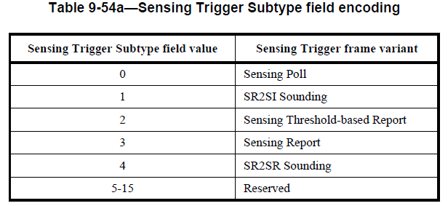
As discussed in TGbf’s conference call on March 27th, the group believes that would be appropriate to adopt the “-ing” form for all variants.

Modifications: Editor – Incorporate the substitutions listed below for different Sensing Trigger frame variants throughout the draft:
- Replace “Sensing Poll” with “Sensing Polling”
- Replace “Sensing Threshold-based Report” with “Sensing Threshold-based Reporting”
- Replace “Sensing Report” with “Sensing Reporting”

CID | Page | Comment | Proposed change | Proposed resolution
1124 | 177.56 | Delete space in "STA X". | Change is required in various places in the paragraph at 117.56-178.10. | ACCEPTED
1602 | 177.60 | The STAs identifier names are not consistent | Change 'STA2' to "STA 2" and 'STA3' to "STA 3" | REVISED  TGbf editor: To ensure consistency with Figure 11-74d, replace all occurrences of "STA X" with "STAX" in the text.
1018 | 177.60 | "change STA 1 to STA1  change STA 3 to STA3  change STA 4 to STA4  change STA 5 to STA5" | where STA1, STA2, and STA3 are sensing transmitters and STA4 and STA5 are sensing receivers. | ACCEPTED
1019 | 177.65 | change STA 6 to STA6 | AP sends a Sensing NDP Announcement frame to STA4, STA5, and STA6, | ACCEPTED

CID | Page | Comment | Proposed change | Proposed resolution
1313 | 141.31 | the name DMG Sensing Monostatic PPDU is not correct. | change the name to DMG monostatic sensing PPDU | ACCEPTED

Discussion: For reference, in 9.4.2.333 (DMG Sensing Instance Duration element):

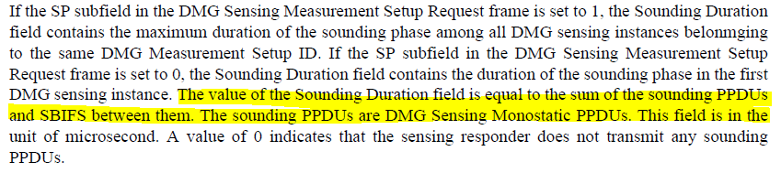

Also, in 9.6.21.9 (DMG Sensing Measurement Setup Response frame format),

CID | Page | Comment | Proposed change | Proposed resolution
1677 | 78.17 | In Figure 9-98c, "B12 B19" should be "B21 B24" | As suggested. | ACCEPTED
1630 | 78.17 | In Figure 9-98c, "B12 B19" for UL HE-MCS subfield must be "B21 B24". | As in comment. | ACCEPTED
1838 | 78.24 | Wrong bit value "4" for subfield UL HE-MCS in Figure 9-98c | Replace Bit value for UL HE-MCS subfield with correct value "8" | REVISED  Discussion: Number of bits (4) is correct per REVme.  TGbf editor: Replace “B12 B19” with “B21 B24” for the UL HE-MCS field.
2094 | 78.24 | The Bit size for 'UL HE-MCS' in Figure 9-98c is 8. | As in comment. | REVISED  Discussion: Number of bits (4) is correct per REVme.  TGbf editor: Replace “B12 B19” with “B21 B24” for the UL HE-MCS field.

Discussion: Comments are on the length of the UL HE-MCS subfield in Figure 9-98c:

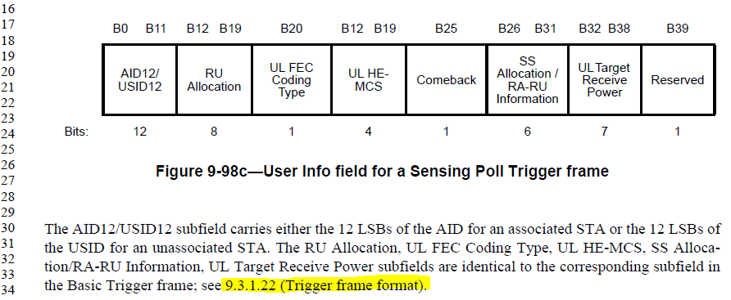

In 9.3.1.22 (Trigger frame format), REVme D2.1, we have:

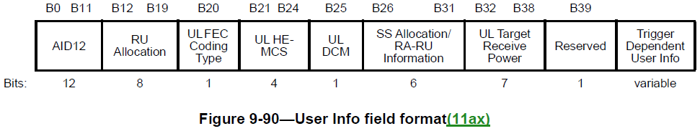

CID | Page | Comment | Proposed change | Proposed resolution
1678 | 79.52 | In Figure 9-98f, "B12 B19" should be "B21 B24" | As suggested. | ACCEPTED
1632 | 79.52 | In Figure 9-98f, "B12 B19" for UL HE-MCS subfield must be "B21 B24". | As in comment. | ACCEPTED
1839 | 79.58 | Wrong bit value "4" for subfield UL HE-MCS in Figure 9-98f | Replace Bit value for UL HE-MCS subfield with correct value "8" | REVISED  Discussion: Number of bits (4) is correct per REVme.  TGbf editor: Replace “B12 B19” with “B21 B24” for the UL HE-MCS field.

Discussion: Comments are on the length of the UL HE-MCS subfield in Figure 9-98f:

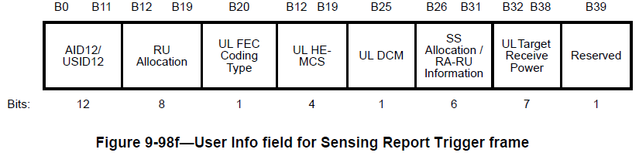

For reference, in 9.3.1.22 (Trigger frame format) REVme D2.1, we have:

CID | Page | Comment | Proposed change | Proposed resolution
1633 | 80.20 | In Figure 9-98g, the bit position of SR2SR Rep subfield must be "B21 B24", and the bit position of the second Reserved bit must be "B25". | As in comment. | REVISED  Discussion: Length of the SR2SR Rep subfield is 3 per Figure 9-61da in 11az/D7.0.  TGbf editor:  - Replace 4 with 3 in the number of bits for the SR2SR Rep field in Figure 9-98g.  - Replace 1 with 2 in the number of bits for the second Reserved field in Figure 9-98g.
1907 | 80.27 | The indicated number of bits do not match | It is indicated that SR2SR corresponds to B21-B23, but this is indicated as being 4 bits, at the same time Reserved corresponds to B24 adn B25, at the same time this is indicated as being only 1 bit. This should be corrected.
1840 | 80.27 | Wrong bit value "1" for subfield Reserved (B24-B25) in Figure 9-98g | Change Bit value to correct value "2" for subfield Reserved (B24-25)
2187 | 80.27 | The number of bits for SR2SR Rep subfield in Figure 9-98g is incorrect. It should be 3 bits. | As in the comment

Discussion: Comments are on the length of the SR2SR Rep subfield (number of HE-LTF repetitions minus 1) in Figure 9-98g:

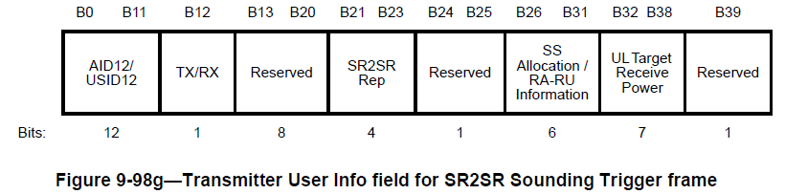

For reference, Figure 9-61da in 11az/D7.0:

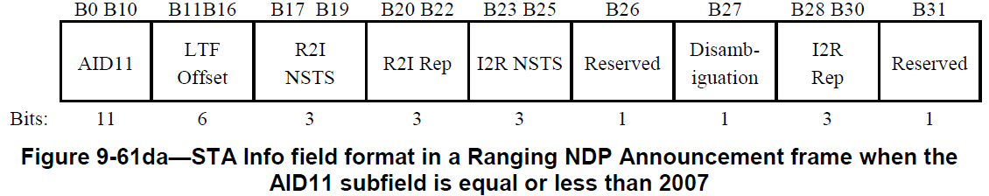

CID | Page | Comment | Proposed change | Proposed resolution
1631 | 78.57 | In Figure 9-98d, the number of the first reserved bits must be 12 because their position is indicated as "B12 B20". | Please fix this typo | REVISED  TGbf editor: Replace the length of the first Reserved field with 9.
2095 | 78.57 | The Bit size for 'Reserved' in Figure 9-98d is 12. | As in comment. | REVISED  TGbf editor: Replace the length of the first Reserved field with 9.

Discussion: Comments are on Figure 9-98d:

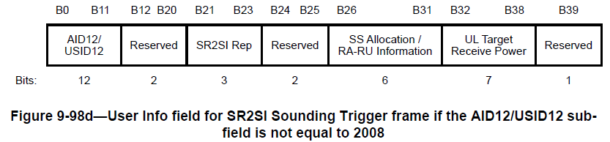

For reference, in 9.3.1.22 (Trigger frame format) REVme D2.1, we have:

CID | Clause | Page | Comment | Proposed change
1981 | 0.00 |  | In many instances, "when" has been used incorrectly and should be replaced with "if". Use "when" if the condition is certain to happen. If the condition is not certain to happen, then use "if". Some examples, at 181.35 and 182.45: "When a PPDU bandwidth is less than or equal to 160 MHz" should be "If a PPDU bandwidth is less than or equal to 160 MHz". At 184.44 "When the CSI Variation Threshold subfield". | Review use if "when" and convert to "if" if appropriate.

Proposed resolution: Revised

Discussion: As discussed in 22/0931r2,
- Use “if” if the condition might occur (is not certain to occur).
- Use “when” if the condition is certain to occur.
- Almost always (in the 802.11 spec) the condition is not certain to occur and so “if” is appropriate. Certain things in 802.11 are pretty certain to occur (such as regular receipt of a beacon), but most things are not. When is currently overused in the .11 spec.

Modifications: Editor – Review the draft and replace "when" with "if" whenever appropriate.

