IEEE P802.11
Wireless LANs
LB271 CR for 35.3.7.1.7 Part I
Date: March 15, 2023
Author(s):
Name | Affiliation | Address | Phone | email
Jason Yuchen Guo | Huawei |  |  | guoyuchen@huawei.com
Ming Gan | Huawei
Yunbo Li | Huawei
Guogang Huang | Huawei
Mengyao Ma | Huawei
Hongjia Su | Huawei
Yousi Lin | Huawei

Abstract
This submission proposes resolutions for following 14 CIDs received for TGbe LB271:
15524 15526 15599 15823 15847 16009 16010 16112 16503 16505
16507 17828 17944 18142
Revisions:
- Rev 0: Initial version of the document.
- Rev 1: change the resolution of some CIDs
- Rev 2: add green tags.

Interpretation of a Motion to Adopt

A motion to approve this submission means that the editing instructions and any changed or added material are actioned in the TGbe Draft. This introduction is not part of the adopted material.

Editing instructions formatted like this are intended to be copied into the TGbe Draft (i.e. they are instructions to the 802.11 editor on how to merge the text with the baseline documents).

TGbe Editor: Editing instructions preceded by “TGbe Editor” are instructions to the TGbe editor to modify existing material in the TGbe draft. As a result of adopting the changes, the TGbe editor will execute the instructions rather than copy them to the TGbe Draft.

CID | Commenter | Page | Clause | Comment | Proposed Change | Resolution
15524 | Chaoming Luo | 519.36 | 35.3.7.1.7 | Better not use double negative. | Change to: If advertised by an AP MLD, a TID-to-link mapping shall map all TIDs to the same link set, | Revised –  Agree in principle with the commenter.  TGbe Editor:  Please implement the changes in this document tagged as #15524
15526 | Chaoming Luo | 519.46 | 35.3.7.1.7 | "a new nondefault advertised TID-to-link mapping will replace it" is not normative text, and the text does not reflect the intention of the procedure. | Change to: if there is already an established advertised TID-to-link mapping and the AP MLD intends to replace it with a new nondefault advertised TID-to-link mapping, the AP MLD shall include two TID-To-Link Mapping elements in the Beacon and Probe Response frames that the APs affiliated with the AP MLD transmit. | Revised –  Agree in principle with the commenter.  TGbe Editor:  Please implement the changes in this document tagged as #15526
15599 | Bo Sun | 520.55 | 35.3.7.1.7 | "Any MLD" is not clear, does it mean non-AP MLD or AP MLD? | clarify the "Any MLD" is non-AP MLD or AP MLD | Revised –  Agree in principle with the commenter.  TGbe Editor:  Please implement the changes in this document tagged as #15599
15823 | Muhammad Kumail Haider | 519.57 | 35.3.7.1.7 | Accoding to NOTE 3, when the newly advertised mapping is default mapping, and once default mapping is established, T2LM element indicating default mapping is not included in beacon and probe resp frames. Then please clarify what is the purpose of Default Link Mapping subfield in the T2LM element and when is this subfield used/set to 1. Normative behavior of setting of this subfield is currently missing. | as in comment | Rejected –  During the negotiation of T2LM, either side may suggest to use the default mapping. When the Default Link Mapping subfield is equal to 1, the Link Mapping Presence Indicator subfield is not present, which saves overhead.
15847 | Xiangxin Gu | 521.45 | 35.3.7.1.7 | At the time that the advertised TID-to-Link Mapping ends, it's more reasonable to go back to the TID-to-Link Mapping A, which was used before the advertised mapping. | As the comment | Rejected –  It is not clear why there’s any benefit to use the original mapping, besides, it requires the non-AP MLD to hold the memory for the original mapping.
16009 | Binita Gupta | 518.63 | 35.3.7.1.7 | Improve readability. Change "Beginning at the  indicated time,..." to "Beginning at the time indicated in the Mapping Switch Time field,..." | As in comment | Accepted.
16010 | Binita Gupta | 518.61 | 35.3.7.1.7 | Add 'shall' for setting the Mapping Switch Time field | Change to  "An AP that advertises a TID-to-link mapping shall include the Mapping Switch Time field and shall set it to the time..." | Accepted.
16112 | Insun Jang | 520.49 | 35.3.7.1.7 | It should be under a specific condition, e.g., after the time indicated by Mapping Switch Time field | As in the comment | Rejected –  It should be under any condition. In other words, the non-AP MLD shall not transmit any TID-to-link mapping request/response frame in response to an advertised TID-to-link mapping.
16503 | Arik Klein | 520.24 | 35.3.7.1.7 | Using the word "advertised" in the term "advertised default mapping" is misleading since according to NOTE 6 and NOTE 3, when a default mapping is applied, the Beacon shall not include any TID-To-Link Mapping element, thus no advertisement occurs in such a case. | Please remove the word "advertised" and use only "default mapping" | Revised –  Agree in principle with the commenter.  TGbe Editor:  Please implement the changes in this document tagged as #16503
16505 | Arik Klein | 521.02 | 35.3.7.1.7 | The term "all the AP MLD link" seems to be improper use. Please revise as suggested | replace the "includes all the AP MLD link in its multi-link setup" with "includes all the links that included in the Multi-link element advertised by the AP MLD in its multi-link setup" | Revised –  Agree in principle with the commenter, but “Links that are included in the Basic Multi-Link element” does not include the link for transmitting the Basic Multi-Link element, So “Links advertised by the AP MLD” is used here.  TGbe Editor:  Please implement the changes in this document tagged as #16505
16507 | Arik Klein | 521.10 | 35.3.7.1.7 | Using the word "advertisement" in the term "treated as an advertisement of a new default mapping" is misleading since according to NOTE 6 and NOTE 3 in this subclause, when a default mapping is applied, the Beacon shall not include any TID-To-Link Mapping element, thus no advertisement occurs in such a case. | Consider revising the sentence as follows: "Note that since no further TID-to link mapping is advertised, the ending of the former advertised TID-to-link mapping is treated as applying a default mapping" | Revised –  Agree in principle with the commenter. Simpler wording is provided here.  TGbe Editor:  Please implement the changes in this document tagged as #16507
17828 | Yunbo Li | 520.24 | 35.3.7.1.7 | there is no explicit indication for default mapping in Beacon frame, so it is not accurate to say an advertised deafult mapping. | remove the word advertised. | Revised –  Agree with the commenter.  TGbe Editor: please implement the changes in this document tagged as #16503
17944 | Yuchen Guo | 518.61 | 35.3.7.1.7 | sets it to the time, or, sets it to the TBTT? Should be TBTT, because the actual transmission time of the DTIM Beacon is not known | change "time" to "TBTT" | Revised –  Agree with the commenter.  TGbe Editor: please implement the changes in this document tagged as #17944
18142 | Abhishek Patil | 520.14 | 35.3.7.1.7 | Clarify that the time indicated is the one carried in the Expected Duration field | Add "via the Expected Duration field" between 'indicated' and 'may' | Revised –  Agree with the commenter.  TGbe Editor: please implement the changes in this document tagged as #18142

35.3.7.1.7 Advertised TID-to-link mapping in Beacon and Probe Response frames
An AP MLD may advertise a mandatory TID-to-link mapping by including a TID-To-Link Mapping element in the Beacon and Probe Response frames that the APs affiliated with the AP MLD transmit.
An AP that advertises a TID-to-link mapping shall include the Mapping Switch Time field and sets it to the time, in units of TUs, of (#17944) the TBTT of a DTIM Beacon of one of the APs affiliated with the AP MLD. Beginning at the indicated time, the indicated TID-to-link mapping is established and the Mapping Switch Time field is no longer included. Figure 35-14 (An illustration of an advertised TID-to-link mapping taking effect on all links) explains the procedure via an example consisting of an AP MLD having three affiliated APs with different DTIM intervals and with TBTTs that are not aligned.
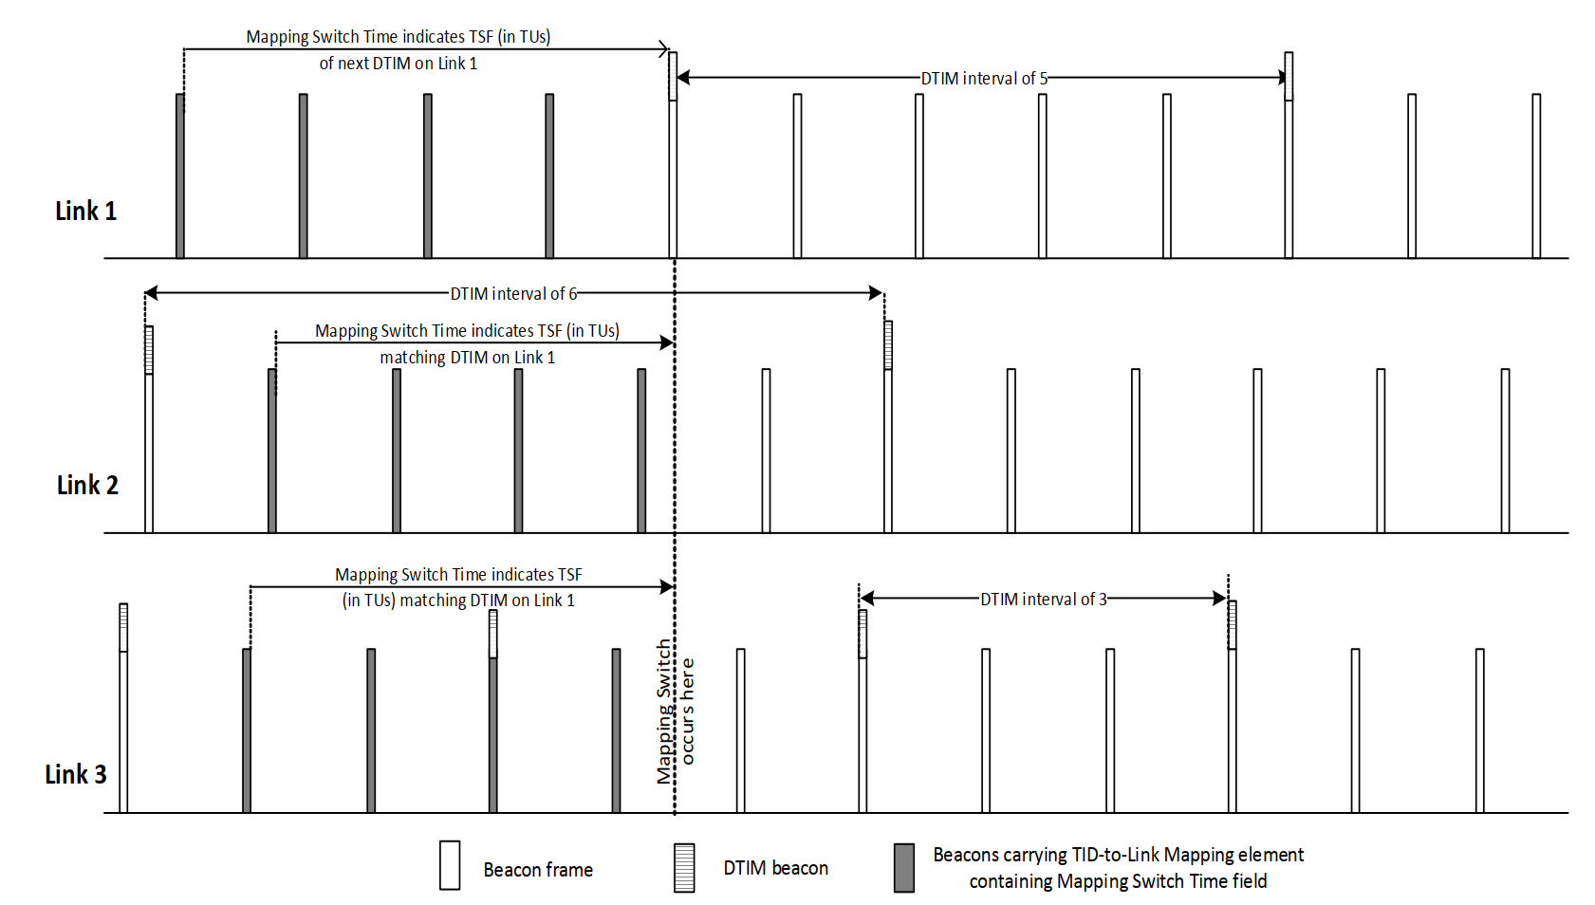
Figure 35-14—An illustration of an advertised TID-to-link mapping taking effect on all links
(#15524)An AP that advertises a TID-to-link mapping shall map all TIDs to the same link set in the advertised TID-to-link mapping, both for DL and UL. The Direction field of an advertised TID-To-Link Mapping element shall be set to 2.
NOTE 1—An advertised TID-to-link mapping will include a mapping for all TIDs.
NOTE 2—If the Link ID of each AP in a multiple BSSID set and affiliated with different MLDs is different, then inheritance will not apply to an advertised TID-to-link mapping for the APs that are part of a multiple BSSID set, and therefore the TID-To-Link Mapping element needs to be carried in each nontransmitted BSSID profile to which an advertised mapping applies.
An AP MLD shall include two TID-To-Link Mapping elements in the Beacon and Probe Response frames that the APs affiliated with the AP MLD transmit, if there is already an established advertised TID-to-link mapping and (#15526)the AP MLD intends to replace it with a new nondefault advertised TID-to-link mapping. In this case, the AP MLD shall not include the Mapping Switch Time field in the currently established advertised TID-To-Link Mapping element, and shall include the Mapping Switch Time field in the new TID-To-Link Mapping element, in order to indicate an advertised TID-to-link mapping that will be established in the future. The value of the Expected Duration field of the existing TID-To-Link Mapping element shall indicate a remaining duration that ends at the same time as indicated by the Mapping Switch Time field of the new TID-To-Link Mapping element.
NOTE 3—If the newly advertised TID-to-link mapping is the default mapping, the AP MLD sets the Expected Duration field of the currently advertised TID-to-link mapping to the remaining time until the default mapping is established as described in 9.4.2.314 (TID-To-Link Mapping element) and does not include the TID-To-Link Mapping element for the newly advertised TID-to-link mapping in the Beacon and Probe Response frames. After the establishment of the default mapping, no TID-To-Link Mapping elements are included in the Beacon or Probe Response frames transmitted by the APs affiliated with the AP MLD.
All APs affiliated with an AP MLD that advertises a TID-to-link mapping shall include the same mapping in all Beacon and Probe Response frames from the time at which the TID-to-link mapping is first advertised until the time at which the TID-to-link mapping is no longer advertised, and shall include the Expected Duration field in all TID-to-link mapping elements in Beacons. From when a new TID-to-link mapping is advertised in a Beacon frame until the advertised TID-to-link mapping is established, the Mapping Switch Time field shall be included in the TID-To-Link Mapping element and set to the time, in units of TUs, at which the TID-to-link mapping will be established, then not included thereafter. The time indicated by the Mapping Switch Time field shall be the TBTT of the DTIM Beacon of one of the APs affiliated with the AP MLD. The Mapping Switch Time field should initially be set to a sufficiently large value. After an advertised TID-to-link mapping is established, the duration indicated by Expected Duration field shall indicate the time when the advertised TID-to-link mapping is expected to end. During the advertisement of the TID-to-link mapping, the time indicated(#18142) in the Expected Duration field may be updated to indicate an earlier time than initially indicated, but shall not be updated to indicate a later time than initially indicated. The duration indicated by Expected Duration field shall be exact when the duration is smaller than two DTIM periods of the AP transmitting the frame carrying the field.
At the time indicated by the Mapping Switch Time field of a TID-To-Link Mapping element in a Beacon or a Probe Response frame received by a non-AP STA affiliated with a non-AP MLD from an AP affiliated with its associated AP MLD, or at the time indicated by the Expected Duration field of an existing advertised TID-to-link mapping which will be replaced by (#16503)the default mapping, the non-AP MLD shall update its TID-to-link mapping according to the rules that establish a TID-to-link mapping in this subclause and with the consequences of the updated mapping defined in 35.3.7.1.1 (General).
The TID-to-link mapping that is established in a non-AP MLD following an advertised TID-to-link mapping from its associated AP MLD is derived as follows:
— The set of mapped links for each TID and direction for a non-AP MLD are the set of links that are included in the non-AP MLD multi-link setup with the associated AP MLD and have been mapped to that TID for that direction in the advertised TID-to-link mapping.
NOTE 4—An individually negotiated TID-to-link mapping whose negotiation was completed prior to the establishment of an advertised TID-to-link mapping is discarded at the time of the establishment of the advertised TID-to-link mapping.
NOTE 5—A non-AP MLD ignores links that are included in the link mappings of an advertised TID-to-link mapping that are not part of the non-AP MLD multi-link setup procedure. For example, if the AP MLD operates on links 1, 2, and 3, and it advertises that link 3 is disabled and all TIDs are mapped to links 1 and 2, then for a non-AP MLD that is associated with the AP MLD using links 1 and 2 the default mapping will apply. In this case, for a non-AP MLD that is associated with the AP MLD using links 1 and 3, link 3 will be disabled.
NOTE 6—In absence of an advertised mapping by the AP a default TID-to-link mapping is assumed unless an individual TID-to-link mapping is successfully negotiated.
NOTE 7—No TID-To-Link Mapping Request nor TID-To-Link Mapping Response frames are transmitted by non-AP STAs affiliated with the associated non-AP MLDs in response to an advertised TID-to-link mapping
A non-AP MLD that is associated with an AP MLD that advertises a TID-to-link mapping may initiate a negotiation for a TID-to-link mapping that is different from the TID-to-link mapping established from the advertisement as described in this subclause. (#15599)A non-AP MLD or an AP MLD shall not initiate a negotiation for a TID-to-link mapping that maps a TID to a link if the requested TID is not already mapped to the link in the advertised TID-to-link mapping
Figure 35-15 (Example TID-to-link mapping frame exchange) shows an example sequence of TID-to-link mapping frame exchanges. The non-AP MLD operates in default mapping mode in the beginning of the sequence. The non-AP MLD then initiates a negotiation of a TID-to-link mapping A. The AP MLD accepts the request, after which TID-to-link mapping A is active for the non-AP MLD. Next the AP MLD starts to advertise a TID-to-link mapping B. At the time indicated by the Mapping Switch field of the advertised TID-to-Link Mapping element, TID-to-link mapping B is established on the non-AP MLD. Note that we assume that the non-AP MLD includes all the (#16505)links advertised by the AP MLD in its multi-link setup, so the same mapping B is established for the non-AP MLD. In the next step the non-AP MLD requests another TID-to-link mapping C. Note that any mapping between TIDs and links that is enabled in C must be already enabled in the advertised TID-to-link mapping B. The AP MLD accepts the request for TID-to-link mapping C, after which TID-to-link mapping C is active for the non-AP MLD. In the next step, the advertised TID-to-link mapping B ends (by expected duration reaching 0). At this point the non-AP MLD also reverts to a default mapping. Note that the ending of the former advertised TID-to-link mapping (#16507) results in a new default mapping, hence the formerly established individually negotiated TID-to-link mapping is discarded.
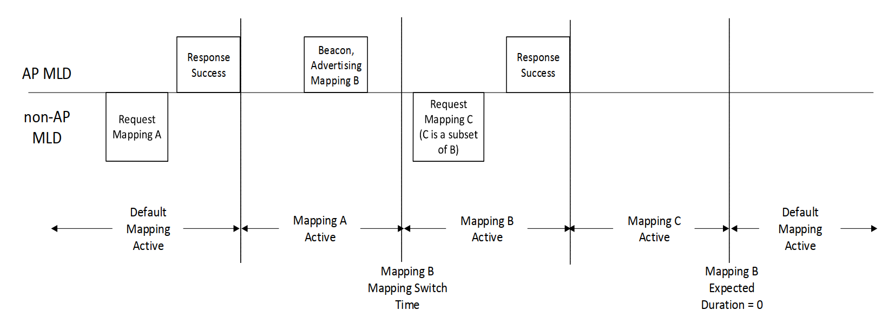
Figure 35-15—Example TID-to-link mapping frame exchange

