IEEE P802.11
Wireless LANs
CR for CID 3435
Date: 2023-03-13
Author(s):
Name | Affiliation | Address | Phone | email
Rui Yang | InterDigital |  |  | rui.yang@interdigital.com
Joseph Levy
Abstract

This submission present proposed resolutions for the following 1 CIDs:
3435

The proposed changes are based on 802.11REVme_D2.0.

Revision history:

r0 – initial version
r1 – updated resolution field

CID | Clause | P.L | Comment | Proposed Change | Resolution
3435 | 26.10.3.4 | 3940. 58 | Equation (26-7) looks dodgy, because it adds dBm + dBm (not dBm + dB) | Make sure the equation is dimensionally sound | REVISED  The units in Table 27-23 of 802.11REVme D2.0 in the meaning column are not correct.  At line 56 of page 3940 change "the value" to "the numeric value", at line 55 delete "numeric", in Table 27-23 delete "dBm" throughout.  After Table 27-23, add "NOTE - The unit for PSR in the Meaning column of Table 27-23 is 10log10(mW^2).”  Note to editor: “^2” means superscript 2.

Discussion
The Equation (26-7) shows the addition of two quantities, each is in the unit of dBm. The result, PSR_INPUT, has the unit of mW^2 in linear domain or (dBm + dBm) in logarithmic domain. Both of these units are not commonly used and using them may cause confusion. PSR_INPUT is used to pick a PSR value in Table 27-23 for the SR subfield in TF (see Figure 1).
The PSR values are used for setting the Tx power upper bound as shown in Figure 2. In the expression:
The unit on the right side is dBm (= (dBm + dBm) – dBm). Therefore, the expression in Equation (26-7) is correct unit-wise. However, since the PSR_INPUT is used to directly compare the values in Table 27-23 as stated in subclause 26.10.3.4 (see Figure 1), the unit (dBm) shown in Table 27-23 is not correct (see Figure 3 below).
Therefore, we suggest remove “dBm” in Table 27-23. The units of the values in the “meaning” column in Table 27-23 are implied by the expression of PSR_INPUT and the description in subclause 26.10.3.4 is complete and consistent; hence the units are not necessary.
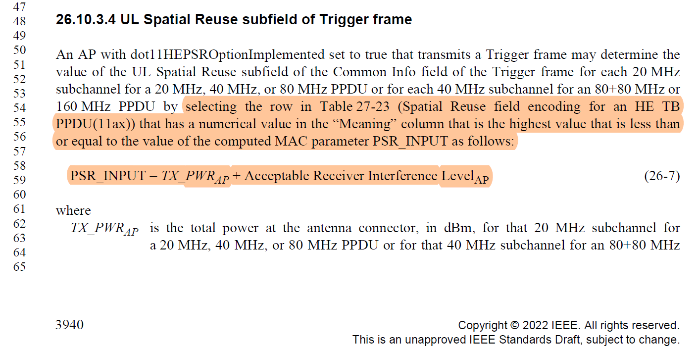
Figure 1. Text from Page 3940 of D2.0

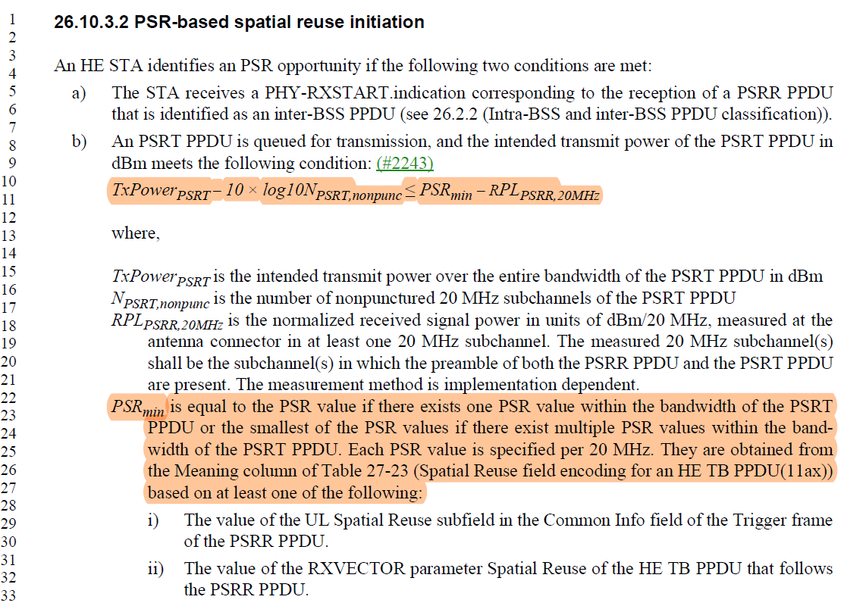
Figure 2. Text from Page 3939 of D2.0

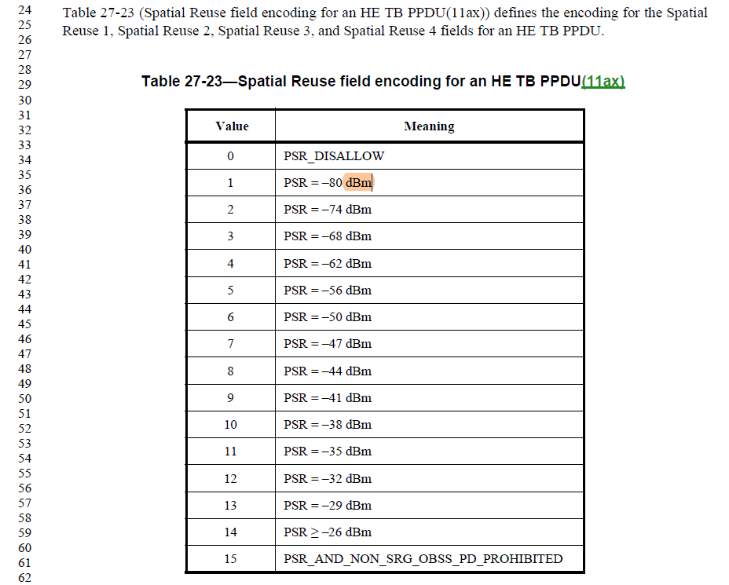
Figure 3. Text from Page 4077 of D2.0

