IEEE P802.11
Wireless LANs
LB271 Comment Resolution on 36.1.1 EHT PHY Introduction section-2
Date: 2023-03-13
Author(s):
Name | Affiliation | Address | Phone | email
Kanke Wu | Qualcomm Inc |  |  | kankew@qti.qualcomm.com
Bin Tian | Qualcomm Inc

Abstract
This submission proposes resolutions for the following comments from LB271 in P802.11be D3.0:
15301, 16353, 16354, 15302, 15305, 15315, 15309, 15319, 15320, 15321,
16630, 16162

This proposed text changes in this document are based on TGbe Draft 3.0

Revisions:

- Rev 0: Initial version of the document.

CID 15301, 16353, 16354
CID | Clause | Page.Line | Comment | Proposed Change | Resolutions
15301 | 36.1.1 | 659.50 | "The EHT PHY also supports preamble puncturing of EHT MU PPDU for both OFDMA and non-OFDMA" is not logically related to the previous sentence in the same paragraph.It should be moved to the paragraph taling about MU PPDUs. | Move the mentioned sentence to the end of the paragraph at P607/L44. And, move the first sentence in the addressed paragraph to the end of the paragraph at P607/L49. | Revised  Agree with the commenter to place these sentences in different paragraphs. The locations suggested by the commenter is not pointing to the correct page.  Instruction to the editor:  Please make the changes at P659 L38 in D3.0 as indicated in 23/0451r2
16353 | 36.1.1 | 659.50 | Add 'an' before 'MRU' | Please change to "The EHT PHY provides support of an MRU..." | Accepted
16354 | 36.1.1 | 659.51 | Add 'an' before 'EHT MU' | Please change to "..also supports preamble puncturing of an EHT MU PPDU..." | Accepted

  - Background
  - P659
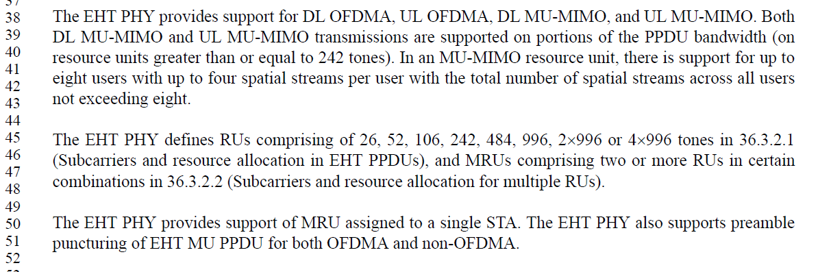

Instruction to the editor:
Please make the indicated modifications at P659 L38 as follows:
The EHT PHY provides support for DL OFDMA, UL OFDMA, DL MU-MIMO, and UL MU-MIMO. Both DL MU-MIMO and UL MU-MIMO transmissions are supported on portions of the PPDU bandwidth (on resource units greater than or equal to 242 tones). In an MU-MIMO resource unit, there is support for up to eight users with up to four spatial streams per user with the total number of spatial streams across all users not exceeding eight. The EHT PHY also supports preamble puncturing of an EHT MU PPDU for both OFDMA and non-OFDMA.

The EHT PHY defines RUs comprising of 26, 52, 106, 242, 484, 996, 2996 or 4996 tones in 36.3.2.1 (Subcarriers and resource allocation in EHT PPDUs), and MRUs comprising two or more RUs in certain combinations in 36.3.2.2 (Subcarriers and resource allocation for multiple RUs). The EHT PHY provides support of an MRU assigned to a single STA.

CID 15302
CID | Clause | Page.Line | Comment | Proposed Change | Resolutions
15302 | 36.1.1 | 659.59 | It's strange to introduce EHT-LTF symbol duration in one paragraph, while introduce EHT modulated fields in another paragraph, with different symbol duration supports. And it's not correct to claim EHT PHY supports 12.8 us symbole duration for the EHT modulated fields, since "EHT modulated field" refers to EHT-STF, EHT-LTF, Data and PE fields, while EHT-STF symbol duration is 4 us or 8 us. | Combine the addressed two paragraphs into "The EHT PHY supports a symbol duration, excluding GI, of 3.2 us for the pre-EHT modulated fields, 4 us and 8 us for the EHT-STF field, 3.2 us (1x), 6.4 us (2x) and 12.8 us (4x) for the EHT-LTF field, 12.8 us for the Data field and PE field in an EHT PPDU. " | Revised  Agree with the commentor that the symbol duration mentioned in L61 should be for the Data field instead of all EHT modulated fields. The description is modified to reflect this.  Instruction to the editor:  Please make the changes at P659 L56 in D3.0 as indicated in 23/0451r2

  - Background
  - P659
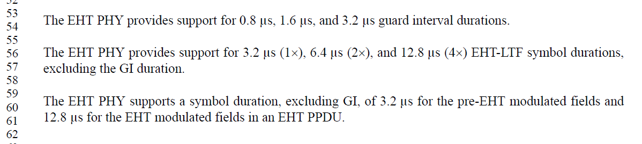

Instruction to the editor:
Please make the indicated modifications at P659 L56 as follows:
The EHT PHY provides support for 3.2 μs (1x), 6.4 μs (2x), and 12.8 μs (4x) EHT-LTF symbol durations, excluding the GI duration.
The EHT PHY supports a symbol duration, excluding GI, of 3.2 μs for the pre-EHT modulated fields and 12.8 μs for the Data field in an EHT PPDU.

CID 15305, 15315, 15309
CID | Clause | Page.Line | Comment | Proposed Change | Resolutions
15305 | 36.1.1 | 661.15 | An EHT STA shall support an EHT SU transmission as stated at pg660/ln12 without any condition. If a special EHT SU format is listed here as optional feature, this format should be excluded from the "shall" statement. | Give specific EHT SU transmission configuration that shall be supported in the "shall" statement, or exclude specific EHT SU transmission configurations which are optional feature from the "shall" statement. | Revised  The bullet at P660L12 focus on mandatory support for EHT SU transmission and reception, while the bullet at P661L15 focus on LTF+GI requirement.  The bullet has been rewritten to unify the description for LTF+GI support requirement in this section.  Instruction to the editor:  Please make the changes in D3.0 as indicated in 23/0451r2
15315 | 36.1.1 | 662.57 | The feature of transmission of non-OFDMA EHT TB PPDUs is stated at pg662/ln34 and pg662/ln57 separately and contraversially. The 1st statement requests an EHT non-AP STA to support UL MU-MIMO transmission if the number of total streams is no more than 8. The 2nd statement requests an EHT non-AP STA to support UL MU-MIMO transmission with 1x EHT-LTF+1.6 us GI without limitation on number of total streams. Those're two different but partially overlapping features. They could be understood as all conditions limited by "A or B", or by "A and B". It's necessary to clarify the relation of those two kinds of statements.  Note, sub-bullets at pg662/ln60, pg662/ln63, and pg663/ln23 have similar issue. | Clarify the relation between those two kinds of statements about the same feature. | Revised  The line at P662L37 is about general non-OFDMA EHT TB PPDU support for no-AP EHT STAs.  The lines at P662L57, 60, 63 and P663L23 are about LTF+GI support requirements when transmitting and receiving EHT TB PPDU.  The bullet has been rewritten to unify the description for LTF+GI support requirement in this section.  Instruction to the editor:  Please make the changes in D3.0 as indicated in 23/0451r2
15309 | 36.1.1 | 661.41 | The feature of receiption of non-OFDMA EHT TB PPDUs is stated at pg661/ln36 and pg661/ln41 separately and contraversially. The 1st statement requests an EHT AP to support receiption of all UL MU-MIMO if the EHT AP supports 4 or more streams. The 2nd statement requests an EHT AP to support receiption of all UL MU-MIMO with 1x EHT-LTF and 1.6 us GI without limitation on AP's support of streams. Those're two different but partially overlapping features. They could be understood as all conditions limited by "A or B", or by "A and B". It's necessary to clarify the relation of those two kinds of statements.  Note, sub-bullets at pg661/ln44 and pg661/ln47 have similar issue. | Clarify the relation between those two kinds of statements about the same feature. | Revised  The line at Ln36 is on general support requirement for non-OFDMA EHT TB PPDUs. The later bullets focus on specific LTF+GI combination support for EHT TB PPDUs.  The bullet has been rewritten to unify the description for LTF+GI support requirement in this section.  Instruction to the editor:  Please make the changes in D3.0 as indicated in 23/0451r2

  - Background
CID 15305
  - P660L12
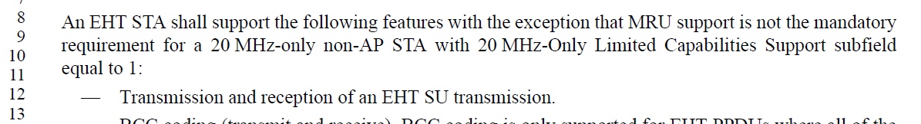
  - P661L15 under “An EHT STA may support”
CID 15315
P662L37
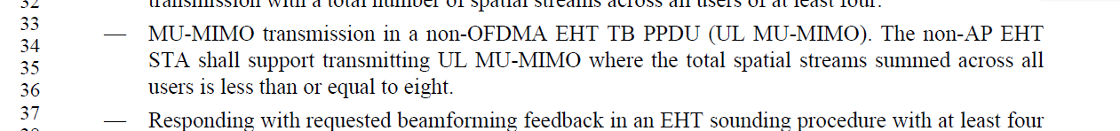
P662L57
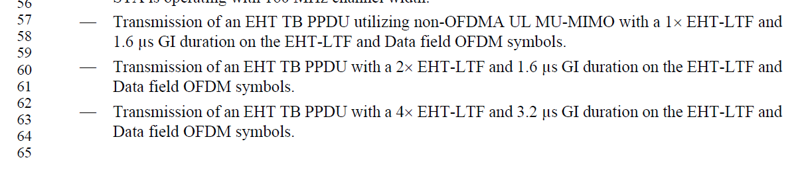
CID 15309
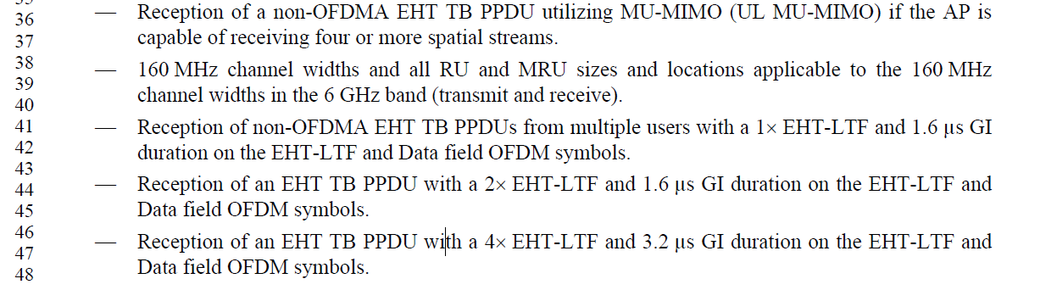
  - Discussion
  - In the PHY introduction section, regarding 4xLTF+0.8us GI support we have:
  - P661L15 under “An EHT STA may support”
  - P662L4 under “An EHT AP may support”
  - P663L23 under “A non-AP EHT STA may support”
  - The description is split into 3 bullets to match the EHT MU PPDU support requirement for SU and MU transmissions.
However, for other LTF+GI duration requirements for EHT MU PPDU, there’s no such split on the requirement:
  - P660 under “An EHT STA shall support”
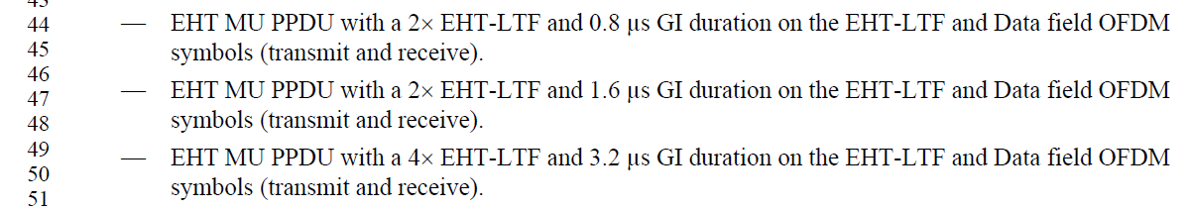
For LTF+GI duration requirements for EHT TB PPDU, the requirements are split into different cases to be consistent with the transmission/reception requirements:
  - P661L41 under “An EHT AP shall support”
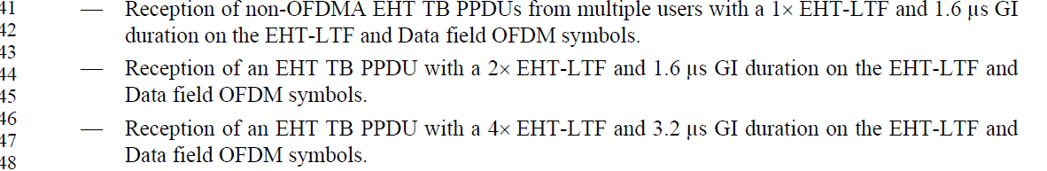
  - P662L57 under “A non-AP EHT STA shall support”
Proposed changes:
Separate transmission and reception requirements from the LTF+GI support requirements for different PPDU formats.

Instruction to the editor:
Please modify the following bullets at P660 L44:
—EHT MU PPDU with a 2x EHT-LTF and 0.8 μs GI duration on the EHT-LTF and Data field OFDM symbols.
—EHT MU PPDU with a 2x EHT-LTF and 1.6 μs GI duration on the EHT-LTF and Data field OFDM symbols.
—EHT MU PPDU with a 4x EHT-LTF and 3.2 μs GI duration on the EHT-LTF and Data field OFDM symbols.
Please insert the following bullets at P660 L51 (EHT STA shall support):
—EHT TB PPDU with a 1x EHT-LTF and 1.6 μs GI duration on the EHT-LTF and Data field OFDM symbols.
—EHT TB PPDU with a 2x EHT-LTF and 1.6 μs GI duration on the EHT-LTF and Data field OFDM symbols.
—EHT TB PPDU with a 4x EHT-LTF and 3.2 μs GI duration on the EHT-LTF and Data field OFDM symbols.
Please make the indicated modifications at P661 L14 as follows (EHT STA may support):
—EHT MU PPDU with a 4x EHT-LTF and 0.8 μs GI duration on the EHT-LTF and Data field OFDM symbols.
Please delete the following bullets at P662L4 (EHT AP may support):

Please delete the following bullets at P663L23 (non-AP EHT STA may support):

Please delete the following bullets at P661L41 (EHT AP shall support):

Please delete the following bullets at P662L57 (non-AP EHT STA shall support):

CID 15319, 15320, 15321
CID | Clause | Page.Line | Comment | Proposed Change | Resolutions
15319 | 36.1.1 | 663.53 | The HE subchannel selective transmission operation defined in sub-clause 26.8.7 (HE subchannel selective transmission) doesn't support operation on MRU. To enable MRU transmission using SST, the sub-clause 26.8.7 should be updated to accommodate EHT special cases, or an EHT SST sub-clause should be defined to accommodate EHT special cases. | As in comment | Rejected.  Section 26.8.7 is about MAC procedure regarding SST operation. It does not mention specific RU/MRU sizes, and as a result it can still apply in this case.
15320 | 36.1.1 | 663.60 | The HE subchannel selective transmission operation defined in sub-clause 26.8.7 (HE subchannel selective transmission) doesn't support operation on MRU. To enable MRU transmission using SST, the sub-clause 26.8.7 should be updated to accommodate EHT special cases, or an EHT SST sub-clause should be defined to accommodate EHT special cases. | As in comment | Rejected.  Section 26.8.7 is about MAC procedure regarding SST operation. It does not mention specific RU/MRU sizes, and as a result it can still apply in this case.
15321 | 36.1.1 | 664.02 | The HE subchannel selective transmission operation defined in sub-clause 26.8.7 (HE subchannel selective transmission) doesn't support operation on MRU. To enable MRU transmission using SST, the sub-clause 26.8.7 should be updated to accommodate EHT special cases, or an EHT SST sub-clause should be defined to accommodate EHT special cases. | As in comment | Rejected.  Section 26.8.7 is about MAC procedure regarding SST operation. It does not mention specific RU/MRU sizes, and as a result it can still apply in this case.

  - Background
  - P663
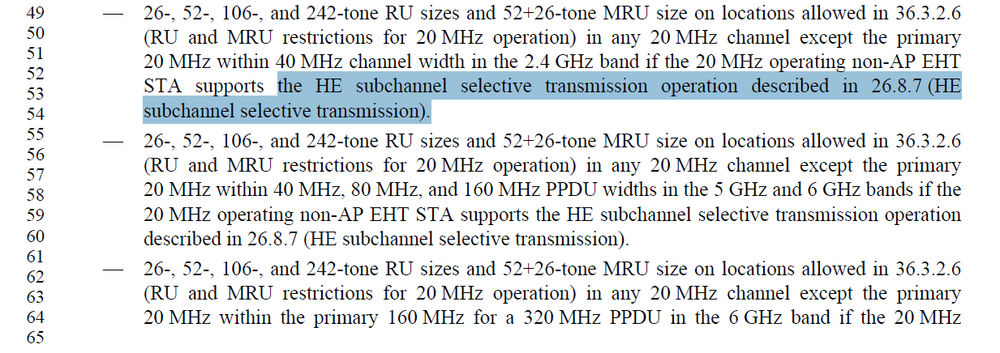
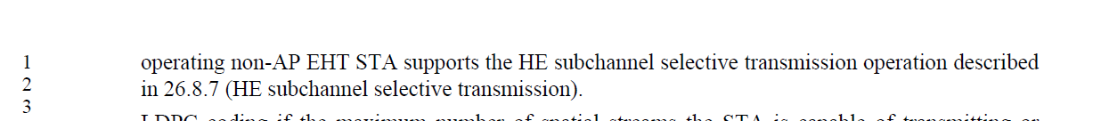

CID 16630
CID | Clause | Page.Line | Comment | Proposed Change | Resolutions
16630 | 36.1.1 | 663.49 | SST related requirements are only in 20 MHz operating non-AP STA optional features. Please clarify whether 80 MHz operating non-AP STA may support SST as well. | As in comment | Revised  80MHz operating device SST supports is the same as defined in 11ax. The spec is modified to reflect this in “a non-AP EHT STA may support” section.  Instruction to the editor:  Please make the changes in D3.0 as indicated in 23/0451r2

Instruction to the editor:
Please insert the following bullets at P663 L22 (non-AP EHT STA may support):
—Reception of a 160 MHz EHT MU PPDU, or transmission of a 160 MHz EHT TB PPDU in the 5 GHz and 6 GHz bands where the assigned RU or MRU is in the secondary 80 MHz channel if the non-AP EHT STA is operating with 80 MHz channel width and supports the HE subchannel selective transmission operation described in 26.8.7 (HE subchannel selective transmission).
—Reception of a 320 MHz EHT MU PPDU, or transmission of a 320 MHz EHT TB PPDU in the 6 GHz bands where the assigned RU or MRU is in the secondary 80 MHz channel if the non-AP EHT STA is operating with 80 MHz channel width and supports the HE subchannel selective transmission operation described in 26.8.7 (HE subchannel selective transmission).

CID 16162
CID | Clause | Page.Line | Comment | Proposed Change | Resolutions
16162 | 36.1.1 | 664.09 | The optional support for SU/MU beamforming of the 20 MHz-only EHT non-AP STA with 20 MHz-Only Limited Capabilities Support subfield equal to 1 was importantly discussed, so wouldn't it be needed to add the support for it here, even we don't necessarily have to describe all the requirements in PHY introduction part likewise no description regarding beamforming capability in other cases of AP/STA. Becasue the concept of the 20 MHz-only EHT non-AP STA with 20 MHz-Only Limited Capabilities Support subfield equal to 1 was introduced first in 11be, it'll be helpful for the reader of the spec to understand what are the major requirements for this type of STA. | As in comment | Revised  SU and MU beamformee support for the 20 MHz-only EHT non-AP STA with 20 MHz-Only Limited Capabilities Support subfield equal to 1 are optional. We need to add description for SU beamforming in the optional support section.  In addition, the bullet regarding sounding support in a non-AP EHT STA shall support section should be modified to exclude 20 MHz-only EHT non-AP STA with 20 MHz-Only Limited Capabilities Support subfield equal to 1.  Instruction to the editor:  Please make the changes in D3.0 as indicated in 23/0451r2

Instruction to the editor:
Please insert the following bullets at P664 L25 (A 20 MHz-only EHT non-AP STA with 20 MHz-Only Limited Capabilities Support subfield equal to 1 may support):
—SU beamforming, if SU Beamformee subfield in the EHT PHY Capabilities information field is set to 1.

Please modify the following bullet at P662L37 (a non-AP EHT STA shall support):
—Responding with requested beamforming feedback in an EHT sounding procedure with at least four spatial streams in the EHT sounding NDP, except for a 20 MHz-only non-AP STA with 20 MHz-Only Limited Capabilities Support subfield equal to 1.

