IEEE P802.11  
Wireless LANs

|  |  |  |  |  |
| --- | --- | --- | --- | --- |
| Technical Report on support of AMP IoT devices in WLAN | | | | |
| Date: 2023-03-15 | | | | |
| Contributors: | | | | |
| Name | Affiliation | Address | Phone | email |
| Weijie Xu | OPPO | Beijing China |  | xuweijie@oppo.com |
| YiNan Qi | OPPO | London UK |  | v-qiyinan@oppo.com |
| Zhisong Zuo | OPPO | Shenzhen China |  | zuozhisong@oppo.com |
| Chuanfeng He | OPPO | Beijing China |  | [hechuanfeng@oppo.com](mailto:hechuanfeng@oppo.com) |
| Shengjiang Cui | OPPO | Beijing China |  | cuishengjiang@oppo.com |
| Rongyi Hu | OPPO | Beijing China |  | [hurongyi@oppo.com](mailto:hurongyi@oppo.com) |
| Shukun Wang | OPPO | Beijing China |  | wangshukun@oppo.com |
| Zhi Zhang | OPPO | Beijing China |  | zhangzhi@oppo.com |
| Lei Huang | Huawei | Singapore |  | Lei.huang1@huawei.com |
| Boyce Bo Yang | Huawei | Nanjing China |  | yangbo59@huawei.com |
| Chenhe Ji | Huawei | Nanjing China |  | jichenhe@huawei.com |
| Bo Sun | Sanechips | Xian China |  | Sun.bo1@sanechips.com.cn |
| Shichao Zhao | Haier | Qingdao China |  | [zhaoshichao@haier.com](mailto:zhaoshichao@haier.com) |
| Zhaojuan Du | Haier | Qingdao China |  | duzhaojuan@haier.com |
| Jiazhi Ni | Tencent | Beijing China |  | andyni@tencent.com |
| Harry Wang | Tencent | Beijing China |  | harryhwang@tencent.com |
| Terry Yan | Tencent | Beijing China |  | terryxyan@tencent.com |
| Wenhao Zhan | China Telecom | Guangzhou China |  | zhanwh@chinatelecom.cn |
| Xiaoqing Tang | HuBei University | Hubei China |  | Tangxq@Hubu.edu.cn |
| Heng Pan | Finsiot | Chengdu China |  | pan.heng@finsiot.com |
| Hongwei Wang | JD | Beijing China |  | Wanghongwei10@jd.com |
| Hao Min | Quanray | Shanghai China |  | hmin@fudan.edu.cn |
| Xu Zhao | Beijing Smart Chip Microelectronics Technology Co., Ltd. | Beijing China |  | [zhaoxu@shchip.sgcc](mailto:%20zhaoxu@shchip.sgcc).com.cn |
| Jie Gan | Beijing Smart Chip Microelectronics Technology Co., Ltd. | Beijing China |  | ganjie[@shchip.sgcc](mailto:%20zhaoxu@shchip.sgcc).com.cn |
| Amichai Sanderovich | Wiliot | Israel |  | amichai.sanderovich@wiliot.com |
| Joerg ROBERT | TU Ilmenau / Fraunhofer IIS | Helmholtzplatz 2, 98693 Ilmenau, Germany |  | joerg.robert@tu-ilmenau.de |
| Steve Shellhammer | Qualcomm |  |  | shellhammer@ieee.org |
| Vytas Kezys | HaiLa Technologies |  |  | vytas@haila.io |
|  |  |  |  |  |
|  |  |  |  |  |
|  |  |  |  |  |
|  |  |  |  |  |

Abstract

This document is Technical Report on support AMP IoT devices in WLAN, which provides description on use cases, device types, functional requirements, technical feasibility and economic feasibility. Recommendations from AMP IoT TIG are outlined.

Revision History

r0 –March 15, 2023. Technical Report on support AMP IoT devices in WLAN.

Note: The content of this Technical Report is from 11-22/1562r8 and 11-23/0172r4.

**Table of Contents**

1. Introduction 5

1.1 Motivation 5

1.2 TIG progress 5

2. Use Cases 6

2.1 Use Case 1 Smart Manufacturing 6

2.2 Use Case 2 Data Center 7

2.3 Use Case 3 Logistics/Warehouse 8

2.4 Use Case 4 Smart Home 10

2.5 Use Case 5 Smart Agriculture 11

2.6 Use Case 6 Indoor Positioning 11

2.7 Use Case 7 Smart Power Grid 12

2.8 Use Case 8 Fresh Food Supply Chain 14

2.9 An Example: Wash Machine Drum Production Line 16

2.10 Gap analysis 16

3. AMP IoT device type and functional requirements 17

3.1 AMP-only IoT device 18

3.2 AMP-assisted IoT device 19

4. Technical Feasibility 20

4.1 Ambient Power and Energy Storage 20

4.2 Challenges of supporting AMP IoT devices 24

4.3 Potential candidate techniques 25

4.4 Feasibility of supporting AMP IoT devices in WLAN 29

4.4.1 Link budget for different AMP IoT device types 29

4.4.2 Co-existence with legacy 802.11 systems 32

4.4.3 Carrier generation for backscattering 33

4.5 Prototypes 34

5. Frequency Regulation Considerations 38

5.1 Frequency Regulation in FCC 15.247: 38

5.2 ETSI Harmonised Standards 39

5.2.1 ETSI Harmonised Standards in the 2.4GHz band 39

5.2.2 ETSI Harmonised Standards in the 863 to 870 MHz and 915 to 921 MHz band 40

5.3 Considerations on regulation requirements for Sub-1 GHz 41

6. Economic Feasibility 42

7. Summary and recommendations 43

8. References 47

# ****Introduction****

In today’s IoT networks, legacy IoT devices are usually driven by batteries with a limited lifespan, which has significantly affected user experience in a negative way. The astronomical growth of IoT networks together with the advent of a huge amount of IoT devices has pushed the limits of maintenance expenditure, including both labor and battery costs, to a whole new level. Billions of batteries have been disposed of every year and only a small part of them can be efficiently recycled, leading to harmful impacts on the earth’s ecosystem. In extreme environmental conditions, maintaining the operation of IoT networks and replacing the batteries can be quite challenging. In this regard, battery-free IoT communication has been proposed and improving the network performance, and sustainability, and expanding the application scenarios. In addition, battery-free communication can be much more environmentally friendly and much safer for children and elders. By removing the battery, the device size and cost can be significantly reduced, thus paving the way to a variety of new applications.

## Motivation

A Wi-Fi IoT network is competitive from the perspective of deployment cost, due to an already widespread deployment and use of unlicensed frequency band. However, there are still lots of use cases and applications that can not be addressed using existing Wi-Fi IoT technologies given the following circumstances. Firstly, a device powered by a conventional battery is not always applicable, e.g., under extreme environmental conditions (e.g., high pressure, extremely high/low temperature, humid environment). Secondly, maintenance-free devices are required (e.g., no need/possibility to replace a conventional battery). Finally, ultra-low complexity, very small device size/form factor (e.g., thickness of a few mms), longer life cycle, etc. are required.

Ambient power-enabled IoT is a promising technology to enable battery-free communication and fulfil the requirements from various verticals. The operation of such devices relies on the energy harvested from a variety of sources including radio waves, light (sunlight), motion, heat, etc.so that the conventional battery can be removed. Ambient power-enabled IoT is different from 802.11ah and standard Wi-Fi due to the following reasons: 1) Wi-Fi devices are typically powered by a conventional battery; 2) the typical peak power of an ambient device is less than 1 milliwatt [mW] (considering device size restriction) and is much lower than the power consumption of legacy WiFi devices, e.g., 802.11ah devices, which is tens to hundreds of mWs; 3) simple waveforms other than OFDM can be used for reduced complexity and power consumption. Combining ambient power-enabled IoT with Wi-Fi will enable new kinds of IoT services, from which the Wi-Fi ecosystem will vastly benefit.

From technical perspective, there are already many emerging implementations in 802.11 network demonstrating both feasibility and technical/business potentials as shown in section 4.5. The AMP function design can be eased by building upon the existing 802.11 features, such as 802.11ba, 802.11ah and legacy 802.11 power management mechanism to minimize design efforts and reuse the existing mechanism, e.g., WUR and OOK, simplified 802.11ah MAC, access control mechanism, power management mechanism, etc. On the other hand, from business perspective, AMP devices and Wi-Fi eco-system are mutually beneficial in the sense that it will create new IoT service opportunities in many to-Business and to-Customer areas by enriching WLAN IoT applications, explore the high WLAN market share, and further expand Wi-Fi ecosystem market portfolio. In addition, unlicensed frequency band and the possibility of reusing legacy 802.11 infrastructure will help AMP device networks achieve much lower CapEx and OpEx for the verticals.

## TIG progress

During the May 2022 IEEE 802 interim session, a contribution on ambient communication in WLAN (11-22/0645) was presented and discussed in WNG SC meeting with two straw polls run as below:

* Straw Poll #1: Do you think ambient power-enabled IoT for WLAN would be an interesting topic for 802.11 to study as a separate activity? (Result: 79Y/23N/28A)
* Straw Poll #2: Do you support the formation of a new 802.11 Topic Interest Group (TIG) for “Support of Ambient Power-Enabled IoT for WLAN”? (Result: 70Y/21N/36A)

And in the closing plenary of the same interim session, an 802.11 WG motion was approved to form an AMP TIG to develop a technical report to

* Describe use cases for 802.11 ambient power-enabled IoT devices, and
* Investigate the technical feasibility of features to enable 802.11 WLAN support of ambient power enabled IoT devices

The WG Chair appointed Bo Sun as the chair of the AMP TIG. The AMP TIG kicked off its first meeting in Jul 2022 IEEE 802 plenary session, and is expected to complete the technical report on ambient power enabled IoT devices in WLAN by the closing of Mar 2023 IEEE 802 plenary session.

Since its first meeting, AMP TIG has held 11 meetings and 6 teleconferences during or between IEEE 802 plenary and interim sessions. Around 30 technical contributions were submitted, presented and discussed, covering use cases, technical feasibility, regulation policies, and impact to standards, etc. Based on the contribution-driven discussion, a technical report draft (11-22/1562) was proposed during Sep 2022 IEEE 802 interim session and was continuously improved to incorporate the following group consensus. To assist the AMP TIG discussion, a contribution of AMP technical report summary (11-22/1960) was also developed with a brief introduction of the framework and mean consensus of the AMP technical report.

# Use Cases

This section summarizes the typical use cases that will benefit from AMP IoT and the relevant requirements to fulfill the goals of various services.

## Use Case 1 Smart Manufacturing

Smart manufacturing plays a critical role in increasing productivity and improving sustainability. The key to smart manufacturing is inter-connectivity and inter-operability between assets, storage tanks, materials and other passive objects in factories or industrial areas, enabled by wireless identification and sensing.

In smart manufacturing, identification is an essential service mainly for asset management and worker tracking, where labels can be attached to human beings or assets including production materials, storage tanks, containers, etc. [1] . The following functionalities can be provided

* Inventory check: once tags are read remotely, the ID of the item to which the tag is attached can be acquired and traced as well as the information associated with the ID, e.g., position, product number, etc. Such information can then be further used for other purpose, e.g., supply chain management, anti-counterfeiting, etc.;
* Attendance check: once a worker enters or leaves a specific area of a factory or a working spot, the tag attached to him can be read and attendance can be automatically checked;
* Real-time inspection and tracing: a product can be assembled and moved along multiple steps in a line of machines and workers as shown in Fig. 2.1-1. Real-time inspection and tracing are needed to guarantee that each machine or worker, that is performing a particular job must finish the job before the product moves to the next step in the production line.

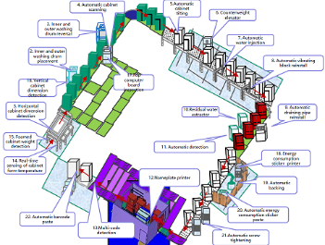

**Fig. 2.1-1 Inspection and tracing in production line**

Environmental sensing and monitoring are needed to collect real-time temperature and humidity information for production lines, computing and data centres and other equipment [1] [2] [3] . The weight and moving speed of a product in a production line can be collected via motion and pressure detection sensors. In addition, to maintain safety within a factory, gas leakage in gas tanks and pipelines can also be detected by such sensing networks.

This use case requires ultra-small size, ultra-low cost and power consumption labels so that they can be deployed in a very high density. In addition, the battery-less devices can enable maintenance-free operation. The following requirements are identified:

* Maintenance-free for long service life;
* Battery-less (i.e., no conventional battery is used);
* Coverage: up to 30 m for indoor case, up to 100 m for outdoor case;
* Data rate: up to 100 kbps.
* Positioning accuracy: 1~3 m Horizontal indoor

## Use Case 2 Data Center

The data center illustrated in Fig. 2.2-1 is the bedrock of modern ICT infrastructure, running software and processing data. The management network is essential to improve the reliability and efficiency, thus guaranteeing the safe and reliable operating conditions. Data centers are unique from all other building types, which need to be managed intelligently and comprehensively with the following functionalities [2] :

* Environmental monitoring to capture data on temperature, pressure, humidity and air flow etc., and highlight potential inefficiencies;
* Facility monitoring to provide visibility into the entire power chain from aa generator down to a specific outlet on an intelligent cabinet power unit, and diagnose potential facility problems;
* Asset management to maintain a centralized database that houses all of the IT and facility asset information including where the asset is located and how it is connected to other assets.

Asset management of a data center is similar to smart manufacturing and the main objective is to keep an up-to-date record of all hardware and software within the data center and track the real time visibility and availability of the asset via label identification. Environmental and facility monitoring in the data center can also be done via a wireless sensor network to monitor the real time operation, data and events of the data center facility, e.g., power consumption, water supply, AC etc.; respond to alerts and events and issuing fault tickets.

 

**Fig. 2.2-1 Asset management in Data Center**

This use case has the same requirements as smart manufacturing:

* Maintenance-free for long service life;
* Battery-less (i.e., no conventional battery is used);
* Coverage: up to 30 m for indoor case, up to 100 m for outdoor case;
* Data rate: up to 100 kbps.

## Use Case 3 Logistics/Warehouse

In logistics, an inventory check is needed to view all products and identify any missing assets and discrepancies within the inventory [4] . Packages are stored in containers such as cartons and the cartons are normally piled in a warehouse. A pile of cartons in a single storage location can be more than 10 m long and up to 8 m high as shown in Fig. 2.3-1.

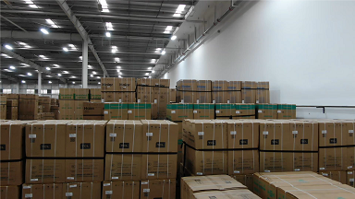

**Fig. 2.3-1 Piles of cartons**

The cartons are labelled for goods tracking and there could be hundreds of labels in a single storage location. It is inevitable that labelling does not follow a standard procedure, thus it is possible that not all labels face the same direction. It is quite time consuming and inefficient to scan these labels manually. Inventory check needs to be completed with high accuracy and in short time. In this regard, manual operation is clearly not preferred. Labels can be attached to the cartons when the cartons are transferred, stored, loaded/unloaded as shown in Fig. 2.3-2. Such tags can provide high sensitivity and omni-directionality so that they can be read remotely from multiple directions.

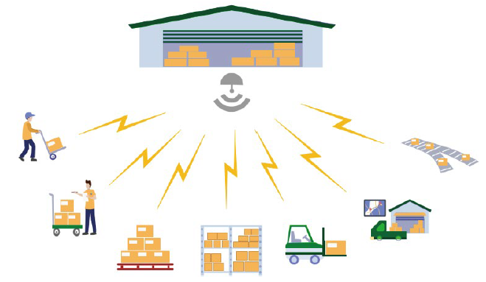

**Fig. 2.3-2 Logistics/warehouse**

Warehouses and distribution centers are usually equipped with sorting systems where random flows of items are sorted into orders for shipping. Sorting of the goods should be performed both when the goods are received and when the orders are prepared for sending out. In a sorting system, goods are usually placed in labelled containers and the container specifications can be either uniform, e.g., cartons and wooden trays, or non-uniform, e.g., packing bags. Information needed for sorting, such as the clients and the place of destination is associated with such labels that should be read when goods are sorted and prepared for transportation to the final destination. Two adjacent containers should be distinguished so that the target container is not misidentified with the adjacent container by the sorting system. For non-uniform container specifications, e.g., a packing bag, scanning from all possible sides should also be supported. Roller conveyors are widely used in sorting systems as shown in Fig. 2.3-3 and the tags attached to the containers may move at a speed of 1.5-2 m/s.

In sorting systems the following functionalities should be provided:

* Accurate label identification for closely adjacent items on the conveyor system;
* Fast label identification of the items on the conveyor belt that moves at a speed of 1.5-2 m/s;
* Real-time monitoring and related information acquisition for the items on the conveyor system;
* Environmental monitoring of temperature, humidity, etc. for specific items such as cold-chain transportation goods.

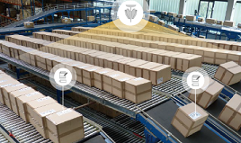

**Fig. 2.3-3 Label reading in sorting system**

The following requirements are identified,

* Ultra-low cost and ultra-small size for extremely high-density deployment;
* Maintenance-free and battery-less for long service time;
* 99.5% identification accuracy;
* Moving speed up to 2 m/s;
* Minimum distance to distinguish adjacent items: 0.5 m
* Coverage: up to 10-30 m for indoor case
* Positioning accuracy: 1~3 m Horizontal indoor

## Use Case 4 Smart Home

In a smart home, many devices such as smartphones, tablets, door locks, thermostats, home monitors, etc. are connected with each other. Low energy consumption and maintenance-free devices should be used for sensing and monitoring as shown in Fig. 2.4-1 [3] . For home environment sensing, such as temperature, humidity, etc., once the sensed information is collected by a controlling node, the heater, air-conditioner and (de)humidifier can be switched on/off automatically accordingly to adjust the temperature and humidity to a comfortable level. Such devices can also be used for home safety. For example, once gas leakage happens, a gas detector can send an alert to warn the home owner. Similarly, if a smoke detector senses there is a fire, it can automatically send the alert. In addition, motion detector is needed to detect the intruders and send alert to the home owner. Another important functionality needed is to locate keys, wallets and other personal belongs with attached labels.

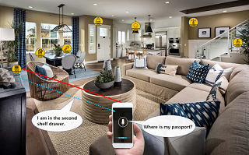

**Fig. 2.4-1 Smart home**

The requirements for smart home use case are identified as follows,

* Low complexity and small size, e.g., thickness of 1 mm and area of several cm2;
* Long service life., e.g., more than 10 years;
* No need to replace/recharge a conventional battery, e.g., maintenance-free
* Coverage up to 10 m
* Horizontal positioning accuracy of 1~3 m

## Use Case 5 Smart Agriculture

Smart agriculture focuses on providing the industry with the infrastructure to leverage advanced technology for tracking, monitoring, automating and analyzing operations. Similar to smart home, low energy consumption and maintenance-free devices can be used for sensing and monitoring, such as monitoring of soil moisture, soil fertility, temperature, wind speed, plant growth etc. [3] . For example, once the soil moisture is sensed, the irrigation system can be controlled to increase or decrease the supply of water to land or crops. Asset management for agricultural facilities can also be done by reading the labels attached to those facilities remotely.

 

**Fig. 2.5-1 Smart agriculture**

The main difference between smart agriculture and smart home is that smart agriculture needs to handle outdoor sensing and monitoring so that a much wider coverage should be maintained. Due to the much wider coverage, the number of connected devices can be hundreds to thousands. The requirements for smart agriculture use case are as follows,

* Battery-less, thus no need to use a battery;
* Low complexity and small size, e.g., thickness of 1 mm and area of no larger than several cm2;
* Coverage: up to 30m for indoor case, up to 200 m for outdoor case;
* Processing (i.e., reading IDs) hundreds to thousands of devices per second.

## Use Case 6 Indoor Positioning

For indoor positioning, reference tags with known location can be densely deployed indoor to establish a navigating and positioning system that has a wide range of potential applicable venues such as giant shopping malls, parking, smart factories, warehouses, etc. [4] . Shopping centers offer a wide range of services and products, including large supermarkets, a collection of retail stores, restaurants, banks, theatres, fitness and leisure facilities, underground parking areas, professional offices and other establishments. Many giant shopping centers have been established all over the world, each can occupy an area of tens to hundreds of thousands m2, composed of one or multiple buildings, each of which has multiple-story both over and underground. While enjoy various services, people often have troubles in finding a vacant parking spot or his/her own car, a target shop/restaurant or a target item in a supermarket. The reference tags can be evenly distributed with high density, e.g., 2-meter intervals, within the entire shopping center on each floor and in each room as shown in Fig. 2.6-1. Indoor positioning can be enabled by a handheld device (e.g., smartphone), which can communicate with the reference tags.

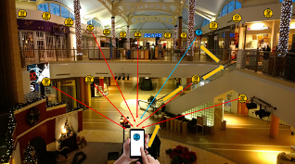 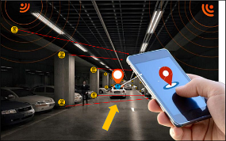

**Fig. 2.6-1 Indoor positioning for shopping center and parking**

Such navigating and positioning system can also be used in the aforementioned use cases, e.g., smart manufacturing in factories, logistics/warehouse and smart home. In smart manufacturing, a product on the production line or conveyor system should be positioned precisely in order to identify in which step the product is. In the industrial area, there are some dangerous zones with toxic materials that are harmful to the health of the workers. Labels can be attached to workers and when they enter the dangerous zones, a safety alert can be immediately sent based on the real-time position of the workers. For logistics/warehouse, inventory and attendance check can also rely on such navigating and positioning system to locate the item or personnel.

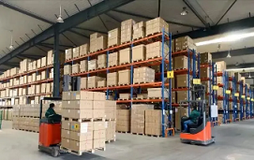

**Fig. 2.6-2 Indoor positioning for smart manufacturing and warehouse**

The following requirements are identified for indoor positioning,

* Small size, maintenance-free, battery-free, and ultra-low-cost IoT devices;
* Coverage: 10-30 meters for indoor (an exemplary product line has an area of 25 thousand m2)
* Positioning accuracy: 1~3 m horizontal accuracy and 1~2 m vertical accuracy
* Moving speed: 1.5-2 m/s

## Use Case 7 Smart Power Grid

Nowadays it is very important to realize real-time monitoring of power grid equipment status and operating environment, and timely discover and deal with potential safety hazards as shown in the below figure in the overhaul and operation and maintenance of power equipment. The use of power sensing technology and communication technology is the key to improving the safe operation of the power grid and ensuring the reliability of power supply. At present, the large-scale application of power sensors in power transmission, substation and power distribution has been realized. The wide deployment of hundreds of sensors and smart terminals such as leakage current, vibration and pressure enable the collection of electrical, non-electrical, and environmental quantities. Converting various physical quantities such as sound, light, electricity, heat, magnetism, force and other physical quantities reacted by power equipment during operation into electrical quantities can achieve full awareness of device/equipment status.

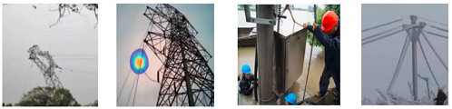

**Fig. 2.7-1 Safety hazards: tower tilting, partial discharge, water in cabinet, icing wire**

With the advancement of digital and intelligent construction of new power grids, the demand for equipment status awareness has increased sharply. The network involves urban and rural areas and requires deployment and topology flexibility for the sensing network. The current sensing network is very costly and offer poor deployment flexibility since the sensors need to be deployed in the areas with power supply. It is quite difficult to maintain the sensing network with active devices driven by conventional battery. The current sensing network also offers low flexibility of communication rate, transmission distance and power sensing services.

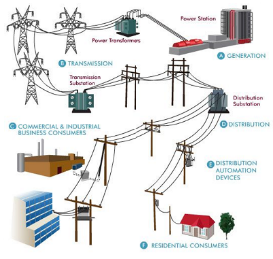

**Fig. 2.7-2 Electrical power system**

Sub-station plays a vital role in the electrical power system to guarantee the continuity of the electrical power supply as illustrated in the fig. 2.7-2. It is deployed as transmission sub-station and distribution sub-station and one sub-station covers around 50000 m2 service area. The sub-stations transform voltage from high to low, or the reverse, or perform some other important functions. Massive number of sensors and meters need to be deployed all over the sub-stations to monitor and report temperature, humidity, etc. Another important part of electrical power system is high voltage transmission lines that deliver electricity over long distances to reduce the amount of energy lost during the distance. Sensing and monitoring of high voltage transmission lines and towers can help to detect operation faults such as power leakage, tower tilting, etc. Such operation faults not only will stop the power supply, leading to large scale blackout, they might also cause damage to the very expensive equipment. Since many sensors and meters need to be deployed in the inaccessible locations, they need to be maintenance free and ideally battery-less to support long life span.

The following requirements are identified,

* Ultra-low cost and massive connection
* Maintenance-free and battery-less for long service time
* Data rate: 20kbps for sub-station and 3kbps for high voltage transmission line
* Coverage: 10-30 m for indoor case and up to 200 meters for outdoor

## Use Case 8 Fresh Food Supply Chain

In the United States alone, food waste is estimated at between 30-40 percent of the food supply ‎[45] . It is known that controlled environment for most of the fresh foods, like vegetables or meat, is critical for both the safety of the food ‎[46] as well its shelf life expectancy ‎[47] ‎[48] .

In this use case, a large food supplier monitors its food supply chain by adding a simple and small form factor device (sticker) on to each of the Reusable Transport Item (RTIs) used for storing and transporting of the food. Example RTI can be seen in Figure 2.8-1. These RTIs are loaded with food at the post harvesting and packaging facilities. They are then transported to the fresh produce distribution center as seen in Figure 2.8-2. From there, the fresh products are routed to the local stores according to demand. After usage, these RTIs are either washed and sent back for more usage cycles or sent to a recycle center.



**Figure 2.8-1 Example of an RTI with an AMP sticker device**

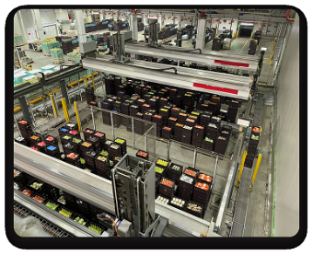

**Figure 2.8-2 Distribution center facility for fresh food**

At the harvester packaging facility, each RTI is attached with a simple, sticker form factor device. The device ID is logged by the supplier using his internal records. The supplier can route the individual RTIs based on the combination of product expected longevity and real time demand from the stores. He can also use this data to alert transport company once temperature was compromised or once a specific RTI got mixed up.

This cycle can be seen on Figure 2.8-3

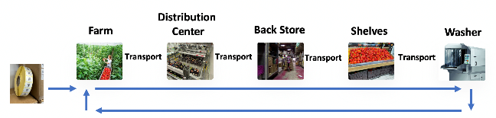

**Figure 2.8-3 The use cycle of the RTI**

The devices come in a sticker form factor, low complexity, and massive quantities. To be effective, they are distributed to the supplier in groups of hundreds, and the supplier expects to activate them all within few seconds from uploading them to the sticking gun. An example for their low complexity is to have their clock calibrated from the network, and in addition, this clock is less stable than larger form factor devices with higher cost.

Location information is added as a meta-data by the Aps to the response – the device is agnostic to this service.

Devices are expected to operate maintenance free – at least for a few years, until recycling the RTI.

The following requirements are identified for fresh food supply chain,

* Sticker form factor and BOM (Bill Of Material), maintenance-free, battery-free, and ultra-low-cost IoT devices;
* Coverage: 10-20 meters for indoor (an exemplary distribution center has an area of 30,000 m2 with 200 servicing Aps)
* Data rate: 0.12 bit/sec
* Readout interval: 15 minutes

## An Example: Wash Machine Drum Production Line

In order to provide a whole picture of AMP IoT network deployment, we take smart manufacturing as an example, more specifically the wash machine drum production line as shown in the fig. 2.1-1. A wash machine drum production line consists of more than twenty steps from cabinet dimension detection to the final barcode paste. As aforementioned, AMP IoT devices mainly provide the following functionalities,

* Sensing and monitoring of the environmental parameters such as temperature, humidity, etc.;
* Positioning of the product, i.e., the drum, to guarantee it goes through every step;
* Attendance check of workers for every working spot along the production line.

A product line normally covers an area 25000 m2 and we assume that this area is in the shape of rectangular, i.e., 500m×500m. Aps and AMP IoT devices should be deployed to fully cover such area. Considering indoor case with coverage up to 30 m, ideally the distance between two Aps can be up to 60 m and 9×9 Aps should be deployed uniformly to cover the whole production line area. For the deployment of AMP IoT devices, we consider two scenarios. The first scenario is to position the product in the production line to know the current production step. For this scenario, the deployment density can be customized based on the coverage of the AP. The second scenario is that the AMP IoT devices are used as anchor points with known locations. For such scenario, considering the positioning requirement, two-meter interval between AMP IoT devices is appropriate. In this regard, 250×250 AMP IoT devices should be deployed uniformly. However, in the realistic deployment, uniform deployment is not always necessary. There might not be needed to deploy many Aps and AMP IoT devices in the central area surrounded by the production line and thus the deployment density can be decreased to save cost. For example, if we assume the central area surrounded by the production line is 300m×300m and the deployment interval is increased from 2m to 10m, the total AMP IoT devices to be deployed is reduced from 62500 to 44500. For the outer area, the deployment can be customized to further reduce the number of deployed AMP IoT devices.

It should be noted that the intention of above example is only to give an initial view on potential deployment and the detailed deployment solution will be designed in the later stage based on the developed technology.

## Gap analysis

In table 2.9-1, for all use cases we analyze the technical gaps between state-of-the-art solution and AMP IoT solution. The use cases are categorized and the same category of use cases share similar technical challenges.

Table 2.9-1 Gap analysis for the use cases of AMP IoT

|  |  |  |
| --- | --- | --- |
| Use case | Open issues for state-of-the-art solutions | Benefits of AMP IoT |
| #1 Smart manufacturing  #2 Data center  #3 Logistics/Warehouse | 1. Manual scanning of labels of barcode or RFID tags for inventory/attendance check  2. Massive deployment of readers due to short communication distance  3. Limited performance on communication distance, system efficiency | 1. Automatic scanning  2. Lower density deployment of Aps  3. Improved performance in terms of communication distance, sensitivity and system efficiency  4. Battery-less and Maintenance free |
| #4 Smart Home | 1. Need to replace battery for many devices  2. High cost and large size devices for applications such as finding small items at home | 1. Battery-less and Maintenance free  2. Small size/low cost to support more applications  3. Support positioning  4. Enable communication between non-AP STA (e.g., smart phone) and AMP IoT devices |
| #6 Indoor positioning | 1. High deployment cost for indoor navigation and positioning systems  2. High maintenance cost | 1. Small size/low deployment cost  2. Enable positioning by non-AP STA (e.g., smart phone), with 1~3m horizontal positioning accuracy  3. Battery-less and Maintenance free |
| #5 Smart Agriculture  #7 Smart Grid | 1. Power supply with wire cable or battery is needed for sensors  2. High maintenance cost  3. Inaccessible in case of hazardous operation conditions | 1. Battery-less so that deployment of AMP IoT devices can be flexible and low deployment cost  2. Maintenance free  3. Lower device cost |
| #8 Fresh Food Supply Chain | 1. Dedicated high cost/massive deployment of RFID readers due to short communication distance.  2. Limited and predefined RFID information types and sizes do not fit all sensors types.  3. No IP stack is defined. | 1. Lower density/cost effective deployments of Aps provide wide coverage  2. Improved performance in terms of communication distance, sensitivity and system efficiency  3. Inherent, standardized and secured internet connectivity  4. Location services |

# AMP IoT device type and functional requirements

To support the aforementioned diverse use cases of AMP IoT, multiple device types should be defined. This section provides definitions of AMP IoT device types. For a particular device type, the specific functional requirements are given accordingly.

In the first category of use cases, such as logistics/warehouse and smart home, object identification is one of the main functionalities provided by the AMP IoT devices. The essential information transmitted to the AP reader is the ID of the devices/tags that requires low peak data rate only (e.g., less than 100kbps). Since the devices/tags should be attached to all the objects within the service area, huge amount of such devices/tags is needed. In this regard, manual operation of the devices/tags is extremely difficult and simple maintenance or even maintenance-free feature is necessary. In some of the use cases requiring environmental monitoring and sensor data reporting, such as smart manufacturing, smart home, etc., only small packet (e.g., less than 200 bits) and infrequent sensor data reporting (e.g., one packet per minute) are needed, e.g., temperature sensing and reporting. In these use cases, the devices/tags should have the features such as ultra-low complexity, ultra-low power consumption, very small form factor and battery-less (i.e., not using conventional battery). This device type is defined as AMP-only IoT device.

However, in some other use cases, e.g., smart manufacturing and smart agriculture, the AMP IoT devices may act as sensors, monitors and actuators. The communication between the AP reader and devices is more complicated in the sense that it may also require higher volume bi-directional data exchange between the AP reader and devices. The required data rate may be close to the existing IoT technologies. Therefore, higher capabilities which are similar as the current Wi-Fi devices are needed. However, for these use cases, it also expects a maintenance-free IoT network (e.g., without replacing/recharging the battery), which is not possible to be achieved by the current technologies. Therefore, it calls for another type of IoT devices which has high capability but optimized for the power consumption and sustainability to adapt to ambient power usage and eventually may achieve the goal of maintenance-free operation. This type of device is defined as AMP-assisted IoT device.

At least the above 2 types, which can also be denoted as “low-end” and “high-end” device types, are envisioned for the AMP IoT devices[5] . More device types can be considered once identified during study phase.

## AMP-only IoT device

The AMP-only IoT device targets at the first category of use cases. It features with ultra-low complexity, ultra-power consumption, very small form factor and battery-less (i.e., not using conventional battery). It may not need power storage or has limited power storage only (e.g., a capacitor).

* AMP-only IoT device has ultra-low complexity and ultra-low power consumption
  + The required data rate for identification is very low (e.g., less than 100kpbs). The device shall be designed as simple as possible while in the meantime fulfilling the requirements of data rate and communication distance. Much lower capability than the current Wi-Fi devices is expected.
  + In order to achieve battery-less, it will use ambient power to drive itself and to communicate with the AP. The available ambient power would be very low as discussed in session 4.1, thus it requires much lower power consumption than the existing Wi-Fi devices.
  + In most of the target use cases, it shall have a small size, which restrict the size of antenna and the energy harvester.
* AMP-only IoT device can have no power storage or very limited power storage.
  + For some of the target use case, the device can’t support power storage due to restriction such as the complexity, the acceptable cost and the constraint of the device size.
  + For some other use cases, the device can have very limited power storage to achieve more functions (e.g., connect to a sensor), higher performance (e.g., longer communication distance), or adapt to some kinds of unstable ambient power (e.g., to store unstable solar power).
* AMP-only IoT device can be used for light-weight applications, such as identification, positioning, infrequent and small sensor data reporting.

For AMP-only IoT device, the potential functional requirements include:

* Supported operation band.

It may be helpful to achieve low complexity and low power consumption by lower frequency band. This is due to its small channel bandwidth and good propagation property in lower frequency band. Therefore, sub 1GHz shall be considered with high priority. The 2.4GHz can also be considered since it is the mature frequency band widely used.

* Constraints of power consumption.

Since ambient power is used and energy harvester with small size can be utilized due to the small size restriction of the device, the power can be harvested is very limited. Therefore, ultra-low power consumption, e.g., less than 1 mW can be considered as the design target for AMP IoT.

* Coexistence.

Irrespective of sub1GHz or 2.4GHz, AMP-only IoT device will share same frequency band(s) with legacy WiFi devices. Therefore, backward compatibility and coexistence with legacy devices shall be supported. The regulation of these frequency band(s) shall be followed.

* Support energy harvesting.

In order to achieve battery-less (i.e., not using conventional battery), it will use ambient power to drive itself and to communicate with the AP. Therefore, energy harvesting should be supported by the AMP-only devices. For different use cases, different ambient power may be available thus different energy harvester can be supported based on the suitable ambient power for a specific use case.

* Coverage

As discussed in the use cases and requirements in session 2, up to 30m for indoor scenario and up to 100 m for outdoor scenario are required.

## AMP-assisted IoT device

For an AMP-assisted IoT device, higher capabilities similar as current Wi-Fi devices should be expected. The key design target is to achieve a maintenance-free IoT network (e.g., without replacing the battery) which can provide relatively high performance, which is similar as what the current Wi-Fi devices can provide. It shall be optimized for the power consumption and sustainability to adapt to ambient power usage and achieve maintenance-free.

* An AMP-assisted IoT device may be similar to a legacy 802.11 (e.g., 802.11n/11ah) device, it can reuse the current PHY design but with enhanced MAC features to adapt to operation with a specific kind of ambient power. Since the ambient power is very limited and sometimes unstable and uncontrollable, the enhanced power saving and power management can be adapted for the unstable and uncontrollable ambient power.
* An AMP-assisted IoT device can have higher power storage capability than an AMP-only IoT device. Although the power consumption of the AMP-assisted IoT device can be further optimized in addition to the current Wi-Fi devices, its power consumption level will be much high than AMP-only IoT devices, e.g., tens to hundreds of mWs during transmission and reception. The typical power storge capacity is comparable to the existing IoT or other electrical devices, e.g., 300mAh.

The potential functional requirements for AMP-assisted IoT device include:

* Supported operation band:

With similar capabilities to the current Wi-Fi devices, it is easy for an AMP-assisted IoT device to operate on the current frequency bands such as 2.4GHz and sub 1GHz. For example, if it is optimized in addition to the 802.11ah devices using sub 1GHz, the AMP-assisted IoT device can also use sub 1GHz to support energy harvesting

In order to achieve maintenance free operation, it will use ambient power to sustain itself and to communicate with the AP. In order to fulfill the required higher power consumption compared with that of AMP-only devices, the energy harvester shall be able to provide a higher output power, e.g., more than 10 mWs.

* Coverage

Similar coverage as the current Wi-Fi devices can be expected, e.g., up to 30m for indoor case and up to 200m for outdoor case (note that for 802.11ah, it can be up to 1km).

# Technical Feasibility

This section introduces different types of ambient power sources and their unique features, discussing potential candidate techniques to fulfil the function requirements and feasibility aspects, including how to maintain backward compatibility and co-existence with legacy 802.11 devices, evaluation of link budget (for potential different IoT device types) and impact on PHY and MAC etc. Some prototypes that use different energy harvesting schemes and communication techniques are also introduced.

## Ambient Power and Energy Storage

Energy can be harvested from different types of ambient power sources including RF radio, solar energy, thermal energy and piezoelectric power etc.

**RF Energy**

RF-based energy can be harvested from radio waves ranging from 3kHz to 300GHz using a single-stage or multistage converter. The amount of power that can be harvested depends on the source power, antenna gain, and the distance from the RF source. Ambient RF energy has a relatively low energy density and the conversion efficiency depends on the received power level e.g.,the power density of RF power transfer is 0.4 to 60 μW at typical working distances (3 ~ 15 meters), assuming 30dBm transmission power, 6dBi antenna gain and 20% RF-DC conversion efficiency, as shown in Figure 4.1-1.



Figure 4.1-1 Received RF power for different working distances

The main advantage of RF-based energy harvesting is its availability in indoor environments and the fact that RF power is controllable (e.g., power can be sent by a transmitter on demand or periodically). Potential applications include logistics/warehouse, manufacturing, smart homes, health monitoring, and environmental monitoring etc. The minimum RF power that can be harvested is around -30dB [7] [8] . The conversion efficiency for RF Energy in the 900MHz band is listed in the table below.

**Table 4.1-1 Conversion efficiency for RF Energy [9]**

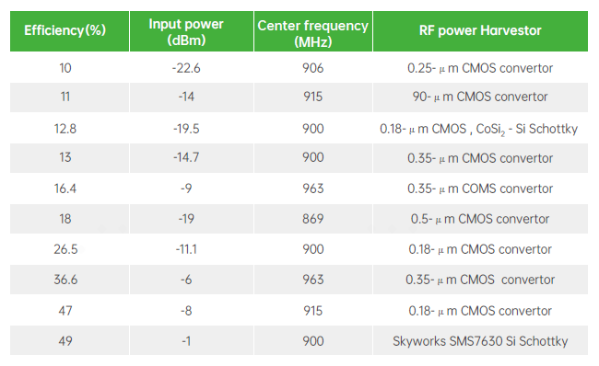

In practical wireless communication system such as Wi-Fi system, the IoT devices may be far away from Wi-Fi transmitters and the far field RF energy is weak. In addition, Wi-Fi signals for data communication are not continuous. Channel Utilization (CU) in a typical office, is around 10% in 2.4GHz channels, expressed as

$$CU =T_{CCA-Busy}/T_{observation}$$

where *TCCA-Busy* is the channel busy time and *Tobservation* is the channel observation time. It is noted that CCA-Busy has a much lower threshold (i.e. -82dBm) than the energy harvesting sensitivity. It means IoT devices can only harvest energy from Wi-Fi signals transmitted by nearby transmitters. In order to improve energy harvesting efficiency greatly and make energy harvesting IoT devices more practical, a dedicated power signal from a dedicated energy source (e.g. an AP) may be needed.

**Solar Energy/Light**

Solar power/light can be transformed into electrical power using photovoltaic cells with a conversion efficiency of 10-40% [10] . For the outdoor case, solar energy is one of the most common ambient power sources. It can supply inexhaustible clean energy and has a high power density of up to 100 mW/cm2 [11] . Solar power is unstable, inconsistent, and intermittent. It is highly dependent on atmospheric conditions and surrounding obstructions, etc. It is available during the daytime but inefficient on a cloudy day or during the night. Solar energy harvesting can be mainly used for outdoor environmental monitoring, agriculture, husbandry and transportation etc. For the indoor cases, light from lighting equipment can be used. Although the power density is lower than solar, 100μW/cm2, it is much stable and controllable. Energy harvested from light can be used for manufacturing and indoor environmental monitoring etc.

**Thermal Energy**

Thermal energy is another ambient power source that is available for lots of use cases. Electrical power is directly generated by exploiting the temperature difference in thermoelectric devices taking advantage of Seebeck or Thomson effect. Thermoelectric generators have low efficiency (only about 5–6%) [12] . The power density is 25~1000μW/cm2 depending the environment conditions. Although the conversion efficiency is low, thermal energy can be used in many outdoor applications or indoor cases as long as the temperature difference or temperature fluctuations can be expected in the environment. Example use cases are outdoor environmental monitoring, agriculture and husbandry.

**Piezoelectric Energy**

The piezoelectric effect generates electrical voltages or currents from mechanical strains, such as vibration or deformation. Typical piezoelectric-based energy harvesters keep creating power when there is a continuous mechanical motion, such as acoustic noises and wind, or they sporadically generate power for intermittent strains, such as human motion (walking, clicking a button, etc.). The volume of a piezoelectric power generator is relatively small and typical output power density values are around 250 μW/cm3 but they can create more power when motion or deformation is intense [13] [14] .

The cons and pros of different energy source types are summarized in the table below.

**Table 4.1-2. Energy harvesting sources**

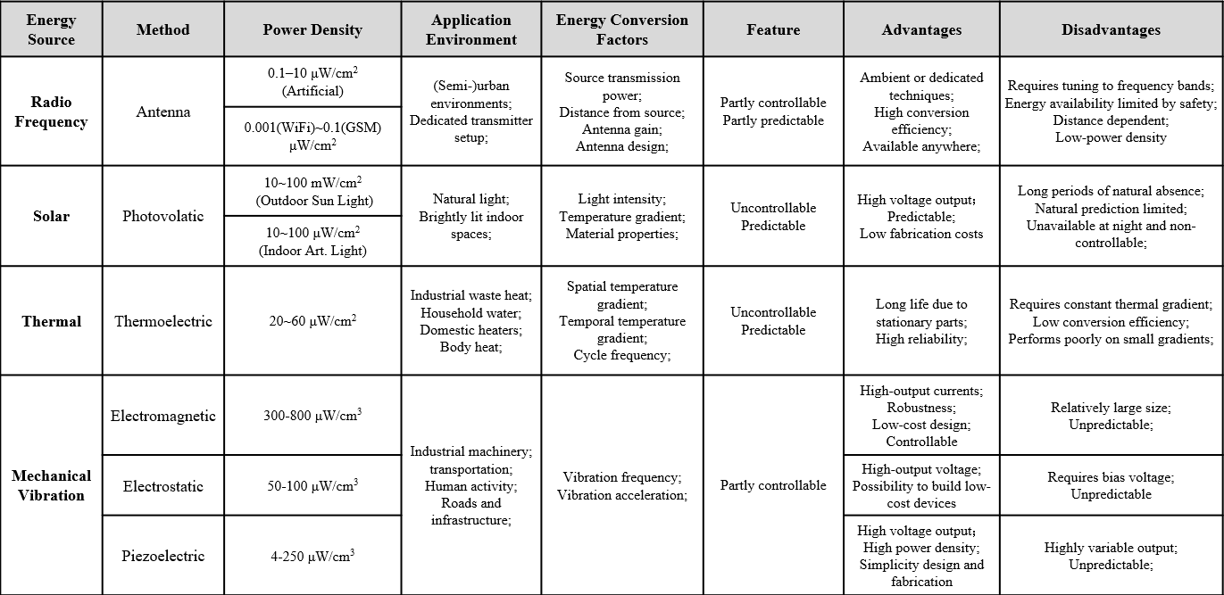

**Power storage**

For typical ambient power, it can be observed that the harvested power is very limited, e.g. from 1µW to 100 mW (per cm2 or cm3). In some applications, limited power is not sufficient to drive sensors that require higher peak power consumption, as shown in Table 4.1-3. For some artificial power sources (e.g., light, RF waves), the power can be stable and constant. However, for other kinds of ambient power such as solar, heat or vibration, the ambient power lacks stability and it is impossible to use the ambient power directly for electronic devices.

**Table 4.1-3 Power consumption of IoT devices[44]**

|  |  |  |  |  |  |
| --- | --- | --- | --- | --- | --- |
| **Components of IoT devices** | | **Average power** | **Peak power** | **Sleep power** | **Comments** |
| **Part1:**  Sensors | Door sensor [27] | 1µW | 5mW | 0.1µW | 5 events /second, 40µs each |
| Humidity sensors [28] | 1µW | 1mW | 0.1µW | 1 event /second , 1ms each |
| Accelerometer [29] | 2µW | 2µW | 0.1µW | average power when output data rate is 100Hz |
| Temperature sensors [30] | 2µW | 400 µW | 0.2µW | 1 event/second, 5ms each |
| Light sensor [31] | 10µW | 10µW | 1µW | average power at full scale lux |
| Proximity sensor [32] | 10µW | 200µW | 10µW | capacitive sensor |
| Pressure sensor [33] | 20µW | 1mW+ | 2µW | 1measure/ second |
| Part2:  MCU | ~ [34] | ~ | 0.6 ~ 9mW | 1µW | varies for different clock frequencies |
| Part 3:  Wireless Radios | Bluetooth Low Energy [35] | 77mW * duty cycle | 77mW | 10µW | [2.4GHz@8dBm](mailto:2.4GHz@8dBm) |
| Wi-Fi [36] | 429mW* duty cycle | 429mW | 40µW | [2.4GHz@8dBm](mailto:2.4GHz@8dBm) |

In this regard, energy storage element is needed for some AMP IoT devices. The energy storage element is able to stabilize and control the power output, smooth the fluctuation of power output and power usage. Typical IoT sensors, such as temperature sensors, humidity sensors, light sensors, etc., turn to active mode around every 30 seconds and then turn back to doze mode several milliseconds later. Hence, it is possible that the energy storage element can harvest energy from weak ambient power (e.g., in the level of µA or even nA) and provide the required peak discharge current (e.g., tens to hundreds of µA) for the AMP IoT devices. Therefore, the usage of energy storage element makes it possible to harvest energy from more kinds of ambient power sources for AMP IoT.

Capacitor and solid-state battery can be considered as the possible energy storage elements for AMP IoT devices to provide limited but appropriate/sufficient power storage capacity. The capacitor or solid-state battery is just like a cistern. The system works well as long as the average input power is equivalent to or larger than the average output power. (The benefit of adding a capacitor or battery is that the input power doesn’t have to be equivalent to or larger than the output power at any time).

For example, a fully charged capacitor of 24µF can drive an AMP IoT device for 3.6 seconds (1.5V and 10µA are assumed). A solid-state battery of 1µAh@1.5V can drive the AMP IoT devices for 6 minutes (1.5V and 10µA are assumed).

## Challenges of supporting AMP IoT devices

AMP IoT devices have distinguished characteristics such as battery-less, ultra-low cost, small size, maintenance-free and long-life cycle. It has great potential to fulfil the unprecedent requirements from vertical industries and create an entirely new market. In order to support AMP IoT devices in Wi-Fi system, following technical challenges should be resolved [5] .

The first challenge is it needs to support low complexity design and to reduce the complexity of AMP IoT devices to an extremely low level so that the cost and power consumption of the AMP IoT devices can be extremely low, and the size can be very small. The ultra-low complexity can be achieved by simplifying the RF chain and baseband architecture, reducing memory size, and removing unnecessary components. In addition, the communication procedure between the AMP IoT device and the AP should be designed as simple as possible. For example, instead of OFDM, simpler waveform can be supported since OFDM requires more complicated baseband processing.

The second challenge is ambient power is unstable and the energy that can be harvested from RF signals is low thus how to significantly reduce the power consumption of the AMP IoT devices needs to studied. Since the main power source is ambient power and the size of the device constrains the size and efficiency of the energy harvester, the power that can be harvested is very limited. For example, as summarized in session 4.1, only up to tens of mW can be harvested from wireless radio waves and less than 1 mW can be harvested from solar panel with size of 1 cm2. In addition, there will be maximum EIRP restriction and transmission duration restriction, which limit the total power available for AMP devices. Therefore, a simplified and low power radio should be designed in the next IEEE 802.11 amendment for IoT devices, e.g., peak power consumption of less than 1 mW can be considered as the design target for AMP-only IoT devices.

The third challenge is efficient power management of the unstable and uncontrollable power supply from energy harvester. In some typical use cases, only small amount of power can be harvested and the ambient power is unstable. Therefore, the device should adapt itself to such condition and the consumed power should be further saved by applying efficient power management schemes.

Finally, although the AMP IoT device has a much lower capability compared with normal Wi-Fi device, when operating in legacy Wi-Fi frequency band e.g., sub 1 GHz or 2.4 GHz, it should be compatible with legacy Wi-Fi system and thus be able to coexist with legacy Wi-Fi devices. In this regard, the AMP IoT device should follow the regulation for these unlicensed frequency bands and use the frequency bands in a fair way with other Wi-Fi devices. For example, it shall meet the PSD requirement and the maximum transmission EIRP requirement.

## Potential candidate techniques

In order to tackle the above challenges faced by the AMP IoT devices, following candidate techniques are investigated [5] .

**Narrow bandwidth operation**

Narrow bandwidth operation is a natural choice to realize low complexity and power consumption because the complexity of both RF and baseband is significantly simplified compared with wideband operation, e.g., 20 MHz in 2.4 GHz. In addition, the circuit can work with much lower frequency cycle and limited calculation is needed for narrow bandwidth transmission and reception. From the perspective of data rate, narrow bandwidth operation is feasible to meet the target peak data rate of 100 kbps, which is sufficient for most of the use cases in session 2.

One of the target frequency bands could be Sub 1GHz, i.e., the same band as 802.11ah, where the channel bandwidth can be as small as 1MHz. In Sub 1GHz, the device can be designed with an operation bandwidth less than or equal to 1MHz. In other frequency band, e.g., 2.4GHz, where only 20MHz channel bandwidth is allowed, AMP IoT devices using narrow bandwidth can still be supported.

In order to support narrow bandwidth operation, a new UL/DL PPDU format shall be defined. It should be noted that 4MHz DL PPDU is already supported for WUR. In the meantime, a wideband preamble for backward compatibility shall be supported for the AMP IoT device. In this regard, potential new PPDU format as shown in Figure 4.3-1 can be considered to support narrow bandwidth operation for AMP IoT devices. In the new PPDU format, there is a legacy preamble followed by AMP portion. The AMP portion is further divided into AMP preamble, AMP header and payload. The legacy preamble has the same bandwidth as the channel bandwidth in the target operation band but the AMP portion can have a smaller bandwidth to meet the peak data rate requirement, e.g., 200kHz in a 1MHz channel bandwidth in sub 1GHz.



**Figure 4.3-1 Potential new PPDU format enable narrow bandwidth operation**

**Simpler waveform/modulation/coding scheme**

In order to achieve ultra-low power consumption and ultra-low complexity, simpler waveform and coding scheme are needed. OFDM is the main waveform used in Wi-Fi and the merit of OFDM is that it can achieve high spectrum efficiency and high peak data rate using wide bandwidth. However, it is difficult to use OFDM to achieve ultra-low power consumption since the operations such ADC, data buffering, FFT, channel estimation, etc. requires high power consumption. Therefore, OFDM may not be suitable for AMP IoT as a simpler waveform is required.

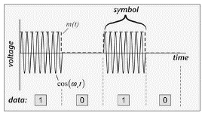

**Figure 4.3-2 OOK modulation**

OOK/FSK may be a promising modulation scheme for AMP IoT to enable ultra-low complexity data transmission/reception. In an OOK receiver, envelope detection can be used and complicated baseband digital processing is replaced with simple analogue envelope detection circuit. Thus ultra-low power (e.g., several to tens of µW) can be achieved by very simple implementation [15] –[16] [17] . For the transmitter, it can also achieve ultra-low power transmission (e.g., around 200 µW) even with an active OOK/FSK transmitter [18] – [20] . In addition, OOK/FSK can be applied together with backscattering to further reduce the device complexity and power consumption significantly. Therefore, with OOK/FSK, the potential target ultra-low power consumption, e.g., lower than 1 mW, can be achieved. Another merit of OOK is that OOK has already been supported in 802.11ba for WUR thus less PHY specification impact is expected.

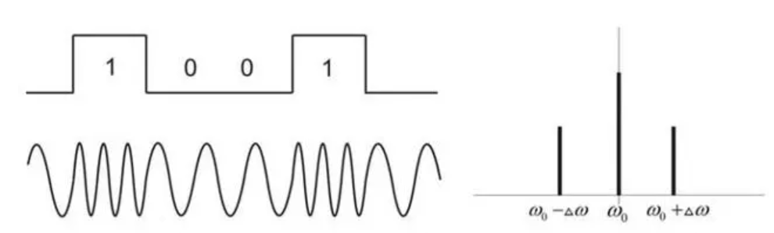

**Figure 4.3-3 FSK modulation**

**Backscattering**

The possible configurations of backscatter system include mono-static, where the transmitting AP and receiving AP is the same, and bi-static, where the transmitting AP and receiving AP are separated. In a backscattering communication system as illustrated in Figure 4.3-4, load modulation is usually used. The load modulation technology mainly includes two methods: resistance-based load modulation and capacitor-based load modulation. For resistance-based load modulation, a resistor which is called a load modulation resistor, is connected in parallel to the load. The resistor is turned on or turned off according to the clock of the data stream, and the switch is controlled by the binary data encoding. For capacitor-based load modulation, a capacitor is connected in parallel with the load to replace the load modulation resistor.

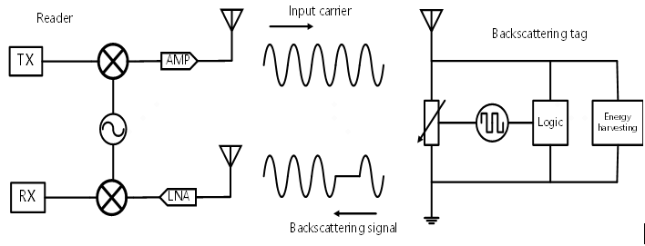

Figure 4.3-4 Backscattering communication

Taking resistance-based ASK modulation as an example, as shown in Figure 4.3-5, the device can switch between absorption state and reflection state by adjusting the load reflection coefficient. In the absorption state, the device achieves impedance matching thus the input RF signal is completely absorbed by the terminal. Hence, the signal received by the reader will be at low-level, which indicates a bit ‘0’. On the contrary, in the reflection state, the device adjusts the circuit impedance that leads to a mismatch of the impedance thus a part of the RF signal is reflected. Then the signal received by the reader will be at high-level to indicate a bit ‘1’.

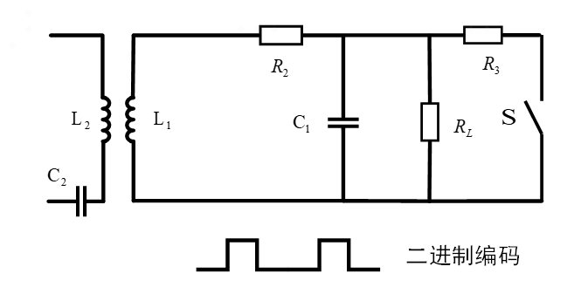

Figure 4.3-5 Resistance-based modulation

For ASK or FSK, the modulation can be regarded as multiplication of the incoming signal and a rectangular carrier (i.e. generated by the switch) with modulated on-off-keying for the payload data modulation. The multiplication in the time domain leads to a convolution in the frequency domain and may cause some additional harmonics [50] . Whether or not this issue will cause significant impact on the demodulation can be further investigated.

Similarly, the device can also change the response frequency of the circuit by adjusting the capacitance of the circuit to realize FSK modulation. FSK has better BER performance than ASK. It is often used to realize frequency division multi-access.

Therefore, backscattering communication achieves extremely low-complexity signal modulation and transmission via impedance modulation. The backscatter terminal does not require complex RF structures, such as PA, high-precision oscillator, duplexer, and high-precision filter. There is also no need for complex baseband processing, complex channel estimation and equalization operations. In addition, one distinguished characteristic is that it doesn’t need to generate a high frequency carrier but instead uses the incoming carrier as the carrier for backscattering transmission. It is a promising scheme to enableultra-low complexity and ultra-low power consumption (e.g., lower than 1 mW). In addition, it is beneficial to use backscattering to support co-existence with legacy devices, e.g., by backscattering the preamble sent by the AP, as discussed in session 4.4.2. For backscattering, since it uses the carrier signal from the AP. The carrier signal has to propagate within both the DL and UL: the carrier signal is sent from the AP to the device and the device backscatter the signal to the AP. Hence, the communication distance will be limited and may not be sufficient for some use cases requiring relative long communication distance. LNA (low noise amplifier) can be used to boost the backscattering signal [21] [22] . The integration of an LNA in an AMP IoT device with a high sensitivity receiver can effectively make up the communication distance of backward link (see session 4.4.1 for more details).

There is also challenge when using backscattering, as shown in Figure 4.3-4, full-duplex operation at the AP side is needed in the case of backscattering with mono-static configuration, i.e., the transmitting AP and receiving AP are the same. The main challenge of such configuration is the much lower Rx signal power compared and the self-interference generated by Tx signal as identified in [49] . However, this issue only happens in mono-static configuration. For bi-static configuration, where the transmitting AP and receiving AP are not the same one, this is not an essential problem. Therefore, high priority can be given to bi-static configuration when studying to support backscattering.

**Light-weight MAC protocol design and enhanced power saving/management**

In order to achieve ultra-low power consumption and ultra-low complexity, MAC can be further simplified on top of 802.11 ah, e.g., simplified MAC PPDU format and communication process between AP and AMP IoT devices, and introducing efficient access control mechanisms etc.

Schemes to support ultra-low power operation with limited power supply from energy harvester also needs to be considered. Currently, TWT/RAW, Energy limited operation, PS-poll etc are introduced in Wi-Fi for power saving. On top of these mechanisms, it can be investigated whether there are additional methods for further power saving. In addition, the characteristics of ambient power sources, e.g., instability, limited amount of harvested power call for efficient power management schemes. Furthermore, the low peak data rate requirement for AMP-IoT devices provide a good perquisite to optimize power consumption and power management.

**Support coexistence schemes with legacy devices**

It is important to maintain coexistence with legacy Wi-Fi for AMP IoT. See session 4.4.2 for the details.

* **Potential Technologies for AMP-only IoT devices**

As discussed in session 3, it targets at use cases requiring ultra-low complexity, ultra-low power consumption and maintenance-free for AMP-only IoT devices. Based on the discussion above, it can be summarized there may be two possible techniques combination for AMP-only IoT devices.

1. **Combination 1: Ultra-low power receiver + Backscattering**

It can utilize techniques such as narrow bandwidth operation for AMP portion (e.g., 187.5 kHz in sub-1 GHz), simpler waveform/modulation/coding scheme (e.g., OOK/FSK), backscattering, simplified MAC protocol design and enhanced power saving/management.

1. **Combination 2: Ultra-low power receiver + Ultra-low power active transmitter**

It can utilize techniques such as narrow bandwidth operation for AMP portion (e.g., 187.5 kHz in sub-1 GHz), simpler waveform/modulation/coding scheme (e.g., OOK/FSK), simplified MAC protocol design and enhanced power saving. The difference with the above combination 1 is the AMP IoT device has an active transmitter with ultra-low power consumption.

* **Potential Technologies for AMP-assisted IoT devices**

For AMP-assisted IoT devices, it targets at uses case where similar performance as legacy WiFi SAT are needed but it shall support ambient power. It requires schemes to adapt itself to operate with ambient power by taking into account its characteristics, e.g., instability, limited amount of harvested power (but it can be higher than use case for AMP-only IoT devices). The key enhancement for AMP-assisted IoT devices is further power saving and power management enhancement. Therefore, the possible techniques combination for AMP-assisted IoT devices is:

1. **Combination 3: Follow legacy PHY design with MAC enhancement**

The AMP IoT device has similar capability as legacy STA, but possibly with simplified MAC protocol design and/or enhanced power saving/management.

## Feasibility of supporting AMP IoT devices in WLAN

### Link budget for different AMP IoT device types

In order to evaluate the coverage performance of AMP IoT. Link budget analysis is performed. AMP-only device defined in session 3 are assumed since AMP-assisted IoT device has similar coverage as the current Wi-Fi device. The frequency band are assumed to be sub 1GHz and 2.4GHz respectively. Three types of AMP IoT device with backscatter transmitter are assumed:

Case 1: energy is harvested from RF and without power storage

Case 2: energy is harvested from RF and with power storage

Case 3: energy is harvested from light and with power storage

In case 1, AMP-only IoT device has no capability of power storage and the device shall operate using the instantaneously harvested power. Typically, with the current implementation, the minimum received RF power shall be no less than -20dBm to power up the device. In case 2, AMP-only IoT device has the capability of power storage and the device can work using the RF power that is harvested and stored. Hence, the minimum received RF power can be relaxed to -30dBm. Even though the instantaneously harvested power may not be sufficient to drive the device but it can be accumulated in the power storage unit. In case 3, other kinds of ambient powers, e.g., light, are assumed so that it doesn’t rely on RF power for energy harvesting. The minimum received signal strength, i.e., the receiver sensitivity of AMP IoT device is assumed to be -45dBm in the evaluation. In order to achieve a long communication distance in the UL, an LNA with 30 dBm gain is assumed to amplify the backscattering signal. It should be noted that Friis equation is applied in the link budget evaluation. The evaluation results for case 1/2/3 at sub1 GHz and 2.4GHz are illustrated in the below Tables.

**Table 4.4 -1 Link budget at sub 1GHz for case 1/2/3**

|  |  |  |  |
| --- | --- | --- | --- |
|  | **Case1** | **Case2** | **Case3** |
| Frequency (MHz) | **920** | **920** | **920** |
| EIRP of AP (dBm) | 30 | 30 | 30 |
| Receiver sensitivity of AP (dBm) | -95 (Note 1) | -95 | -95 |
| Antenna gain of IoT device (dBi) | 2 | 2 | 2 |
| Minimum receiving power for IoT device (dBm) | -20 (Note 2) | -30 (Note 2) | -45 (Note 3) |
| Maximum communication distance from AP to IoT device (m) | 10.33 | 32.67 | 183.71 |
| Backscattering loss at IoT device (dB) | 5 | 5 | 5 |
| Low Noise Amplifier factor (dB) | 0 | 0 | 30 (Note 4) |
| Maximum communication distance from IoT device to AP (m) | 103.31 | 32.67 | 183.71 |
| *Notes:   1. Reuse the receiver sensitivity of an 802.11 ah AP 2. The minimum required signal power for an IoT device is -20dBm when the IoT device can’t store power itself. It can be -30dBm when the IoT device has the capability of power storage. 3. -45 dBm is assumed as the sensitivity of ultra-low power receiver[15] [16] [17] . 4. LNA with 30 dBm gain is assumed to boost the backscattering signal, it can have ultra-low power consumption [21] [22] . | | | |

**Table 4.4-2 Link budget at 2.4GHz for case 1-3**

|  |  |  |  |
| --- | --- | --- | --- |
|  | **Case1** | **Case2** | **Case3** |
| Frequency (GHz) | **2.4** | **2.4** | **2.4** |
| EIRP of AP (dBm) | 27 | 27 | 27 |
| Receiver sensitivity of AP (dBm) | -95 (Note 1) | -95 | -95 |
| Antenna gain of IoT device (dBi) | 2 | 2 | 2 |
| Minimum receiving power for IoT device (dBm) | -20 (Note 2) | -30 (Note 2) | -45 (Note 3) |
| Maximum communication distance from AP to IoT device (m) | 2.8 | 8.87 | 49.85 |
| Backscattering loss at IoT device (dB) | 5 | 5 | 5 |
| Low Noise Amplifier factor (dB) | 0 | 0 | 30 (Note 4) |
| Maximum communication distance from IoT device to AP (m) | 39.60 | 12.52 | 70.42 |
| *Notes:   1. Reuse the receiver sensitivity of an 802.11 ah AP 2. The minimum required signal power for an IoT device is -20dBm when the IoT device can’t store power itself. It can be -30dBm when the IoT device has the capability of power storage. 3. -45 dBm is assumed as the sensitivity of ultra-low power receiver. 4. LNA with 30 dBm gain is assumed to boost the backscattering signal, it can have ultra-low power consumption. | | | |

One additional type of AMP IoT device with an active transmitter is assumed:

Case 4: energy is harvested from light, and the AMP IoT device is with power storage and using active transmitter

In case 4, light is assumed to be the ambient power source. Similarly, -45dBm is assumed as the receiver sensitivity of the AMP IoT device. The difference from case 3 is that an active transmitter is used and the maximum transmission power is assumed to be -15dBm. With such an active transmitter, the power consumption can still be lower than 1mW [18] –[20] . The evaluation results are illustrated as below.

**Table 4.4-3 Link budget at sub 1GHz and 2.4GHz for case 4**

|  |  |  |
| --- | --- | --- |
|  | **Case4** | **Case4** |
| Frequency (GHz) | **920** | **2.4** |
| EIRP of AP (dBm) | 30 | 30 |
| Receiver sensitivity of AP (dBm) | -95 | -95 |
| Antenna gain of IoT device (dBi) | 2 | 2 |
| Minimum receiving power for IoT device (dBm) | -45 | -45 |
| Maximum communication distance from AP to IoT device (m) | 183.71 | 70.42 |
| Maximum transmission power of IoT device (dBm) | -15(Note) | -15(Note) |
| Maximum communication distance from IoT device to AP (m) | 259.49 | 99.47 |
| *Notes: Ultra-low power active transmitter is assumed. | | |

From the link budget results, it can be observed that:

* When RF power is adopted, the communication distance of downlink is the bottleneck due to RF energy harvesting.
* With RF power harvesting, the communication distance of downlink would be limited and at 2.4GHz if the device has no power storage.
* Energy harvesting from other ambient power source can support a medium downlink coverage (up to 180 meters at sub1 GHz and up to 50 meters at 2.4GHz) for AMP IoT device.
* A low power LNA can efficiently boost the UL coverage.
* With an active low power transmitter, a relative larger uplink coverage can be achieved (up to 180 meters at sub 1GHz and up to 70 meters at 2.4GHz).

### Co-existence with legacy 802.11 systems

As discussed in section 3, AMP IoT will operate at sub 1GHz or 2.4GHz, the co-existence with legacy 802.11 technologies should be studied to guarantee backward compatibility[6] . Co-existence requires the AMP IoT device to follow the regulation for these unlicensed frequency bands and use the frequency bands in a fair way with other Wi-Fi system. For example, it shall meet the PSD requirement and the maximum transmission EIRP requirement.

The following issues are identified for the co-existence of AMP IoT and legacy 802.11 systems.

* AMP IoT device may only support simple waveform due to its ultra-low complexity requirement, such as ASK modulated waveform, which is different from OFDM waveform used by legacy Wi-Fi system in Sub 1GHz or 2.4GHz. How to support co-existence if new waveform for AMP IoT is used should be studied.
* When AMP IoT and legacy 802.11 systems share the same frequency band, a uniform CSMA/CA mechanism should be used between them. It is a challenge for AMP-only IoT device to support CSMA/CA due to its ultra-low complexity. For example, it is difficult or even impossible for AMP-only IoT device to transmit and detect legacy preamble for carrier sensing. In addition, the power consumed for CSMA/CA operation may be beyond the capability of AMP IoT devices with ultra-low power consumption.

In order to solve the co-existence issue, proper mechanism taking into account both the regulation requirement and the constraints of AMP IoT devices shall be studied.

AMP PPDU format should be defined for AMP IoT. The co-existence issues shall be taken into account when designing the AMP PPDU format. In Figure 4.4-1, one example of AMP PPDU format is illustrated. In this PPDU format, there is a legacy preamble portion and an AMP portion. The preamble portion is transmitted for carrier sensing by legacy 802.11 devices. With this preamble, the legacy 802.11 devices can detect the transmission from AMP IoT devices. For AMP-only IoT devices operating in Sub 1GHz, the AMP PPDU format contains 802.11ah preamble (e.g., LTF, STF and SIG portion), followed by the AMP portion. For AMP-only IoT devices operating in 2.4GHz, the AMP PPDU format contains legacy preamble (e.g., L-STF, L-LTF, L-SIG), followed by AMP portion.

However, it is challenging for AMP-only IoT device to generate the OFDM based preamble with a low complexity transmitter which can only generates simple waveform such as OOK. Backscattering can be one method to realize the transmission of legacy preamble from AMP-only IoT device. The AP can help to generate a preamble and send it to the AMP-only IoT device. Then the device backscatters the preamble. Immediately after the preamble, the AMP-only IoT device transmits the AMP portion. Therefore, the whole AMP PPDU format can be transmitted by the AMP-only IoT device. This procedure is shown in the following Figure.



**Figure 4.4-1 Preamble transmission using backscattering**

Although AMP-only IoT device can send legacy preamble through backscattering, it is still difficult for AMP-only IoT device to perform channel access due to its ultra-low power and low complexity receiver.

TXOP sharing defined in 802.11ah can be reused for the channel access for AMP-only IoT device. AP can be responsible for channel occupation with normal channel access procedure. Then, the AP can share its TXOP to AMP-only IoT device when there is uplink transmission. With this method, AMP-only IoT device does not have to perform channel access by itself.

The AMP PPDU with the AMP portion can only be received by the AP that is able to support AMP IoT. As shown in Figure 4.3-1, the bandwidth of AMP portion can be narrower than that of the preamble part and simple waveform (e.g., OOK) will be adopted for the AMP portion. For the AP, it is beneficia to ease the implementation if the legacy OFDM transmitter can be reused to transmit the AMP PPDU format which contains ana AMP portion.

### Carrier generation for backscattering

Based on previous discussion, it can be concluded that backscattering is a promising technique to achieve ultra-low power consumption and ultra-low complexity for AMP IoT. However, a continuous wave, e.g., sine wave, is used as the carrier for backscattering in a typical backscattering system. If backscattering is introduced for AMP IoT, the following issues need to be considered:

* The carrier shall be able to provide enough RF power to drive the IoT devices
* The higher the power, the longer the communication distance. Based on the evaluation in 4.3.1, a high power is needed in order to provide a sufficient communication distance.
* There is PSD regulation restriction, e.g. 10 dBm/MHz (or 17 dBm in China for device with high antenna gain) at 2.4GHz. It means that a narrow bandwidth signal can not provide sufficient power for backscattering. For example, a carrier narrower than 1MHz can only provide a signal lower than 10dBm at 2.4GHz.
* The maximum transmission power of Wi-Fi devices, e.g. 20/27dBm
* Backward compatibility shall be maintained considering the impact of specification and implementation
* For a typical OFDM transmitter, it may not be able to generate a sine wave with a narrow bandwidth.

There may be two potential carrier signals for AMP IoT devices.

* Carrier signal with narrower bandwidth, e.g., a sine wave
* Carrier signal spanning a wider bandwidth, e.g., the signal spanning across the 20MHz channel bandwidth at 2.4GHz

It seems that carrier signal spanning a wider bandwidth is more appropriate to serve as the carrier signal for backscattering. It allows higher RF power with wider transmission bandwidth due to the maximum PSD restriction. It can also improve the RF energy transfer (i.e., the diversity gain) and energy harvesting efficiency with a carrier signal spanning a wider bandwidth [23] . A carrier signal spanning a wider bandwidth is illustrated in the following Figure 4.4-2. In addition, from backward compatibility perspective, it is also beneficial for carrier signal to span a wider bandwidth as the legacy transmitter can be reused.

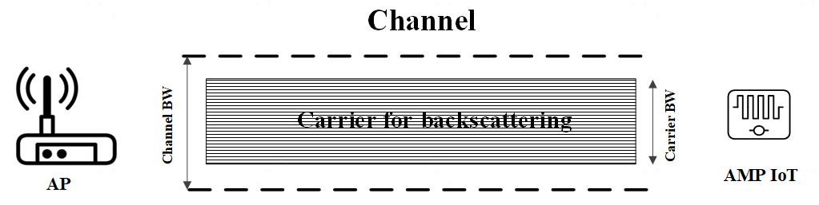

**Figure 4.4-2 Carrier signal spanning wider bandwidth within a channel bandwidth**

## Prototypes

There are already some prototypes to verify the feasibility of AMP IoT. Multiple prototypes are presented to show the potential communication techniques, e.g., backscattering, the feasibility of energy harvesting from ambient power, e.g., RF radio, heat, etc., and the ultra-low power consumption.

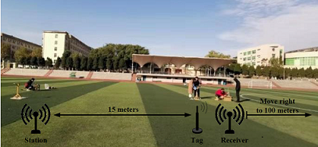

**Figure 4.5-1 Prototype 1 for RF radio energy harvesting and backscattering**

Prototype 1 is shown in Fig. 4.5-1, where the source for energy harvesting is RF radios and the communication is via backscattering. The signal generator (the Station in Fig. 4.5-1) will transmit a sine wave with transmission power 30dBm at 430MHz. The AMP IoT devices (Tag in Fig.4.5-1) are placed 15-16 m away from the signal generator. A microwave analyser is placed in the same location of the AMP IoT devices and the received signal power is -20dBm as shown in Figure 4.5-2. A standalone receiver is used to receive the backscattered signal from the AMP IoT devices. Based on the field test, it can be seen the receiver can decode the backscattered signal even when the receiver is 130 meters away from the AMP IoT devices.

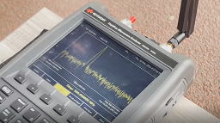

**Figure 4.5-2 Received signal (from the signal generator) strength at AMP IoT devices**

The AMP IoT devices consist of two main parts including antenna and AMP circuit and the size of the AMP circuit is very small as shown in below figure.

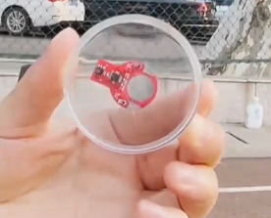

**Figure 4.5-3 AMP circuit of prototype 1**

This prototype shows following three main functions:

* Energy harvesting of the RF radio signal from the signal generator 15-16m away;
* Sensor data collection and reporting with three sensors integrated including temperature, humidity and vibration sensors;
* Backscattering communications with more than 130m communication distance.

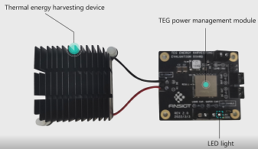

**Figure 4.5-4 Prototype 2 for thermal energy harvesting**

Prototype 2 is shown in Fig. 4.5-4, where the energy is harvested from the temperature difference. It consists of two parts: 1) thermal energy harvesting device which harvests energy from the temperature difference and converts it into electrical power; 2) TEG power management module which manages and supplies power to the LED light. The main observation we have made from this prototype is that energy can be harvested from different power sources, e.g., temperature difference.

Another prototype is similar to the first one and shown in Fig. 4.5-5, where the energy is harvested from a signal generator transmitting sine wave with transmission power 32dBm at 902MHz. A temperature sensor is integrated with the AMP IoT device. Once the AMP IoT device is heated by the blow dryer, it can sense the temperature increase and report such data to the cell phone receiver.

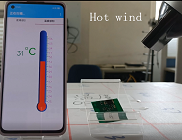

**Figure 4.5-5 Prototype 3**

Energy harvesting and sensing can also be done from induced current as shown in Figure 4.5-6. The AMP device harvests power from the power source of induced current and the harvested energy will be used for temperature sensing, voltage and current.

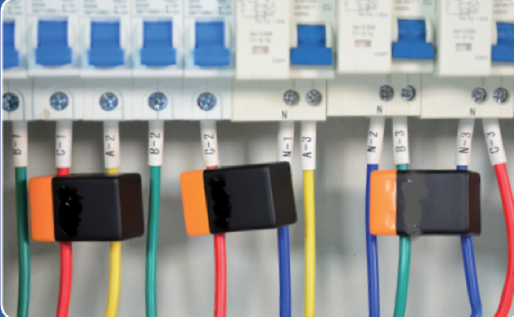

**Figure 4.5-6 Prototype 4 for induced current energy harvesting and sensing**

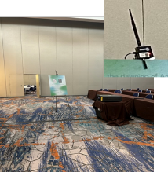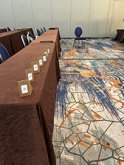The fourth prototype is shown in Figure 4.5-7. In this prototype, the off the shelf device can energize the   
ambient IoT devices in a sticker form factor sticked onto small carton plates on the table and then the IoT devices can use the harvested power to actively transmit to a standard mobile phone as a receiver. The RF energy harvesting sensitivity can be as low as -32dBm and thus both the energy harvest distance and communication distance can be larger than 10m.

**Figure 4.5-7 Prototype 5 for sticker form factor IoT device**

The last prototype is built based on the legacy 802.11 system and shown in Figure 4.5-8. A conventional transmitter (TX) sends 802.11 compliant frame and the tag backscatters the frame such that the sensor data is embedded and remains 802.11 compliant. The backscattered signal is received by an 802.11 device (RX). TX and RX can be standard access points or other 802.11 devices without any hardware changes. This prototype shows the potential of reusing the legacy 802.11 infrastructure.

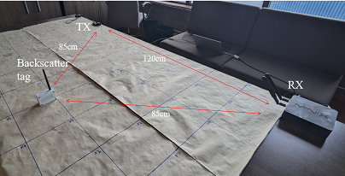

**Figure 4.5-8 Prototype 8 for legacy 802.11 system compatible backscattering communication**

# Frequency Regulation Considerations

Besides the technical feasibility, also the frequency regulation plays an important role.

For the USA, the relevant frequency regulation is given in FCC 15.247. In Europe, wireless systems should follow the so-called “ETSI Harmonised Standards”. Theoretically, following these harmonized standards is not a legal requirement. However, the introduction of new devices to the European market is significantly much simpler if devices follow these harmonized standards.

Generally, the frequency regulation for the existing Std IEEE 802.11 is well known. The frequency regulation for IEEE 802.11 typically assumes a high bandwidth with a limited power spectral density. However, this may change, especially in case of wireless power transfer. This wireless power transfer is mandatory for backscatter modulation. Furthermore, it also can be used to charge a capacitor inside an AMP device. For this reason, high transmission powers are required for energizing the AMP devices. The calculations in the previous chapters assume transmission powers in the order of 30dBm EIRP (equivalent isotropically radiated power).

The following sections will review the frequency regulation in the USA and the “ETSI Harmonised Standards”.

## Frequency Regulation in FCC 15.247:

The frequency regulation in FCC 15.247 covers both relevant frequency bands, i.e. 902-928MHz, and 2400-2483.5MHz. The maximum electrical transmission power is limited by 1W, i.e., 30dBm. Additionally, antennas with up to 6dBi gain can be used. This offers an EIRP at the AP of up to 36dBm.

For FH systems,

* From 15.247 (a)(1)(i) The maximum allowed 20 dB bandwidth of the hopping channel is 500 kHz
* From 15.247 (b)(2) The max output power shall be 1 watt for systems with at least 50 hopping channels; otherwise, 25 Watts.
* In addition, if the 20 dB BW of the hopping channel is less than 250 kHz, the system shall use at least 50 hopping frequencies and the average time on a frequency shall not be greater than .4 seconds within a 20 second period. Otherwise, the system shall use at least 25 hopping frequencies and the average time on frequency shall not be greater than .4 seconds within a 10 second period.

For digital modulation techniques,

* From 15.247 (a)(2) The minimum 6 dB bandwidth shall be at least 500 kHz
* From 15.247 (b)(3) The max output power shall be 1 Watt

In summary, the frequency regulation according to FCC 15.247 should support all aforementioned techniques. The maximum EIRP for wireless power transfer to is up to 36dBm EIRP (i.e., 4W).

## ETSI Harmonised Standards

There exist multiple harmonized standards for the desired frequency bands. These standards assume different characteristics of the transmission signal. The following sub-sections will review the situation for the 2.4GHz and the sub-GHz bands respectively.

### ETSI Harmonised Standards in the 2.4GHz band

**ETSI EN 300 328** covers “Wideband transmission systems; Data transmission equipment operating in the 2,4 GHz band; Harmonised Standard for access to radio spectrum”. This standard especially covers IEEE 802.11, referred as wide-band data transmission. Furthermore, it covers frequency hopping spread spectrum systems (FHSS) (e.g., Bluetooth). The frequency range is 2400 to 2483.5MHz. The maximum transmission power is 100mW EIRP, i.e., 20dBm.

Additional restrictions apply in case of a transmission powers higher than 10dBm EIRP. For wide-band transmissions, the maximum power spectral density is limited to 10dBm/MHz. FHSS systems have a maximum transmission TX-sequence time of 5ms, followed by a TX-gap time of 5ms. Additionally, FHSS have to follow additional restrictions concerning the hopping frequency separation.

**ETSI EN 300 440** covers “Short Range Devices (SRD); Radio equipment to be used in the 1 GHz to 40 GHz frequency range; Harmonised Standard for access to radio spectrum”. This standard covers communication systems not covered by ETSI EN 300 328 and RFID in the 2.4GHz band covering 2400 to 2483.5MHz. Unspecific communication devices may transmit with a maximum power of 10dBm EIRP without any additional restrictions.

RFID is allowed in the frequency range between 2446 and 2454MHz resulting in a maximum bandwidth of 8MHz. The maximum transmission power is 4W EIRP (i.e., 36dBm). However, 4W EIRP “shall by technical means be restricted to in building use” and has duty cycle restrictions of 15%. These restrictions do not apply for transmission powers of 500mW EIRP (i.e. 27dBm). However, even in this case the frequency regulation mandates an antenna with ±45 degrees horizontal beamwidth in addition to a side-lobe attenuation of equal or more than 15dB. Furthermore, it requires “physical protection (e.g. antenna dome) which dimension limits a power transfer from the RFID antenna to a quarter wave matched dipole at positioned at an extreme close proximity to +15dBm”.

Summarizing the findings for the European harmonized standards in the 2.4GHz band:

* No restrictions up to **10dBm** EIRP (i.e., 10mW).
* **20dBm** EIRP (i.e. 100mW) in case of frequency hopping or wide-band signals
* **27dBm** EIRP (i.e. 500mW) with directive antennas, bandwidth of 8MHz only, can be extended to **36dBm** EIRP (i.e. 4W) for stationary indoor use (possible to verticals not sensitive to the cost)

### ETSI Harmonised Standards in the 863 to 870 MHz and 915 to 921 MHz band

For sub-GHz ETSI uses the ERP (equivalent radiated power) instead of the EIRP (equivalent isotropically radiated power). A transmitter with 1mW ERP (i.e. 0dBm) is identical to a transmitter with 1.64mW EIRP (2.15dBm).

**ETSI EN 302 208** covers “Radio Frequency Identification Equipment operating in the band 865 MHz to 868 MHz with power levels up to 2 W and in the band 915 MHz to 921 MHz with power levels up to 4 W; Harmonised Standard for access to radio spectrum”.

The frequency range between 865 to 867MHz defines four channels, each having a bandwidth of 400kHz. The maximum transmission power is 2W ERP (i.e. 35.15dBm EIRP) with antennas having a beamwidth ≤90°. For omni-directional antennas the maximum power is limited to 500mW ERP (i.e. 29.14dBm EIRP). The maximum transmission time is 4s, followed by a break of at least 100ms. The maximum transmit power of the tags is -20dBm ERP in addition to a maximum bandwidth of 400kHz in one of the four available channels.

The frequency range of 915 to 921 MHz also defines four channels. However, it is currently available in few European countries only. Power levels of up to 4W ERP (i.e. 38.17dBm EIRP) require antennas having a beamwidth ≤90°. For omni-directional antennas, the maximum power is limited to 1W ERP (i.e. 32.15dBm EIRP). The maximum transmission time is again 4s, followed by a break of at least 100ms. The maximum transmission power of the tags is -10dBm ERP in addition to a maximum bandwidth of 800kHz in one of the four available channels.

**ETSI EN 300 220-2** covers “Short Range Devices (SRD) operating in the frequency range 25 MHz to 1 000 MHz; Part 2: Harmonised Standard for access to radio spectrum for non specific radio equipment”. Relevant in the scope of this document is the frequency range 863 to 870MHz and 915 to 921 MHz. Generally, the aforementioned frequency ranges are divided into many bands with different transmission power, duty cycle, or other restrictions. Annex B and C in ETSI EN 300 220-2 give a complete overview. In addition, only the bands defined in annex B (only 863 to 870MHz) are harmonized within the European Union. The frequencies between 915 and 921MHz are available in few European countries only.

The maximum transmission power is typically limited to 10mW or 25mW ERP. The only frequency band offering higher transmission powers is band O between 869.4 and 869.65MHz. It has a bandwidth of 250kHz and offers a maximum transmission power of 500mW ERP (i.e. 29.14dBm EIRP). This band is furthermore limited by a duty cycle of ≤10%.

**ETSI EN 303 659** is currently under development. It will cover “Short Range Devices (SRD) in Data Networks; Radio equipment to be used in the frequency ranges 865 MHz to 868 MHz and 915 MHz to 919,4 MHz with power levels ranging up to 500 mW e.r.p.; Harmonised Standard for access to radio spectrum”. This will also cover IEEE 802.11ah.

The frequency regulation already allocated the corresponding frequency bands. According to the “Commission Implementing Decision (EU) 2019/1345 of 2 August 2019” the frequency regulation allows for 500mW ERP (i.e. 29.14dBm EIRP) if the channel bandwidth is ≤ 200kHz. The available four channels are identical to the four channels defined for RFID usage in ETSI EN 302 208. Additional restrictions are a duty cycle of 10% for AP and 2.5% otherwise. Furthermore, also systems with a bandwidth of up to 1MHz are possible, e.g. IEEE 802.11ah. The parameters are mainly identical to the parameters of the 200kHz mode, but the maximum transmission power is limited to 25mW ERP (i.e., 16.13dBm EIRP).

Summarizing the findings of the European harmonized standards in the sub-GHz bands:

* Highly fragmented into many different bands with different parameters (e.g., duty cycle, transmission power, bandwidth)
* **16.13dBm** EIRP (i.e., 25mW ERP) for 1MHz wide channels with duty cycle limitations
* **29.14dBm** EIRP (i.e., 500mW ERP) for systems with up to 200kHz bandwidth with duty cycle limitations, one channel with up to 250kHz bandwidth
* **35.15dBm** EIRP (i.e., 2W ERP) for RFID systems with **directive antennas**, bandwidth limited to 200kHz for downlink and 400kHz for uplink
* **38.17dBm** EIRP (i.e., 4W ERP) for RFID systems with **directive antennas** in bands that are **only available in some EU countries**, bandwidth limited to 400kHz for downlink and 800kHz for uplink

In conclusion, even though some European frequency regulation may limit the available bandwidth in case of high transmission powers to approx. 30dBm, based on the review of the frequency regulation, the intended use-cases can be covered.

## Considerations on regulation requirements for Sub-1 GHz

As discussed above and in [53] , there are different regional regulations for the relevant frequency bands. e.g., the regulation for China [54] , EU [55] and US [51] [52] . On the other hand, For Sub-1 GHz, there has already frequency band regulation requirement as specified in 802.11 amendment shown in the below table[53].

Table 5.3-1 Maximum STA transmit power and maximum BW allowed for the S1G band

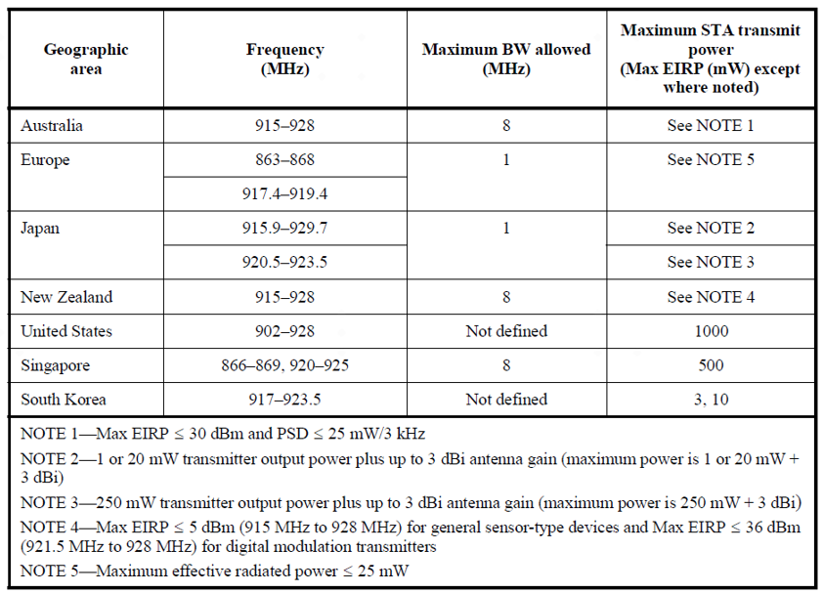

First of all, it is understood that the regulation requirement for S1G band as specified in 802.11 amendment and the regional regulation requirement don’t conflict with each other. The regulation requirement for S1G band as specified in 802.11 amendment shall follow the regional regulation requirement. Therefore, for countries such as United states, Australia, the regulation requirement for S1G band as specified in 802.11 amendment can be directly followed. Since there have already the regulation requirement for S1G band as specified in 802.11 amendment and based on the regulation requirement parameters such as the maximum transmission power is sufficient to support AMP device in WLAN.

On the other hand, for countries and regions for which there is no regulation requirement for S1G band as specified in 802.11 amendment (e.g. China) or there is regulation requirement for S1G band as specified in 802.11 amendment but it is not suitable to support AMP device in WLAN (e.g. EU), the regional regulation requirements can be followed. For example, in China, the regulation for 920MHz ~ 925MHz (i.e., that for RFID) can be followed. For EU, South Korea etc., seek the possibilities to follow the regional regulation on the relevant frequency bands.

If different regulation requirements are followed in different countries, different channelization may be required., e.g., the channel bandwidth may be different for different regions based on the requirements. Fortunately, as discussed in session 4.3, simple waveform such as OOK (also what WUR uses) will be used for AMP device, and it is not sensitive to the channel bandwidth for OOK waveform.

# Economic Feasibility

IoT network has spread into nearly every aspect of life, and, as such, is a driver for economic growth, social cohesion/inclusion, and for the improvement of welfare and well-being. Disruptive solutions are however required to sustain this evolution. In this regard, explosive market growth is predicted for battery-free tags and sensors. AMP IoT will tackle all the main challenges, in order to create battery-free via energy harvesting and thus maintenance free and sustainable networks, enabling IEEE to strengthen the position in the field and remain at the forefront of the evolution.

Based on discussion of the use cases in section 2, at least 3 main functions should be provided by AMP IoT:

* Identification
* Sensor data transmission
* Positioning

One of the most important functionalities that is required in many identified use cases is object identification. Nowadays, the main technique used for object identification is RFID. Hence, the market for RFID can be served as a reference. The RFID Market is projected to reach USD 35.6 billion by 2030 from USD 14.5 billion in 2022 and it is expected to grow at a CAGR of 11.9% from 2022 to 2030 [24] . The RFID sensor market is expected to expand from an output of 18,836.5 million units in 2021 and surpass 49,116.4 million units by 2031 [25] . AMP IoT is a promising candidate technology to play a critical role in the market of object identification by potentially providing remote, automatic, omni-directional, highly efficient and reliable object identification. With these new characteristics, AMP IoT can be further applied in asset management in new market such as smart agriculture where the coverage requirement is beyond the capability of RFID.

AMP IoT can also be used for positioning, e.g., for positioning in manufacturing, establishing an indoor positioning and navigation system etc. The global Indoor positioning and navigation market was valued at $6.92 billion in 2020 and is projected to grow to $23.6 billion in 2025 at a CAGR of 27.9% [26] . Unlike the outdoor use cases where Global Navigation Satellite System can be used, it calls for much more efficient indoor positioning and navigation technologies for indoor use cases. AMP IoT based indoor positioning and navigation system can be easily deployed with low cost and can be easily used by the verticals and individual customer.

Finally, AMP IoT can be used for sensor networks [37] . The global industrial wireless sensor network market size is expected to reach USD 8,669.8 million by 2025, growing at a CAGR of 15.2% from 2019 to 2025, according to this study. The benefits offered by IWSN over wired networks, such as mobility, self-discovery capability, compact size, cost-effectiveness, and reduced complexity, are anticipated to play a significant role in increasing global demand. For example, the development of smart grid requires the sensor network to realize intelligent perception and data fusion. The combination of communication network and sensing technology applied in the power grid will develop towards the deep integration of sensing and communication. China’s State Grid plans to invest more than 150 billion yuan ($22 billion) in the second half of 2022 in ultra-high voltage (UHV) power transmission lines. Millions of sensors and meters need to be deployed along these UHV power transmission lines to monitor temperature, humidity, etc., and detect fault operations, which creates a huge market for AMP IoT devices with unique features such as maintenance-free and battery-less.

Therefore, the AMP IoT solution will pave the way for the deployment of new sensors by significantly reducing both CapEx including deployment cost and OpEx including operation cost. In this regard, the largest growth of future AMP IoT devices is foreseen in the next decade attending to the expected growth of number of devices, the wish of long term and maintenance-free connection and the rise of new services and applications.

# Summary and recommendations

This technical report presents the design of ultra-low power consumption and ultra-low complexity AMP devices with energy harvesting capability from a variety of power sources including RF, solar, heat, vibration, etc. In this technical report, we have discussed seven use cases for AMP IoT, the requirements for these use cases are summarized in Table 7-1:

Table 7-1 Requirement of use cases for AMP IoT

|  |  |  |  |  |
| --- | --- | --- | --- | --- |
| Use case | Coverage | Data rate | Positioning accuracy | Other requirements |
| #1Smart manufacturing | 30m indoor  100m outdoor | 100kbps | 1~3 m Horizontal indoor | Battery-less  Maintenance-free |
| #2 Data center | 30m indoor  100m outdoor | 100kbps | - | Battery-less  Maintenance-free |
| #3 Logistics/ Warehouse | 10-30 m for indoor case | - | 1~3 m Horizontal indoor | Battery-less,  Maintenance-free  99.5% identification accuracy  Ultra-low cost and ultra-small size |
| #4 Smart Home | 10m | - | 1~3 m Horizontal | maintenance-free  Battery-less  Long service life., e.g., more than 10 years  Low complexity and small size |
| #5 Smart Agriculture | 30m indoor,  200m outdoor | - |  | Battery-less,  Low complexity and small size,  Processing (i.e., reading IDs) hundreds to thousands of devices per second |
| #6 Indoor positioning | 10-30 meters indoor |  | 1~3 m horizontal accuracy and 1~2 m vertical accuracy | Small size, maintenance-free, battery-free, and ultra-low-cost IoT devices;  Moving speed: 1.5-2 m/s |
| #7 Smart Grid | 10-30 m indoor, up to 200 m outdoor | 20kbps for sub-station, 3kbps for high voltage transmission line. |  | Maintenance-free and battery-less |
| #8 Fresh Food Supply Chain | 10-20m | 0.12bps |  | Maintenance-free, ultra low cost, sticker form factor with low BOM  Traffic interval equals to 15 minutes |

For the discussed use case, the main functions to be supported can be generally categorized into 3 classes:

* Identification
* Sensing
* Positioning

As shown in Figure 7-1 and Table 7-2, in order to fulfill the requirements of all use cases, the main design target is to create a new type of device (namely AMP device) in between RFID and existing IoT devices and the AMP device will be powered by energy harvested from ambient power sources, e.g., radio waves, solar/light, heat, vibration etc. and the device will have ultra-low power consumption, e.g., less than 1mw.

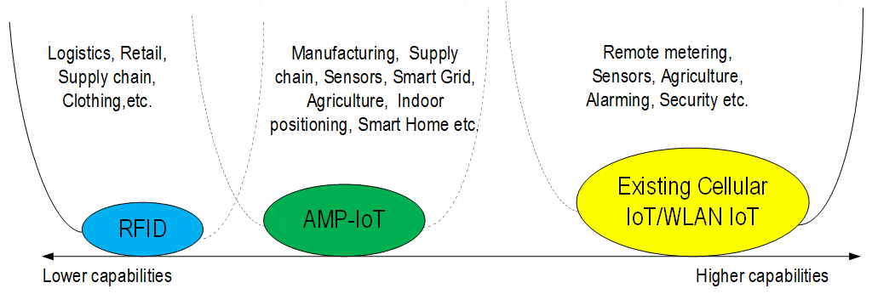

**Figure 7-1 Expectation of AMP-IoT**

Table 7-2 Comparison of RFID, AMP IoT and exiting 802.11 Technologies

|  |  |  |  |
| --- | --- | --- | --- |
|  | **RFID** | **AMP IoT** | **Existing WLAN IoT(e.g. 802.11 ah)** |
| Coverage | <10 m | 10m~30m (RF power);  Up to 200m (other ambient power) | >=1000m |
| Power Source | RF power only | Various ambient power | Battery |
| Techniques | RF power harvesting  Backscattering | WUR receiver  Backscattering/Active transmitter  Enhanced power saving  Power management | OFDM  Narrow bandwidth  Simplified RF chain  Relaxed processing  TWT  PS-Poll  Energy limited Operation |
| Power Consumption | 1uw~10uw | <1mw | 100x mw |
| Device Cost | Low | Medium | High |
| Maintenance/operation cost | Labor cost for operation | Maintenance-free  Automated operation | Replace/recharge the battery  Automated operation |

In order to fulfil the design target, the following potential candidate techniques have been identified and discussed:

* Narrow bandwidth operation
* Simpler waveform/modulation/coding scheme
* Backscattering
* Light-weight MAC protocol design and enhanced power saving/management
* Etc.

The feasibility to support AMP device in WLAN is also investigated. With the evaluation of the link budget, it can be seen that sufficient coverage can be provided to fulfil the requirement of the targeted use cases. Coexistence with legacy WLAN devices and the potential to support backscattering are also analysed. Based on the discussion, it can be concluded that it is feasible to support AMP device in WLAN.

In summary, the standardization work in order to support AMP device in WLAN should enable AMP devices to be ultra-low complexity and operate battery free, and may include:

* PHY: WUR (100x uW) + Simplified UL PHY (10x uW~100x uW)
* In the DL, WUR (802.11ba) like design as a starting point.
  + Reuse legacy design as much as possible, such as OOK, channel structure, waveform, PPDU formats, etc.
  + Additional signaling in WUR to transmit additional signaling or payload data.
  + Some re-design may be necessary if AMP in WLAN is implemented in frequency band other than 2.4GHz, e.g., S1G.

Note: Other schemes than 802.11ba are not precluded if useful.

* In the UL, legacy design as a starting point for the UL PHY, e.g., 802.11ba OOK, 802.11b DSSS modulation, etc.
  + Both active transmitter and backscatter transmitter can be supported.
    - The carrier for backscattering shall be specified considering the regulation requirement
    - Optimizations for full-duplex operation in case of backscatter modulation can be considered

Note: other schemes, e.g., FSK/PSK are not precluded if useful.

* + The carrier and bandwidth of backscattering signal should be specified including signal of narrow bandwidth or wide bandwidth and carrier signal using the existing signal can also be considered.
* MAC: Simplified MAC + Enhanced power saving/ power management (Note 2, Note 3), e.g.,
  + Efficient PLCP and MAC for limited payload message sizes, e.g., 100bits.
  + Coordination of AMP device channel access (e.g., may not be able to use conventional CSMA-like approaches since backscattering devices potentially undetectable by other devices)

Note 1: Energy harvesting (except RF power) is based on implementation and can be transparent to specification. For RF power, TBD.

Note 2: Use of existing 802.11 MAC wherever possible with necessary modifications and extensions to support AMP specific requirements.

Note 3: Enhanced power saving/ power management mechanism can be extended to existing Wi-Fi devices.

Note 4: Consider frequency bands of Sub 1 GHz, and 2.4GHz. The existing frequency regulations need to be complied with.

Note 5: Other issues such as additions to the security measures to enable battery free operation will also be considered if necessary.

Clear benefits and advantages of support AMP devices in WLAN are foreseen due to the following features:

* Free frequency band and much lower CapEx and OpEx;
* Lean Wi-Fi protocol stack design;
* Good matching to the local area deployment requirement;
* Less specifications efforts starting from WUR,OOK and 802.11ah MAC;

From regulation point of view, the carrier signal to be transmitted to the AMP device from the AP can follow the existing regulation requirements for total transmission power and PSD. For the backscattering uplink signal (i.e., from the AMP device to the AP), it depends on whether there is a reflection amplifier. Regulation requirements for total transmission power and PSD only apply to the case with reflection amplifier. Based on the review of the frequency regulation in US, EU, China, etc., the intended use-cases can be covered.

Therefore, based on all the works conducted with in AMP TIG [1]-[6], [38]-[44], it is recommended to form a study group (SG) to further study AMP IoT and develop the PAR and CSD documents.

During the March 2023 IEEE 802 plenary meeting, a contribution on ambient communication in WLAN (11-23/0406r1) was presented and discussed in AMP session with the following straw poll:

* Straw Poll: Do you agree on the following features/requirements for AMP WLAN as the baseline for future discussion?
  + Support ultra-low complexity and ultra-low power consumption transmission and reception for device using ambient power sources:
    - WUR-similar design could be as the starting point for downlink receiver
    - Simplified UL PHY
      * Both active transmitter and backscatter transmitter can be supported
  + Simplified MAC (on top of existing WLAN technologies) + Enhanced power saving/ power management
  + Consider frequency bands of Sub-1 GHz and 2.4GHz
  + Optimized security mechanism
  + Coexistence with existing 802.11 devices when operating in the same frequency band.
  + The PAR/CSD scope could be further harmonized during SG discussion.
* Result: 61Y/2N/28A

During the March 2023 IEEE 802 plenary meeting, a contribution on ambient communication in WLAN (11-23/0172r4) was presented and discussed in AMP session with two motions run below:

* Motion #1: Approve to incorporate the content of 11-22/1562r8, together with the result of consensus SP in 11-23/0406r1 and result of motions on slide 23 and 24 in 11-23/0172r4 into the final version of the AMP technical report (11-23/0436r0) and grant the AMP TIP chair editorial privilege.
* Moved: Weijie Xu
* Seconded: Joerg Robert
* Result: approved unanimously
* Motion #2: Request 802.11 Working Group approval to form an 802.11 AMbient Power Study Group (AMP SG) with the intent of creating a PAR and CSD.
  + The Study Group will investigate MAC and PHY capabilities to enable 802.11 WLAN support of ultra-low complexity and ultra-low power consumption (e.g. less than one milliwatt) devices powered by ambient power source (e.g. radio waves, light, heat, motion etc.) and reuse existing 802.11 features as much as possible, with a target start of the task group in Jan 2024.
* Moved: Joerg Robert
* Seconded: James Yee
* Result: 39Y/0N/3A

# References

1. IEEE 802.1122/1339r0, Use Cases of smart manufacturing
2. IEEE 802.1122/1341r1, Use Cases of Data Center Infrastructure Management.
3. IEEE 802.11-22/0963r0, Use Cases for AMP IoT Devices.
4. IEEE 802.11-22/1559, Updated Use Cases for AMP IoT Devices.
5. IEEE 802.11-22/0962r0, Potential Techniques to Support AMP IoT Devices in WLAN
6. IEEE 802.11-22/970r0, Feasibility of supporting AMP IoT devices in WLAN
7. Noghabaei S M, Radin R L, Savaria Y, et al. A high-efficiency ultra-low-power CMOS rectifier for RF energy harvesting applications[C]//2018 IEEE International Symposium on Circuits and Systems (ISCAS). IEEE, 2018: 1-4
8. Wu Z, Zhao Y, Sun Y, et al. A Self-Bias Rectifier with 27.6% PCE at-30dBm for RF Energy Harvesting[C]//2021 IEEE International Symposium on Circuits and Systems (ISCAS). IEEE, 2021: 1-5.
9. Valenta C R, Durgin G D. Harvesting wireless power: Survey of energy-harvester conversion efficiency in far-field, wireless power transfer systems[J]. IEEE Microwave Magazine, 2014, 15(4): 108-120.
10. Kim S, Vyas R, Bito J, et al. Ambient RF energy-harvesting technologies for self-sustainable standalone wireless sensor platforms[J]. Proceedings of the IEEE, 2014, 102(11): 1649-1666.
11. Green M, Dunlop E, Hohl‐Ebinger J, et al. Solar cell efficiency tables (version 57)[J]. Progress in photovoltaics: research and applications, 2021, 29(1): 3-15.
12. Prauzek M, Konecny J, Borova M, et al. Energy harvesting sources, storage devices and system topologies for environmental wireless sensor networks: A review[J]. Sensors, 2018, 18(8): 2446.
13. Kim S, Vyas R, Bito J, et al. Ambient RF energy-harvesting technologies for self-sustainable standalone wireless sensor platforms[J]. Proceedings of the IEEE, 2014, 102(11): 1649-1666.
14. H. S. Kim, J. -H. Kim, and J. Kim, ‘‘A review of piezoelectric energy harvesting based on vibration,’’ Int. J. Precision Eng. Manuf., vol. 12, no. 6, pp. 1129–1141, Dec. 2011.
15. J. Im, H. -S. Kim and D. D. Wentzloff, "A 470µW −92.5dBm OOK/FSK Receiver for IEEE 802.11 WiFi LP-WUR," ESSCIRC 2018 - IEEE 44th European Solid State Circuits Conference (ESSCIRC), 2018, pp. 302-305, doi: 10.1109/ESSCIRC.2018.8494331.
16. J. Im, H. Kim and D. D. Wentzloff, "A 217µW −82dBm IEEE 802.11 Wi-Fi LP-WUR using a 3rd- Harmonic Passive Mixer," 2018 IEEE Radio Frequency Integrated Circuits Symposium (RFIC), 2018, pp. 172-175, doi: 10.1109/RFIC.2018.8428988.
17. R. Liu et al., "An 802.11ba-Based Wake-Up Radio Receiver With Wi-Fi Transceiver Integration," in IEEE Journal of Solid-State Circuits, vol. 55, no. 5, pp. 1151-1164, May 2020, doi: 10.1109/JSSC.2019.2957651.
18. K. Tang et al., "A 75.3 pJ/b Ultra-Low Power MEMS-Based FSK Transmitter in ISM-915 MHz Band for Pico-IoT Applications," 2021 IEEE International Symposium on Circuits and Systems (ISCAS), 2021, pp. 1-4, doi: 10.1109/ISCAS51556.2021.9401715
19. M. S. Jahan, J. Langford and J. Holleman, "A low-power FSK/OOK transmitter for 915 MHz ISM band," 2015 IEEE Radio Frequency Integrated Circuits Symposium (RFIC), 2015, pp. 163-166, doi: 10.1109/RFIC.2015.7337730.
20. J. Bae and H. Yoo, "A low energy injection-locked FSK transceiver with frequency-to-amplitude conversion for body sensor applications," 2010 Symposium on VLSI Circuits, 2010, pp. 133-134, doi: 10.1109/VLSIC.2010.5560325
21. J. Kimionis, A. Georgiadis, Sangkil Kim, A. Collado, K. Niotaki and M. M. Tentzeris, "An enhanced-range RFID tag using an ambient energy powered reflection amplifier," 2014 IEEE MTT-S International Microwave Symposium (IMS2014), 2014, pp. 1-4, doi: 10.1109/MWSYM.2014.6848653.
22. D Matos, R Correia,NB Carvalho, ”Dual-Band FET-Based Reflection Amplifier for Backscatter Modulator Performance Enhancement” URSI Radio Science Letters, 202
23. Clerckx B, Huang K, Varshney L R, et al. Wireless power transfer for future networks: Signal processing, machine learning, computing, and sensing[J]. IEEE Journal of Selected Topics in Signal Processing, 2021, 15(5): 1060-1094.
24. 11-22-0645-00-0wng-ambient power enabled IoT for Wi-Fi

1. <https://www.marketsandmarkets.com/Market-Reports/rfid-market-446.html?gclid=EAIaIQobChMI1KnTy-Tl-AIVydeWCh1CqArgEAAYASAAEgJhX_D_BwE>

1. <https://www.researchandmarkets.com/reports/4531980/indoor-positioning-and-navigation-market>.
2. Texas Instruments, DRV5032 datasheet
3. Texas Instruments, HDC2080 datasheet
4. Analog Devices, Inc., ADXL367 datasheet
5. Sensirison, STS4x datasheet
6. Texas Instruments , OPT3001 datasheet
7. Analog Devices, Inc., AD715 datasheet
8. ST, ILPS22QS datasheet
9. Texas Instruments. MSP430 datasheet
10. Silicon Labs, BGM111 datasheet
11. Silicon Labs, RS9116 datasheet

1. <https://www.researchandmarkets.com/reports/4479733/industrial-wireless-sensor-network-iwsn-market>
2. IEEE 802.11-22/1560r0, Ambient powers and energy storage
3. IEEE 802.11-22/1561r0, Further discussion on feasibility of supporting AMP IoT devices in WLAN
4. IEEE 802.11-22/1799r0, On energy harvesting and the differentiation with RFID
5. IEEE 802.11-22/1800r0, New Use Case for AMP IoT Devices: Smart Grid
6. IEEE 802.11-22/1961r0, Prototype presentations for AMP IoT
7. IEEE 802.11-22/1562r3, Draft Technical Report on support of AMP IoT devices in WLAN
8. IEEE 802.11-22/1294r0，Wireless Power Transmission and Energy Harvesting for IoT Applications
9. <https://www.usda.gov/foodwaste/faqs>
10. <https://www.fda.gov/food/new-era-smarter-food-safety#:~:text=Welcome%20to%20the%20New%20Era,reducing%20the%20number%20of%20illnesses>
11. Alam AU, Rathi P, Beshai H, Sarabha GK, Deen MJ. Fruit Quality Monitoring with Smart Packaging. Sensors (Basel). 2021 Feb 22;21(4):1509. doi: 10.3390/s21041509. PMID: 33671571; PMCID: PMC7926787.
12. Taoukis, Petros & Nychas, George-John. (2000). Use of time-temperature integrators and predictive modeling for shelf life control of chilled fish under dynamic storage conditions. International journal of food microbiology. 53. 21-31. 10.1016/S0168-1605(99)00142-7.
13. IEEE 802.11-18/498r8, Technical Report on Full Duplex for 802.11
14. IEEE 802.11-23/0106 Some Thoughts on Backscatter Modulation
15. IEEE 802.11-22/2207r0, FCC Part 15 and channel widths
16. https://www.ecfr.gov/current/title-47/chapter-I/subchapter-A/part-15/subpart-C/subject-group-ECFR2f2e5828339709e/section-15.247
17. IEEE 802.11-23/0064r0 Discussion on S1G regulation requirements
18. http://www.srrc.org.cn/article29539.aspx
19. https://www.etsi.org/deliver/etsi_en/302200_302299/302208/03.03.01_60/en_302208v030301p.pdf