IEEE P802.11
Wireless LANs
LB271 Comment Resolution on 36.1.1 EHT PHY Introduction section
Date: 2023-03-10
Author(s):
Name | Affiliation | Address | Phone | email
Kanke Wu | Qualcomm Inc |  |  | kankew@qti.qualcomm.com
Bin Tian | Qualcomm Inc

Abstract
This submission proposes resolutions for the following comments from LB271 in P802.11be D3.0:
17175, 16626, 16628, 17176, 16629, 16161, 16627, 15303, 15304, 15021,
15306, 15307, 15308, 15311, 15070, 18324, 18325, 18326, 16350, 16351,
15310, 17236, 15312, 15313, 15314, 15316, 15317, 15318, 17804, 15322,
15454, 17177, 15323

This proposed text changes in this document are based on TGbe Draft 3.0

Revisions:

- Rev 0: Initial version of the document.

CID 17175, 16626
CID | Clause | Page.Line | Comment | Proposed Change | Resolutions
17175 | 36.1.1 | 660.08 | It doesn't make sense to call out the exception for 20 MHz-only with limited capabilities here. Better to place it in the bullet that deals with MRU support. A similar thing is in fact done in multiple bullets for 20 MHz only STAs. | See comment. | Revised  Agree with the commenter. The requirement for 20 MHz only devices with limited capabilities should be reflected in separate sub bullets.  Instruction to the editor:  Please make the changes in in D3.0 as indicated in 23/0429r3
16626 | 36.1.1 | 660.08 | The paragraph is for mandatory features. Having an exception for 20MHz-only non-AP STA in the first line makes unclear for entire paragraph for 20MHz-only non-AP STA. | Suggest to seprate 20MHz-only non-AP STA in separate paragraph. | Revised  Agree with the commenter. The requirement for 20 MHz only devices with limited capabilities should be reflected in separate sub bullets  Instruction to the editor:  Please make the changes in in D3.0 as indicated in 23/0429r3
  - Background
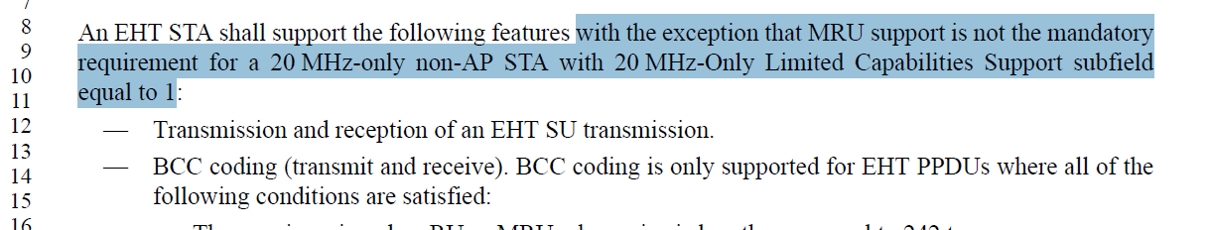

Instruction to the editor:
Please make the indicated modifications at P660 L8 as follows:

An EHT STA shall support the following features:

Please make modifications to P660L56 as indicated below:
Transmission and reception using 20 MHz channel width and all RU and MRU sizes and locations applicable to the 20 MHz channel width in the 2.4 GHz, 5 GHz, and 6 GHz bands except for a 20 MHz-only non-AP STA with 20 MHz-Only Limited Capabilities Support subfield equal to 1.

Please insert the following bullet at P660L58:
Transmission and reception using 20 MHz channel width and all RU sizes and locations applicable to the 20 MHz channel width in the 2.4 GHz, 5 GHz, and 6 GHz bands if the STA is a 20 MHz-only non-AP STA with 20 MHz-Only Limited Capabilities Support subfield equal to 1.

CID 16628, 17176
CID | Clause | Page.Line | Comment | Proposed Change | Resolutions
16628 | 36.1.1 | 662.16 | The paragraph is for mandatory features. Having an exception for 20MHz-only non-AP STA in the first line makes unclear for entire paragraph for 20MHz-only non-AP STA. | Suggest to seprate 20MHz-only non-AP STA in separate paragraph. | Revised  Agree with the commenter. The requirement for 20 MHz only devices with limited capabilities should be reflected in separate sub bullets.  Instruction to the editor:  Please make the changes in in D3.0 as indicated in 23/0429r3
17176 | 36.1.1 | 662.17 | It doesn't make sense to call out the exception for 20 MHz-only with limited capabilities here. Better to place it in the bullets that deal with MRU, DL MU-MIMO, ... support. | See comment | Revised  Agree with the commenter. The requirement for 20 MHz only devices with limited capabilities should be reflected in separate sub bullets  Instruction to the editor:  Please make the changes in in D3.0 as indicated in 23/0429r3
  - Background
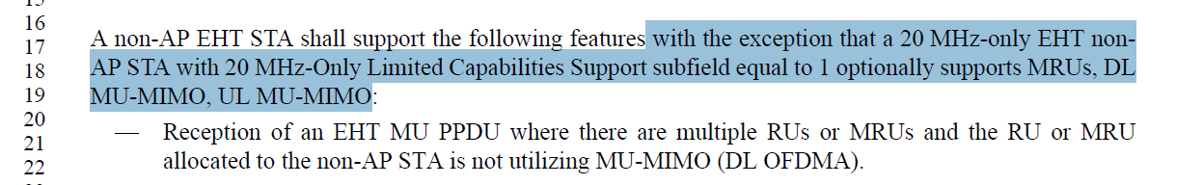

Instruction to the editor:
Please make the indicated modifications at P662 L16-17 as follows:

A non-AP EHT STA shall support the following features:
Please make modifications starting at P662L20 as indicated below:
—Reception of an EHT MU PPDU where there are multiple RUs or MRUs and the RU allocated to the non-AP STA is not utilizing MU-MIMO (DL OFDMA).
—Reception of an EHT MU PPDU where there are multiple RUs or MRUs and the MRU allocated to the non-AP STA is not utilizing MU-MIMO (DL OFDMA), except for a 20 MHz-only non-AP STA with 20 MHz-Only Limited Capabilities Support subfield equal to 1.
—Transmission of an EHT TB PPDU where there are multiple RUs or MRUs and the RU allocated to the non-AP STA is not utilizing MU-MIMO (UL OFDMA).
—Transmission of an EHT TB PPDU where there are multiple RUs or MRUs and the MRU allocated to the non-AP STA is not utilizing MU-MIMO (UL OFDMA), except for a 20 MHz-only non-AP STA with 20 MHz-Only Limited Capabilities Support subfield equal to 1.
—Reception of a non-OFDMA EHT MU PPDU utilizing MU-MIMO (DL MU-MIMO) in the supported bandwidth, except for a 20 MHz-only non-AP STA with 20 MHz-Only Limited Capabilities Support subfield equal to 1. The maximum number of spatial streams per user the non-AP STA can receive in the DL MU-MIMO transmission shall be equal to min(n, 4), where n is the maximum number of spatial streams supported for reception of a non-OFDMA EHT MU PPDU sent to single non-AP STA. The non-AP STA shall be able to receive its intended spatial streams in a DL MU-MIMO transmission with a total number of spatial streams across all users of at least four.
—MU-MIMO transmission in a non-OFDMA EHT TB PPDU (UL MU-MIMO), except for a 20 MHz-only non-AP STA with 20 MHz-Only Limited Capabilities Support subfield equal to 1. The non-AP EHT STA shall support transmitting UL MU-MIMO where the total spatial streams summed across all users is less than or equal to eight.
Please make modification to the following bullet at P662L57 (A non-AP EHT STA shall support):
—Transmission of an EHT TB PPDU utilizing non-OFDMA UL MU-MIMO with a 1 EHT-LTF and 1.6 μs GI duration on the EHT-LTF and Data field OFDM symbols, except for a 20 MHz-only non-AP STA with 20 MHz-Only Limited Capabilities Support subfield equal to 1.
Please insert the following bullet at P664L14 (A 20 MHz-only EHT non-AP STA with 20 MHz-Only Limited Capabilities Support subfield equal to 1 may support):
—Reception of an EHT MU PPDU where there are multiple RUs or MRUs and the MRU allocated to the non-AP STA is not utilizing MU-MIMO (DL OFDMA).
—Transmission of an EHT TB PPDU where there are multiple RUs or MRUs and the MRU allocated to the non-AP STA is not utilizing MU-MIMO (UL OFDMA).

CID 16629, 16161
CID | Clause | Page.Line | Comment | Proposed Change | Resolutions
16629 | 36.1.1 | 663.30 | What is the requirement for 20 MHz operating STA with "20 MHz-Only Limited Capabilities Support subfield equals to 0"? | Please clarify. | Revised  The requirement for 20 MHz operating STAs with 20 MHz-Only limited capabilities field set to 1 and 0 has been separated.  Instruction to the editor:  Please make the changes in in D3.0 as indicated in 23/0429r3
16161 | 36.1.1 | 663.31 | "A 20 MHz operating non-AP EHT STA shall support the following with the exception that a 20 MHz-only EHT non-AP STA with 20 MHz-Only Limited Capabilities Support subfield equal to 1 optionally supports MRUs" which describes the mandatory requirement of 20 MHz operating non-AP EHT STA which is not a 20 MHz-only EHT non-AP STA with 20 MHz-Only Limited Capabilities Support subfield equal to 1 (regarding MRU) seems to be overapped with the sentence in P662L20~25 "shall support reception of an EHT MU PPDU where there are multiple RUs or MRUs and the RU or MRU allocated to the non-AP STA is not utilizing MU-MIMO (DL OFDMA), transmission of an EHT TB PPDU where there are multiple RUs or MRUs and the RU or MRU allocated to the non-AP STA is not utilizing MU-MIMO (UL OFDMA)." which is also addressing the mandatory MRU support. It it's the case, it would be better to adjust those two parts. | As in comment | Revised  The requirement for 20 MHz operating STAs with 20 MHz-Only limited capabilities field set to 1 and 0 has been separated.  The bullets at P662 are for general non-AP EHT STA support requirements and updated to reflect this change based on CID 16628, 16626.  Instruction to the editor:  Please make the changes in in D3.0 as indicated in  23/0429r3

  - Background
  - P663L30
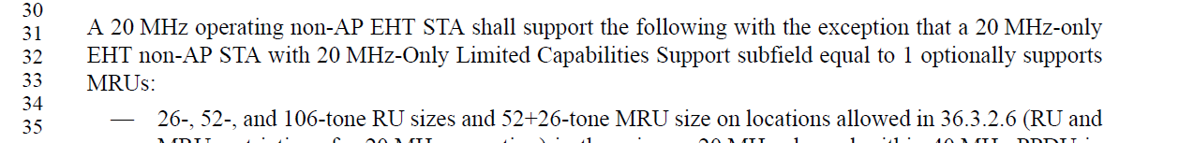

Instruction to the editor:
Please make the indicated modifications at P663 L30 as follows:
A 20 MHz operating non-AP EHT STA shall support the following:
—26-, 52-, and 106-tone RU sizes on locations allowed in 36.3.2.6 (RU and MRU restrictions for 20 MHz operation) in the primary 20 MHz channel within 40 MHz PPDU in the 2.4 GHz band, and 40 MHz, 80 MHz, and 160 MHz PPDU in the 5 GHz and 6 GHz bands, and 320 MHz PPDU in the 6 GHz band.
—52+26 tone MRU size on locations allowed in 36.3.2.6 (RU and MRU restrictions for 20 MHz operation) in the primary 20 MHz channel within 40 MHz PPDU in the 2.4 GHz band, and 40 MHz, 80 MHz, and 160 MHz PPDU in the 5 GHz and 6 GHz bands, and 320 MHz PPDU in the 6 GHz band, except for a 20 MHz-only non-AP STA with 20 MHz-Only Limited Capabilities Support subfield set to 1.

CID 16627
CID | Clause | Page.Line | Comment | Proposed Change | Resolutions
16627 | 36.1.1 | 660.14 | The paragraph is to specify which features are mandatory features. However, the subbullets are when a STA can use BCC. BCC itself is mandatory feature. Moreover, MCS8-9 are optional for 20MHz only STA. | Delete subbullets and modify sentence in line 14-15 as follows:  BCC coding (transmit and receive). BCC coding is only supported for EHT PPDUs when all of the conditions specified in section 36.3.13.3.2 are satisfied. | Revised  The current text for BCC coding is drafted in the same style as requirements for LDPC coding. It is helpful to list in this section when BCC coding is used just as in the LDPC case.  The last subbullet under this requirement section is modified to clarify MCS 8-9 for 20MHz only STAs.  Instruction to the editor:  Please make the changes in in D3.0 as indicated in  23/0429r3
  - Background
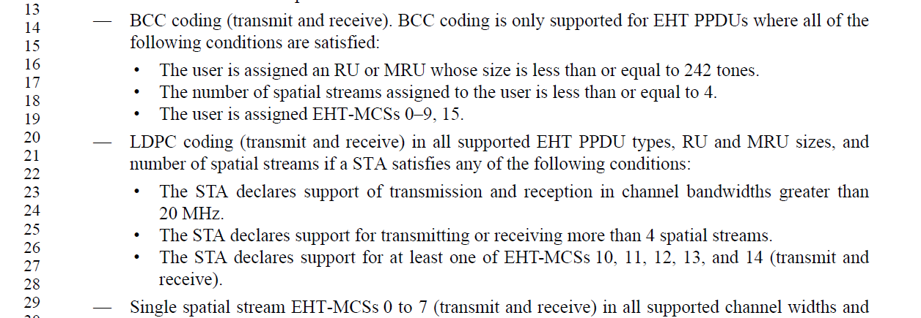
Instruction to the editor:
Please make the indicated modifications at P660 L14 as follows:

—BCC coding (transmit and receive). BCC coding is only supported for EHT PPDUs where all of the following conditions are satisfied:
•The user is assigned an RU or MRU whose size is less than or equal to 242 tones.
•The number of spatial streams assigned to the user is less than or equal to 4.
•The user is assigned one of the EHT-MCSs 0–9, 15 within its supported MCS set.

CID 15303
CID | Clause | Page.Line | Comment | Proposed Change | Resolutions
15303 | 36.1.1 | 660.27 | The braced "transmit and receive" at the end of the last sub-bullet is confusing or redundant. It's better to use same phase for demanding of both transmission and reception in neighbour sub-bullets. Meanwhile, "support of " and "support for" should be unified as well. | Change to "The STA declares support of transmission and reception EHT PPDUs of at least one of EHT-MCSs 10, 11, 12, 13, and 14." | Revised  Agree with the commenter. The bullets are modified to reflect the suggested change and unify the use of “support of” and “support for”  Instruction to the editor:  Please make the changes in in D3.0 as indicated in 23/0429r3
  - Background
Instruction to the editor:
Please make the indicated modifications at P660 L27 as follows:
—LDPC coding (transmit and receive) in all supported EHT PPDU types, RU and MRU sizes, and number of spatial streams if a STA satisfies any of the following conditions:
•The STA declares support for transmitting and receiving in channel bandwidths greater than 20 MHz.
•The STA declares support for transmitting or receiving more than 4 spatial streams.
•The STA declares support for transmitting and receiving using at least one of EHT-MCSs 10, 11, 12, 13, and 14.

CID 15304
CID | Clause | Page.Line | Comment | Proposed Change | Resolutions
15304 | 36.1.1 | 660.59 | tx/rx of non-OFDMA is a conditionally mandatory feature of an EHT AP as stated at pg661/ln33, but tx/rx of non-OFDMA is mandatory for all EHT STA as stated at pg660/ln59. | Clarify the difference between these two features or update the statement for consistency. | Rejected  The statement at P660L59 is mandatory support for preamble puncturing pattern of non-OFDMA EHT MU PPDU.  The statement at P661L33 is conditional mandatory support on the EHT AP side of non-OFDMA EHT MU PPDU using MU-MIMO.  The statement at P660L59 does not mandate support for non-OFDMA EHT MU PPDU using MU-MIMO and the two bullets do not contradicts each other.
  - Background
P660L59, under EHT STA shall support
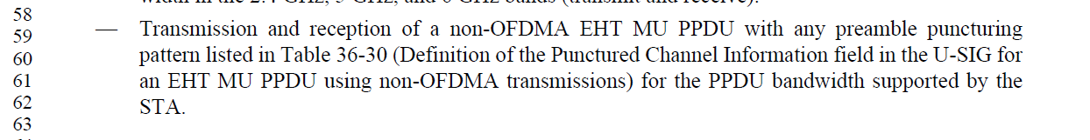
P661L33, under EHT AP shall support

CID 15021
CID | Clause | Page.Line | Comment | Proposed Change | Resolutions
15021 | 36.1.1 | 661.62 | MU-MIMO requires >=242RU has already been covered in P659/L39. | remove "where the RU or MRU is of size larger than or equal to 242 tones in the supported bandwidth" | Accepted  The paragraph at P659 is a general description of EHT PHY features. The bullet at P661 describes optional feature for EHT APs.  In the general description paragraph, MU-MIMO support is described to only exist for RU/MRU larger than or equal to 242 tones. So there’s no need to state >=242 tones in the EHT AP may support section. Including this specification can cause confusion on MU-MIMO support for RU/MRU<242 tones.  Further, in other sections where MU-MIMO is mentioned, RU/MRU >=242 tones are not mentioned. This change is consistent with other places.
  - Background
P659L39 under general EHT PHY introduction
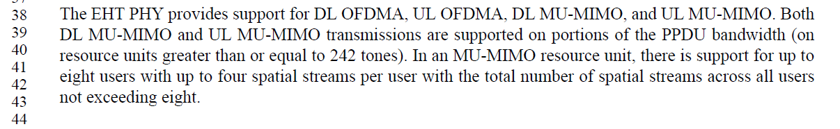
P661L62 under EHT AP may support section
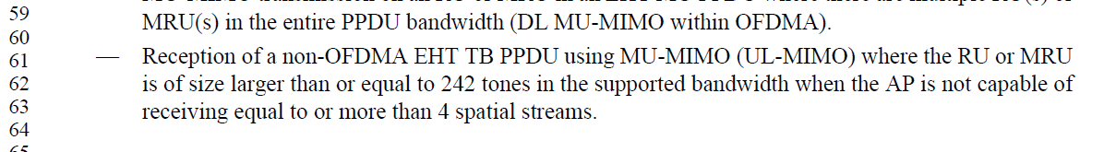

CID 15306, 15307, 15308
CID | Clause | Page.Line | Comment | Proposed Change | Resolutions
15306 | 36.1.1 | 661.17 | The statement is not accurate. Some RU and MRU sizes larger than 242 tones are not applicable in the 2.4 GHz band. | Change to "All applicable RU and MRU sizes larger than 242 tones within 40 MHz channel width in the 2.4 GHz band (transmit and receive)." | Revised  Agree with the commenter. However, the change should specify within 40MHz PPDU instead of within 40MHz channel width.  Instruction to the editor:  Please make the changes in in D3.0 as indicated in 23/0429r3
15307 | 36.1.1 | 661.20 | The statement is not accurate. Some RU and MRU sizes larger than 996 tones are not applicable within 160 MHz band. | Change to "All applicable RU and MRU sizes larger than 996 tones within 160 MHz channel width in the 5 GHz band (transmit and receive)." | Revised  Agree with the commenter. However, the change should specify within 160MHz PPDU instead of within 160MHz channel width.  Instruction to the editor:  Please make the changes in in D3.0 as indicated in 23/0429r3
15308 | 36.1.1 | 661.23 | The statement is not accurate. The 320 MHz channel width should be a restriction to the mentioned RU and MRU sizes. | Change to "All applicable RU and MRU sizes larger than 996 tones within 320 MHz channel width in the 6 GHz band (transmit and receive)." | Revised  Agree with the commenter. However, the change should specify within 320MHz PPDU instead of within 320MHz channel width.  Instruction to the editor:  Please make the changes in in D3.0 as indicated in 23/0429r3
  - Background
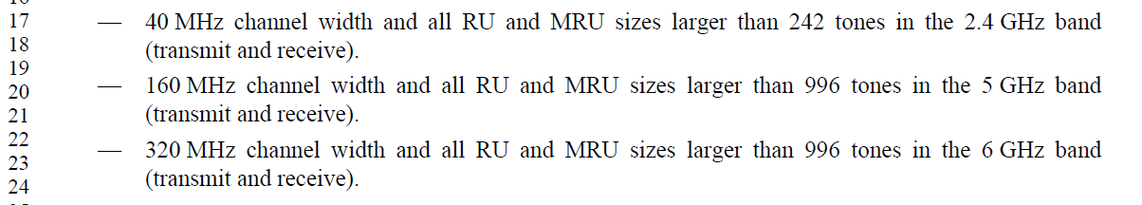
Instruction to the editor:
Please make the indicated modifications at P661 L17 as follows:
—40 MHz channel width and all applicable RU and MRU sizes larger than 242 tones within 40 MHz PPDU in the 2.4 GHz band (transmit and receive).
—160 MHz channel width and all applicable RU and MRU sizes larger than 996 tones within 160 MHz PPDU in the 5 GHz band (transmit and receive).
—320 MHz channel width and all applicable RU and MRU sizes larger than 996 tones within 320 MHz PPDU in the 6 GHz band (transmit and receive).

CID 15311
CID | Clause | Page.Line | Comment | Proposed Change | Resolutions
15311 | 36.1.1 | 662.13 | The statement is not accurate. The 320 MHz channel width should be a restriction to the mentioned RU and MRU sizes. | Change to "All applicable RU and MRU sizes larger than 2x996 tones within 320 MHz channel width in the 6 GHz band (transmit and receive)." | Revised  Agree with the commenter. However, the change should specify within 320MHz PPDU instead of within 320MHz channel width.  Instruction to the editor:  Please make the changes in in D3.0 as indicated in 23/0429r3
  - Background
P662L13
Instruction to the editor:
Please make the indicated modifications at P662 L13 as follows:
—320 MHz channel width and all applicable RU and MRU sizes larger than 2996 tones within 320MHz PPDU in the 6 GHz band (transmit and receive).

CID 15070
CID | Clause | Page.Line | Comment | Proposed Change | Resolutions
15070 | 36.1.1 | 663.08 | On page 663, line 8 and 27, these two paragraphs are kind of duplicated since both 160 MHz and 320 MHz channels are optional to non-AP STA. | Combine the two paragraphs into a single one as: "160 MHz channel width and 320 MHz channel width and RU and MUR size larger than 996 tones in the 6 GHz band (transmit and receive)" | Revised  Agree with the commenter these two bullets can be combined into one.  Instruction to the editor:  Please make the changes in in D3.0 as indicated in 23/0429r3

  - Background
P663L08
P663L27

Instruction to the editor:
Please make the indicated modifications at P663 L08 as follows:
—160 MHz and 320 MHz channel widths and all applicable RU and MRU size larger than 996 tones within its PPDU in the 6 GHz band (transmit and receive).
Please delete the bullet at P663 L27:

CID 18324
CID | Clause | Page.Line | Comment | Proposed Change | Resolutions
18324 | 36.1.1 | 661.37 | Number of spatial streams is written as a worjd, while in most places a digit '4' or other is used, better be consistent along the draft | replace 'four' by '4' here and in other places along the draft | Revised  Agree with the commenter to change “four” to 4 throughout this section.  In addition, when 8 spatial streams are mentioned, “eight” should be changed to “8” to be consistent.  Instruction to the editor:  Please change “four” to 4 at the following locations  P659L41 P661L34 P661L37 P662L32 P662L37 P663L16 P664L24  Please change “eight” to 8 at the following locations  P659L41 P659L43 P662L36 P663L21 P664L18
  - Background

CID 18325, 18326, 16350, 16351
CID | Clause | Page.Line | Comment | Proposed Change | Resolutions
18325 | 36.1.1 | 661.38 | s' should be removed from 'widths' | as in comment | Accepted
18326 | 36.1.1 | 661.39 | s' should be removed from 'widths' | as in comment | Accepted
16350 | 36.1.1 | 661.38 | widths' is a typo - should be 'width' | as in comment | Accepted
16351 | 36.1.1 | 661.39 | widths' is a typo - should be 'width' | as in comment | Accepted

CID 15310
CID | Clause | Page.Line | Comment | Proposed Change | Resolutions
15310 | 36.1.1 | 661.49 | It's strange to mandate an OFDMA transmission to follow a non-OFDMA transmission rule. | Change "Transmission of an OFDMA EHT MU PPDU" to "Transmission of a non-OFDMA EHT MU PPDU". | Rejected  The support for preamble puncturing pattern for non-OFDMA EHT MU PPDU is already specified in P660L59 under “An EHT STA shall support”.  This bullet specifies preamble puncturing pattern support requirements for OFDMA MU PPDU on the AP side.  Preamble puncturing patterns for non-OFDMA transmission is a subset of preamble puncturing patterns for OFDMA transmission.  For OFDMA MU PPDU, only the preamble puncturing patterns that are also patterns defined for non-OFDMA transmissions are mandatory. The rest of the preamble puncturing patterns defined for OFDMA transmissions are optional.  This bullet is correctly reflecting the requirements.
  - Background
P661L49, under EHT AP shall support
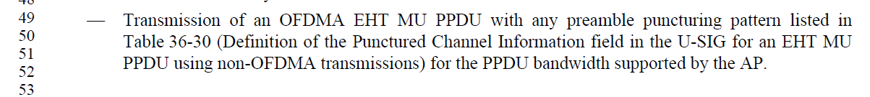

CID 17236
CID | Clause | Page.Line | Comment | Proposed Change | Resolutions
17236 | 36.1.1 | 661.61 | "Reception of a non-OFDMA EHT TB PPDU using MU-MIMO (UL-MIMO)" | Change "UL-MIMO" to "UL MU-MIMO" | Accepted

CID 15312, 15313, 15314
CID | Clause | Page.Line | Comment | Proposed Change | Resolutions
15312 | 36.1.1 | 662.27 | A non-AP STA has no idea about a "per user". It's expected to only see its own streams (per it). | Remove "per user". | Revised  Removing “per user” here makes the requirement unclear whether the maximum spatial stream referred to here is the total number of spatial streams or spatial streams for that user.  Instruction to the editor:  Please make the changes in in D3.0 as indicated in 23/0429r3
15313 | 36.1.1 | 662.30 | "...spatial streams supported for reception of....sent to single non-AP STA" is confusing. If n is per user, then n is a specific value for a particular STA but not for any "single non-AP STA". | Change to "The maximum number of spatial streams per user the non-AP STA can receive in the DL MU-MIMO transmission shall be equal to min(n, 4), where n is the maximum number of spatial streams supported by the non-AP STA for reception of a non-OFDMA EHT MU PPDU sent to itsingle non-AP STA." | Revised  Instruction to the editor:  Please make the changes in in D3.0 as indicated in 23/0429r3
15314 | 36.1.1 | 662.31 | "The non-AP STA shall be able to receive its intended spatial streams in a DL MU-MIMO  transmission with a total number of spatial streams across all users of at least four." This statement is redundant with the first sentence in the same sub-bullet. Its purpose is only to add a condition for the DL MU-MIMO receiption feature. | Remove the last sentence and change the first sentence in the same sub-bullet as "Reception of a non-OFDMA EHT MU PPDU utilizing MU-MIMO (DL MU-MIMO) in the supported bandwidth with a total number of spatial streams across all users of at least four." | Accepted

  - Background
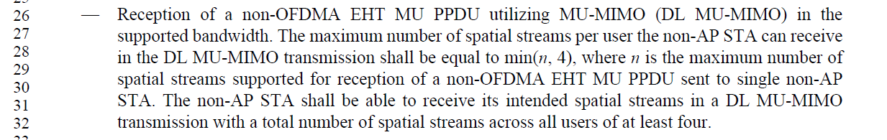
Instruction to the editor:
Please make the indicated modifications at P662 L26 as follows:
—Reception of a non-OFDMA EHT MU PPDU utilizing MU-MIMO (DL MU-MIMO) in the supported bandwidth with a maximum total number of spatial streams across all users of at least 4. The maximum number of spatial streams a non-AP STA can receive from its assignment in the DL MU-MIMO transmission shall be equal to min(n, 4), where n is the maximum number of spatial streams supported by the non-AP STA for reception of a non-OFDMA EHT MU PPDU sent to that single non-AP STA.

CID 15316, 15317
CID | Clause | Page.Line | Comment | Proposed Change | Resolutions
15316 | 36.1.1 | 663.12 | “The maximum number of spatial streams per user in the DL MU-MIMO within OFDMA transmission that the non-AP STA can receive shall be min(n, 4) where n is the maximum number of spatial streams supported for reception of non-OFDMA EHT MU PPDU sent to that single non-AP STA” is confusing. The maximum number of spatial streams should be particularly for the mentioned non-AP STA. | Change to “The maximum number of spatial streams per user in the DL MU-MIMO within OFDMA transmission that the non-AP STA can receive shall be min(n, 4) where n is the maximum number of spatial streams supported by the non-AP STA for reception of non-OFDMA EHT MU PPDU sent to that single non-AP STA.” | Revised.  Agree with the commentor’s suggestion. The language is modified to match the description used in the non-OFDMA DL MU-MIMO case.  Instruction to the editor:  Please make the changes in in D3.0 as indicated in 23/0429r3
15317 | 36.1.1 | 663.15 | “The total number of spatial streams (across all users) in a DL MU-MIMO within OFDMA transmission that the non-AP STA can receive shall be at least four.” This statement is more like a limitation on AP instead of a non-AP STA. It should be expressed as a condition on the DL MU-MIMO within OFDMA feature. | Remove the last sentence and change the first sentence in the same sub-bullet as “MU-MIMO reception on an RU or MRU in an EHT MU PPDU which consist of multiple RUs and/or MRUs (DL MU-MIMO within OFDMA) with a total number of spatial streams (across all users) of at least four .” | Accepted
  - Background
P663L10
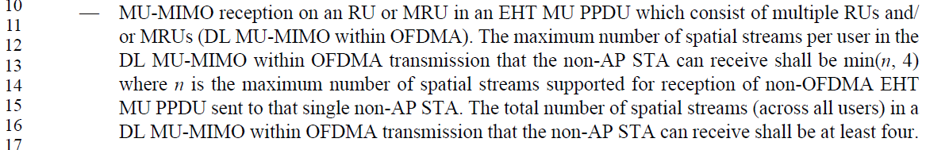
Instruction to the editor:
Please make the indicated modifications at P663 L26 as follows (A non-AP EHT STA may support):
—MU-MIMO reception on an RU or MRU in an EHT MU PPDU which consist of multiple RUs and/or MRUs (DL MU-MIMO within OFDMA) with a maximum total number of spatial streams (across all users) of at least 4. The maximum number of spatial streams a non-AP STA can receive from its assignment in the DL MU-MIMO within OFDMA transmission shall be min(n, 4) where n is the maximum number of spatial streams supported by the non-AP STA for reception of non-OFDMA EHT MU PPDU sent to that single non-AP STA.

CID 15318
CID | Clause | Page.Line | Comment | Proposed Change | Resolutions
15318 | 36.1.1 | 663.20 | "If supported, then the non-AP EHT STA shall support transmitting UL MU-MIMO where the total spatial streams summed across all users is less than or equal to eight." The purpose of this statement is only adding a condition of total streams no more than eight. But this limitation should be for AP instead of non-AP STAs, e.g. a non-AP STA cannot guarantee the number of total streams is no more than 8. | Remove this sentence and add corresponding limitation on AP if needed. | Rejected.  The sentence is here because in the case where UL MU-MIMO within OFDMA is supported, the non-AP EHT STA need to be able to transmit UL MU-MIMO packets of up to 8ss, i.e. the non-AP STA need to be able to process 8 LTFs, etc. So this description is needed.
  - Background
P663L20 “an non-AP EHT STA may support”
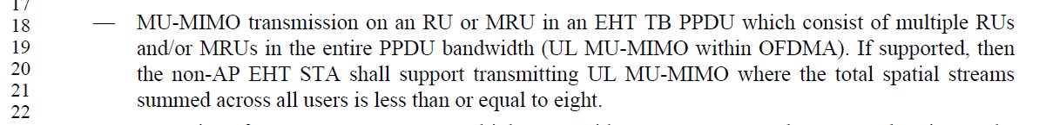

CID 17804, 15322, 15454, 17177, 15323
CID | Clause | Page.Line | Comment | Proposed Change | Resolutions
17804 | 36.1.1 | 664.17 | The maximum number of spatial streams  per user the non-AP STA can receive in the UL MU-MIMO transmission shall be equal to min(n,  4), where n is the maximum number of spatial streams supported for reception of a non-OFDMA  EHT MU PPDU sent to single non-AP STA.  The non-AP STA shall be able to receive its  intended spatial streams in a UL MU-MIMO transmission with a total number of spatial streams  across all users of at least four. | change UL MU-MIMO to DL MU-MIMO.  (Non-AP cannot be required to receive UL MU-MIMO) | Revised.  The sentences pointed out by the commenter are copied from DL MU-MIMO support section and misplaced in the UL MU-MIMO support requirement. The sentences should be deleted instead.  Instruction to the editor:  Please make the changes in in D3.0 as indicated in 23/0429r3
15322 | 36.1.1 | 664.18 | What's the impact of total spatial streams summed across all users imposed on a specific non-AP STA transmitting UL MU-MIMO? Does this statement intend to say a non-AP STA may support up to 8 steams in an UL MU-MIMO transmission but the number of streams in a specific UL MU-MIMO PPDU is indicated by AP. If it's that case, please say it directly. | As in comment | Revised  Same as CID17804.  Instruction to the editor:  Please make the changes in in D3.0 as indicated in 23/0429r3
15454 | 36.1.1 | 664.18 | "The maximum number of spatial streams per user the non-AP STA can receive in the UL MU-MIMO transmission shall be equal to min(n, 4), where n is the maximum number of spatial streams supported for reception of a non-OFDMA EHT MU PPDU sent to single non-AP STA. The non-AP STA shall be able to receive its intended spatial streams in a UL MU-MIMO transmission with a total number of spatial streams across all users of at least four" should be changed to "The maximum number of spatial streams per non-AP STA in the UL MU-MIMO transmission shall be equal to min(n, 4), where n is the maximum number of spatial streams supported for the reception of an EHT SU transmission" | As in comment | Revised.  The sentences pointed out by the commenter are copied from DL MU-MIMO support section and misplaced in the UL MU-MIMO support requirement. The sentences should be moved to DL MU-MIMO support requirements instead.  Instruction to the editor:  Please make the changes in in D3.0 as indicated in 23/0429r3
17177 | 36.1.1 | 664.18 | A non-AP STA does not receive UL MU-MIMO. It looks like the sentence starting with "The maximum number of spatial streams per user the non-AP can receive ..." is copied from DL MU-MIMO. | Delete sentence starting with "The maximum number of spatial streams per user the non-AP can receive ..." and following sentence. | Accept
15323 | 36.1.1 | 664.19 | The 2nd and 3rd sentences in the sub-bullet are confusing. They are describing requirements for UL MU-MIMO receiving which makes no sense to a non-AP STA. | Remove the 2 sentences or rephrase them to contrentrate the requirements for UL MU-MIMO transmission. | Accept
  - Background
P664L15
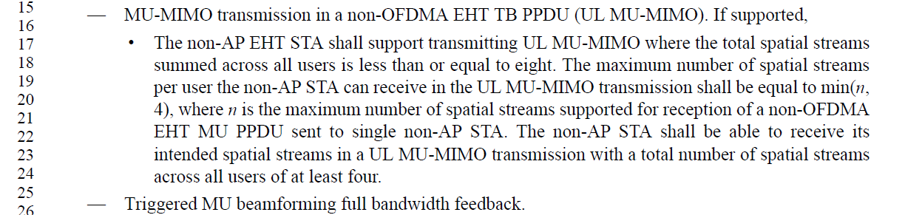
Instruction to the editor:
Please make the indicated modifications starting at P664 L15 as follows (A 20 MHz-only EHT non-AP STA with 20 MHz-Only Limited Capabilities Support subfield equal to 1 may support):
—Reception of a non-OFDMA EHT MU PPDU utilizing MU-MIMO (DL MU-MIMO) in the supported bandwidth with a maximum total number of spatial streams across all users of at least 4. The maximum number of spatial streams a non-AP STA can receive from its assignment in the DL MU-MIMO transmission shall be equal to min(n, 4), where n is the maximum number of spatial streams supported by the non-AP STA for reception of a non-OFDMA EHT MU PPDU sent to that single non-AP STA.
—MU-MIMO transmission in a non-OFDMA EHT TB PPDU (UL MU-MIMO). If supported,
•The non-AP EHT STA shall support transmitting UL MU-MIMO where the total spatial streams summed across all users is less than or equal to 8.
—Triggered MU beamforming full bandwidth feedback.

