IEEE P802.11
Wireless LANs
11bk Spec text for NDP Announcement
Date: 2023-03-11
Author(s):
Name | Affiliation | Address | Phone | Email
Yanjun Sun | Qualcomm
Ali Raissinia
Steve Shellhammer
George Cherian

Abstract
We propose the draft specification skeleton for NDP Announcement to help the creation of TGbk draft D0.1.

Revisions:

- Rev 0: Initial version of the document.

Interpretation of a Motion to Adopt

A motion to approve this submission means that the editing instructions and any changed or added material are actioned in the TGbk 0.1 Draft. This introduction is not part of the adopted material.

Editing instructions formatted like this are intended to be copied into the TGbk D0.1 Draft (i.e. they are instructions to the 802.11 editor on how to merge the text with the baseline documents).

TGbk Editor: Editing instructions preceded by “TGbk Editor” are instructions to the TGbk editor to modify existing material in the TGbk draft. As a result of adopting the changes, the TGbk editor will execute the instructions rather than copy them to the TGbk Draft.

Discussion:
The text is prepared for the following motion:
The Ranging NDP Announcement frame of 802.11bk will use the existing 320MHz indication of 802.11be:
• For a non-HT dup PPDU: set B7 in SERVICE field to 1 to indicate 320 MHz
• For an EHT MU PPDU: use the Bandwidth field in the U-SIG field to indicate 320 MHz
(11-23-48: 202301-12)

Proposed spec text:

TGbk editor: Please note Baseline is REVme_D2.1 and 11bk D7.0

9. Frame formats
9.3 Format of individual frame types
9.3.1 Control frames
9.3.1.19 VHT/HE/Ranging NDP Announcement frame format
… …
The TA field is set to the address of the STA transmitting the VHT/HE/Ranging NDP Announcement frame or the bandwidth signaling TA of the STA transmitting the VHT/HE/Ranging NDP Announcement frame. In a VHT/HE/Ranging NDP Announcement frame transmitted by a VHT or HE STA in a non-HT or non-HT duplicate format and where the scrambling sequence carries the TXVECTOR parameter CH_BANDWIDTH_IN_NON_HT, the TA field is set to a bandwidth signaling TA.
Discussion: in 11be D3.0, we have the following on 320 MHz bandwidth indication for EHT NDPA in non-HT duplicate PPDU:
The TA field is set to the address of the STA transmitting the VHT/HE/Ranging NDP Announcement frame or the bandwidth signaling TA of the STA transmitting the VHT/HE/Ranging NDP Announcement frame. In an EHT NDP Announcement frame transmitted by an EHT STA that is a STA 6G with 320 MHz bandwidth support in a non-HT or non-HT duplicate format and where the scrambling sequence and SERVICE field carry the TXVECTOR parameter CH_BANDWIDTH_IN_NON_HT, the TA field is set to a band width signaling TA.
and the following for EHT MU PPDU:
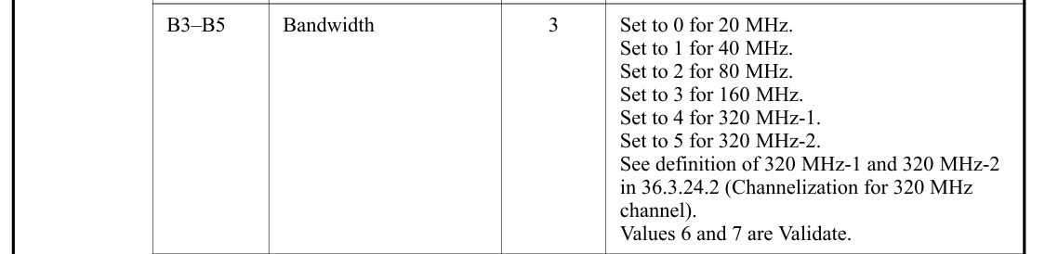
so similar text is added below for 320 MHz Ranging NDPA
TGbk editor: Please add the following two paragraphs as follows for NDPA in non-HT Duplicate PPDU and EHT MU PPDU (track changes enabled):
In a Ranging NDP Announcement frame transmitted by an EHT STA that is a STA 6G with 320 MHz bandwidth support in a non-HT duplicate format and where the scrambling sequence and SERVICE field carry the TXVECTOR parameter CH_BANDWIDTH_IN_NON_HT, the TA field is set to a bandwidth signaling TA (see Figure 17-6 (SERVICE field bit assignment)).
In a Ranging NDP Announcement frame transmitted by an EHT STA that is a STA 6G with 320 MHz bandwidth support in a 320 MHz EHT MU PPDU, the Bandwidth field in the U-SIG field of the PPDU is set to 4 or 5.
If a Ranging NDP Announcement frame is addressed to a set of ISTAs in which at least two ISTAs have a TB ranging measurement exchange with a different BSSID in the Multiple BSSID set of the RSTA then the TA field is the transmitted BSSID.

35. Extremely high throughput (EHT) MAC specification

35.14 PPDU format, BW, MCS, NSS, and DCM selection rules

35.14.2 PPDU format selection
TGbk editor: Please add the following paragraph for NDPA (track changes enabled):

A 320 MHz Ranging NDP Announcement frame shall be transmitted in a non-HT Duplicate PPDU or EHT MU PPDU and the frame shall satisfy the following rules:
• the NDP Announcement Type subfield of the frame shall be set to 1;
• the format of a STA Info field in the frame shall be one of the formats defined in Figure 9-61da, Figure 9-61db, Figure 9-61dc and Figure 9-61dd.

Straw Poll: Do you support to incorporate the proposed draft text in this document 11-23/0390r0 to the TGbk Draft 0.1?
Result: Yes/No/Abstain

