IEEE P802.11
Wireless LANs
LB271 CR for CID 16417
on 35.8.5.1 TXOP and backoff procedures rules for R-TWT SPs
Date: 2023-07-12
Author(s):
Name | Affiliation | Address | Phone | email
Liuming Lu | OPPO |  |  | luliuming@oppo.com

Abstract
This submission proposes resolutions for the following CIDs for TGbe LB271:
16417

Revisions:
- Rev 0: Initial version of the document
- Rev 1: Editorial changes
- Rev 2: update the document according to Brian’s suggestion (including the default value of dot11RTWTSPStartGuardTime set to 9 µs))
- Rev 3: update the document according to Chunyu’s suggestion (including the modification of “behavior as the overlapping quiet interval does not exist” as “ignore the overlapping quiet interval”)

Interpretation of a Motion to Adopt

A motion to approve this submission means that the editing instructions and any changed or added material are actioned in the TGbe Draft. This introduction is not part of the adopted material.

Editing instructions formatted like this are intended to be copied into the TGbe Draft (i.e. they are instructions to the 802.11 editor on how to merge the text with the baseline documents).

TGbe Editor: Editing instructions preceded by “TGbe Editor” are instructions to the TGbe editor to modify existing material in the TGbe draft. As a result of adopting the changes, the TGbe editor will execute the instructions rather than copy them to the TGbe Draft.

TGbe editor: The baseline for this document is 11be D3.0.

CID | Commenter | Clause | Pg/Ln | Comment | Proposed Change | Resolution
16417 | Liuming Lu | 35.8.5.1 TXOP and backoff procedures rules for R-TWT SPs | 620.03 | The protection mechanism for the delivery of latency sensitive traffic during r-TWT SPs including trigger-enabled SPs and non-trigger-enabled SPs seems to be not enough, which would impact the transmission of latency sensitive traffic during the r-TWT SPs. | Suggest to specify a mechanism to ensure the sceduling AP can obtain the TXOP near the start time of the trigger-enabled R-TWT SPs and the member STA can obtain the TXOP near the start time of the non-trigger-enabled R-TWT SPs | Revised  Agree in principle. It is proposed that the non-AP STA that supports R-TWT but is not a member of the R-TWT SP is allowed for transmission a guard time after the start time of the R-TWT SP during the R-TWT SP  Instruction to the editor, please update the text in the subclause 35.8.4.1 TXOP and backoff procedures rules for R-TWT SPs, as shown in this document (doc.: IEEE 802.11-23/383 r3).

Discussion:

The protection mechanism of r-TWT SPs specified in 11be Draft D3.0 seems to be not enough, which would impact the scheduled transmition of lantency-sensitve traffic during the R-TWT SPs. For example, the Non-AP EHT STAs may ignore the overlapping quiet intervals, which means that the unscheduled EHT STAs may contend for channel access during the SPs.
To guanrantee that the AP has higher priority of channel access to gain the TXOP at the start time of trigger-enabled R-TWT SP the non-AP STA that supports R-TWT and ignores the overlapping quiet interval but is not a member of the R-TWT SP is proposed to be allowed for transmission dot11RTWTSPStartGuardTime after the start time of the R-TWT SP during the R-TWT SP, shown in the following Figure as an example.

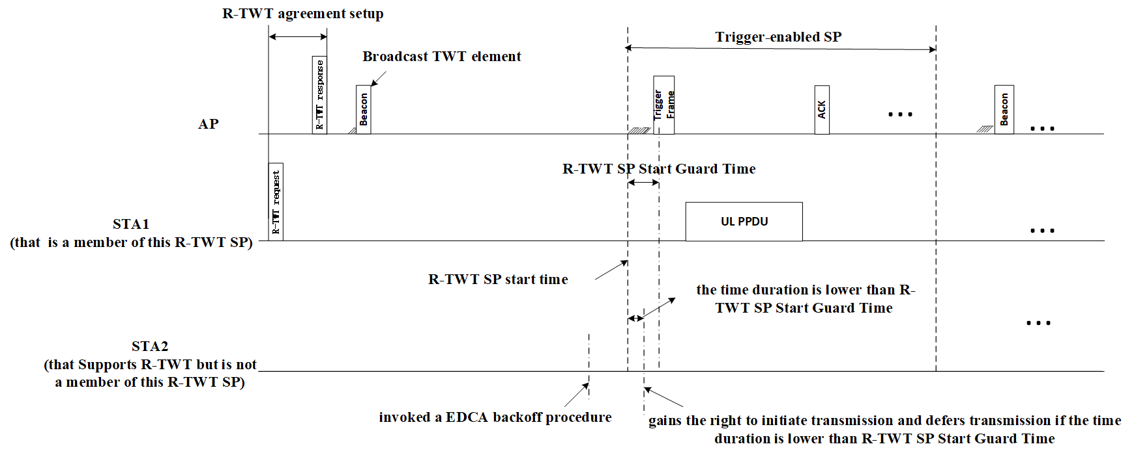
Proposed Text Change:

      - EHT Operation element
…
The Element ID, Length, and Element ID Extension fields are defined in 9.4.2.1 (General).The EHT Operation Parameters field is defined in Figure 9-1002b (EHT Operation Parameters field format).
TGbe editor: please change Figure 9-1002b—EHT Operation Parameters field format as follows:

 | B0 | B1 | B2 | B3 | B4 B5 | B6 B7
 | EHT Operation Information Present | Disabled Subchannel Bitmap Present | EHT  Default PE Duration | Group Addressed BU Indication Limit | Group Addressed BU Indication Exponent | R-TWT SP Start Guard Time
Bits: | 1 | 1 | 1 | 1 | 2 | 2
Figure 9-1002b—EHT Operation Parameters field format
…
The Group Addressed BU Indication Exponent subfield is set to the exponent from which N is calculated as defined in 35.3.15.1 (AP MLD operation for group addressed frames).
TGbe editor: please insert the following text:
The R-TWT SP Start Guard Time subfield indicates the time duration during which the EHT STA(s) with dot11RestrictedTWTOptionImplemented equal to true that is not member STA(s) of the R-TWT SP and ignores the overlapping quiet interval is not allowed for initiating transmission during this R-TWT SP. The R-TWT SP Start Guard Time subfield is set as defined in Table 9-xxx (Encoding of the R-TWT SP Start Guard Time subfield).
Table 9-xxx—Encoding of the R-TWT SP Start Guard Time subfield
R-TWT SP Start Guard Time subfield value | R-TWT SP Start Guard Time
0 | 0 µs
1 | 9 µs
2 | 18 µs
3 | 36 µs

35.8.5 Channel access rules for R-TWT SPs
35.8.5.1 TXOP and backoff procedures rules for R-TWT SPs
…
When an R-TWT SP starts, a member STA may suspend decrementing the backoff counter of any AC that does not have any R-TWT TID(s) mapped to until it has delivered all its frames from R-TWT TID(s), and resume the decrementing afterwards or when the SP is ended.
TGbe editor: please insert the following text:
The EHT STA(s) with dot11RestrictedTWTOptionImplemented equal to true initializes dot11RTWTSPStartGuardTime to 9 µs, and should update dot11RTWTSPStartGuardTime with the R-TWT SP Start Guard Time indicated in the R-TWT SP Start Guard Time field, if present, of the EHT Operation element in the most recent frame received from its associated AP.
Before starting transmission of the frame during the R-TWT SP, the non-AP EHT STA with dot11RestrictedTWTOptionImplemented set to true that is not a member of this R-TWT SP and ignores the overlapping quiet interval and has gained the right to initiate transmission of a frame of an AC as described in 10.23.2.4 (Obtaining an EDCA TXOP) may check if the time duration after the start time of this R-TWT SP is lower than dot11RTWTSPStartGuardTime, if it is lower than dot11RTWTSPStartGuardTime, then the STA may defer transmission by selecting a random backoff count using the present CW (without advancing to the next value in the sequence). The QSRC[AC] for the MSDU or A-MSDU is not affected.

Annex C
(normative)
ASN.1 encoding of the MAC and PHY MIB
C.3 MIB Detail
…
-- **********************************************************************
-- * dot11EHTStationConfig TABLE
-- **********************************************************************
…
TGbe editor: please update the text as follows:

Dot11EHTStationConfigEntry ::= SEQUENCE {
dot11EHTPPEThresholdsRequired TruthValue,
dot11TIDtoLinkMappingActivated TruthValue,
dot11EHTEPCSPriorityAccessActivated TruthValue,
dot11MSDTimerDuration Unsigned32,
dot11MSDTXOPMAX Unsigned32,
dot11MultiLinkActivated TruthValue,
dot11MLDAssociationSAQueryMaximumTimeout Unsigned32,
dot11EHTMCSFeedbackOptionImplemented INTEGER,
dot11EHTEMLSROptionImplemented TruthValue,
dot11EHTEMLSROptionActivated TruthValue,
dot11EHTEMLMROptionImplemented TruthValue,
dot11EHTEMLMROptionActivated TruthValue,
dot11OperationParameterUpdateImplemented TruthValue,
dot11RTWTSPStartGuardTime Unsigned32
}
…

TGbe editor: please insert the following text:

dot11RTWTSPStartGuardTime OBJECT-TYPE
SYNTAX Unsigned32 (0..255)
UNITS "microseconds"
MAX-ACCESS read-write
STATUS current
DESCRIPTION
"
This is a capability variable.
Its value is determined by device capabilities.
This attribute indicates the R-TWT SP start guard time, in microseconds, during which the STA with dot11RestrictedTWTOptionImplemented set to true that is not a member of the R-TWT SP and ignores the overlapping quiet interval is not allowed for initiating transmission after the start time of this R-TWT SP during this R-TWT SP."
DEFVAL {9}
::= { dot11EHTStationConfigEntry x }

References:

- 2022/2182r0, LB266 CR for misc CIDs in 35.9 and 35.9.4.1

