IEEE P802.11
Wireless LANs

CR for non-HT 320MHz BW Indication
Date: 2023-03-09
Author(s):
Name | Affiliation | Address | Phone | email
Yunbo Li | Huawei |  |  | liyunbo@huawei.com
Ming Gan
Yuchen Guo
Guogang Huang
Yousi Lin
Zhenguo Du
Stephen McCann
Edward Au
Youhan Kim | Qualcomm
Brian Hart | Cisco
Kaiying Lu | Mediatek

Abstract
This submission proposes comment resolution(s) for the following 15 CID(s) received in LB271 on TGbe D3.0

CIDs:
15717, 18292, 17411, 17412, 17413, 17414, 17415, 17417, 18002, 18286, 18287, 18288, 18289, 18290, 18291,

Revisions:
- Rev 0: Initial version of the document.
- Rev 1-2: modify base on offline feedback
- Rev 3: add two “,” in the resolution of CID 18292
- Rev 4: updated version with the help from Youhan and Brian.

CID | Commenter | Clause | P.L | Comment | Proposed Change | Resolution
17415 | Brian Hart | 9.3.1.2 | 155.54 | The third para is not well written | Option A (cleaner and clearer than the current language, while preserving the ?unwarranted attention to CBW320): "The TA field is the address of the STA transmitting the RTS frame or the bandwidth signaling TA of the STA transmitting the RTS frame.  In an RTS frame transmitted in a non-HT or non-HT duplicate format by a VHT STA, an HE STA, an EHT STA that is not a STA 6G, or an EHT STA that is a STA 6G without 320 MHz bandwidth support to another VHT STA, HE STA, or an EHT STA, then the TA field of the RTS frame is a bandwidth signaling TA, and this indicates that the PPDU carries the TXVECTOR parameters CH_BANDWIDTH_IN_NON_HT and DYN_BANDWIDTH_IN_NON_HT (see 10.3.2.7 (VHT and SIG RTS procedure)), wherein CBW320 is not an allowed value for CH_BANDWIDTH_IN_NON_HT.  In an RTS frame transmitted in a non-HT or non-HT duplicate format by an EHT STA that is a STA 6G with 320 MHz bandwidth support to another EHT STA that is a STA 6G, then the TA field of the RTS frame is a bandwidth signaling TA, and this indicates that the PPDU carries the TXVECTOR parameters CH_BANDWIDTH_IN_NON_HT and DYN_BANDWIDTH_IN_NON_HT (see 10.3.2.7 (VHT and SIG RTS procedure))."  Option B (most streamlined): "The TA field is the address of the STA transmitting the RTS frame or the bandwidth signaling TA of the STA transmitting the RTS frame.  In an RTS frame transmitted in a non-HT or non-HT duplicate format by a VHT STA, an HE STA, or an EHT STA to another VHT STA, HE STA, or an EHT STA, then the TA field of the RTS frame is a bandwidth signaling TA, and this indicates that the PPDU carries the TXVECTOR parameters CH_BANDWIDTH_IN_NON_HT and DYN_BANDWIDTH_IN_NON_HT (see 10.3.2.7 (VHT and SIG RTS procedure))." ... then add a xref to normative language where CBW320 can't be sent if the transmitter or recipient doesn't understand it.  Ditto for PS-Poll, CF-End (mostly), BAR etc | Revised-  Agree with the commenter.  The modifications based on Option B are provided.  TGbe editor to make the changes under tag 17415 in 11-23-0374r4
17417 | Brian Hart | 9.3.1.19.1 | 160.21 | MAC language violates layering. MAC needs to know about the TXVECTOR parameters CH_BANDWIDTH_IN_NON_HT but nothing below that. Worse, all duplicated detail (sentences L20 and L24) arise because 320M needs the Service field which the MAC just doesn't care about. Instead, merge the sentences and in clause 9 merely provide a xref to *normative* language where a transmitter can't send CBW320 to a recipient that doesn't understand it. | Try to replace L17-28 by "The TA field is set to the address of the STA transmitting the VHT/HE/Ranging NDP Announcement frame or the bandwidth signaling TA of the STA transmitting the VHT/HE/Ranging NDP Announcement frame. In an NDP Announcement frame transmitted by a VHT STA, an HE STA or an EHT STA in a non-HT or non-HT duplicate format and where the PPDU carries the TXVECTOR parameter CH_BANDWIDTH_IN_NON_HT, the TA field is set to a bandwidth signaling TA." Then append NOTE, with xref to a MAC clause, explaining that "don't send CBW320 if the TX/recipient doesn't understand it" | Revised-  The proposed resolution is shown in doc 11-13/0374r4.  TGbe editor to make the changes under tag 17415 in 11-23-0374r4
17411 | Brian Hart | 9.3.1.2 | 155.57 | MAC language violates layering. MAC needs to know about the TXVECTOR parameters CH_BANDWIDTH_IN_NON_HT and DYN_BANDWIDTH_IN_NON_HT but nothing below that. | Ap P155L58, change "the scrambling sequence and SERVICE field carry" to "the PPDU carries". Ditto, at P155L61.5, change "The scrambling sequence" to "the PPDU". | Revised-  The proposed resolution is shown in doc 11-13/0374r4.  TGbe editor to make the changes under tag 17415 in 11-23-0374r4
17412 | Brian Hart | 9.3.1.2 | 155.57 | Clearest if new info for a new PHY is added after the associated material for an old PHY | Move the 320MHz EHT-related sentence to P155L4 | Revised-  The proposed resolution is shown in doc 11-13/0374r4.  TGbe editor to make the changes under tag 17415 in 11-23-0374r4
17413 | Brian Hart | 9.3.1.2 | 155.65 | Typo: "in" should be "is" | As in comment | Revised-  The proposed resolution is shown in doc 11-13/0374r4.  TGbe editor to make the changes under tag 17415 in 11-23-0374r4
17414 | Brian Hart | 9.3.1.2 | 155.65 | "either on of the following cases", but there is only one case | Figure out what was intended and fix. E.g., omit the "either one of the following cases" | Revised-  The proposed resolution is shown in doc 11-13/0374r4.  TGbe editor to make the changes under tag 17415 in 11-23-0374r4
18002 | Yanjun Sun | 9.3.1.2 | 156.02 | The text is confusing. Suggest to move "an EHT STA that is a STA 6G  without 320 MHz bandwidth support to another VHT STA, HE STA, or an EHT STA" to a new bullet and add "from" in the beginning. | As in comment | Revised-  The proposed resolution is shown in doc 11-13/0374r4.  TGbe editor to make the changes under tag 17415 in 11-23-0374r4
18286 | kaiying Lu | 9.3.1.2 | 155.55 | In an RTS frame transmitted by any EHT STA that is a STA 6G in a non-HT or non-HT duplicate format to another EHT STA that is a STA 6G, scrambling sequence and SERVICE field carry the TXVECTOR parameters CH_BANDWIDTH_IN_NON_HT and DYN_BANDWIDTH_IN_NON_HT and the TA field is a bandwidth signaling TA. Remove "with 320MHz bandwidth support". | As in comment. | Revised-  The proposed resolution is shown in doc 11-13/0374r4.  TGbe editor to make the changes under tag 17415 in 11-23-0374r4
18287 | kaiying Lu | 9.3.1.2 | 156.02 | Remove "an EHT STA that is a STA 6G without 320 MHz bandwidth support" | As in comment. | Revised-  The proposed resolution is shown in doc 11-13/0374r4.  TGbe editor to make the changes under tag 17415 in 11-23-0374r4
18288 | kaiying Lu | 9.3.1.5.1 | 156.08 | Remove "with 320MHz bandwidth support" and "an EHT STA that is a STA 6G without 320 MHz bandwidth support" | As in comment. | Revised-  The proposed resolution is shown in doc 11-13/0374r4.  TGbe editor to make the changes under tag 17415 in 11-23-0374r4
18289 | kaiying Lu | 9.3.1.6 | 156.26 | Remove "with 320MHz bandwidth support" and "an EHT STA that is a STA 6G without 320 MHz bandwidth support" | As in comment. | Revised-  The proposed resolution is shown in doc 11-13/0374r4.  TGbe editor to make the changes under tag 17415 in 11-23-0374r4
18290 | kaiying Lu | 9.3.1.7 | 156.50 | Remove "with 320MHz bandwidth support" and "an EHT STA that is a STA 6G without 320 MHz bandwidth support" | As in comment. | Revised-  The proposed resolution is shown in doc 11-13/0374r4.  TGbe editor to make the changes under tag 17415 in 11-23-0374r4
18291 | kaiying Lu | 9.3.1.19 | 160.17 | Remove "with 320MHz bandwidth support" and "an EHT STA that is a STA 6G without 320 MHz bandwidth support" | As in comment. | Revised-  The proposed resolution is shown in doc 11-13/0374r4.  TGbe editor to make the changes under tag 17415 in 11-23-0374r4

Discussion：

Proposed spec text

Instruction to TGbe editor: Add 9.2.4.3.8 at 11be D3.0 P138L4 as shown below. (#17415)
9.2.4.3.8 TA field

Change the first paragraph as follows:

The TA field contains a MAC address that identifies the STA that has transmitted, onto the WM, the MPDU contained in the frame body field. If the Individual/Group bit is 0, then the TA field is the individual address of the STA; otherwise, the TA field is a bandwidth signaling TA, indicating that the PPDU carries the TXVECTOR parameters CH_BANDWIDTH_IN_NON_HT and, in some cases, DYN_BANDWIDTH_IN_NON_HT (see 17.2.2 (TXVECTOR parameters)).

TGbe editor: Please make the following changes in subclause 9.3.1.2 (RTS frame format): (#17415)
9.3.1.2 RTS frame format
The TA field is the address of the STA transmitting the RTS frame or the bandwidth signaling TA of the STA transmitting the RTS frame.
NOTE – A VHT or HE STA transmitting an RTS frame carried in non-HT or non-HT duplicate format and addressed to a VHT or HE STA sets the TA field to the bandwidth signaling TA (see 9.2.4.3.8 (TA field) and 10.3.2.7 (VHT, HE and S1G RTS procedure)).

TGbe editor: Please make the following changes in subclause 9.3.1.5 (PS-Poll frame format): (#17415)
9.3.1.5 PS-Poll frame format
9.3.1.5.1 General
The BSSID (RA) field is set to the address of the STA contained in the AP. The TA field value is the address of the STA transmitting the frame or a bandwidth signaling TA (see 9.2.4.3.8 (TA field) and 10.6.6.6 (Channel Width selection for Control frames)).

TGbe editor: Please make the following changes in subclause 9.3.1.6 (CF-END frame format): (#17415)
9.3.1.6 CF-End frame format

If transmitted by a non-DMG non-S1G STA that is not a VHT or HE STA, the BSSID (TA) field is the address of the STA contained in the AP.
If transmitted by a VHT or HE STA, the BSSID (TA) field is the address of the STA contained in the AP with the Individual/Group bit of the BSSID (TA) field set to 0 or 1 as specified in 10.6.6.6 (Channel Width selection for Control frames).
If transmitted by an S1G STA, the BSSID (TA) field is the address of the STA contained in the AP.
If transmitted by a DMG STA, the TA field is the MAC address of the STA transmitting the frame.

TGbe editor: Please make the following changes in subclause 9.3.1.7 (BlockAckReq frame format): (#17415)
9.3.1.7 BlockAckReq frame format
9.3.1.7.1 Overview
The TA field value is the address of the STA transmitting the BlockAckReq frame or a bandwidth signaling TA (see 9.2.4.3.8 (TA field) and 10.6.6.6 (Channel Width selection for Control frames)).

TGbe editor: Please make the following changes in subclause 9.3.1.19 (NDP Announcement frame format): (#17415)
9.3.1.19 NDP Announcement frame format
9.3.1.19.1 General description
The TA field is set to the address of the STA transmitting the NDP Announcement frame or the bandwidth signaling TA of the STA transmitting the NDP Announcement frame (see 9.2.4.3.8 (TA field) and 10.6.6.6 (Channel Width selection for Control frames)).

Instruction to TGbe editor: Add 10.3.2.7 at 11be D3.0 P332L4 as shown below. (#17415)

10.3.2.7 VHT, HE and S1G RTS procedure
Change the first three paragraphs as follows:

A VHT or HE STA transmitting an RTS frame carried in non-HT or non-HT duplicate format and addressed to a VHT or HE STA shall set the TA field to a bandwidth signaling TA and shall set the TXVECTOR parameters CH_BANDWIDTH_IN_NON_HT and CH_BANDWIDTH to the same value. (#1782)If the STA sending the RTS frame is capable of dynamic bandwidth operation as the RTS originator (see 10.3.2.9 (CTS and DMG CTS procedure)), the STA shall set the TXVECTOR parameter DYN_BANDWIDTH_IN_NON_HT to Dynamic. Otherwise, the STA shall set the TXVECTOR parameter DYN_BANDWIDTH_IN_NON_HT to Static.
NOTE – The TXVECTOR parameter CH_BANDWIDTH_IN_NON_HT is carried in the scrambling sequence and the SERVICE field. The TXVECTOR parameter DYN_BANDWIDTH_IN_NON_HT is carried in the scrambling sequence – see 17.3.5.2 (SERVICE field). The allowed values for these TXVECTOR parameters are also specified in 17.3.5.2 (SERVICE field).

A VHT STA that initiates a TXOP by transmitting an RTS frame with the TA field set to a bandwidth signaling TA shall not send an RTS frame to a non-VHT STA for the duration of the TXOP.
An HE STA 2G4 that initiates a TXOP by transmitting an RTS frame with the TA field set to a bandwidth signaling TA shall not send an RTS frame to a non-HE STA for the duration of the TXOP.

NOTE—A STA that is neither VHT nor HE considers the bandwidth signaling TA as the address of the TXOP holder. If an RTS frame is sent to a STA that is neither VHT nor HE during a TXOP that is initiated by an RTS frame with a bandwidth signaling TA, the STA does not recognize the RTS sender as the TXOP holder.

Instruction to TGbe editor: Add 10.6.6.6 at 11be D3.0 P339L49 as shown below. (#17415)
10.6.6.6 Channel Width selection for Control frames
Change the first thirteen paragraphs as follows:

The rules in this subclause, combined with the rules in 10.6.6.1 (General rules for rate selection for Control frames), determine the format of control response frames.
(11ax)If a VHT or HE STA transmits to another VHT or HE STA a Control frame that is not an RTS frame or a CF-End frame, if that Control frame is an HE NDP Announcement frame or elicits a control response frame, a VHT Compressed Beamforming frame, or an HE Compressed Beamforming/CQI frame, and
— If the Control frame is transmitted in a non-HT duplicate PPDU (channel width 40 MHz or wider), the transmitting (11ax)VHT or HE STA shall set the TA field to a bandwidth signaling TA.
— If the Control frame is transmitted in a non-HT PPDU (channel width 20 MHz), the transmitting (11ax)VHT or HE STA may set the TA field to a bandwidth signaling TA.
If the TA is a bandwidth signaling TA, the transmitting VHT or HE STA shall set the TXVECTOR parameters CH_BANDWIDTH_IN_NON_HT and CH_BANDWIDTH to the same value.
NOTE 1—Such Control frames are BlockAckReq frames, PS-Poll frames, VHT NDP Announcement frames, and Beamforming Report Poll frames.
NOTE 2—Control Wrapper frames follow the rules pertaining to the carried Control frame (see 10.9 (Control Wrapper operation)).
NOTE 3 – The TXVECTOR parameter CH_BANDWIDTH_IN_NON_HT is carried in the scrambling sequence and the SERVICE field – see 17.3.5.2 (SERVICE field). The allowed values for these TXVECTOR parameters are also specified in 17.3.5.2 (SERVICE field).

Channel width selection rules for RTS frames are described in 10.3.2.7 (VHT, HE and S1G RTS procedure).
A VHT or HE STA that transmits a CF-End frame in a non-HT duplicate PPDU (channel width 40 MHz or wider) addressed to a VHT or HE AP shall set the Individual/Group bit in the BSSID(TA) field to 1.
A VHT or HE STA that transmits a CF-End frame in a non-HT PPDU (channel width 20 MHz) addressed to a VHT or HE AP may set the Individual/Group bit in the BSSID(TA) field to 1.

If the Individual/Group bit in the BSSID(TA) field of the CF-End frame is set to 1, the transmitting VHT or HE STA shall set the TXVECTOR parameters CH_BANDWIDTH_IN_NON_HT and CH_BANDWIDTH to the same value.
A STA that sends a Control frame in response to a frame carried in an HT PPDU or a VHT PPDU shall set the TXVECTOR parameter CH_BANDWIDTH to indicate a channel width that is the same as the channel width indicated by the RXVECTOR parameter CH_BANDWIDTH of the frame eliciting the response.
A STA that sends a Control frame in response to a frame carried in a non-HT or non-HT duplicate PPDU with a nonbandwidth signaling TA
— Should set the TXVECTOR parameter CH_BANDWIDTH to the same value as the RXVECTOR parameter CH_BANDWIDTH for the frame eliciting the response.
— Shall not set the TXVECTOR parameter CH_BANDWIDTH to a value greater than the RXVECTOR parameter CH_BANDWIDTH for the frame eliciting the response.
NOTE 3—According to this rule, a STA can respond with a 20 MHz PPDU if it receives a non-HT duplicate frame but is not able to detect the channel width occupied by the frame (whether by design or because the frame was received over a channel that is narrower than the channel on which it was transmitted).
A VHT or HE STA that sends a Control frame that is in response to a non-HT or non-HT duplicate format frame with a bandwidth signaling TA and that is not a CTS shall set the channel width indicated by the TXVECTOR parameter CH_BANDWIDTH to the same value as the channel width indicated by the RXVECTOR parameter CH_BANDWIDTH_IN_NON_HT for the frame eliciting the response. The RA field of a Control frame that is not a CF-End frame and that is sent in response to a Control frame with a bandwidth signaling TA shall be set to a nonbandwidth signaling TA obtained from the TA field of the immediately previous Control frame. For the channel width selection rules for CTS sent in response to an RTS with a bandwidth signaling TA, see 10.3.2.9 (CTS and DMG CTS procedure).

CID | Commenter | Clause | P.L | Comment | Proposed Change | Resolution
15717 | Yapu Li | 17.3.5.2 | 464.07 | The description of "If TX...If RX" is not clear. Does TX/RX mean transmitter/receiver or TXVECTOR/RXVECTOR. | Clarify the meaning of TX and RX | Revised-  Agree with the commenter in principle.  TGbe editor to change “If TX” to “In TXVECTOR”, and change “If RX” to “In RXVECTOR” in Figure 17-6.

Discussion:
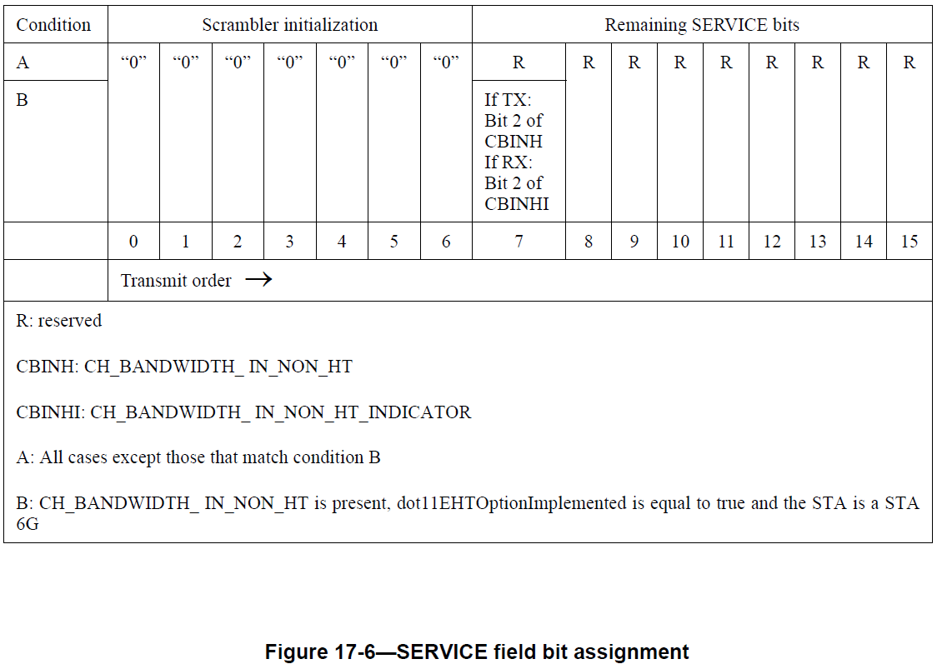

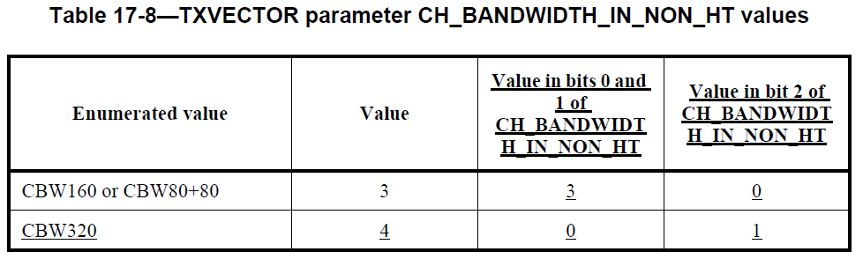

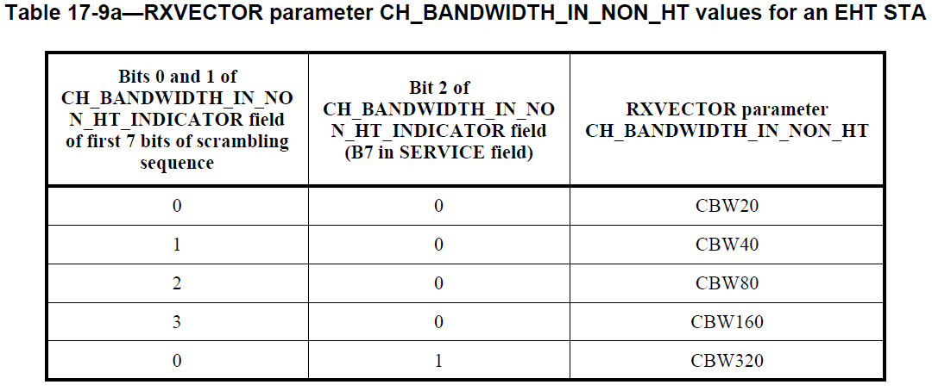

CID | Commenter | Clause | P.L | Comment | Proposed Change | Resolution
18292 | kaiying Lu | 17.2.2.7 | 462.60 | Remove "for CBW320" | As in comment. | Revised-  Following the agreement that all EHT STA at 6GHz are mendatary to understanding 320MHz BW signaling (in order to receive an EHT NDP Announcement frame with 320MHz BW). So as a receiver, an EHT STA at 6GHz will check SERVICE field to get the BW signaling.  To transmit a 320MHz non-HT duplicated frame, B7 of SERVICE field will be set to 1. To transmit a non-HT duplicated frame with BW less than 320MHz, B7 of SERVICE field will be set to 0 which is same as default value. Which means the same result can got whether a TX STA set B7 base on BW, or leave it to default value.  In order to unify the operation and simply the description, “for CBW320” is removed.  TGbe editor to make the changes under tag 18292 in 11-23-0374r4
TGbe editor: Please make the following changes in subclause 17.2.2.7 (TXVECTOR CH_BANDWIDTH_IN_NON_HT):
17.2.2.7 TXVECTOR CH_BANDWIDTH_IN_NON_HT
If present, the allowed values for CH_BANDWIDTH_IN_NON_HT are CBW20, CBW40, CBW80, CBW160, CBW80+80, and CBW320. If present, this parameter is used to modify the first 7 bits of the scrambling sequence, and B7 of the SERVICE field (#18292) in the 6 GHz band, to indicate the bandwidth of the non-HT duplicate PPDU.

