IEEE P802.11
Wireless LANs

CR for non-HT 320MHz BW Indication
Date: 2023-03-09
Author(s):
Name | Affiliation | Address | Phone | email
Yunbo Li | Huawei |  |  | liyunbo@huawei.com
Ming Gan
Yuchen Guo
Guogang Huang
Yousi Lin
Zhenguo Du
Stephen McCann
Edward Au

Abstract
This submission proposes comment resolution(s) for the following 15 CID(s) received in LB271 on TGbe D3.0

CIDs:
15717, 18292, 17411, 17412, 17413, 17414, 17415, 17417, 18002, 18286, 18287, 18288, 18289, 18290, 18291,

Revisions:
- Rev 0: Initial version of the document.
- Rev 1-2: modify base on offline feedback
- Rev 3: add two “,” in the resolution of CID 18292

CID | Commenter | Clause | P.L | Comment | Proposed Change | Resolution
17415 | Brian Hart | 9.3.1.2 | 155.54 | The third para is not well written | Option A (cleaner and clearer than the current language, while preserving the ?unwarranted attention to CBW320): "The TA field is the address of the STA transmitting the RTS frame or the bandwidth signaling TA of the STA transmitting the RTS frame.  In an RTS frame transmitted in a non-HT or non-HT duplicate format by a VHT STA, an HE STA, an EHT STA that is not a STA 6G, or an EHT STA that is a STA 6G without 320 MHz bandwidth support to another VHT STA, HE STA, or an EHT STA, then the TA field of the RTS frame is a bandwidth signaling TA, and this indicates that the PPDU carries the TXVECTOR parameters CH_BANDWIDTH_IN_NON_HT and DYN_BANDWIDTH_IN_NON_HT (see 10.3.2.7 (VHT and SIG RTS procedure)), wherein CBW320 is not an allowed value for CH_BANDWIDTH_IN_NON_HT.  In an RTS frame transmitted in a non-HT or non-HT duplicate format by an EHT STA that is a STA 6G with 320 MHz bandwidth support to another EHT STA that is a STA 6G, then the TA field of the RTS frame is a bandwidth signaling TA, and this indicates that the PPDU carries the TXVECTOR parameters CH_BANDWIDTH_IN_NON_HT and DYN_BANDWIDTH_IN_NON_HT (see 10.3.2.7 (VHT and SIG RTS procedure))."  Option B (most streamlined): "The TA field is the address of the STA transmitting the RTS frame or the bandwidth signaling TA of the STA transmitting the RTS frame.  In an RTS frame transmitted in a non-HT or non-HT duplicate format by a VHT STA, an HE STA, or an EHT STA to another VHT STA, HE STA, or an EHT STA, then the TA field of the RTS frame is a bandwidth signaling TA, and this indicates that the PPDU carries the TXVECTOR parameters CH_BANDWIDTH_IN_NON_HT and DYN_BANDWIDTH_IN_NON_HT (see 10.3.2.7 (VHT and SIG RTS procedure))." ... then add a xref to normative language where CBW320 can't be sent if the transmitter or recipient doesn't understand it.  Ditto for PS-Poll, CF-End (mostly), BAR etc | Revised-  Agree with the commenter.  The modifications based on Option B are provided.  TGbe editor to make the changes under tag 17415 in 11-23-0374r3
17417 | Brian Hart | 9.3.1.19.1 | 160.21 | MAC language violates layering. MAC needs to know about the TXVECTOR parameters CH_BANDWIDTH_IN_NON_HT but nothing below that. Worse, all duplicated detail (sentences L20 and L24) arise because 320M needs the Service field which the MAC just doesn't care about. Instead, merge the sentences and in clause 9 merely provide a xref to *normative* language where a transmitter can't send CBW320 to a recipient that doesn't understand it. | Try to replace L17-28 by "The TA field is set to the address of the STA transmitting the VHT/HE/Ranging NDP Announcement frame or the bandwidth signaling TA of the STA transmitting the VHT/HE/Ranging NDP Announcement frame. In an NDP Announcement frame transmitted by a VHT STA, an HE STA or an EHT STA in a non-HT or non-HT duplicate format and where the PPDU carries the TXVECTOR parameter CH_BANDWIDTH_IN_NON_HT, the TA field is set to a bandwidth signaling TA." Then append NOTE, with xref to a MAC clause, explaining that "don't send CBW320 if the TX/recipient doesn't understand it" | Revised-  The proposed resolution is shown in doc 11-13/0374r3.  TGbe editor to make the changes under tag 17415 in 11-23-0374r3
17411 | Brian Hart | 9.3.1.2 | 155.57 | MAC language violates layering. MAC needs to know about the TXVECTOR parameters CH_BANDWIDTH_IN_NON_HT and DYN_BANDWIDTH_IN_NON_HT but nothing below that. | Ap P155L58, change "the scrambling sequence and SERVICE field carry" to "the PPDU carries". Ditto, at P155L61.5, change "The scrambling sequence" to "the PPDU". | Revised-  The proposed resolution is shown in doc 11-13/0374r3.  TGbe editor to make the changes under tag 17415 in 11-23-0374r3
17412 | Brian Hart | 9.3.1.2 | 155.57 | Clearest if new info for a new PHY is added after the associated material for an old PHY | Move the 320MHz EHT-related sentence to P155L4 | Revised-  The proposed resolution is shown in doc 11-13/0374r3.  TGbe editor to make the changes under tag 17415 in 11-23-0374r3
17413 | Brian Hart | 9.3.1.2 | 155.65 | Typo: "in" should be "is" | As in comment | Revised-  The proposed resolution is shown in doc 11-13/0374r3.  TGbe editor to make the changes under tag 17415 in 11-23-0374r3
17414 | Brian Hart | 9.3.1.2 | 155.65 | "either on of the following cases", but there is only one case | Figure out what was intended and fix. E.g., omit the "either one of the following cases" | Revised-  The proposed resolution is shown in doc 11-13/0374r3.  TGbe editor to make the changes under tag 17415 in 11-23-0374r3
18002 | Yanjun Sun | 9.3.1.2 | 156.02 | The text is confusing. Suggest to move "an EHT STA that is a STA 6G  without 320 MHz bandwidth support to another VHT STA, HE STA, or an EHT STA" to a new bullet and add "from" in the beginning. | As in comment | Revised-  The proposed resolution is shown in doc 11-13/0374r3.  TGbe editor to make the changes under tag 17415 in 11-23-0374r3
18286 | kaiying Lu | 9.3.1.2 | 155.55 | In an RTS frame transmitted by any EHT STA that is a STA 6G in a non-HT or non-HT duplicate format to another EHT STA that is a STA 6G, scrambling sequence and SERVICE field carry the TXVECTOR parameters CH_BANDWIDTH_IN_NON_HT and DYN_BANDWIDTH_IN_NON_HT and the TA field is a bandwidth signaling TA. Remove "with 320MHz bandwidth support". | As in comment. | Revised-  The proposed resolution is shown in doc 11-13/0374r3.  TGbe editor to make the changes under tag 17415 in 11-23-0374r3
18287 | kaiying Lu | 9.3.1.2 | 156.02 | Remove "an EHT STA that is a STA 6G without 320 MHz bandwidth support" | As in comment. | Revised-  The proposed resolution is shown in doc 11-13/0374r3.  TGbe editor to make the changes under tag 17415 in 11-23-0374r3
18288 | kaiying Lu | 9.3.1.5.1 | 156.08 | Remove "with 320MHz bandwidth support" and "an EHT STA that is a STA 6G without 320 MHz bandwidth support" | As in comment. | Revised-  The proposed resolution is shown in doc 11-13/0374r3.  TGbe editor to make the changes under tag 17415 in 11-23-0374r3
18289 | kaiying Lu | 9.3.1.6 | 156.26 | Remove "with 320MHz bandwidth support" and "an EHT STA that is a STA 6G without 320 MHz bandwidth support" | As in comment. | Revised-  The proposed resolution is shown in doc 11-13/0374r3.  TGbe editor to make the changes under tag 17415 in 11-23-0374r3
18290 | kaiying Lu | 9.3.1.7 | 156.50 | Remove "with 320MHz bandwidth support" and "an EHT STA that is a STA 6G without 320 MHz bandwidth support" | As in comment. | Revised-  The proposed resolution is shown in doc 11-13/0374r3.  TGbe editor to make the changes under tag 17415 in 11-23-0374r3
18291 | kaiying Lu | 9.3.1.19 | 160.17 | Remove "with 320MHz bandwidth support" and "an EHT STA that is a STA 6G without 320 MHz bandwidth support" | As in comment. | Revised-  The proposed resolution is shown in doc 11-13/0374r3.  TGbe editor to make the changes under tag 17415 in 11-23-0374r3

Discussion：

Proposed spec text

TGbe editor: Please make the following changes in subclause 9.3.1.2 (RTS frame format):
9.3.1.2 RTS frame format
The TA field is the address of the STA transmitting the RTS frame or the bandwidth signaling TA of the STA transmitting the RTS frame. In an RTS frame transmitted in a non-HT or non-HT duplicate format by a VHT STA, an HE STA, or an EHT STAto another VHT STA, HE STA, or EHT STA, then the TA field is a bandwidth signaling TA, and this indicates that the PPDU carries the TXVECTOR parameters CH_BANDWIDTH_IN_NON_HT and DYN_BANDWIDTH_IN_NON_HT (see 10.3.2.7 (VHT and SIG RTS procedure)). The TXVECTOR parameter CH_BANDWIDTH_IN_NON_HT is not set to CBW320 (see 17.2.2.7 (TXVECTOR CH_BANDWIDTH_IN_NON_HT)) when an RTS frame is transmitted in a non-HT or non-HT duplicate format
from a VHT STA, an HE STA, an EHT STA that is not a STA 6G, or an EHT STA that is a STA 6G without 320 MHz bandwidth support to another VHT STA, HE STA, or an EHT STA. (#17415)

TGbe editor: Please make the following changes in subclause 9.3.1.5 (PS-Poll frame format):
9.3.1.5 PS-Poll frame format
9.3.1.5.1 General

The BSSID (RA) field is set to the address of the STA contained in the AP. The TA field value is the address of the STA transmitting the frame or a bandwidth signaling TA. In a PS-Poll frame transmitted in a non-HT or non-HT duplicate format by a VHT STA, an HE STA, or an EHT STA, then the TA field value is a bandwidth signaling TA and this indicates that the PPDU carries the TXVECTOR parameter CH_BANDWIDTH_IN_NON_HT. The TXVECTOR parameter CH_BANDWIDTH_IN_NON_HT is not set to CBW320 (see 17.2.2.7 (TXVECTOR CH_BANDWIDTH_IN_NON_HT)) when a PS-Poll frame is transmitted in a non-HT or non-HT duplicate format from a VHT STA, an HE STA, an EHT STA that is not a STA 6G, or an EHT STA that is a STA 6G without 320 MHz bandwidth support. (#17415)

TGbe editor: Please make the following changes in subclause 9.3.1.6 (CF-END frame format):
9.3.1.6 CF-End frame format
If transmitted by a VHT STA, an HE STA, or an EHT STA to a VHT AP, an HE AP, or an EHT AP, the BSSID (TA) field is the address of the STA contained in the AP except that the Individual/ Group bit of the BSSID (TA) field is set to 1 in a CF-End frame in a non-HT or non-HT duplicate format to indicate that the PPDU carries the TXVECTOR parameter CH_BANDWIDTH_IN_NON_HT. The TXVECTOR parameter CH_BANDWIDTH_IN_NON_HT is not set to CBW320 (see 17.2.2.7 (TXVECTOR CH_BANDWIDTH_IN_NON_HT)) when a CF-End frame is transmitted in a non-HT or non-HT duplicate format from a VHT STA, an HE STA, an EHT STA that is not a STA 6G, or an EHT STA that is a STA 6G without 320 MHz bandwidth support to another VHT STA, HE STA, or an EHT STA. If transmitted by a DMG STA, the TA field is the MAC address of the STA transmitting the frame. (#17415)

TGbe editor: Please make the following changes in subclause 9.3.1.7 (BlockAckReq frame format):
9.3.1.7 BlockAckReq frame format
9.3.1.7.1 Overview
The TA field value is the address of the STA transmitting the BlockAckReq frame or a bandwidth signaling TA. In a BlockAckReq frame transmitted in a non-HT or non-HT duplicate format by a VHT STA, an HE STA, or an EHT STA , then the TA field value is a bandwidth signaling TA, and this indicates that the PPDU carries the TXVECTOR parameter CH_BANDWIDTH_IN_NON_HT. The TXVECTOR parameter CH_BANDWIDTH_IN_NON_HT is not set to CBW320 (see 17.2.2.7 (TXVECTOR CH_BANDWIDTH_IN_NON_HT)) when a BlockAckReq frame is transmitted in a non-HT or non-HT duplicate format from a VHT STA, an HE STA, an EHT STA that is not a STA 6G, or an EHT STA that is a STA 6G without 320 MHz bandwidth support. (#17415)

TGbe editor: Please make the following changes in subclause 9.3.1.19 (NDP Announcement frame format):
9.3.1.19 NDP Announcement frame format
9.3.1.19.1 General description
The TA field is set to the address of the STA transmitting the NDP Announcement frame or the bandwidth signaling TA of the STA transmitting the NDP Announcement frame. In an NDP Announcement frame transmitted in a non-HT or non-HT duplicate format by a VHT STA, an HE STA, or an EHT STA , then the TA field is set to a bandwidth signaling TA and this indicates that the PPDU carries the TXVECTOR parameter CH_BANDWIDTH_IN_NON_HT. The TXVECTOR parameter CH_BANDWIDTH_IN_NON_HT is not set to CBW320 (see 17.2.2.7 (TXVECTOR CH_BANDWIDTH_IN_NON_HT)) when a NDP Announcement frame is transmitted in a non-HT or non-HT duplicate format from a VHT STA, an HE STA, an EHT STA that is not a STA 6G, or an EHT STA that is a STA 6G without 320 MHz bandwidth support. (#17415)

CID | Commenter | Clause | P.L | Comment | Proposed Change | Resolution
15717 | Yapu Li | 17.3.5.2 | 464.07 | The description of "If TX...If RX" is not clear. Does TX/RX mean transmitter/receiver or TXVECTOR/RXVECTOR. | Clarify the meaning of TX and RX | Revised-  Agree with the commenter in principle.  TGbe editor to change “If TX” to “In TXVECTOR”, and change “If RX” to “In RXVECTOR” in Figure 17-6.

Discussion:
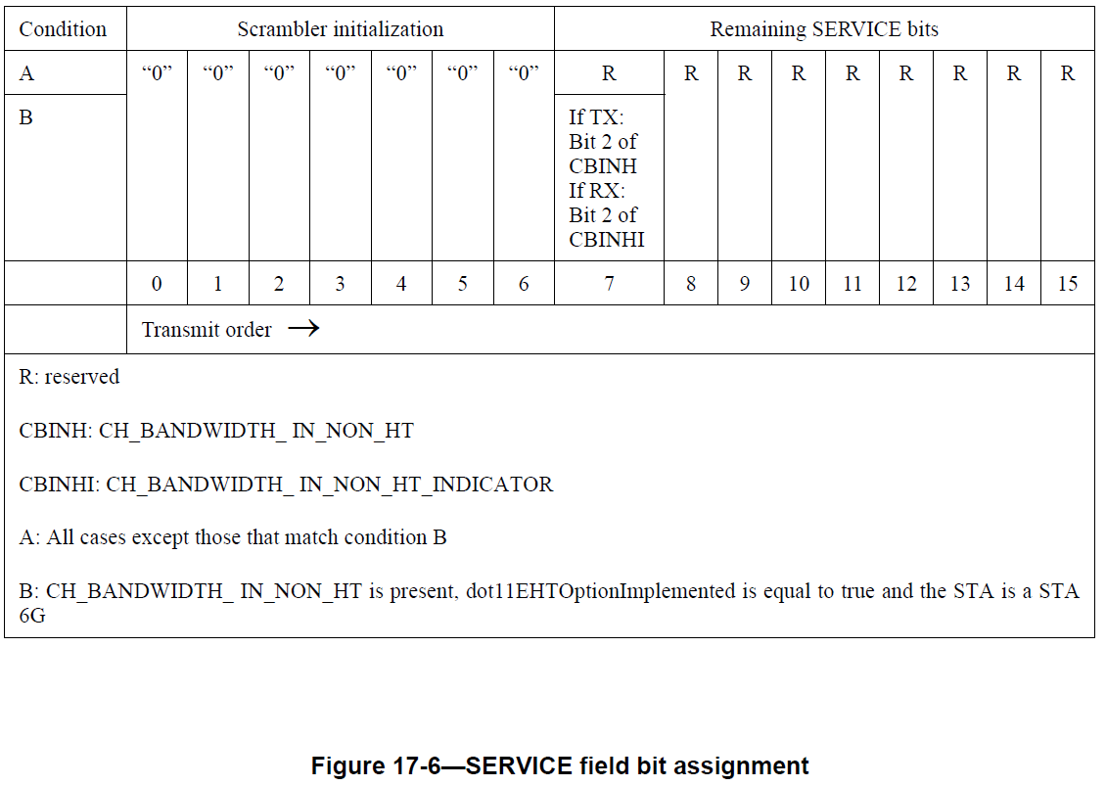

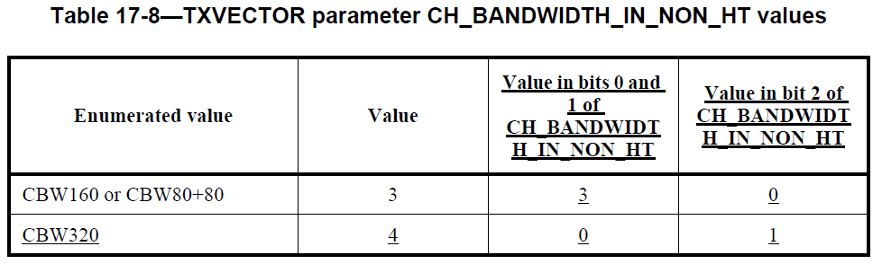

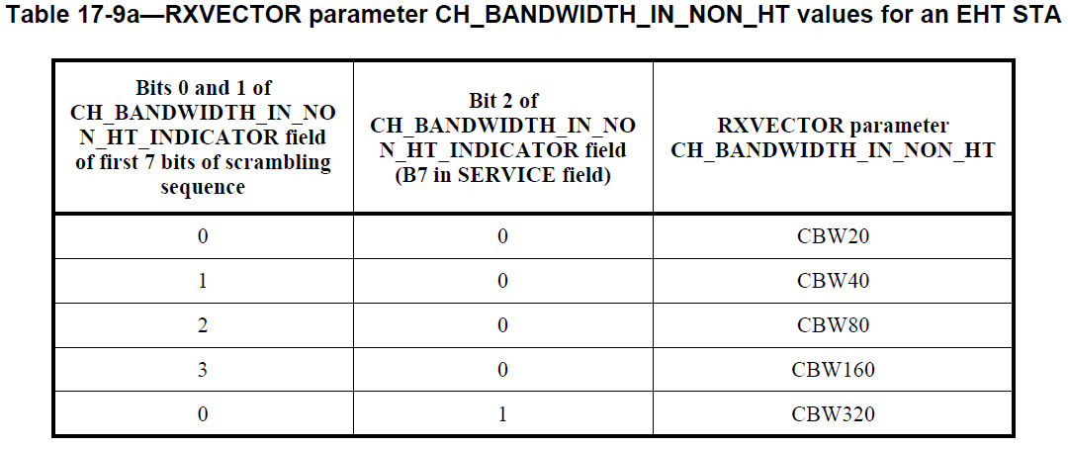

CID | Commenter | Clause | P.L | Comment | Proposed Change | Resolution
18292 | kaiying Lu | 17.2.2.7 | 462.60 | Remove "for CBW320" | As in comment. | Revised-  Following the agreement that all EHT STA at 6GHz are mendatary to understanding 320MHz BW signaling (in order to receive an EHT NDP Announcement frame with 320MHz BW). So as a receiver, an EHT STA at 6GHz will check SERVICE field to get the BW signaling.  To transmit a 320MHz non-HT duplicated frame, B7 of SERVICE field will be set to 1. To transmit a non-HT duplicated frame with BW less than 320MHz, B7 of SERVICE field will be set to 0 which is same as default value. Which means the same result can got whether a TX STA set B7 base on BW, or leave it to default value.  In order to unify the operation and simply the description, “for CBW320” is removed.  TGbe editor to make the changes under tag 18292 in 11-23-0374r3
TGbe editor: Please make the following changes in subclause 17.2.2.7 (TXVECTOR CH_BANDWIDTH_IN_NON_HT):
17.2.2.7 TXVECTOR CH_BANDWIDTH_IN_NON_HT
If present, the allowed values for CH_BANDWIDTH_IN_NON_HT are CBW20, CBW40, CBW80, CBW160, CBW80+80, and CBW320. If present, this parameter is used to modify the first 7 bits of the scrambling sequence, and B7 of the SERVICE field (#18292) in the 6 GHz band, to indicate the bandwidth of the non-HT duplicate PPDU.

