IEEE P802.11
Wireless LANs
LB270: Resolution for CID 3820
Date: 2023-03-09
Author(s):
Name | Affiliation | Address | Phone | email
Yusuke Asai | NTT |  |  | yusuke.asai.ux@hco.ntt.co.jp
Abstract
This submission proposes resolutions for the CID 3820 received for TGme LB270.

Revisions:
- Rev 0: Initial version of the document.
- Rev 1: Revise the resolution text.

Comments

CID | PP.LL | Clause | Comment | Proposed Change | Resolution
3820 | 5503.12 | E.1 | The recent update of Japanese 6 GHz (5925 - 6425 MHz) regulatory rules should be applied to table E-3 and E-4. | The commentor is considering the revised document. | Rejected.  The 6 GHz channelization has been defined only in the table for Global operating classes (Table E4) and the operating classes in table E4 already includes the newly Japanese channelization. Therefore, there is no need to change the current draft.

Discussion

The technical conditions regarding 6 GHz WLAN usage in Japanese 6 GHz band have been approved at the council in Japanese government (MIC: Ministry of Internal Affairs and Communications) on 19th April, 2022 [1]. After that, the regulation for 6 GHz band has been updated to allow 6 GHz WLANs on 2nd September 2022. The newly defined channels in Japanese 6 GHz bands (5 925 – 6 425 MHz) are described in Fig. 1 (page 128 in [2]). The commentor claims that the new channels should be implemented to the REVme draft.

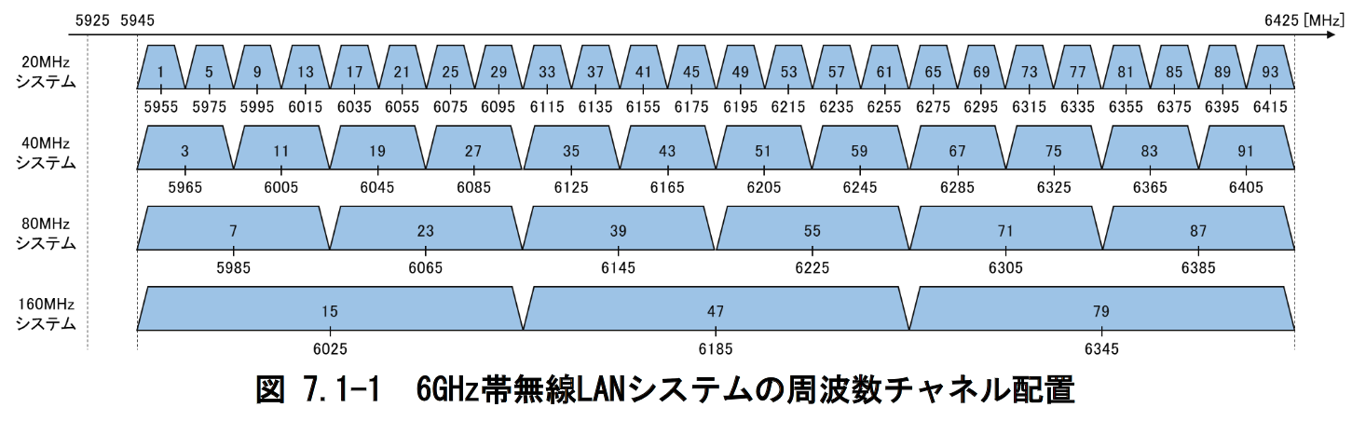

Fig. 1: The newly defined channels in Japanese 6 GHz bands

Regarding 6 GHz bands, E.2.7 (6 GHz band) in REVme D2.0 defines operating classes in 6 GHz is only defined in Table E-4.

“When operating in the 6 GHz band, Table E-4 (Global operating classes) is used for the operating
classes, so the third octet of the dot11CountryString is 4. “

This means there is no need to change Table E-3 (Operating classes in Japan).

In addition, the exising operating classes of 131, 132, 133 and 134 already include all of the channel numbers in Japanese 6 GHz band (see Tables 1-4).

For these reasons, there is no need change current operating classed, and thus CID 3820 should be rejected.
Table 1: Channel center frequency indices for the Global operating class of 131
(20 MHz channels in 6 GHz bands)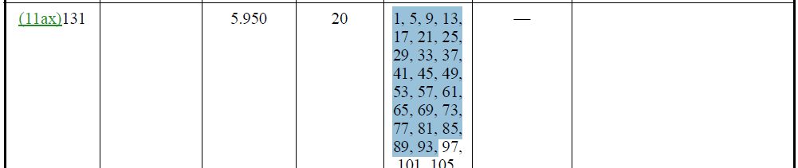

Table 2: Channel center frequency indices for the Global operating class of 132
(40 MHz channels in 6 GHz bands)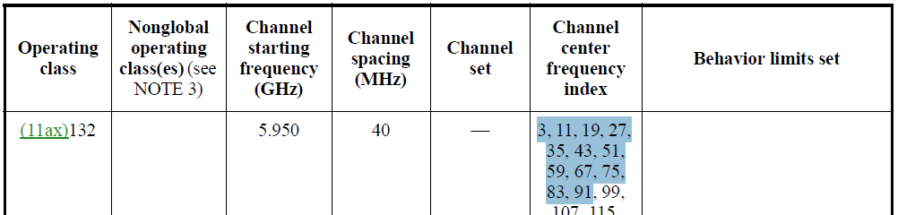

Table 3: Channel center frequency indices for the Global operating class of 133
(80 MHz channels in 6 GHz bands)

Table 4: Channel center frequency indices for the Global operating class of 134
(160 MHz channels in 6 GHz bands)

References

[1] "Technical Requirements Relating to the Introduction of 6 GHz Band Wireless LAN - Partial report from the Information and Communications Council," Ministry of Internal Affairs and Communications, Japan, April 19, 2022
https://www.soumu.go.jp/main_sosiki/joho_tsusin/eng/pressrelease/2022/4/19_01.html

[2] The report regarding the press release [1] (Japanese only)
https://www.soumu.go.jp/main_content/000810602.pdf

