IEEE P802.11
Wireless LANs
LB270: Resolution for CID 3820
Date: 2023-03-09
Author(s):
Name | Affiliation | Address | Phone | email
Yusuke Asai | NTT |  |  | yusuke.asai.ux@hco.ntt.co.jp
Abstract
This submission proposes resolutions for the CID 3820 received for TGme LB270.

Revisions:
- Rev 0: Initial version of the document.

Comments

CID | PP.LL | Clause | Comment | Proposed Change | Resolution
3820 | 5503.12 | E.1 | The recent update of Japanese 6 GHz (5925 - 6425 MHz) regulatory rules should be applied to table E-3 and E-4. | The commentor is considering the revised document. | Rejected.  See the resolution presenteded in 23/xxxx (this document).

Discussion

The technical conditions regarding 6 GHz WLAN usage in Japanese 6 GHz band have been approved at the council in Japanese government (MIC: Ministry of Internal Affairs and Communications) on 19th April, 2022 [1]. After that, the regulation for 6 GHz band has been updated to allow 6 GHz WLANs on 2nd September 2022. The newly defined channels in Japanese 6 GHz bands (5 925 – 6 425 MHz) are described in Fig. 1 (page 128 in [2]). The commentor claims that the new channels should be implemented to the REVme draft.

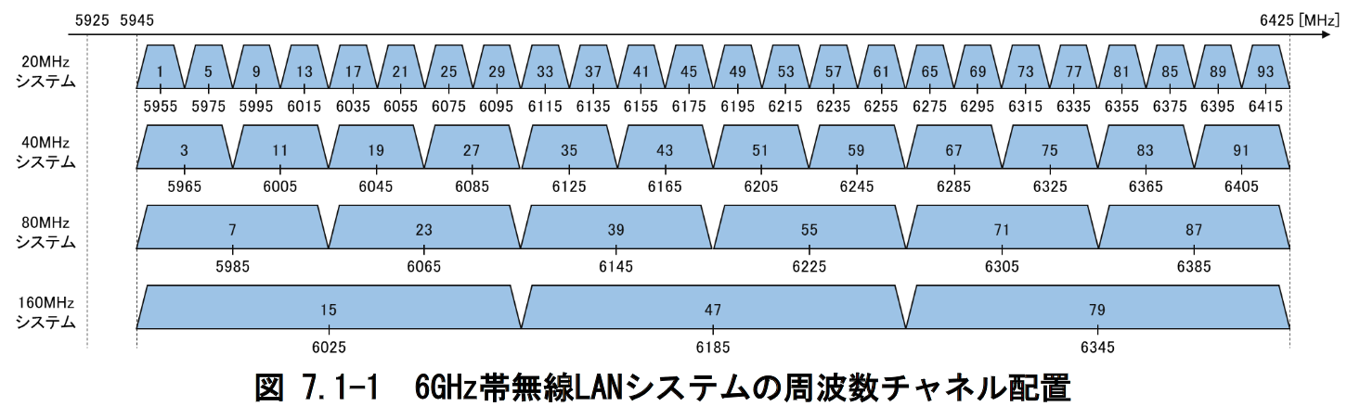

Fig. 1: The newly defined channels in Japanese 6 GHz bands

Regarding 6 GHz bands, E.2.7 (6 GHz band) in REVme D2.0 defines operating classes in 6 GHz is only defined in Table E-4.

“When operating in the 6 GHz band, Table E-4 (Global operating classes) is used for the operating
classes, so the third octet of the dot11CountryString is 4. “

This means there is no need to change Table E-3 (Operating classes in Japan).

In addition, the exising operating classes of 131, 132, 133 and 134 already include all of the channel numbers in Japanese 6 GHz band (see Tables 1-4).

For these reasons, there is no need change current operating classed, and thus CID 3820 should be rejected.

Table 1: Channel center frequency indices for the Global operating class of 131
(20 MHz channels in 6 GHz bands)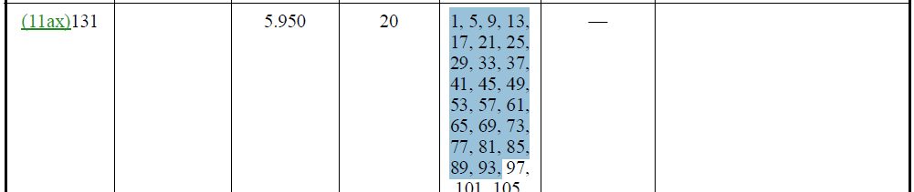

Table 2: Channel center frequency indices for the Global operating class of 132
(40 MHz channels in 6 GHz bands)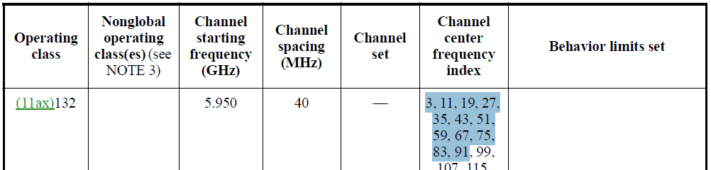

Table 3: Channel center frequency indices for the Global operating class of 133
(80 MHz channels in 6 GHz bands)

Table 4: Channel center frequency indices for the Global operating class of 134
(160 MHz channels in 6 GHz bands)

References

[1] "Technical Requirements Relating to the Introduction of 6 GHz Band Wireless LAN - Partial report from the Information and Communications Council," Ministry of Internal Affairs and Communications, Japan, April 19, 2022
https://www.soumu.go.jp/main_sosiki/joho_tsusin/eng/pressrelease/2022/4/19_01.html

[2] The report regarding the press release [1] (Japanese only)
https://www.soumu.go.jp/main_content/000810602.pdf

