IEEE P802.11
Wireless LANs
Comment Resolutions for 11be D3.0 Probe Request MLE CIDs
Date: 2023-03-09
Author(s):
Name | Affiliation | Address | Phone | email
Rojan Chitrakar | Huawei |  |  | Rojan.chitrakar@huawei.com
Lei Huang
Abstract
This submission proposes resolutions of comments received from TGbe LB271 (TGbe Draft 3.0).
- CIDs: 17908, 17966, 17967 (3 CIDs)

Revisions:

- Rev 0: Initial version of the document.
- Rev 1: 17908 green tagged by Alfred.
- Rev 2: Changed resolution for CID 17967 to Revised based on offline feedback.

- Introduction

Interpretation of a Motion to Adopt

A motion to approve this submission means that the editing instructions and any changed or added material are actioned in the TGbe Draft. The introduction and the explanation of the proposed changes are not part of the adopted material.

Editing instructions formatted like this are intended to be copied into the TGbe Draft (i.e. they are instructions to the 802.11be editor on how to merge the text with the baseline documents).

TGbe Editor: Editing instructions preceded by “TGbe Editor” are instructions to the TGbe editor to modify existing material in the TGbe draft. As a result of adopting the changes, the TGbe editor will execute the instructions rather than copy them to the TGbe Draft.

CID | Commenter | Clause | Page | Line | Comment | Proposed Change | Resolution
17908 | Kazuto Yano | 9.4.2.312.3 | 264 | 13 | A period is missing at the end of this sentence. | As in comment. | REVISED.  Agree with the comment to add a period.  TGbe editor to make the changes shown in IEEE 802.11-23/0344r2 under all headings that include CID 17908.
17966 | Xiaofei Wang | 9.4.2.312.3 | 263 | 44 | Is AP MLD ID really needed in the probe request Multi-link element since "The Probe Request Multi-Link element is used to request an AP to provide information of other APs affiliated with the same AP MLD as the AP". Otherwise, the quoted sentence needs revision. | as in comment | REVISED.  The responding AP need not necessarily be affiliated with the targeted AP MLD, this is clearly mentioned in 35.3.4.2 (Use of multi-link probe request and response). See P492L50. Agree with the comment to clarify this by revising the quoted text to align with 35.3.4.2.  TGbe editor to make the changes shown in IEEE 802.11-23/0344r2 under all headings that include CID 17966.
17967 | Xiaofei Wang | 9.4.2.312.3 | 264 | 23 | The note contains important information and should be regular spec text. | as in comment | REVISED.  The corresponding behavioural text is already present in 35.3.4.2 (Use of multi-link probe request and response). See P492L59. Reference to 35.3.4.2 is added in the text.  TGbe editor to make the changes shown in IEEE 802.11-23/0344r2 under all headings that include CID 17967.
SP: Do you agree to incorporate the changes proposed in IEEE 802.11-23/0344r2 to the latest 11be draft for the following CIDs? 17908, 17966, 17967
Reference texts:
CID 17908 (P264):
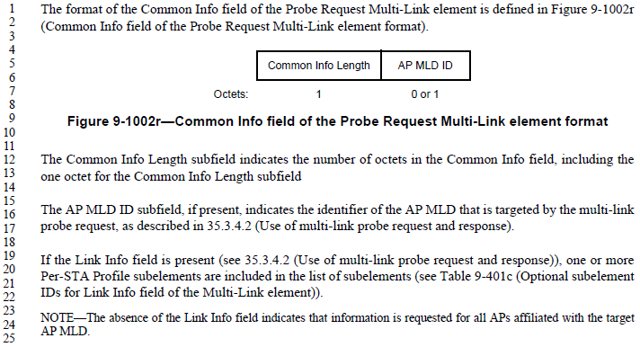

CID 17966 (P492):
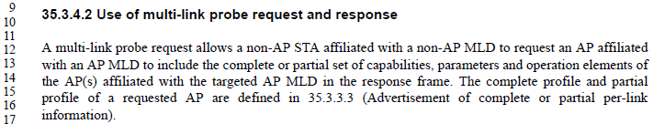
…
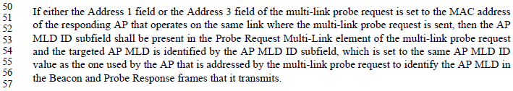

CID 17967 (P492L59):
9.4.2.312.3 Probe Request Multi-Link element (#17966, #17908, #17967)

TGbe editor: Modify the subclause as the following (Track Changes ON):

The Probe Request Multi-Link element is used to request an AP to provide information of (#17966) the APs affiliated with an AP MLD. The inclusion of a Probe Request Multi-Link element in a Probe Request frame identifies it as a multi-link probe request (see 35.3.4 (Discovery of an AP MLD)).

…

The Common Info Length subfield indicates the number of octets in the Common Info field, including the one octet for the Common Info Length subfield (#17908).

…

NOTE—The absence of the Link Info field indicates that information is requested for all APs affiliated with the target AP MLD (#17967) (see 35.3.4.2 (Use of multi-link probe request and response)).

