IEEE P802.11
Wireless LANs
CR for 11be D3.0
Date: 2020-05-13
Author(s):
Name | Affiliation | Address | Phone | email
Xiaogang Chen | ZEKU |  |  | Xiaogang.g.chen@gmail.com

Abstract
This submission proposes text changes of TGbe Draft 3.0 for CIDs:

15103
15104
15106
15107
16154
17250
17251
15914
15649
15916

Revisions:

- Rev 0: Initial version of the document.
- Rev 2: update the resolution for sounding related CIDs and minimum RU related CIDs.
- Rev 3: update based on the discussions online for minimum RU allocation and sounding.

Interpretation of a Motion to Adopt

A motion to approve this submission means that the editing instructions and any changed or added material are actioned in the TGbe Draft 3.1. This introduction is not part of the adopted material.

Editing instructions formatted like this are intended to be copied into the TGbe Draft (i.e. they are instructions to the 802.11 editor on how to merge the text with the baseline documents).

TGbe Editor: Editing instructions preceded by “TGbe Editor” are instructions to the TGbe editor to modify existing material in the TGbe draft. As a result of adopting the changes, the TGbe editor will execute the instructions rather than copy them to the TGbe Draft.

CID | Clause | P.L. | Comment | Proposed Changes | Resolutions
15107 | 36.3.13.2 | 825.28 | "The DATA field, composed of SERVICE, PSDU, Tail (if BCC is used), and pre-FEC pad parts, shall be  scrambled with a..."PSDU includes most of the pre-FEC padding if not all of them. | change to "The DATA field, composed of SERVICE, PSDU, Tail (if BCC is used), and the pre-FEC padding bits added by PHY, shall be  scrambled with a.." | Accepted

Discussions on CID 15107
PSDU includes pre-EOF padding and EOF padding already. Only the bits (<8) in 36-67 are not included.

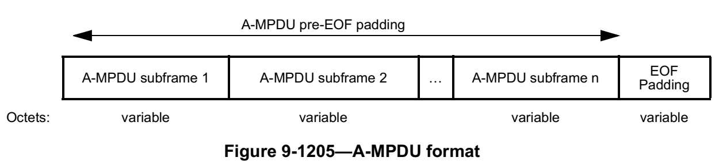
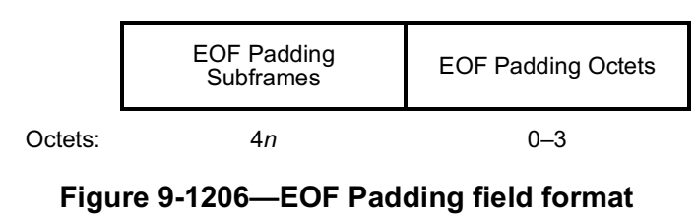

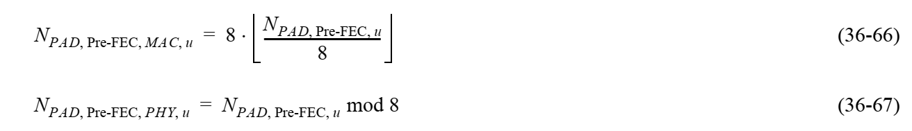

CID | Clause |  | P.L. | Comment | Proposed Changes | Resolutions
15106 | 26.5.1.3a | 468.45 |  | "At least N x 4 x 26 subcarriers are modulated by the allocated RUs within the entire PPDU, where N  is the number of 20 MHz subchannels that are not preamble punctured in the PPDU."if the requriement is simply the entired PPDU, then for a narrow BW operating STA in larger BW PPDU, it cannot gurentee sufficient number of Rus in the STA's operating BW and the STA will still suffer from FFT bitwidth issue. | change "within the entire PPDU" to "within the operating BW of each non-AP STA". Or maybe simply change to "within each 20Mhz of the PPDU BW" | Revised.  11be editor please make changes under CID 15106 in DCN 23/317r3

Discussions on CID 15106:
The rule was added in early 11ax. The intention at the very beginning is to make sure the energy is not too concentrated after FFT to avoid overflow. However, 11ax doesn’t mandate smaller BW device to participate in wider BW OFDMA transmission but 11be does. It’s possible that AP meets the minimum RU allocation rule for the PPDU but a narrow BW operating STA still have the issue of power condensing (left sub-figure).

Proposed changes: 11be editor please make the following changes on P.L. 472.48

An HE MU PPDU shall have a sufficient number of RUs allocated to users such that all of the following conditions are satisfied:
a) At least N × 4 × 26 subcarriers are modulated by the allocated RUs within the entire PPDU if the PPDU bandwidth is smaller than or equal to the operating bandwidth of the non-AP STA(s), where N is the number of 20 MHz subchannels that are not preamble punctured in the PPDU;
b) At least N × 4 × 26 subcarriers are modulated by the allocated RUs within the operating bandwidth of the non-AP STA(s) if the PPDU bandwidth is greater than the operating bandwidth of the non-AP STA(s), where N is the number of 20 MHz subchannels that are not preamble punctured within the operating bandwidth of the non-AP STA.
c) For each 20 MHz subchannel S….
d) At least one RU is allocated in the primary 20 MHz.

CID | Clause | P.L. | Comment | Proposed Changes | Resolutions
15103 | 35.7.3 | 615.14 | "In the EHT TB sounding sequence, the STAs identified in the NDP Announcement frame should be the same as the ones identified in the Trigger frame(s) in the same TXOP". Add a note for EMLSR mode | add "Note: when a non-AP STA which is associated with non-AP MLD is in EMLSR mode, the non-AP STA should be addressed in the first BFRP trigger frame. Otherwise, this non-AP STA shall not be addressed by other BFRP trigger frames in this TXOP " | Revised-  11be editor please refer to the proposed changes under CID 15103 in DCN 23/317r3
15104 | 35.3.17 | 569.19 | add a note after note 10 "if Beamformee 1is not addressed in the first BFRP trigger frame, it shall not be addressed by other BFRP trigger frames in this TXOP" or change the rule that Bfee in EMLSR mode doesn't goes back to listening operation till the end of the sounding TXOP | as in the comment | Revised-  11be editor please refer to the proposed changes under CID 15103 in DCN 23/317r3
15914 | 35.3.17 | 566.47 | "a NDP Announcement frame that has one of the STA Info fields addressed to the non-AP STA affiliated with the non-AP MLD and a sounding NDP" is not sufficient to cover the sounding sequence for eMLSR STAs. | Add extra rules that mandating AP to solicte sounding feedback from eMLSR STAs in the first BFRP trigger frame if TB based sounding sequence is used. | Revised-  11be editor please refer to the proposed changes under CID 15103 in DCN 23/317r3
17250 | 35.3.17 | 569.34 | It is not specified if the One or more sequences of BFRP trigger should include different STAs in each sequence as illustrated in Figure 35-47 | Edit Figure 35-34 to follow the same rules as in Figure 35-47 and edit the corresponding text accordingly. | Revised-  11be editor please refer to the proposed changes under CID 15103 in DCN 23/317r3
17251 | 35.3.17 | 569.56 | It is not specified if the One or more sequences of BFRP trigger should include different STAs in each sequence as illustrated in Figure 35-47 | Edit Figure 35-35 to follow the same rules as in Figure 35-47 and edit the corresponding text accordingly. | Revised-  11be editor please refer to the proposed changes under CID 15103 in DCN 23/317r3
15649 |  | 571.21 | There will be an issue in the Trigger Based sounding sequence when the non-AP STA affiliated with a non-AP MLD in EMLSR mode operating on one of EMLSR links is not the only beamformee and is not triggered for the feedback by the first BFRP TF. It may switch back to listening state during the first BFRP round. | Fix the issue | Revised-  11be editor please refer to the proposed changes under CID 15103 in DCN 23/317r3
15916 |  | 571.55 | "a NDP Announcement frame that has one of the STA Info fields addressed to the non-AP STA affiliated with the non-AP MLD and a sounding NDP" is not sufficient to cover the sounding sequence for eMLSR STAs. | Add extra rules that mandating AP to solicte sounding feedback from eMLSR STAs in the first BFRP trigger frame if TB based sounding sequence is used. | Revised-  11be editor please refer to the proposed changes under CID 15103 in DCN 23/317r3

Discussions on additional changes if necessary:
Disallowed sounding sequences:
- With the presence of EMLSR STA: MU-RTS (STA1, STA2) + CTS + NDPA (STA1, STA2) + NDP + BFRP (STA1) + CBF (STA1) + MU-RTS (STA2) + CTS + BFRP (STA2) + …
- Without the presence of EMLSR STA: NDPA + NDP + BFRP + CBF + (some other frame) + BFRP + CBF.

Proposed changes:
11be editor please add the following paragraph in P.L. 618.43 (35.7.3 Rules for EHT sounding protocol sequences).

A beamformer shall address a beamformee that is affiliated with a non-AP MLD operating in EMLSR or EMLMR mode only in the first BFRP Trigger frame of a sounding sequence.

In addition, modify the paragraph below in P.L. 618.36
An EHT beamformer that initiates an EHT TB sounding sequence shall transmit an EHT NDP Announcement frame with two or more STA Info fields and the RA field set to the broadcast address. The EHT NDP Announcement frame shall be followed after a SIFS by an EHT sounding NDP, which shall be followed after a SIFS by a BFRP Trigger frame. If more than one BFRP Trigger frames are present in a sounding sequence, the EHT TB PPDU that contains the EHT Compressed Beamforming/CQI frame(s) shall be followed, after a SIFS, by another BFRP Tigger frame until the last EHT Compressed Beamforming/CQI frame in a sounding sequence is transmitted. Each EHT beamformee that is addressed by a BFRP Trigger frame shall respond after a SIFS with an EHT TB PPDU containing one or more EHT Compressed Beamforming/CQI frames.

CID | Clause | P.L. | Comment | Proposed Changes | Resolutions
16154 | 9.4.2.313 | 275.01 | If a STA support 320MHz it shall support full BW MUMIMO feedback which may introduce memory management issue | add a capability to optional support the 320MHz MU feedback for a STA support 320MHz | Rejected.  No consensus can be reached.

