IEEE P802.11
Wireless LANs
CR for 11be D3.0
Date: 2020-05-13
Author(s):
Name | Affiliation | Address | Phone | email
Xiaogang Chen | ZEKU |  |  | Xiaogang.chen@zeku.com

Abstract
This submission proposes text changes of TGbe Draft 3.0 for CIDs:

15103
15104
15106
15107
16154
17250
17251
This document also propose to remove MD detection which is not related to any CID.

Revisions:

- Rev 0: Initial version of the document.

Interpretation of a Motion to Adopt

A motion to approve this submission means that the editing instructions and any changed or added material are actioned in the TGbe Draft 3.0. This introduction is not part of the adopted material.

Editing instructions formatted like this are intended to be copied into the TGbe Draft (i.e. they are instructions to the 802.11 editor on how to merge the text with the baseline documents).

TGbe Editor: Editing instructions preceded by “TGbe Editor” are instructions to the TGbe editor to modify existing material in the TGbe draft. As a result of adopting the changes, the TGbe editor will execute the instructions rather than copy them to the TGbe Draft.

CID | Clause | P.L. | Comment | Proposed Changes | Resolutions
15107 | 36.3.13.2 | 825.28 | "The DATA field, composed of SERVICE, PSDU, Tail (if BCC is used), and pre-FEC pad parts, shall be  scrambled with a..."PSDU includes most of the pre-FEC padding if not all of them. | change to "The DATA field, composed of SERVICE, PSDU, Tail (if BCC is used), and the pre-FEC padding bits added by PHY, shall be  scrambled with a.." | Accepted

Discussions on CID 15107
PSDU includes pre-EOF padding and EOF padding already. Only the bits (<8) in 36-67 are not included.

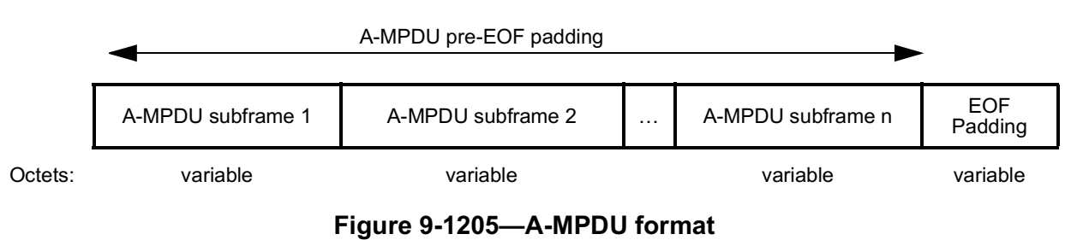
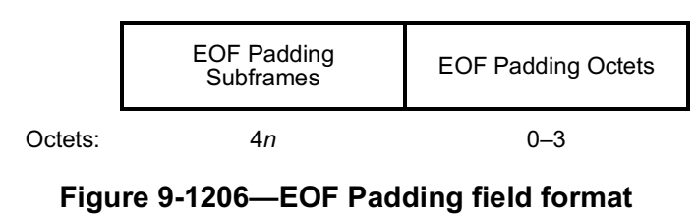

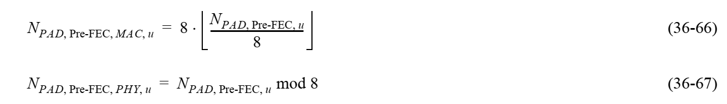

CID | Clause |  | P.L. | Comment | Proposed Changes | Resolutions
15106 | 26.5.1.3a | 468.45 |  | "At least N x 4 x 26 subcarriers are modulated by the allocated RUs within the entire PPDU, where N  is the number of 20 MHz subchannels that are not preamble punctured in the PPDU."if the requriement is simply the entired PPDU, then for a narrow BW operating STA in larger BW PPDU, it cannot gurentee sufficient number of Rus in the STA's operating BW and the STA will still suffer from FFT bitwidth issue. | change "within the entire PPDU" to "within the operating BW of each non-AP STA". Or maybe simply change to "within each 20Mhz of the PPDU BW" | Revised.  11be editor please make changes under CID 15106 in DCN 23/317r1

Discussions on CID 15106:
The rule was added in early 11ax. The intention at the very beginning is to make sure the energy is not too concentrated after FFT. However, 11ax doesn’t mandate smaller BW device to participate in wider BW OFDMA transmission but 11be does. It’s possible that AP meets the minimum RU allocation rule for the PPDU but a narrow BW operating STA still have the power condensing issue.

One alternative to change:
An HE MU PPDU shall have a sufficient number of RUs allocated to users such that all of the following conditions are satisfied:
a) At least N × 4 × 26 subcarriers are modulated by the allocated RUs within the entire PPDU if the PPDU bandwidth is smaller than or equals to the operating bandwidth of the non-AP STA(s), where N is the number of 20 MHz subchannels that are not preamble punctured in the PPDU.
b) At least N × 4 × 26 subcarriers are modulated by the allocated RUs within the operating bandwidth of the non-AP STA if the PPDU bandwidth is greater than the operating bandwidth of the non-AP STA(s), where N is the number of 20 MHz subchannels that are not preamble punctured in the PPDU.

Proposed changes: 11be editor please make the following changes on P.L. 468.50

An HE MU PPDU shall have a sufficient number of RUs allocated to users such that all of the following conditions are satisfied:
a) At least 4 × 26 subcarriers are modulated by the allocated RUs in each nonpunctured 20MHz subchannel within the PPDU.

CID | Clause | P.L. | Comment | Proposed Changes | Resolutions
15103 | 35.7.3 | 615.14 | "In the EHT TB sounding sequence, the STAs identified in the NDP Announcement frame should be the same as the ones identified in the Trigger frame(s) in the same TXOP". Add a note for EMLSR mode | add "Note: when a non-AP STA which is associated with non-AP MLD is in EMLSR mode, the non-AP STA should be addressed in the first BFRP trigger frame. Otherwise, this non-AP STA shall not be addressed by other BFRP trigger frames in this TXOP " | 11be editor please refer to the proposed changes under CID 15103 in DCN 23/317r1
15104 | 35.3.17 | 569.19 | add a note after note 10 "if Beamformee 1is not addressed in the first BFRP trigger frame, it shall not be addressed by other BFRP trigger frames in this TXOP" or change the rule that Bfee in EMLSR mode doesn't goes back to listening operation till the end of the sounding TXOP | as in the comment | 11be editor please refer to the proposed changes under CID 15103 in DCN 23/317r1
15914 | 35.3.17 | 566.47 | "a NDP Announcement frame that has one of the STA Info fields addressed to the non-AP STA affiliated with the non-AP MLD and a sounding NDP" is not sufficient to cover the sounding sequence for eMLSR STAs. | Add extra rules that mandating AP to solicte sounding feedback from eMLSR STAs in the first BFRP trigger frame if TB based sounding sequence is used. | 11be editor please refer to the proposed changes under CID 15103 in DCN 23/317r1
17250 | 35.3.17 | 569.34 | It is not specified if the One or more sequences of BFRP trigger should include different STAs in each sequence as illustrated in Figure 35-47 | Edit Figure 35-34 to follow the same rules as in Figure 35-47 and edit the corresponding text accordingly. | 11be editor please refer to the proposed changes under CID 15103 in DCN 23/317r1
17251 | 35.3.17 | 569.56 | It is not specified if the One or more sequences of BFRP trigger should include different STAs in each sequence as illustrated in Figure 35-47 | Edit Figure 35-35 to follow the same rules as in Figure 35-47 and edit the corresponding text accordingly. | 11be editor please refer to the proposed changes under CID 15103 in DCN 23/317r1

Discussions:
Two directions to solve this issue:
- Change the rule of eMLSR:
  - Force the eMLSR STA in receiving mode during the whole TB sounding TXOP.
  - Add BFRP as ICF.
Either option will allow AP to pull the STA with whichever BFRP within the TXOP. eMLSR STA hold the feedback till the end of the TXOP.

- Change the rule of sounding:
  - Force AP to pull the eMLSR STA ONLY in the 1st BFRP, otherwise the EMLSR STA will not be pulled in this TXOP.
eMLSR STA hold the feedback only till the end of the 1st BFRP.

Proposed changes:
11be editor please make the following changes:
In P.L. 569.2,

An example of an EHT TB sounding sequence with one or more beamformees operating in the EMLSR mode is shown in Figure 35-35 (An example of EHT TB sounding in the EMLSR operation (the BSRP Trigger frame is used as the initial Control frame)). If a beamformee is operating in EMLSR mode, the beamformee shall only be addressed in the first BFRP trigger frame in the current sounding TXOP. Otherwise, this beamformee shall not be addressed by the other BFRP trigger frame(s) in the current sounding TXOP.

CID | Clause | P.L. | Comment | Proposed Changes | Resolutions
16154 | 9.4.2.313 | 275.01 | If a STA support 320MHz it shall support full BW MUMIMO feedback which may introduce memory management issue | add a capability to optional support the 320MHz MU feedback for a STA support 320MHz | Revised -  Please modify according to the proposed changes under CID 16154 in DCN 23/317r1
Discussions:
For a STA support 320MHz, full BW DLMUMIMO is mandatory.
For PPDU BW > 160MHz, NDP has PE of 8us. The PE duration is stringent for non-AP STA to process the NDP and BFRP and then send back the CBF. Either extending the PE of NDP or add a capability will simplify the implementation in TB sounding.

Proposed changes for CID 16154:
11be editor please modify Figure 9-1002ai—EHT PHY Capabilities Information field format as below:

 | B65 | B66 |  | B67 |  | B68 |  | B69 |  | B70 |  |  | B71
Rx 4096-QAM In  Wider Bandwidth DL OFDMA  Support |  |  | 20 MHz-Only Limited Capabilities Support |  | 20 MHz-Only Triggered MU Beamforming Full BW Feedback And DL MU-MIMO |  | 20 MHz-Only M-RU Support |  | Non-OFDMA DL MUMIMO (BW > 160MHz) |  | Reserved

Subfield | Definition | Encoding
Non-OFDMA DL MUMIMO (BW > 160MHz) | For a non-AP STA indicates the support for non-OFDMA DL MUMIMO in a PPDU of BW > 160MHz. | Set to 0 if not supported. Set to 1 if supported.  Reserved for an AP.

Proposed changes not related to any CID:

Discussions: Mid-packet detection highlighted below was mostly obsoleted given the multiple hypotheses of GI introduced in 11ax. A parallel MD detection across all subchannels is power hungry. In addition, the aCCAMidTime has not been updated since 11ac even the symbol duration increased. Moreover, the reference of aCCAMidTime doesn’t exist…

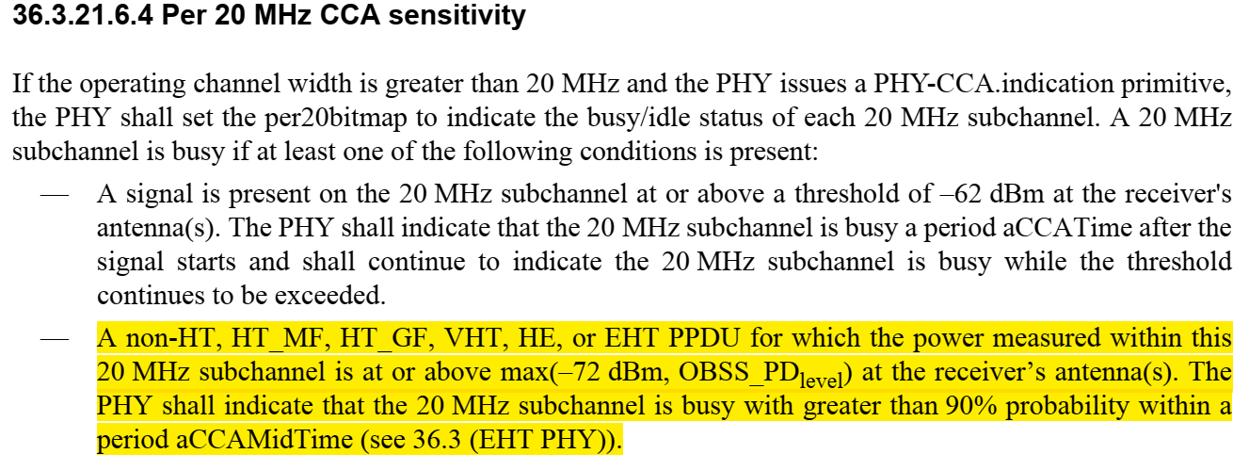

Proposed changes: 11be editor, please remove the paragraph below (the highlighted paragraph above)

