IEEE P802.11
Wireless LANs
11be D3.0 CR for OM
Date: 2023-03-07
Author(s):
Name | Affiliation | Address | Phone | email
Po-Kai Huang | Intel
Abstract
This submission proposes resolutions for the following CIDs:

16390, 17275, 17276, 17277, 17278, 17096, 17097, 17279, 17280, 17346,
17987, 15363, 15906, 17557, 17595, 17596, 17489

Revisions:
- Rev 0: Initial version of the document.
- Rev 1: Green tag and editorial revision.

Interpretation of a Motion to Adopt

A motion to approve this submission means that the editing instructions and any changed or added material are actioned in the TGbe D3.0 Draft. This introduction is not part of the adopted material.

Editing instructions formatted like this are intended to be copied into the TGbe D3.0 Draft. (i.e. they are instructions to the 802.11 editor on how to merge the text with the baseline documents).

TGbe Editor: Editing instructions preceded by “TGbe Editor” are instructions to the TGbe editor to modify existing material in the TGbe draft. As a result of adopting the changes, the TGbe editor will execute the instructions rather than copy them to the TGbe Draft.

CID | Commenter | Clause | P.L | Comment | Proposed Change | Resolution
16390 | Massinissa Lalam | 9.2.4.7.8 | 142.42 | "EHT OM Control" is read in conjunction with "OM Control". Something should be added to enforce that both variants sent in the same frame (A-Control). Something like "An EHT OM Control subfield shall be sent in the same A-Control subfield as the OM Control subfield it extends". | As in comment | Rejected –  Statements like this are added in 35.9.  An EHT STA that transmits a frame with an A-Control subfield of HE variant HT Control field, which includes an EHT OM Control subfield shall concatenate the OM Control subfield within the same A-Control subfield after the EHT OM Control field. An EHT STA shall not include an EHT OM Control field in an A- Control field unless the OM Control field is present in the same A-Control field.
17275 | Zinan Lin | 9.2.4.7.8 | 142.64 | Per table 9-33a, the combined subfields indicate Nss, not Nss -1 | change "Nss - 1" to "Nss" | Rejected –  We explain with a simple example. If the combined subfields has value 0, then it indicates 1 based on the table.  Hence, the value is equal to Nss-1 in general.
17276 | Zinan Lin | 9.2.4.7.8 | 143.03 | Per table 9-33a, the combined subfields indicate Nss, not Nss -1 | change "Nss - 1" to "Nss" | Rejected –  We explain with a simple example. If the combined subfields has value 0, then it indicates 1 based on the table.  Hence, the value is equal to Nss-1 in general.
17277 | Zinan Lin | 9.2.4.7.8 | 144.45 | To be consistent with the description on line 28, it should be Nsts. | change "Nss " to "Nsts" | Accepted -
17278 | Zinan Lin | 9.2.4.7.8 | 144.28 | Per table 9-33c, the combined subfields indicate Nss, not Nss -1 | change "Nsts - 1" to "Nsts" | Rejected –  We explain with a simple example. If the combined subfields has value 0, then it indicates 1 based on the table.  Hence, the value is equal to Nsts-1 in general.
17096 | Mark RISON | 35.9 | 621.47 | "supports 320 MHz" too casual | Append "operation" | Revised –  We revise the description using capability bit.  TGbe editor to make the changes shown in 11-23/0299r1 under all headings that include CID 17096
17097 | Mark RISON | 35.9 | 621.57 | "An EHT STA that transmits a frame with an A-Control subfield of HE variant HT Control field, which  includes an EHT OM Control subfield shall concatenate the OM Control subfield within the same A-Control  subfield after the EHT OM Control field." poor grammar and "concatenate after" not clear | Change to "An EHT STA that transmits a frame with an A-Control subfield of HE variant HT Control field that  includes an EHT OM Control subfield shall include an OM Control subfield within the same A-Control  subfield after the EHT OM Control subfield." | Revised-  We change “which” to “that” as suggested.  We still use concatenated to preserve the right after another meaning and follow the following usage of “concatnate".  The original MPDU header is concatenated with the plaintext data resulting from the successful CCM recipient processing to create the plaintext MPDU.  TGbe editor to make the changes shown in 11-23/0299r1 under all headings that include CID 17097
17279 | Zinan Lin | 35.9 | 622.22 | What Eqn 35-3 calculates is the Rx-Nss value among all EHT-MCS. No need to have "for a given EHT-MCS" here. It may be better to remove "for a given EHT-MCS" | Chang "for a given EHT-MCS" to "for any EHT-MCS" | Rejected –  We note that the rules and texts align with what we have in baseline for HE MCS.  If the operating channel width of the STA is greater than 80 MHz, then the maximum number of spatial streams that the STA supports in reception for a given HE-MCS as a function of the received HE PPDU bandwidth BW at an HE STA transmitting an OM Control subfield is defined in Equation (26-4).  Floor (Rx-NSS-from-OMI × (Max-HE-NSS-at-BW / Max-HE-NSS-at-80)) (26-4)
17280 | Zinan Lin | 35.9 | 622.38 | The value of Eqn. 35-3 may go to 0 when Rx-Nss-from-OMI is 1 and Max-EHT-Nss-atBW/Max-EHT-NSS-at-80 is smaller than 1. The value of Eqn(35-3) may go to more than 8, when Rx-Nss-from-OMI is larger than 4, say 8 and max-EHT-Nss-at BW/Max-EHT-NSS-at-80 is larger than 1. | Eqn. 35-3 may need to be changed to min(max(1, floor (...),8) | Rejected –  We note that the rules and texts align with what we have in baseline for HE MCS. If it is 0, then that you can not receive EHT PPDU with that bandwidth.  If the operating channel width of the STA is greater than 80 MHz, then the maximum number of spatial streams that the STA supports in reception for a given HE-MCS as a function of the received HE PPDU bandwidth BW at an HE STA transmitting an OM Control subfield is defined in Equation (26-4).  Floor (Rx-NSS-from-OMI × (Max-HE-NSS-at-BW / Max-HE-NSS-at-80)) (26-4)
17346 | Alfred Asterjadhi | 35.9 | 621.63 | Values from 8 to 16 of NSS RX and TX have now been set to reserved for EHT. Hence this subclause needs to be amended in such a way that NSS calculations only rely on the OM Control field itself as opposed to the combo with EHT variant. | As in comment. | Rejected –  The extension field can still be set to 0, so joint computation is fine. It is just that the value will never go above 8.
17987 | Sigurd Schelstraete | 35.9 | 622.03 | Change "EHT STA with dot11EHTOMIOptionImplemented to true" to "EHT STA with dot11EHTOMIOptionImplemented equal to true" | See comment | Accepted -
15363 | John Wullert | 9.4.2.157.3 | 237.01 | The sentence contains two consecutive prepositions ("in by") and contains a single letter "f" | Rephrase as "The maximum supported NSS as indicated by the value of the Rx NSS field of the OM Control subfield of EHT OM Control subfield is not present..." | Accepted -
15906 | Xiaofei Wang | 9.4.2.157.3 | 237.01 | The sentence "The maximum supported NSS as indicated in by the value of the Rx NSS field of the OM Control subfield f EHT OM Control subfield is not present in the same A-Control field or by the value of the Rx NSS Extension field of the EHT OM Control subfield combined with the value of the Rx NSS field of the OM Control subfield (and further defined in the Table 26-9 (Setting of VHT Channel Width and VHT NSS at an HE STA transmitting the OM Control subfield))" seems to be missing letters and is not correct | rewrite to correct sentence | Revised –  We do editorial revision  TGbe editor to make the changes shown in 11-23/0299r1 under all headings that include CID 15363
17557 | Brian Hart | 9.4.2.157.3 | 237.03 | "A if condA or B" does not make sense. Should be "A if condA or B if not condA" or "A if cond, and B otherwise" | As in comment (e.g. change "or" to "and otherwise") | Revised –  We do editorial revision  TGbe editor to make the changes shown in 11-23/0299r1 under all headings that include CID 17557
17595 | Brian Hart | 9.4.2.248.4 | 247.54 | Missing condition in final option: "as indicated by O1 if R1, or by O2 if R2 or by O3". That is, we are missing reason3 for option3. | Add the condition for using "the value of the Rx NSS Extension field of the EHT OM Control subfield combined with the value of the Rx NSS field of the OM Control subfield". Maybe "if both the the EHT OM Control and OM Control subfields are present" or simiar | Revised –  We do editorial revision along the line of the suggestion from the commenter.  TGbe editor to make the changes shown in 11-23/0299r1 under all headings that include CID 17557
17596 | Brian Hart | 9.4.2.248.4 | 247.64 | Two options but not clear when to use on or the other!? | Are we still using the smaller of " the smaller of" from L59.5? If so, make this next text a new bullet. Or is this "OptionA if EHT OM Ctrl subfield is not present or OptionB if the EHT OM Ctrl subfield is present"? Figure out the answer and include it in the draft | Revised –  We do editorial revision along the line of the suggestion from the commenter.  TGbe editor to make the changes shown in 11-23/0299r1 under all headings that include CID 17557
17489 | Brian Hart | 9.4.1.53 | 209.09 | For the NOTE at L23 to make sense, considering if the max NSS for 160/320M is higher than the max NSS for 80MHz, this equation should consdier <=80 MHz separately. | Write this as two rows with non-overlapping conditions:  "{floor(rxNSSexOMF * MaxNSSAtBw / MaxNssAt80) if PPDU BW > 80 MHz  {rxNSSexOMF if PPDU BW <= 80 MHz | Rejected –  Note 2 just means that for bandwidth <=80, the equation will just givesyou RX-NSS-from-OMF. The texts align with what we have in baseline for HE-MCS. The reason is that all less than 80 MHz indication are provided in just one field.

Discussion: Texts referred by CID 17489

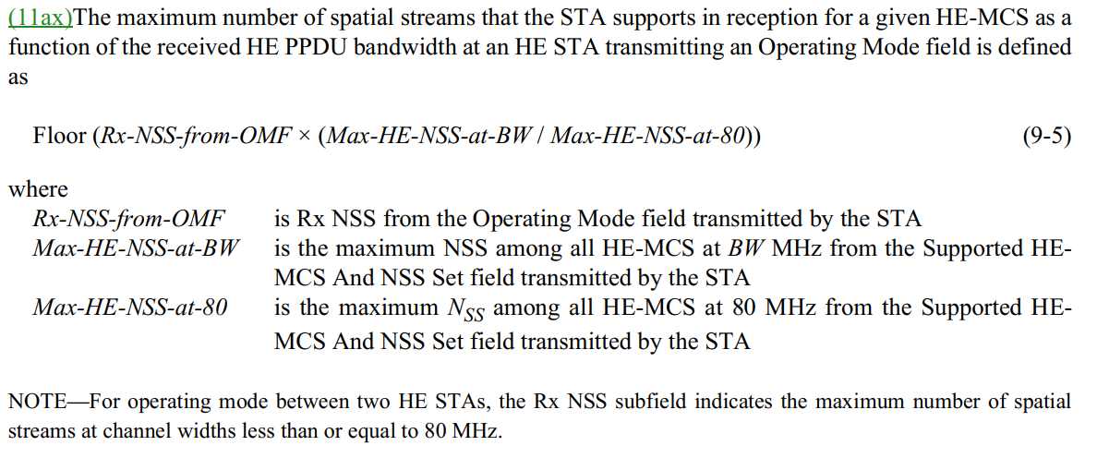

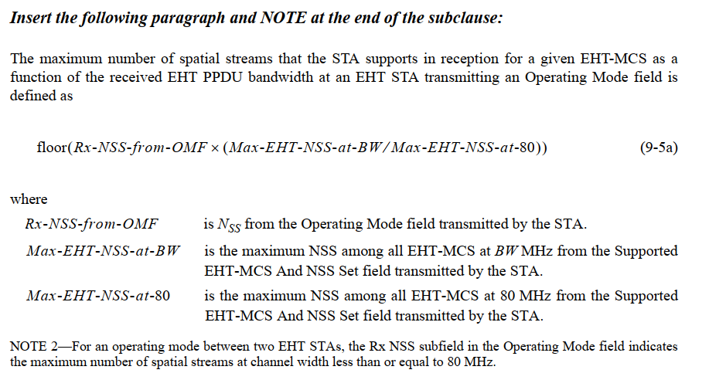

TGbe editor: Change Clause 9.2.4.7.8 as follows (track change on):

        - EHT OM Control

The Control Information subfield in an EHT OM Control subfield contains information related to the OM changes for bandwidth of 320 MHz, Tx NSTS extension, and Rx NSS extension for the STA transmitting the frame containing this information (see 35.9 (Operating mode indication)). The format of the subfield is shown in Figure 9-33a (Control Information subfield format in an EHT OM Control subfield).

B0 B1 B2 B3 B5
Rx NSS  Extension | Channel Width Extension | Tx NSTS  Extension | Reserved

Bits: 1 1 1 3
Figure 9-33a—Control Information subfield format in an EHT OM Control subfield
If the operating channel width of the STA is greater than 80 MHz, then the Rx NSS Extension subfield in the EHT OM Control subfield combined with the Rx NSS subfield in the OM Control subfield indicates N_{SS} – 1 , where N_{SS} is the maximum number of spatial streams that the STA supports in reception for PPDU bandwidths less than or equal to 80 MHz.
If the operating channel width of the STA is less than or equal to 80 MHz, then the Rx NSS Extension sub- field in the EHT OM Control subfield combined with the Rx NSS subfield in the OM Control subfield indi- cates N_{SS} – 1 , where N_{SS} is the maximum number of spatial streams that the STA supports in reception.

The encoding of the Rx NSS Extension subfield in the EHT OM Control subfield combined with the Rx NSS subfield in the OM Control subfield is described in Table 9-33a (The encoding of the Rx NSS Exten- sion subfield in the EHT OM Control subfield combined with the Rx NSS subfield in the OM Control sub- field).

Table 9-33a—The encoding of the Rx NSS Extension subfield in the EHT OM Control sub- field combined with the Rx NSS subfield in the OM Control subfield

Rx NSS Extension subfield  in the EHT OM Control subfield | Rx NSS subfield  in the OM Control subfield | Indication of the NSS
0 | 0 | 1
0 | 1 | 2
0 | 2 | 3
0 | 3 | 4
0 | 4 | 5
0 | 5 | 6
0 | 6 | 7
0 | 7 | 8
1 | 0–7 | Reserved

If the operating channel width of the STA is greater than 80 MHz, then the maximum number of spatial streams that the STA supports in reception for non-EHT PPDU bandwidths greater than 80 MHz is defined in 26.9 (Operating mode indication).

If the operating channel width of the STA is greater than 80 MHz, then the maximum number of spatial streams that the STA supports in reception for EHT PPDU bandwidths greater than 80 MHz is defined in
35.9 (Operating mode indication).

The Channel Width Extension subfield in the EHT OM Control subfield combined with the Channel Width subfield in the OM Control subfield indicates the operating channel width supported by the STA for both reception and transmission.

The encoding of the Channel Width Extension subfield in the EHT OM Control subfield combined with the Channel Width subfield in the OM Control subfield is described in Table 9-33b (The encoding of the Chan- nel Width Extension subfield in the EHT OM Control subfield combined with the Channel Width subfield in the OM Control subfield).

Table 9-33b—The encoding of the Channel Width Extension subfield in the EHT OM Control subfield combined with the Channel Width subfield in the OM Control subfield

Channel Width Extension subfield in the EHT OM Control subfield | Channel Width subfield in the OM Control subfield | Indication of the operating channel width
0 | 0 | Primary 20 MHz
0 | 1 | Primary 40 MHz
0 | 2 | Primary 80 MHz
0 | 3 | Primary 160 MHz
1 | 0 | 320 MHz
1 | 1–3 | Reserved

The Tx NSTS Extension subfield in the EHT OM Control subfield combined with the Tx NSTS subfield in OM Control subfield indicates N_{STS} – 1 , where N_{STS} is the maximum number of space-time streams that the STA supports in transmission.
NOTE—EHT PHY does not support STBC. The terms “space-time stream” and “spatial stream” are equivalent in EHT.

The encoding of the Tx NSTS Extension subfield in the EHT OM Control subfield combined with the Tx NSTS subfield in the OM Control subfield is described in Table 9-33c (The encoding of the Tx NSTS Extension subfield in the EHT OM Control subfield combined with the Tx NSTS subfield in the OM Con- trol subfield).

Table 9-33c—The encoding of the Tx NSTS Extension subfield in the EHT OM Control sub- field combined with the Tx NSTS subfield in the OM Control subfield

Tx NSTS Extension subfield in the EHT OM Control subfield | Tx NSTS subfield  in the OM Control subfield | Indication of the NSTS(#17277)
0 | 0 | 1
0 | 1 | 2
0 | 2 | 3
0 | 3 | 4
0 | 4 | 5
0 | 5 | 6
0 | 6 | 7
0 | 7 | 8
1 | 0–7 | Reserved

TGbe editor: Change Clause 35.9 as follows (track change on):

  - Operating mode indication

An EHT AP that sets the Support For 320 MHz in 6 GHz subfield in the EHT Capabilities element to 1 (#17096)shall set dot11EHTOMIOptionImplemented to true.

An EHT STA with dot11EHTOMIOptionImplemented that is equal to true shall set the EHT OM Control Support subfield in the EHT MAC Capabilities Information field in the EHT Capabilities element it transmits to 1; otherwise the EHT STA shall set the EHT OM Control Support subfield to 0.

An EHT STA with dot11EHTOMIOptionImplemented that is equal to true shall set dot11OMIOptionImplemented to true.

An EHT STA that transmits a frame with an A-Control subfield of HE variant HT Control field that includes an EHT OM Control subfield shall concatenate the EHT OM Control subfield with the OM Control subfield within the same A-Control subfield, and the OM control subfield shall be located after the EHT OM Control field.(#17097) An EHT STA shall not include an EHT OM Control field in an A- Control field unless the OM Control field is present in the same A-Control field.
NOTE 1—An EHT STA is an HE STA and as such inherits all the functionalities defined in 26.9 (Operating mode indication).

NOTE 2—Based on the requirement to concatenate the OM Control subfield after an EHT OM Control subfield and the definition of OMI initiator and OMI responder in 26.9 (Operating mode indication), an EHT STA that transmits a frame including an EHT OM Control subfield is an OMI initiator, and an EHT STA with dot11EHTOMIOptionImplemented equal(#17987) to true that receives a frame including an EHT OM Control subfield is an OMI responder.

For an EHT STA that is an OMI initiator or an OMI responder, the rule described in 26.9.3 (Transmit operating mode (TOM) indication) that applies to HE TB PPDU shall also apply to EHT TB PPDU.

An OMI initiator that transmits a frame including an EHT OM Control subfield and an OMI responder that receives a frame including an EHT OM Control field shall follow the rules defined in 26.9 (Operating mode indication), except that the N_{SS} , the N_{STS} , and/or the maximum operating channel width shall be calculated by the EHT OM Control subfield combined with the OM Control subfield as defined in 9.2.4.7.8 (EHT OM Control).

NOTE 3—EHT PHY does not support STBC. The terms “space-time stream” and “spatial stream” are equivalent in EHT.

If the operating channel width of the STA is greater than 80 MHz, then the maximum number of spatial streams that the STA supports in reception for a given EHT-MCS as a function of the received EHT PPDU bandwidth BW at an EHT STA transmitting only an OM Control subfield or an EHT OM Control subfield combined with an OM Control subfield is defined in Equation (35-3).
floor(Rx-NSS-from-OMI × (Max-EHT-NSS-at-BW ⁄ Max-EHT-NSS-at-80)) (35-3) where
Rx-NSS-from-OMI is NSS indicated by the Rx NSS subfield in the OM Control subfield (see 9.2.4.6a.2
(OM Control)) if an EHT OM Control subfield is not present in the same A-Control field(#17557) or indicated by the Rx NSS Extension subfield in the EHT OM Control subfield combined with the Rx NSS subfield in the OM Control subfield if an EHT OM Control subfield is present in the same A-Control field(#17557) (see 9.2.4.7.8 (EHT OM Control)).
Max-EHT-NSS-at-BW is the maximum NSS among all EHT-MCS at BW MHz from the Supported EHT-MCS And NSS Set field (9.4.2.313.4 (Supported EHT-MCS And NSS Set field)) transmitted by the STA.
Max-EHT-NSS-at-80 is the maximum NSS among all EHT-MCS at 80 MHz from the Supported EHT- MCS And NSS Set field (9.4.2.313.4 (Supported EHT-MCS And NSS Set field)) transmitted by the STA.

TGbe editor: Change Clause 9.4.2.157.3 as follows (track change on):

9.4.2.157 VHT Capabilities element

9.4.2.157.3 Supported VHT-MCS and NSS Set field

Change the second last paragraph as follows:

The value of Max VHT NSS for a given MCS is equal to the smaller of
— The maximum value of n for which the Max VHT-MCS for n SS has a value that indicates support for that MCS or
— The maximum supported NSS as indicated (#15363)by the value of the Rx NSS field of the OM Control subfield if(#15363) an EHT OM Control subfield is not present in the same A-Control field or by the value of the Rx NSS Extension field of the EHT OM Control subfield combined with the value of the Rx NSS field of the OM Control subfield if an EHT OM Control subfield is present in the same A-Control field(#17557) (and further defined in the Table 26-9 (Setting of VHT Channel Width and VHT NSS at an HE STA transmitting the OM Control subfield))

TGbe editor: Change Clause 9.4.2.248.4 as follows (track change on):

9.4.2.248 HE Capabilities element

9.4.2.248.4 Supported HE-MCS and NSS Set field

Change the fourth last paragraph as follows:

The maximum receive NSS for a given HE-MCS is equal to the smaller of
- The maximum value of n for which the Max HE-MCS For n SS has a value that indicates support for that HE-MCS or
- The maximum supported NSS as indicated by the value of the Rx NSS field of the Operating Mode Notification frame or the Operating Mode Notification element if the value of Rx NSS Type is 0, or by the value of the Rx NSS field of the OM Control subfield if an EHT OM Control subfield is not present in the same A-Control field, or by the value of the Rx NSS Extension field of the EHT OM Control subfield combined with the value of the Rx NSS field of the OM Control subfield if an EHT OM Control subfield is present in the same A-Control field(#17557).

Change the second last paragraph as follows:

The maximum transmit NSS for a given HE-MCS is equal to the smaller of
- The maximum value of n for which the Max HE-MCS For n SS has a value that indicates support for that HE-MCS (0, 1, or 2 for HE-MCS 0–7, 1 or 2 for HE-MCS 8–9, 2 for HE-MCS 10–11) or
- The maximum supported NSTS as indicated by the value of the Tx NSTS field of the OM Control subfield sent by a non-AP STA if an EHT OM Control subfield is not present in the same A-Control field(#17557) or by the value of the Tx NSTS Extension field of the EHT OM

Control subfield combined with the value of the Tx NSTS field of the OM Control subfield sent by a non-AP STA if an EHT OM Control subfield is present in the same A-Control field(#17557).

TGbe editor: Change Clause 9.4.2.313.4 as follows (track change on):

9.4.2.313.4 Supported EHT-MCS And NSS Set field

(…existing texts…)

The maximum receive Nss for a given EHT-MCS is equal to the smaller of:
- The value of the Rx Max Nss That Supports Specified MCS subfield for the given EHT-MCS
- The maximum supported Nss as indicated by the value of the Rx NSS field of the Operating Mode Notification frame or the Operating Mode Notification element if the value of Rx NSS Type is 0, or by the value of the Rx NSS field of the OM Control subfield if an(#17557) EHT OM Control subfield is not pres- ent in the same A-Control field, or by the value of the Rx NSS Extension field of the EHT OM Con- trol subfield combined with the value of the Rx NSS field of the OM Control subfield if an EHT OM Control subfield is present in the same A-Control field(#17557)

The maximum transmit Nss for a given EHT-MCS is equal to the smaller of:
- The value of the Tx Max Nss That Supports Specified MCS subfield for the given EHT-MCS
- The maximum supported Nss as indicated by the value of the Tx NSTS field of the OM Control sub- field sent by a non-AP STA if an EHT OM Control subfield is not present in the same A-Control field(#17557) or by the value of the Tx NSTS Extension field of the EHT OM Control subfield combined with the value of the Tx NSTS field of the OM Control subfield sent by a non-AP STA if an EHT OM Control subfield is present in the same A-Control field(#17557)

