IEEE P802.11
Wireless LANs
11be D3.0 CR for 13
Date: 2023-03-06
Author(s):
Name | Affiliation | Address | Phone | email
Po-Kai Huang | Intel
Abstract
This submission proposes resolutions for the following CIDs:

15388, 15389, 15690, 15390, 15391, 15393, 17912

Revisions:
- Rev 0: Initial version of the document.
- Rev 1: Green tag and editorial revision.

Interpretation of a Motion to Adopt

A motion to approve this submission means that the editing instructions and any changed or added material are actioned in the TGbe D3.0 Draft. This introduction is not part of the adopted material.

Editing instructions formatted like this are intended to be copied into the TGbe D3.0 Draft. (i.e. they are instructions to the 802.11 editor on how to merge the text with the baseline documents).

TGbe Editor: Editing instructions preceded by “TGbe Editor” are instructions to the TGbe editor to modify existing material in the TGbe draft. As a result of adopting the changes, the TGbe editor will execute the instructions rather than copy them to the TGbe Draft.

CID | Commenter | Clause | P.L | Comment | Proposed Change | Resolution
15388 | John Wullert | 13.5.1 | 438.23 | The other text in this section has been updated to account for replace references to non-AP STAs with FTO, but this sentence has not. | Revise as "To prevent key reinstallation attacks, the FTO shall maintain a copy..." | Rejected –  The texts refer to operaton of GTK/IGTK/BIGTK which is per link under MLO rather than just one for FTO under MLO.
15389 | John Wullert | 13.5.2 | 439.01 | The revised text refers to an FTR, but does not specify which of the two FTRs (current or target) | Revise as "The FTO and AP target FTR use the FT authentication..." Similar change on line P439, Line 19. | Revised –  We note that this is a baseline issue because the baseline texts only uses AP and does not say current AP or target AP.  However, agree that the context is for target AP since the context talks about the following. “This exchange enables a fresh PTK to be computed in advance of reassociation.”  TGbe editor to make the changes shown in 11-23/0287r1 under all headings that include CID 15389
15690 | Thomas Derham | 13.5.3 | 442.46 | There is a note that says the MAC address of an FTR is the MLD MAC address (if the FTR if an AP MLD).  However there is no similar note regarding the MAC address of an FTO.  The definition of FTO in 13.1 "a non-AP MLD [known as the .. FTO]" implies the MLD address should be used for FTO too. | Add to the note clarifying that the MAC address of FTO is the MLD address when the FTO is a non-AP MLD. | Revised –  Agree in principle with the commenter. We add similar description for FTO.  TGbe editor to make the changes shown in 11-23/0287r1 under all headings that include CID 15690
15390 | John Wullert | 13.5.3 | 441.58 | The text has a space between "MLME-REMOTEREQUEST." and "Indication" that should not be there | Remove the space (MLME-REMOTEREQUEST.Indication) | Accepted -
15391 | John Wullert | 13.6.2 | 444.17 | Text in figure13-10 says "FTO determines it needs to transition to the Target AP", but references to "Target AP" have been replaced with "Target FTR" | Replace text with "FTO determines it needs to transition to the Target FTR" | Accepted -
15393 | John Wullert | 13.11.2 | 459.45 | Text says "TR" when it should say "FTR" | Replace "When sent by an APa target TR..." with "When sent by an APa target FTR..." | Accepted -
17912 | Kazuto Yano | 13.11.3.2 | 461.13 | An unnecessary new paragraph is started. | Please join this paragraph to the previous paragraph. | Accepted -

Discussion: None

TGbe editor: Change Clause 13 as follows (track change on):

  - FT protocol

13.5.2 Over-the-air FT protocol authentication in an RSN

Change (including Figure 13-5) as follows:

The over-the-air FT protocol in an RSN is shown in Figure 13-5 (Over-the-air FT protocol in an RSN).
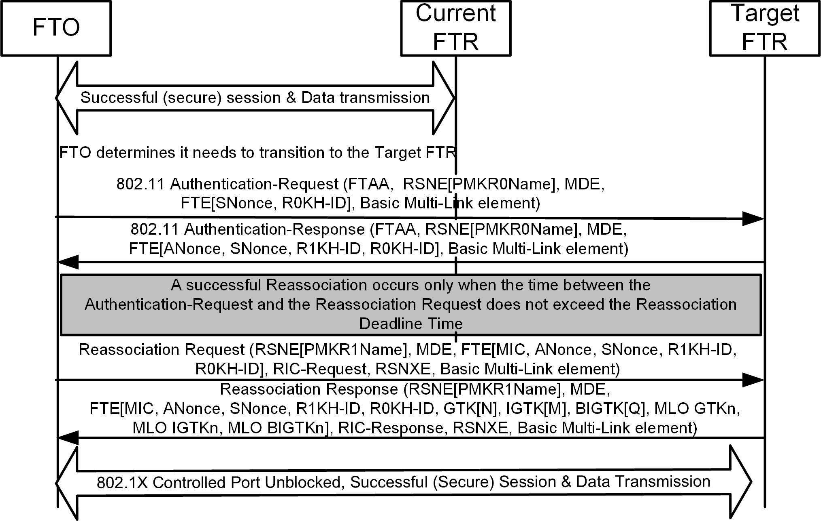

Figure 13-5—Over-the-air FT protocol in an RSN

The FTO and APtarget(#15389) FTR use the FT authentication sequence to specify the PMK-R1 security association and to provide values of SNonce and ANonce that enable a liveness proof, replay protection, and PTK separation. This exchange enables a fresh PTK to be computed in advance of reassociation. The PTKSA is used to protect the subsequent reassociation transaction, including the optional RIC-Request.

(…existing texts…)

    - Over-the-DS FT protocol in an RSN

Change (including Figure 13-6 and Figure 13-7) as follows:

(…existing texts ….)

The SME of the FTO initiates the FT Request frame to the target APFTR by issuing an MLME- REMOTEREQUEST.request primitive with parameters including the contents of the FT Request frame (FT Action frame with an FT Action field value indicating FT Request) to be sent. The MAC of the FTO trans- mits this Action frame. For processing at the current APFTR and target APFTR, see 13.10 (Remote request broker (RRB) communication). When the MAC of the FTO receives the FT Response frame (FT Action frame with an FT Action field value indicating FT Response), it passes it to the SME by use of MLME- REMOTEREQUEST.Indication(#15390) primitive, with parameters including the contents of the received Action frame. The MLME interfaces on the FTO, current APFTR, and the target APFTR for executing the over-the- DS fast BSS transition are shown in Figure 13-7 (MLME interfaces for over-the-DS FT protocol messages).

(…existing texts…)

The STA Address field of the FT Request frame shall be set to the MAC address of the FTO, and the Target AP Address field of the FT Request frame shall be set to the BSSID of the target AP’s BSSMAC address of the target FTR. The elements in the FT Request frame, and their required contents, shall be as given in
13.8.2 (FT authentication sequence: contents of first message).

NOTE— The MAC address of the FTO is the MLD MAC address of a non-AP MLD if the FTO is the non-AP MLD and is the MAC address of a non-AP STA if the FTO is the non-AP STA. The(#15690) MAC address of the target FTR is the MLD MAC address of an AP MLD if the target FTR is the AP MLD and is the MAC address of an AP if the target FTR is the AP.

(…existing texts…)

    - Over-the-air fast BSS transition with resource request

Change the first paragraph and Figure 13-10 as follows:

The over-the-air FT resource request protocol in an RSN is shown in Figure 13-10 (Over-the-air FT resource request protocol in an RSN).

(#15391)
Figure 13-10—Over-the-air FT resource request protocol in an RSN

(…existing texts…)

    - Resource information container (RIC)

Change the second entry of Table 13-3 as follows (not all lines shown):

Table 13-3—Resource types and resource descriptor definitions

Resource type | Resource Descriptor definition | Notes
Block Ack Parameters | In a request: RIC Descriptor (see 9.4.2.50 (RIC Descriptor element)), containing a Resource Type field identifying Block Ack.  In a response: RIC Descriptor (see 9.4.2.50 (RIC Descriptor element)), containing a Resource Type field identifying Block Ack. | Resource request procedures shall be as given in 11.5 (Block ack operation) or 35.3.8 (Block ack procedures in Multi-link operation).

Change the 11th paragraph as follows (Figure 13-28 not shown):

When sent by an APa target FTR(#15393) in response to a RIC-Request, the RIC-Response consists of a list of one or more Resource Responses including one response for each of the Resource Requests that was contained in the RIC-Request. The basic format of a RIC-Response is shown in Figure 13-28 (RIC-Response format).

      - APFTR procedures

Change the first paragraph as follows:

When a RIC appears in a request message, the APFTR shall check its ability to allocate one resource for each RDE in the RIC in the order appearing in the RIC. In a Reassociation Request frame, the QoS Capability element shall be processed prior to the QoS resource requests in the RIC.

Change the second paragraph (including the figure caption of Figure 13-30) as follows (Figure 13-30 not shown):

The behavior of the APFTR shall be identical to that described in the flowchart in Figure 13-30 (Overview of RIC processing at an APa FTR).

Figure 13-30—Overview of RIC processing at an APa FTR

Change the third, fourth, and fifth paragraphs as follows:

As shown in Figure 13-30 (Overview of RIC processing at an APa FTR), the Resource Descriptors are examined by the APFTR in the order presented, and the first that could have been allocated is accepted. Thus the preference ordering by the FTO is honored.

The target APFTR’s SME examines the resource requests in the RIC. For requests that require processing by the MAC sublayer, the SME generates an MLME-RESOURCE-REQUEST-LOCAL.request primitive. The MAC shall respond with MLME-RESOURCE-REQUEST-LOCAL.confirm primitive that indicates

(#17912)whether the MAC has accepted the resource request. The SME may also send these resource requests to an external entity such as a backend QoS module for its consideration; these procedures are beyond the scope of this standard. The acceptance of a TSPEC by the target AP results in the resource allocation for a TS at the target AP.

In response to a RIC-Request, the APFTR shall construct a RIC-Response. The RIC-Response shall contain one RDE for each RDE in the RIC-Request. The RDEs shall be in the same order as in the request, and the RDE Identifier field in each RDE shall be the value of the RDE Identifier field in the corresponding RDE in the request. The Status Code field in the RDE shall be set according to the result of the allocation request as follows:
- Status code = SUCCESS indicates that the resource request has been accepted. The RDE shall also be followed by the Resource Descriptor that was accepted.
- Status code = not SUCCESS indicates that the resources could not be accepted. The Status Code field contains a value from 9.4.1.9 (Status Code field) indicating the reason for the failure. In this case, the APFTR may include a single Resource Descriptor following the RDE indicating a sug- gested resource that could have been accepted. The Resource Count field shall be set to 0 or 1 depending whether the suggested Resource Descriptor is attached. A not SUCCESS status code in an RDE shall not cause a not SUCCESS status code in the frame containing the RIC.

