IEEE P802.11
Wireless LANs
EMLSR link change with AP MLD's link enablement/disablement operation
Date: 2023-05-15
Author(s):
Name | Affiliation | Address | Phone | email
Kyumin Kang | ETRI |  |  | kmkang@etri.re.kr
Sunghyun Hwang | ETRI |  |  | shwang@etri.re.kr
Juseong Moon | KNUT |  |  | jsmoon0211@ut.ac.kr
Ronny Yongho Kim | KNUT |  |  | ronnykim@ut.ac.kr
Abstract
This submission proposes to resolve issue of EMLSR link change operation related with link disablement/enablement operation related with CID 16310

R0: Initial version
R1: Modified discussion and proposed text

Related Comment
CID | Commeter | Subclause | Page.  Line | Comment | Proposed Change | Resolution
16310 | Juseong Moon | 35.3.7.3.2 | 523.54 | When a link is disbled/enabled by an AP MLD, EMLSR/EMLMR operation of associated non-AP MLD related to the disabled/enabled link shall be clarifyed. When one or more links in the multi-link are disabled, the EMLSR/EMLMR operation of the non-AP MLD that is related to the disabled link(s) can be automatically modified or disabled. Alternatively, the non-AP MLD can transmit an EML OMN frame to modify or disable the EMLSR/EMLMR operation. Similarly, when a link is re-enabled, the non-AP MLD's EMLSR/EMLMR operation can be automatically enabled or modified, or the non-AP MLD can transmit an EML OMN frame to enable or modify the EMLSR/EMLMR operation. | Please clarify EMLSR/EMLMR operation that may be affected by link disablement/enablement. | Revised:  Agree with the commenter.  TGbe editor: Please make the changes tagged with (#16310)

Discussions

- Current specification defines link disablement and enablement. However, there are no following operations of EMLSR link change method.
- If some of link(s) of EMLSR link are disabled and only one EMLSR link is available, AP MLD may perform unnecessary operation. For example, AP MLD may transmit initial Control frame of EMLSR even if only one link is available.
- In this document, the SMPS operation is proposed when only one EMLSR link is available.
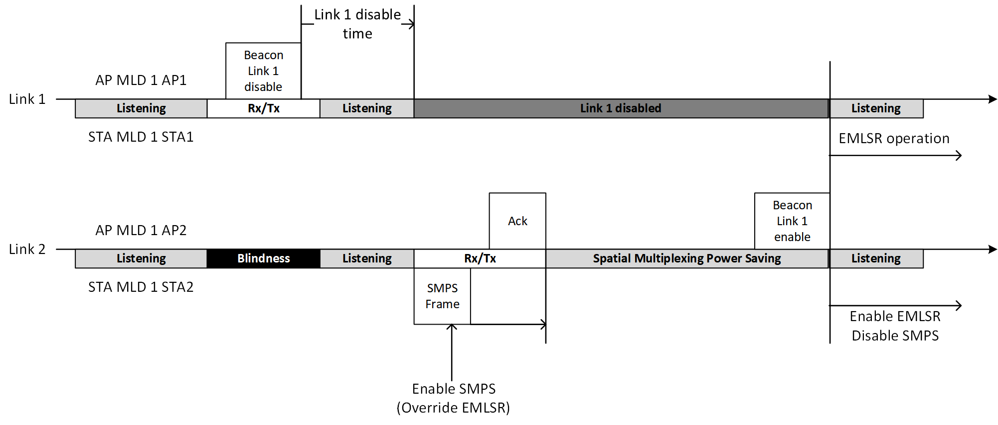

- If link 1 is disabled by an AP MLD, its associated STA MLD which is operating in EMLSR mode can enable SMPS and override EMLSR operation in link 2, until the link 1 is re-enabled. When SMPS is enabled in link 2, STA 2 can receive its frame(s) without initial Control frame. Vice versa, AP 2 can transmit its frame(s) to STA 2 without initial Control frame.

- When link 1 is re-enabled, its associated STA MLDs which is operating in EMLSR mode shall disable SMPS in link 2. STA MLD shall perform EMLSR operation in link 1 and link 2.

- These operations can avoid inefficiency of initial Control frame which has padding delay. A non-AP MLD operating in EMLSR mode can improve its utilization without harming its power efficiency.

Proposed Changes to 11be Draft 3.1

35.3.17 Enhanced multi-link single radio operation
TGbe editor: make the following changes at 570L19 of 11be draft 3.1:
(#16310) When a non-AP MLD is operating in EMLSR mode on the EMLSR links, and only one link is enabled among the EMLSR links, the non-AP STA can operate in dynamic SM power save mode (11.2.6 (SM power save)) and suspend the EMLSR operation on the link until two or more EMLSR links are (re)enabled.
Otherwise, the non-AP STAs operating on the EMLSR links and affiliated with the non-AP MLD shall not operate in dynamic SM power save mode on the EMLSR links.

