Minutes IEEE P802.11
Wireless LANs
IEEE 802.11 TGbh Meeting Minutes, February 28, 2023
Randomized and Changing MAC addresses (RCM)
Date: 2023-02-28
Author(s):
Name | Affiliation | Address | Phone | email
Stephen Orr | Cisco | Wallkill, NY |  | sorr@cisco.com
Abstract
This document contains the minutes of the IEEE 802.11bh telecon meeting of February 28, 2023.

Note: Highlighted text are action items.
Q- proceeds a question asked at the meeting
A- proceeds an answer
C- proceeds a comment

Meeting February 28th, 2023 9:30 a.m. to 11:30 a.m. ET

Chair: Mark Hamilton (Ruckus/CommScope)
Vice Chair: Peter Yee (NSA-CSD/AKAYLA)
Vice Chair: Stephen Orr (Cisco)
Secretary: Peter Yee
Editor: Carol Ansley (Cox)

The teleconference was called to order by the Chair at 9:33 a.m. EST.

Agenda slide deck 11-23/0247r00

- Policies and procedures were presented by the Vice Chair Peter Yee. (Slides 4 to 14)
There were no Patent declarations.
Copyright policy slides were presented (Slides 10 and 11)

- Agenda:
- Attendance, noises/recording, meeting protocol reminders
- Policies, duty to inform, participation rules
- Organization topics (see Backup slides)
  - Timeline reminder (slide 24)
  - Teleconference plan, going forward (slide 17)
- Issues Tracking: 11-21/0332r37
- Results of Comment Collection on D0.2: 11-22/0973r14
- Motions record: 11-22/0651r9
- Discussion on Way Forward
  - Technical comments on RRCM proposal 1079r4 Option 1
  - Motion #14 on RRCM proposal
  - Next Steps
- Review D0.2 CC comments and prepare for final clean up on CC comments
- WBA liaison response
Any comments? [None]
Any objections to agenda? [None] – approved

- Discussions on Way forward
Technical comments on RRCM proposal
C: 1079 contains two proposals
A: Chair – 1079r4 only has RRCM proposal
C: Only option 1
A: Chair correct – and changed
C: RRCM generates overhead and is complicated to use.
C: Worried about the overhead of RRCM to the AP – creates a lot of overhead. If it’s a lot for the STA to handle – its even worse for the AP (2¹⁶ MAC Addresses for an association)
A: We can work on this to address the overhead
C: Chair – just because we put this material in the draft, doesn’t mean we can’t continue to comment and make changes.
C: RRCM is generating multiple MAC addresses on both sides. This proposal doesn’t have to generate 2¹⁶ MAC Addresses. This could cause a lot of storage problems – but there could be another enhancement to avoid.
C: We’ve had some email exchanges during the week. We could change the use of MAC addresses for IE’s. It would be preferred if we could use some IE instead of a MAC address to communicate the ID.
A: In the future we can extend RRCM to include a key based solution to include IE.
C: The Target of RRCM in general is the pre-assoc ID. RRCM was based on use case 4.8 – this use case device was doing beacon measurement. A statement was made that the beacon report does not contain CSI information – there should be an enhancement to the Beacon Report to aid in client steering.
A: 4.8 provides additional use cases. We should keep this simple.
C: General comment on use cases. The use case document is a basic guideline for this group – cannot think of every use case. Limiting the uses cases to what is in the tracking document is not logical. Instead of focusing on 1 or 2 uses cases – we should focus on the identity.
Chair – appreciate everyone getting some offline conversations going. It would be helpful if any of that supporting material would be posted to the reflector so that others can follow.
C: Not in favor of pre-assoc use case – they are all nonsense.
C: Explain the private exchange with two other members. The seed being used is a waste of space. The process is forcing us to have a motion on something that is suboptimal vs having a motion on a better agreed upon proposal. I cannot support 1079r4 in its current state. All those changes require 75% approval, and it is a high bar
Chair: An option is to continue working on this and address at the f2f
C: I’d like to understand better why pre-assoc use cases are nonsense. Two examples – 20k devices connected at an event about 1k devices were sending malformed probe requests. It turns out it was from a laptop from a vendor against pre-assoc use cases. Having an ID would have helped a lot to determine the issue. Second IoT devices their CCA was using UP6 connecting to 5Ghz – because CCA was aggressive, it was dropping people from real UP6 traffic. So people were having poor experiencing and we were not able to steer clients to the 2.4 band
Chair – once we put material in the draft it raises the bar to 75%.
C: In this 11bh group we are stuck to identification. .11 doesn’t really specify rules on device steering. We can’t come up with rules on device steering. It would be much better to let the device associate and then steer the device.
C: In favor of pre-assoc use cases.
C: Been on both sides of this discussion. RRCM is way overcomplicated than what we need. Just need a simple identifier included by the STA. The issue for pre-assoc is that its not well defined. There is a difference between a client searching for a network and a client selecting a network. Once my device selects a network – I would be ok with my device being steered to a different network.
C: Going to the associated state is not the remediation. I don’t think we can do much on the discovery stage – however we could do something once the network is selected. Two modes: First we don’t know anything about each other – Second, returning device.
Q: What about the use case of “during association”
C: 802.11 is a spec that provides tools to implementers and providers that can do things that they want to do. We open the door and allow people to use the tools we put in place to build networks. If some want to control their space to move pre-assoc STAs around – this is not in line with the 802.11 enabling tools. The more straightforward and simpler – the easier it is for people to use. If providers want to use these tools for their networks, we should help provide them.
Chair – The queue is exhausted, what do we want to do for next steps.
If we think we have consensus coming soon and we need a little more cleaning up – we may want to let that conversation go. If we take the motion and it fails – it does nothing. If we are going to continue to work on this proposal and a path toward consensus, then it may make sense to wait. We need to get a document out to letter ballot to get feedback from the entire working group.
C: 11bh was panned to be a short group (2 years) – now we have multiple rounds of down selection. It would be good if we could make some progress and have a meaningful motion for the group. We keep on bringing up the same topics over and over. We have been stuck on this topic.

Chair discussed Motion #14 – RRCM
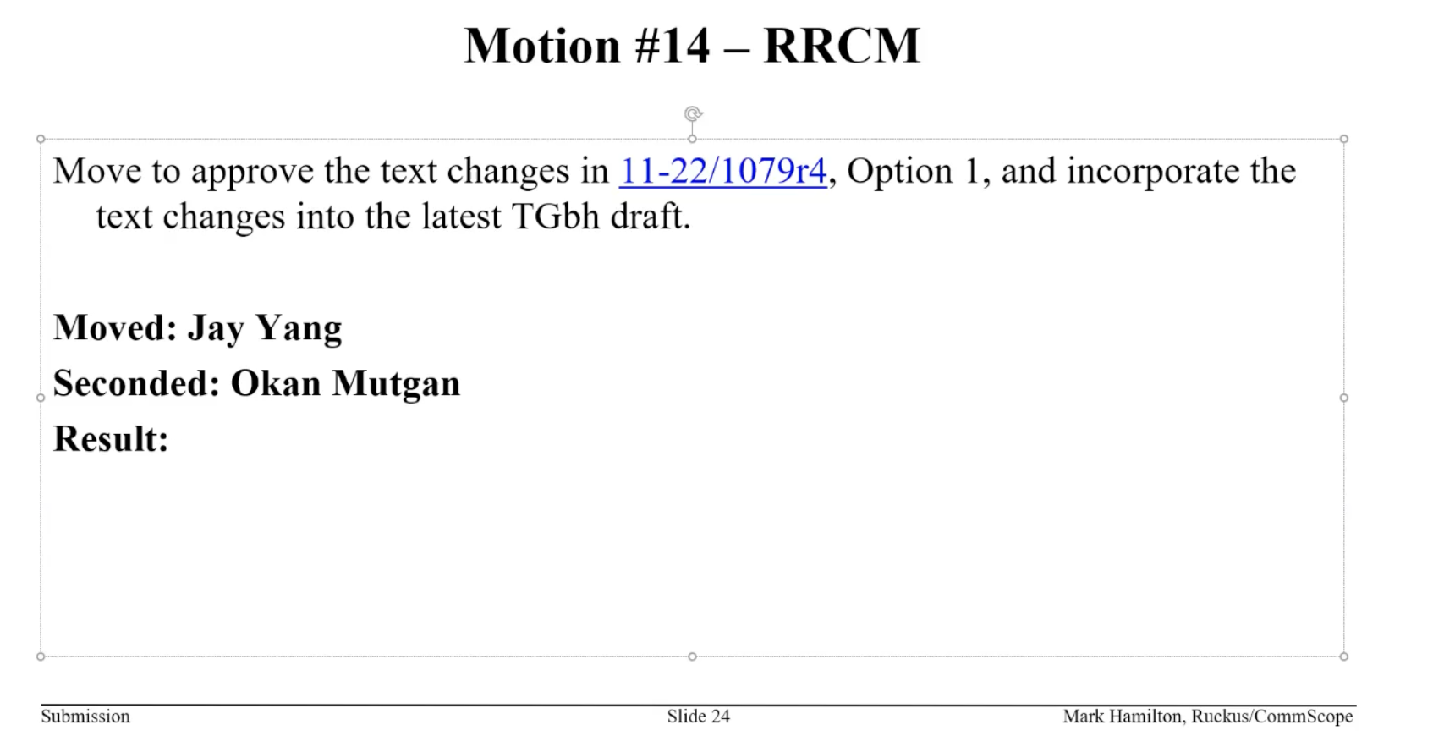

Reminder that this is for Voters only.
Results: Yes (8), No (17), Abstain (4)
Motion Failed

Q: Seems pretty obvious that the group will not accept additional input other than device ID. Is that still valid – is it worth putting device ID into the market? There are some that believe that Device ID alone does not meet the PAR, then what do we do about it?
Chair: There were a number of comments suggesting that some updates to RRCM could get it put into the draft. If not then we proceed with just Device ID.
C: It sounds reasonable to proceed with proposed updates to RRCM. If it falls below 75% then we could modify the PAR for what we have. If that does not achieve 75% - then its time to disband this group as it is not moving anywhere.
C: Support the Chair’s proposed way forward except modifying the PAR.
C: Maybe if we cannot get to letter ballot we should disband.
C: Not strongly proposing that we do the PAR work now – but would like to see a 75% motion. The only way to get by this pre-assoc use case is to approve RRCM or modify the PAR. Need a clear motion for a clear result otherwise we will continue to be stuck in this loop.
C: If you updated and change RRCM – then its not RRCM. It was one of the most complex things that were down selected. If you change it – it is something completely different. This group is never going to agree on a solution for the pre-assoc use cases.
Chair: The proposals will be put to motion at the F2F – they will either be approved or we will move on.
Discussion on various straw polls that could be run.
Chair trying to determine if there is 75% support for either pre-assoc solution (using the MAC address or in an IE)
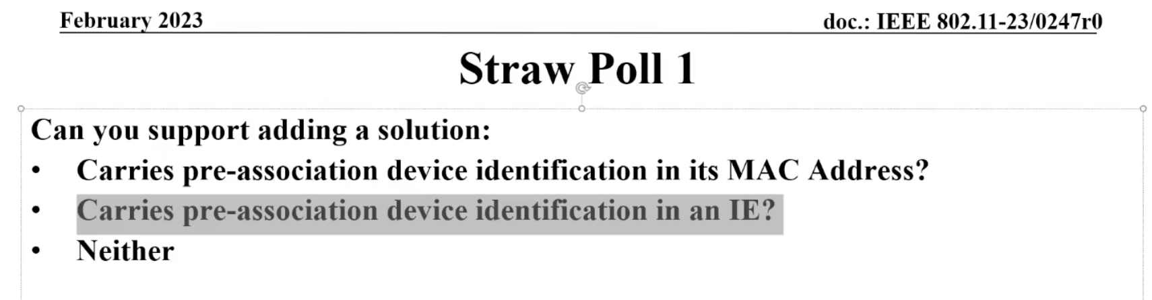
Results
MAC (7)
IE(13)
Neither (6)
N/A (5)
C: IE has a 2:1 margin over MAC – what are the concerns with IE?
C: With the results of the SP – not sure we should expend effort on RRCM.
C: This is something that is verified on the SP – that we will not get 75% on any of the proposals
C: We are not going to get anything agreed to – there is too much of a split. How long do we want to go on? This was supposed to be quick.

Chair – there are a number of proposal that fit into the IE category – that may meet this but need some tweaking. Work offline if you are a proponent – bring it to the F2F we will see if we can bring it to consensus and see if we can get to letter ballot.

Meeting adjoined at 11:30 a.m. EST.

Attendance
Breakout | Timestamp | Name | Affiliation
TGbh | 2/28 | Ansley, Carol | Cox Communications Inc.
TGbh | 2/28 | Bahn, Christy | IEEE STAFF
TGbh | 2/28 | baron, stephane | Canon Research Centre France
TGbh | 2/28 | Berkema, Alan | HP Inc.
TGbh | 2/28 | Hamilton, Mark | Ruckus/CommScope
TGbh | 2/28 | Harkins, Daniel | Hewlett Packard Enterprise (Aruba Networks)
TGbh | 2/28 | Hedayat, Ahmadreza | Apple Inc.
TGbh | 2/28 | Henry, Jerome | Cisco Systems, Inc.
TGbh | 2/28 | Jiang, Jinjing | Apple Inc.
TGbh | 2/28 | Kneckt, Jarkko | Apple, Inc.
TGbh | 2/28 | Levy, Joseph | InterDigital, Inc.
TGbh | 2/28 | Liu, Yong | Apple, Inc.
TGbh | 2/28 | Lumbatis, Kurt | CommScope, Inc.
TGbh | 2/28 | Malinen, Jouni | Qualcomm Technologies, Inc
TGbh | 2/28 | Montemurro, Michael | Huawei Technologies Co., Ltd
TGbh | 2/28 | Mutgan, Okan | Nokia
TGbh | 2/28 | Nezou, Patrice | Canon Research Centre France
TGbh | 2/28 | Orr, Stephen | Cisco Systems, Inc.
TGbh | 2/28 | Riegel, Maximilian | Nokia
TGbh | 2/28 | Rosdahl, Jon | Qualcomm Technologies, Inc.
TGbh | 2/28 | Sam, Harvey | Broadcom Corporation
TGbh | 2/28 | Sevin, Julien | Canon Research Centre France
TGbh | 2/28 | Smith, Graham | SRT Wireless
TGbh | 2/28 | Smith, Luther | Cable Television Laboratories Inc. (CableLabs)
TGbh | 2/28 | Stanley, Dorothy | Hewlett Packard Enterprise
TGbh | 2/28 | Thakore, Darshak | Cable Television Laboratories Inc. (CableLabs)
TGbh | 2/28 | Thakur, Sidharth | Apple Inc.
TGbh | 2/28 | Verma, Lochan | Apple, Inc.
TGbh | 2/28 | Wang, Qi | Apple, Inc.
TGbh | 2/28 | Yang, Jay | Nokia
TGbh | 2/28 | Yong, Su Khiong | Apple, Inc.

